**Sensory Pathways**

Sensory impulse will come through the periphery and tries to go to the brain through the sensory pathway.

In the peripheral nervous system, we have spinal nerves that enter through one level of the spinal vertebrae. We have 35 pairs of peripheral nerves and their entire sensation pathways enter through the posterior spinal root order named first order neuron, usually here we have the posterior ganglia. Once it enters the spinal cord it will take a pathway that will lead it to the cortex.



Somatic from outside or from the inside (visceral) usually are of the same somatosensory sensation.

The main idea is that we have 2 types of sensation. Forget the general and special sensation for now; we have two types of sensation from the body; one from the visceral organ and one from the somatic non-visceral organs. Even in the somatic non –visceral sensation we have two types of sensations. A sensation from outside the body, from the environment called the external sensation. We have also internal environment sensation the body makes, to feel the changes of the body.

Eg. Does the hand contain any visceral? It doesn’t if we exclude the blood.

You can place your hand on the table and feel a sensation; this type is an external sensation, because you felt something from outside the body. Moving your hand you will feel that your hand is moving; this is a sensation from the body itself. And so we divide the sensation into external (external receptor) and proprio-receptors.

What can you feel of your arm upon moving it?

1. Joint sensation when it moved.
2. Muscle length
3. Muscle tension

So the propriception includes all these 3 mentioned above. Know in what angle is your arm. All this is in the periphery till it reaches the spinal cord then it will go to the brain. We have two pathways for the somatosensory. The main difference between the 2 pathways is the speed.

**1. Posterior column medial lamiscus pathway (PCML)**

This is the main and the fast pathway.

Sensation will begin from the periphery. First order neuron is a unipolar or a psudo-unipolar which is in the dorsal root.

Notice that the first order neuron is located from the thumb (for example) till the dorsal root, but the neuron (the cell body) itself is in the dorsal root ganglia. So the first order neuron is located in the dorsal root ganglion.

The axon will enter the spinal cord, ascends up as the same axon in the posterior column till it reaches the medulla where it will synapse with the second order neuron. The second order neuron will decussate then ascend to the thalamus where it will synapse with the third order neuron which will go to the cortex.

Posterior column has two nucleus and two columns which are gracilis and coneatus fasciculus. One is medial and one is lateral, on is for the lower limb and the other is for the upper limb.

**2. spinothalamic tract or Anterolateral system (ALS)**

Sensation:

Will begin in the periphery 🡪 1st order neuron in the posterior root ganglion 🡪 direct synapse with the 2nd order neuron🡪 anterior and a lateral part reaching the thalamus 🡪 synapse with the 3rd order neuron 🡪 cortex

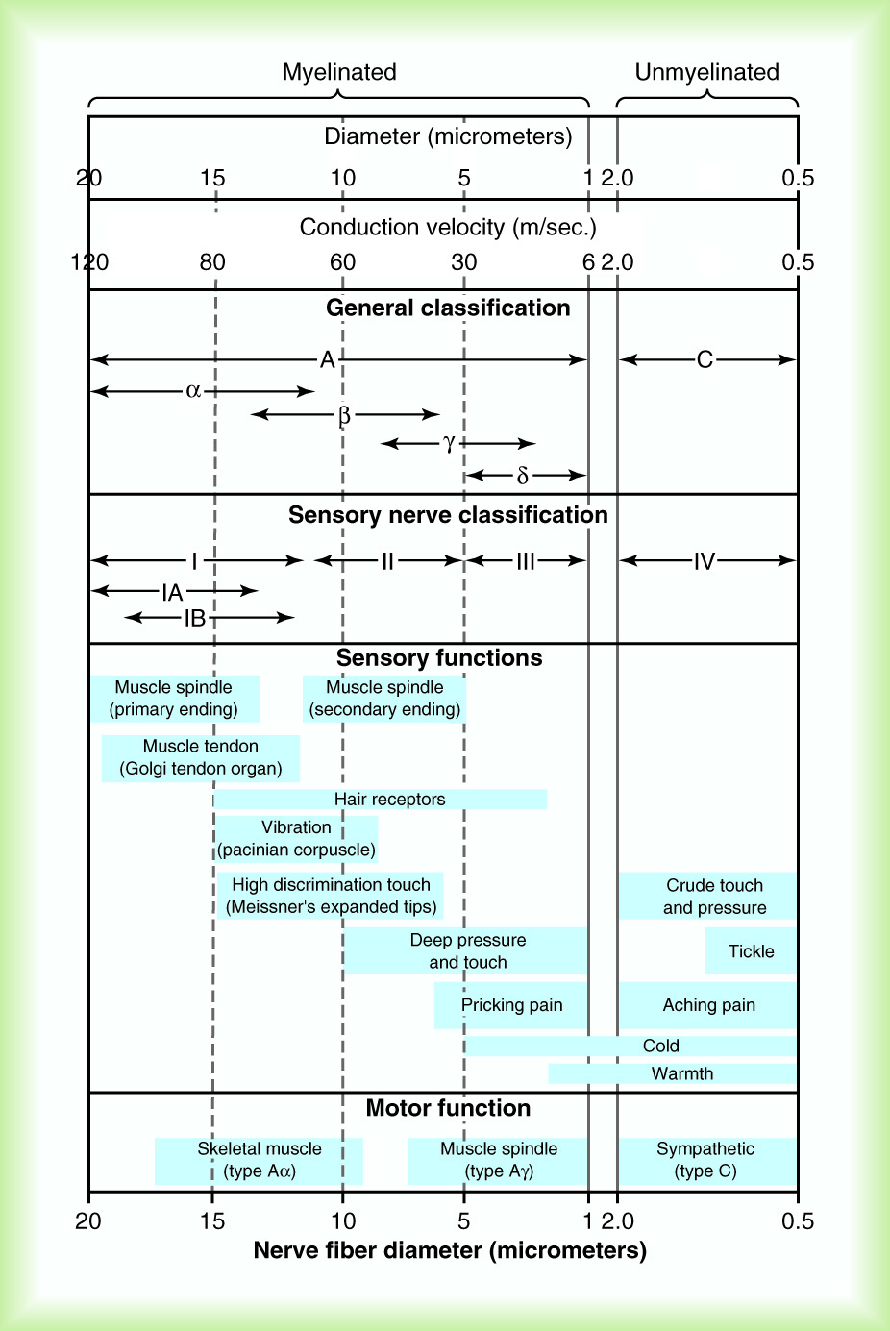In the cortex, they will reach a certain area specialized in sensation, anatomically called “*Postcentral gyrus*” and physiologically called “*primary sensory cortex*”.

Upon reaching the cortex, we had 2 pathways the PCML and the ALS, and both will go to the same place in the cortex. Some sensation will go through PMCL and some through ALS. From the finger, sensation will flow through the 2 pathways, and the sensation from the 2 pathways will reach the specific area that is responsible on the finger. The pathway will differ until we reach the thalamus then they’ll be the same.

All pathways will be distributed to the specific area for the body part it came from. In the cortex, the distribution os not based upon size. Hans has a large area compared to the trunk because it depends on the sensation and the receptor quantity. Two things we need to know, receptor quantity and two point discrimination (the resolution of sensation, the distance between two points that you can differentiate between them). Receptor quantity is usually hand-in-hand with the two point discrimination. Because the hand has a higher number of receptors so it has a better two point discrimination over shorter distance. More neurons will give more axons taking a bigger area. This is the hand compared to the arm or the trunk.

The conduction of a pathway (speed) depends on:

1. Myelination
2. Axon size (the diameter)
3. Synapses (but both have the same number of synapsing, 3, so really it isn’t a factor)

Note: the length doesn’t determine conduction since both pathways have 3 order neurons and travelling the same distance. Decussation isn’t a factor since it doesn’t increase the distance and both decussate.

Anatomically axons are divided to Unmyelinated ***C*** and myelinated.

The myelinated differ in size, so they named them α, β, γ, δ depending on the diameter.



But physiology is interested in the function of the axon which is the conduction and so they divided them according to conduction speed. The fastest conducting speed is the 120m/s.

Myelination and size both affect the speed so they go hand in hand. ASL sensation will use thin fibers with non-myelibated axons while the PCML will be myelinated and thick fibered axons. Since the main factors affecting speed are size and myelination.

In the general sensation, the brain wants some information fast so they travel via PCML and if the info isn’t needed quickly it will travel via ALS.

The two point discrimination is a fine touch sensation therefore it’s fast.

What we have in the fast conducting pathway they need higher processing to be meaningful. Proprioception is needed constantly to know in what position are you limbs. While in the slow conducting pathway does not need higher processing and also because we have other centers that work on analyzing them and perform the necessary reflex like the spinal cord and subcortix. So the brain does not necessary need this information immediately.

Example: upon bumping your small toe with the table, you will jump up and down before sensing the pain.

Another difference between the two pathways is the decussation place. PCML stays on the same side till the medulla while the ALS decussates at the spinocortical. So if we have a lesion in the spinal cord, all the sensation will be lost but PCML will be lost on the same side while the ALS will be lost contra-laterally.

**Receptors:**

Receptor is an energy transformer. It transforms the energy from a type to another.

Types of receptors:

Mechanical to electrical impulses which is the action potential

Thermoreceptors that will change from heat to electrical impulses

Shape-sensitive receptors

Nociceptors that are pain-senstive

Electromagnetic that are light-sensitive for vision

Chemoreceptors taste and smell- sensitive.

**Mechanical receptors:**

We have the receptor. Force will compress the receptor which has mechanical gated ion channels (open by mechanical force) that will upon exerted pressure. We will have depolarizaltion and graded potential because of the ions entering, it will get us to the threshold if the force was enough an action potential will take place. Usually in a neuron the action potential takes place in the axon. Here we have the same principle but the receptor doesn’t have voltage gate. Voltage gated will start at the first rod of the axon. If deformation happened here it will give an graded potential. If it reached the reshold it will give action potential and if it didn’t reach the threshold there will be no action potential. So the receptor potential is usually like the cell body; it will give graded potential. And each receptor will have an ions’ type depending on the signal transfer. For the mechanical receptor it will be mechanical gated. For the chemical receptors they will be chemical gated. And for the electromagnetic receptors, it works somehow by sensing of photon (the electrons of light).

Because it’s a graded potential it will allow you to know if it’s a small pressure or big. The difference in the information of both is differentiated by the frequency. The action potential does not differ in the amplitude. The quantity and size of the potential depends on the kinetics of its ion gates. It’s height depends on the same thing, when will they open and close, the ion composition in the environment. So that’s why here the action potential doesn’t differ in length or speed. The only difference is the frequency.

We have other receptors that will differentiate between a light pressure and heavy pressure by frequency. The mechanism: a light pressure will open about 8 channels; some sodium will enter (say about 120). This 120 will get you to the threshold so you will have an action potential.

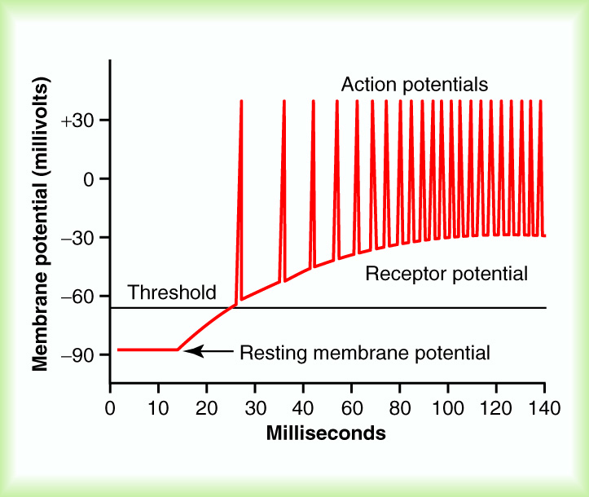 If we have a heavy pressure, more channels will be opened and a bigger number of sodium entering (instead of 120 we will have 200 maybe 300). This will not affect the action potential because in both ways it will reach the threshold, what differs is the next action potential site, in the relative refractory period or after. So the frequency if what differs.

A receptor with a certain threshold, give it some pressure, you will not have an action potential. A bit bigger pressure will reach the threshold and result in an action potential. Bigger pressure will give higher potential.

In other words, the length and force of the action potential are constant for the neuron and the axon. Notice that almost all of them are +30. Giving a mall pressure will reach the sub-threshold and no action potential will occur, no information will be received by the brain. If the pressure reaches the supra-threshold it will give an action potential. Giving a bigger force will not change the action potential because it’s constant but what will happen is a higher number of action potential will occur per unit time thus the frequency increases. Why? Depending on the gates opened and the number of sodium ions that will get you to the threshold. In the relative refractory period we have supra-threshold. So if you a limited number of sodium to barely reach the threshold, the action potential will happen with a greater relative refractory period and the threshold will not happen again unless you’re back to the resting state. But if we have a high number of sodium, you will finish the action potential and start a new one in the middle of the relative refractory period. And so the action potentials are closer, the frequency increased.

**Adaptation of the receptors**

The receptors are divided into 2 types:

Fast adapting: senses a change then after sending the information once or a few times it will stop sending it.

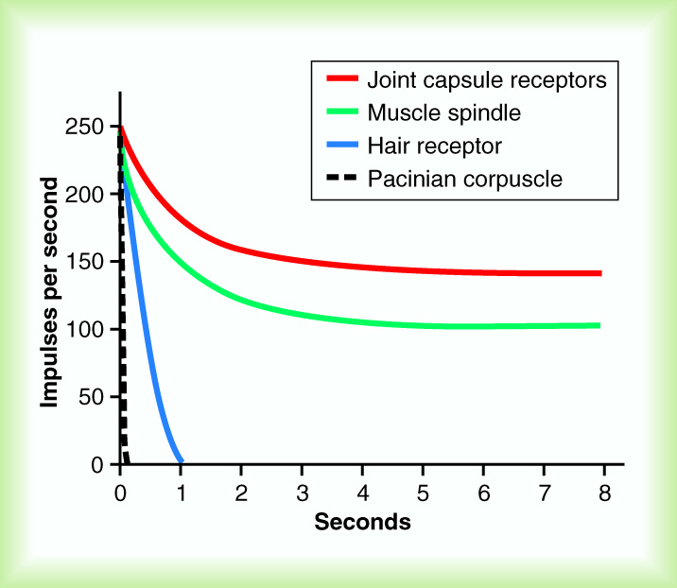Slow adapting: constantly sends the same information to the brain. It will not stop. Even here, there will be some adaptation (lowering the number of impulses) but will still send the information.

Referring to the graph:

Below a second, it is fast adapting. Comparing the slopes after 8 seconds, the first will give 0 impulses. The second will give also 0, the third, about 125 and the fourth will give about 150. In conclusion, the first and the second are fast adapting while the third and fourth are slow adapting.

Back to the sensation, which does the cell want it to be fast and which does it want it to be slow adapting?

[The information we need to constantly know about it will be slow adapting, and what we do not need to know about it anymore will be fast adapting.]

|  |  |
| --- | --- |
| Slow adapting | Fast adapting |
| * Temperature * Pain * Proprioception*(you need to know your arm position constantly*) * Muscle tension * Muscle length | * Fine touch and vibration * Joint position and movement *(because you want to know the speed of its change)* |

**Receptor names**

In the receptors we have overlapping and to override this overlap, we’ll see the main function each.

Vibration and pressure are usually *Pacinian corpuscles*

Pressure’s receptors are the *Merckle cells*

Fine touch has 2 receptors; mainly *Meissener corpuscle* (*present in the non-haired skin only)*

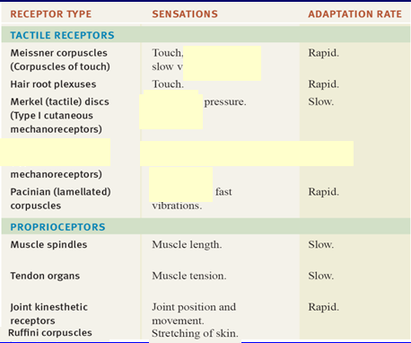In the hairy skin, fine touch is sensed by the *Hair follicles*.

For the proprioception, we have 3 things to be sensed

Joint position and movement*: stretching of the skin + muscle information*

*Ruffini corpuscle:* is a third receptor for the joint movement and position. It calculates skin stretch, helps in giving information about the speed of movement of the joint.

Muscle tension: *tendon organ Golgi*

Muscle length: *Muscle spindle*

Regarding the ALS pathway, we have crude touch and pain and have same receptor *Free nerve endings.* The nerve has no specialized receptor but it has a bigger end to act as a receptor. Different types will feel the extreme pressure as a pain and so they have a threshold to only sense pain if the pressure applied is huge. Can also feel some chemicals that are responsible for pain like inflammation (like prostaglandin, histamines, 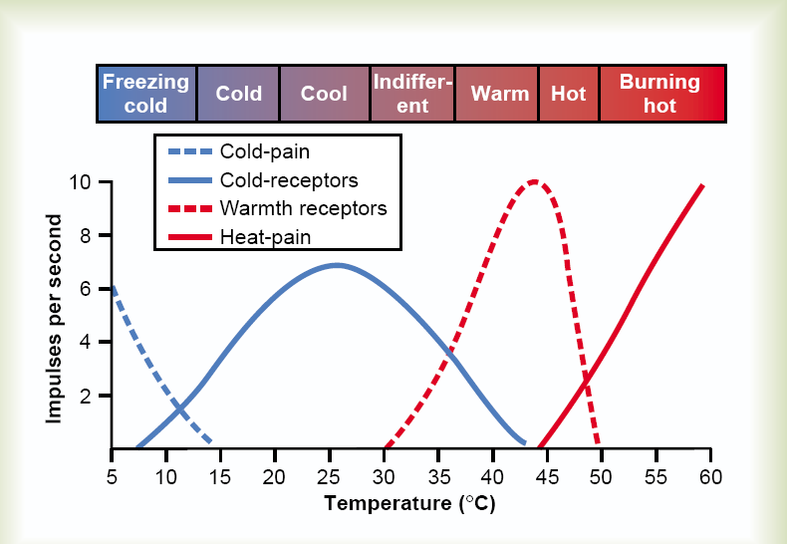and serotonins), we will sense this as pain. Has a slow adaptation rate.

We have to receptors for temperature, one for cold and one for hot. We know the temperature because of the combination of the two receptors. So at 10°C, lower than body temperature, cold will give high frequency impulses while the hot will give low impulses. At 30°C or 35°C there’s different combination and the 40°C, the hot will give more impulses than the cold.

