Page 193 in the booklet:
Insulin and glucagon provide a short-term regulation of plasma glucose level, both of them normalize the level but in an antagonistic way, one of them is hypoglycemic (insulin) the other is hyperglycemic (glucagon).
Other hormones that are involved in regulation of plasma glucose, are similar to the growth.
Insulin is the only hypoglycemic hormone in the body whereas Glucagon is the most potent hyperglycemic hormone in the body. Nevertheless a number of other hormones contribute to the maintenance of a stable blood glucose ,as well as mobilizing glucose when necessary . these hormones include cortisol, GH, catacholamines and thyroid hormones
What is the most important function of cortisol in this aspect?
Gluconeogenesis
RECALL : The receptors of insulin as well as the second messengers are different than those of other hormones.
Page 187 :
The receptor of insulin is composed of 4 subunits (2 α+ 2 β), each subunit has its own location,2 α-subunits are on the cell membrane, and the 2 β-subunits are inside the cell membrane.
The second messenger is connected with β-subunits; Insulin binds with α-subunit, once insulin binds to α-subunit, β-subunit is activated and the second messenger will be activated as well , then physiological response occurs (the insulin functions) .
The first function is the activation of glucose transporters. there are many glucose transporters such as gluco-transporter number 4 .
Other functions of insulin are ;protein synthesis ,fat synthesis ,glucose synthesis , growth and secretion
Keep in mind that The passage of glucose from high concentration to low concentration is by the facilitated diffusion and in the opposite direction (from low to high) is by active transport.
Fig 46-10, page 195:
Insulin activates phospholipase C and tyrosine kinase to produce the two second messengers; diacylglycerol and IP3, by the activation of these two second messengers electrolytes (K, Mg, P) entry to the cells might occur , as well as amino acids entry occur to start protein synthesis.
Tyrosine kinase may also permit the entry of electrolytes to the cells.
The figure in Page 191 shows the similarity in the structure of insulin, insulin growth factor 1 (IGF I), insulin growth factor 2 (IGF II).
*the secretion of insulin has many stimuli ,Glucose is the most important stimulus for its secretion , but it has to be metabolized (in the form glucose 6-phosphte), then depolarization occurs and once there’s depolarization the concentration of Ca increases in the cell, then insulin starts to be released from the β cells. ‘’this mechanism is similar to Acetylcholine secretion’’.
*Refer to table 78-1 , Page 212;factors that increase or decrease insulin secretion .
Ghrelin stimulates insulin secretion, it also stimulates the appetite.
*Page 201 there’s a graph that shows the relation between insulin secretion and plasma glucose concentration.
Insulin is not secreted all the time . when glucose level in the plasma is below 50mg/dL there’s almost no insulin secretion, in addition to that, the maximal level of insulin secretion is between 300-400mg/dL.
In down regulation ,the individual needs more insulin in order to bring glucose concentration back to normal since the number and the affinity of the receptors are low .
The doctor explained a slide (from guyton) that shows the concentration of insulin when a person takes a glucose injection, the concentration first shows a sudden increase then it decreases and finally it gets back to the normal ratio, the explanation is :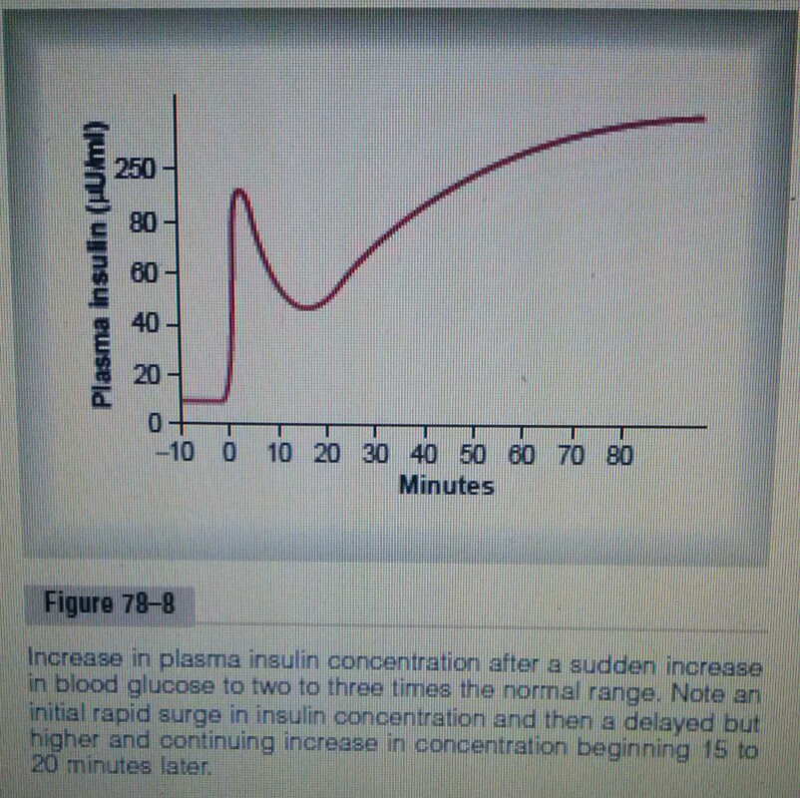
First, the sudden increase is due to the secretion of the pre-existent insulin, then there’s a gap because it takes time to synthesize new insulin, after the new synthesis secretion occurs, and insulin concentration is back to normal.
Table 7.6 ,page 198 :
Insulin affects carbohydrate, lipids, proteins, ions and as a result growth (protein synthesis )
From the biological effects of insulin on carbohydrate metabolism, that it reduces rate of release of glucose from the liver and increases the rate of uptake of glucose into all insulin-sensitive tissues, mainly liver, adipose tissue and muscles.
Whereas On lipid metabolism, insulin reduces the rate of release of free fatty acids from adipose tissue.
On protein metabolism, it increases the entry of amino acids into cells. And On ion transport, insulin helps in transport of (K, Mg, and P).
*table 19-3 ,page 200 :
There’s some tissues in which insulin doesn’t facilitate the entry of glucose to them , those are brain, kidney tubules, intestinal mucosa and red blood cells (all of these are essential organs), in the others insulin facilitates glucose uptake.
*Fig 17-14,Page 203; normal homeostasis of blood glucose
normal glucose concentration in the blood ranges from 70-100mg/dL, but usually it’s 92mg/dL, glucose enters the liver under the effect of insulin, it enters as well fat , muscle and other tissues,( brain doesn’t need insulin according to what we said previously).
If glucose concentration remains 180mg/dL, no glucose appears in the urine and this is called renal threshold.
* Fig 19-7 , page 204 :
When there’s an issue in insulin, the homeostasis of glucose is affected in fat, liver, muscles and other tissues, and there will be glucose in the urea (once the concentration becomes above 180) .
*As a conclusion ,Insulin deficiency has many effects on the metabolisms of the body. We are going to talk about them in details .
First ,The effect of insulin deficiency on fat metabolism :
The most important effect is that the enzyme hormone-sensitive lipase in fat cells becomes strongly activated, this causes hydrolysis of the stored triglyceride, releasing free fatty acids and glycerol into the circulation, then the plasma concentration of free fatty acids begins to rise to a maximal level, in this case the body depends on free fatty acids for energy, because it can’t utilize glucose and it remains in the blood without entering the cells.
Also the level of ketoacid, acetoacetic acids and β-hydroxybutyric acid in the body fluid rises, these are called ketone bodies; and this results in acidosis due to the increase of the level of ketone bodies .
ketone bodies are execrated in the urine, sometimes they bind with Na, so Na+ becomes replaced by H+, and then acidosis becomes more dangerous to the individual in addition to the concentration of ketone bodies . (when Na binds to ketone bodies, Na gets outside the blood, and H will enter instead which increases the acidosis). Now ,the effects of Acidosis are ketone bodies and the replacement of Na by H .
*The effect of insulin deficiency on protein metabolism:
The catabolism of proteins increases .Protein synthesis stops, large quantities of amino acids are released into the plasma, amino acids concentration rise in the plasma ,and most of the excess amino acids are either used as energy or as substrates in gluconeogenesis (RECALL :gluconeogenesis is the production of glucose ) ,even after this gluconeogenesis, the body can’t utilize the produced glucose.
The resulting protein is one of the most serious effect of severe diabetes mellitus, it can lead to extreme weakness and too many delayed function of the organ.
In diabetes mellitus there’s a decrease in glucose uptake, this causes hyperglycemia, glycosuria, osmotic diuresis,and electrolyte depletion.
A person who suffers from diabetes mellitus urinate more than a normal person, why?
Since There’s too much glucose in urine and in renal tubules, this leads the osmotic pressure to rise, which prevents water from being reabsorbed but it is excreted instead. this is called the osmotic dieresis, also electrolytes cannot be reabsorbed so they will be excreted, and this is called electrolyte depletion.
*Fig 19-10 , page 205 :
Insulin deficiency increases Protein catabolism ,which increases amino acids , as well as results in nitrogen loss. Lipolysis increases ,which in turn increases plasma free fatty acids, ketogenesis, ketonuria, ketonemia, ALL of these lead to dehydration , acidosis then coma and finally death.
( the doctor explained a slide about coma ,which is not in the booklet )
Diabetes causes coma which can be due to acidosis or dehydration, however, the plasma glucose can be elevated to a sub degree that is independent of acidosis, the hyperosmolarity of the plasma causes coma as well.
Other causes of coma : Accumulation of lactic acid in the blood , hypoglycemia causes coma’’ when the concentration reaches below 40mg/dL ‘’ .
Now there’re three types of coma: acidosis, glucose concentration and lactic acid.
How to differentiate between coma of diabetes and coma of hypoglycemia ?
Acetone smell gets out of a person with a hypoglycemic coma.
*Back to Diabetes, There’re two types of it:
Type (1) diabetes; insulin dependent diabetes (IDDM) or Juvenile diabetes, related to insulin deficiency or a problem in the pancreas.
Type (2) diabetes ; Non-insulin dependent diabetes (NIDDM) or maturity-onset diabetes or obesity –onset diabetes, a patient with this type of diabetes takes drugs that stimulates the Beta cells . However insulin might be taken at the end when those drugs are not giving any results since the Beta cells are destroyed .
The doctor explained a slide that includes a comparison between these two types in many aspects as in age, body mass, (plasma insulin, glucagon and glucose), sensitivity and therapy. Similar to pages 207 and 208.
*Obesity :
In obesity, the number of fat cells stays constant but the size increases.
-Refer to page 210 ; Obesity slide .
The measures in which determine if a person is obese or not :
1.The relation between height and weight ; for males : Height -100 whereas for females : Height-105
2.The measurement of the waist, it must be less than the half of the height.
3.The body mass index (BMI)
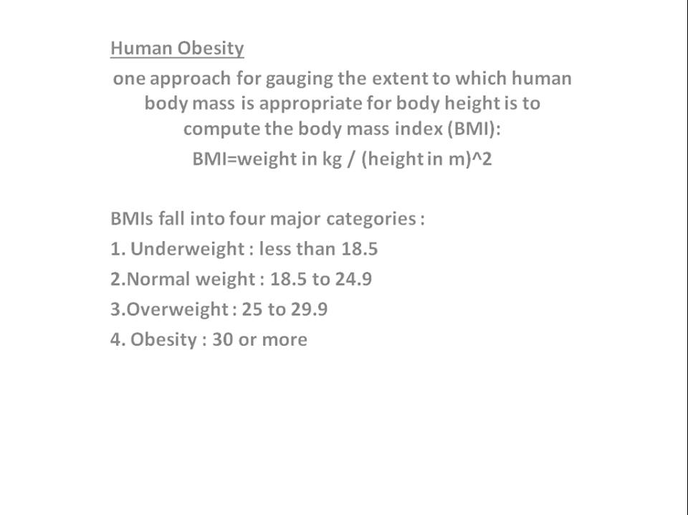
Obesity causes many complications as in the cardiovascular system, hypertension, pulmonary diseases, diabetes type 2 , cancers, varicose and gall bladder diseases.
*What are the most important functions of glucagon?
Since it is the most potent hyperglycemic hormone, its functions are ( arranged from the most important to the least) :glycogenolysis, gluconegenesis, ketogenesis, lypolysis.
Factors that stimulate glucagon : hypoglycemia, amino acids, acetyl choline, nor epinephrine and epinephrine. Whereas Fatty acids, somatostatin and insulin inhibit glucagon.
In normal conditions there’s balance between glucagon and insulin. during exercise glucagon concentration increases while insulin decreases .on the other hand , after a carbohydrate meal glucagon concentration decreases while insulin increases and then after a short time glucose concentration reaches 130mg/dL, but still constant to the brain and other tissues.
Glucose to the liver is 80 (constant), 40 to the muscles and 6 to the brain.

