We talked about airway resistance and restrictive diseases (examples: RDS the patient may die either because of pulmonary edema or because of fatigue, pulmonary fibrosis is another famous disease)
Restrictive disease I can’t inflate the lung
**What do we expect from the respiratory system ?
We expect two things :
- To have proper enough ventilation
- To have enough perfusion
The intra plural pressure in the lung of a standing individual is more negative in the apex (which is equal to -8) , less negative at the base (which is equal to -2) and the average (is equal to -5) ; this makes the alveoli at the apex more inflated because they are surrounded by more negative pressure and makes the alveoli at the basal region less inflated ; therefore from yesterdays lecture we know that it’s difficult to inflate an already inflated alveoli , it’s easier to inflate partially inflated alveoli .

**when you take 500 ml (tidal volume) it’s easier for the air to go to the apex rather than the base, why?!!!!
Because the airways there are more patent

When we talk about breathing we should consider two things:
- Airways if they are opened its easier for the air to pass through them
- Balloon is it inflatable or not!!

Regarding to the apex: because of the more negative pressure (compared to the base) the airways are more patent (opened) but the balloon itself isn’t inflatable because it works at the high portion of the compliance curve , so the end result most of the ventilation goes to the base and less to the apex so the ventilation (500 ml) isn’t distributed equally between the apex and the base
At the base more ventilation will occur and the alveoli are partially inflated so it’s easy to inflate them (from the compliance curve)
Note: we must have both ventilation and perfusion because ventilation alone isn’t enough (it’s wasted without perfusion) and vice versa.
Note: it’s much easier for the blood to go down because of gravity so again the perfusion for the base is greater than the perfusion for the apex

We have four important statements:
- Ventilation at the base > ventilation at the apex
- Perfusion at the base > perfusion at the apex
- Ventilation/perfusion at the base <1 …. That means perfusion > ventilation at the base
- Ventilation/perfusion at the apex >1
“And always remember that what we care the most is the ratio (ventilation/perfusion)”
AND THIS GRAPH EXPLAINS THESE STATMENTS

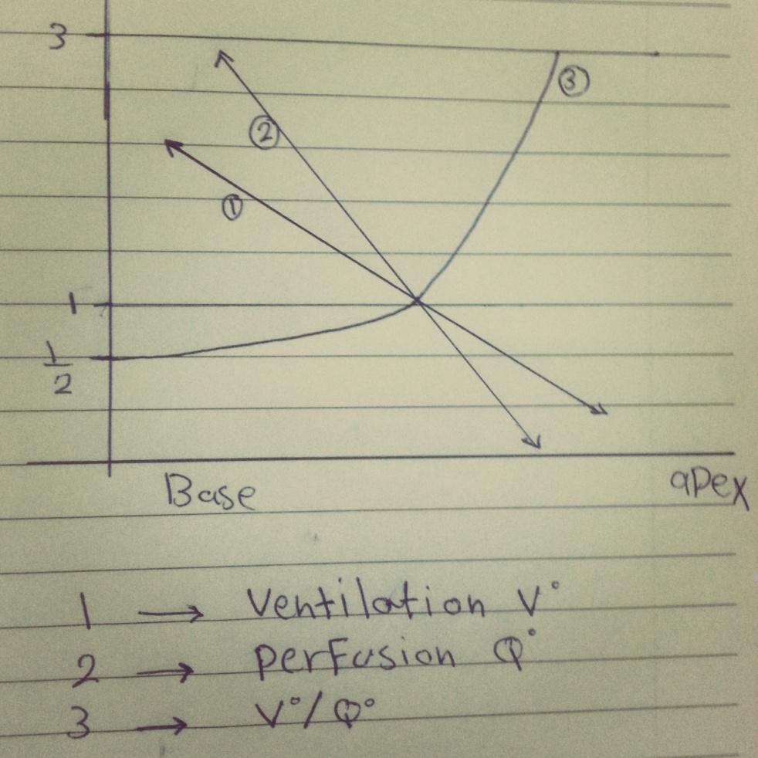

NOTE: THE PERFUSION SLOPE > THE VENTILATION SLOP BECAUSE UNLIKE THE AIR ,THE BLOOD IS SEEVEERLY AFFETED BY THE GRAVITY.
The apex: the amount of air that enters it > the amount of blood that enters it but both of them are in small amounts ( and vice versa about the base)

The Po2 inside the alveoli (=100) is almost constant … why?!!
Because the amount of oxygen that inters the alveoli = the amount of oxygen that enters the blood (or the amount of oxygen that exits the alveoli) ,It’s in equilibrium
So, if the amount of oxygen that enters the alveoli > the amount of oxygen that enters the blood the Po2 inside the alveoli will increase to reach 110,120,130 it depends on the amount of oxygen
But, if there is no blood at all, the Po2 inside the alveoli will be equal to 150 but impossible to reach above 150 … why?!!!!
I’m going to explain it by giving you an example …. You have a balloon (its maximum capacity =150) and the maximum thing that I want to achieve is for the Po2 inside it = Po2 outside which equals to 150 (not 160 because of the water vapor )

You may wonder why is it impossible for the Po2 inside the alveoli to reach 160?!!!
Because as we mentioned in the last lecture, there is water vapor
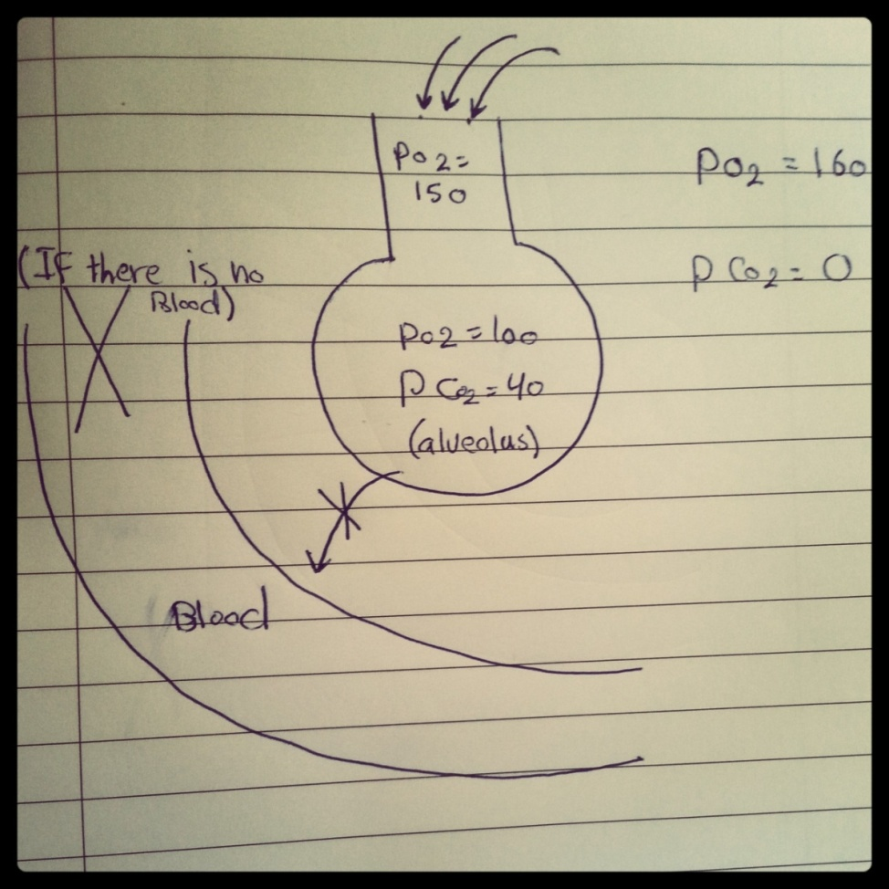

When we increase ventilation the Po2 will increase until the Po2 reaches 150 (at 150 no matter how much we increase ventilation the Po2 will not increase any more)
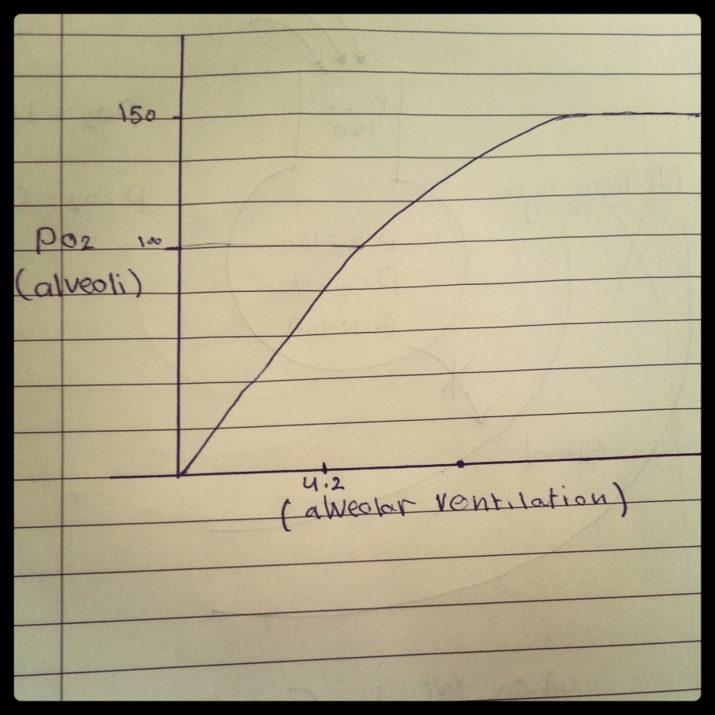
By increasing the ventilation there would be an increasing in the PO2 till we reach 150 as PO2 (the maximum pressure we can reach )
Now …
Po2 = Va /Vo2 * K
Po2 alveolar Po2
Va alveolar ventilation
Vo2 oxygen consumption
K constant
So from this equation:
- Alveolar ventilation ↑ … Po2 ↑ (directly proportional to a limit)
- Perfusion ( oxygen consumption) ↑ … Po2 ↓ ( inversely proportional)

Now we are going to talk about Co2 …
If there is ventilation but no perfusion, the Pco2 will decrease from 40 until it reaches zero ( the Pco2 inside equals the Pco2 outside)
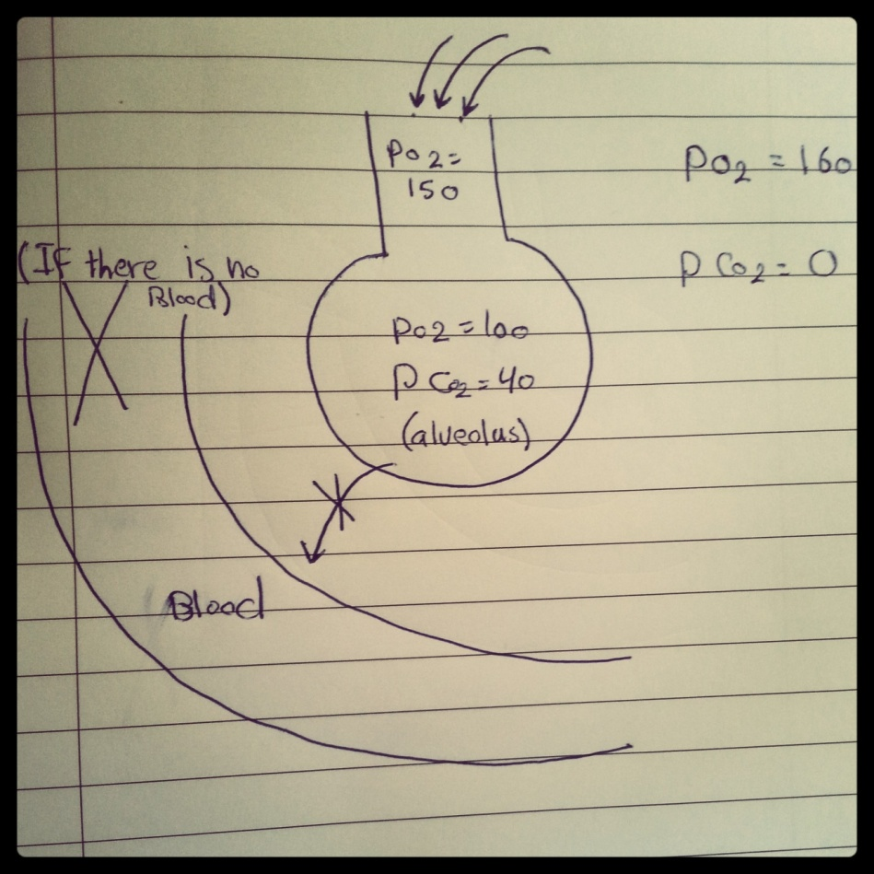

Hyperventilation:
Definition is the action of breathing larger amounts of air than normal either by taking bigger breathes or by breathing more rapidly or both , one of the main measurable effects of hyper ventilation and also a criterion for defining it is the Pco2 which decreases below 40 mmHg ( notice that we are talking about CO2 not O2 )
What is the purpose of hyper ventilation?
- increase alveolar Po2
- decrease alveolar Pco2
- Try to make the composition of alveolar air closer to the composition of the outside air

There is another equation that we are going to mention now …
Pco2 = Vco2 / Va * K2
Vco2 co2 production
Va alveolar ventilation

Pco2 is directly proportional to Vco2
Pco2 is inversely proportional to Va

During exercise:
The alveolar ventilation increases But the co2 production also increases so the alveolar ventilation won’t change .

**During exercise we are breathing 12L NOT 6L …. But do we call it hyperventilation?
NO, we call it increased respiratory minute ventilation

NOW we have another definition for hyperventilation which is: when the ventilation results in decrease in alveolar ventilation
Let’s return to the previous question (why don’t we call it hyperventilation?)
Hyperventilation doesn’t mean to increase the pulmonary ventilation , and during exercise pulmonary ventilation has nothing to do with any change that happens to co2 in the alveoli , that’s why we don’t call it hyperventilation

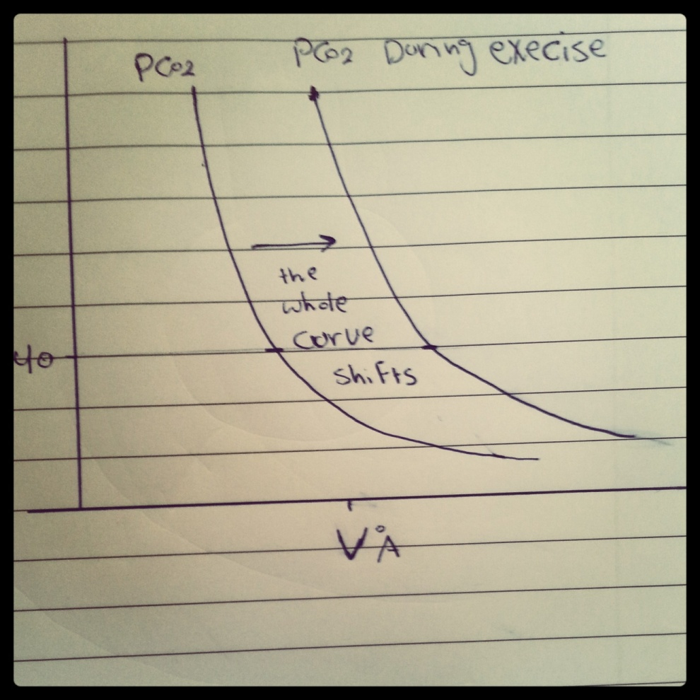

“And it has the same effect on the Po2 curve”

**Based on what we explained earlier, how much are the Po2 and the Pco2 in the apex and how much are they in the base?
In the apex the Po2 > 100 mmHg and the Pco2 < 40 mmHg (because the ventilation > perfusion)
In the base the Po2 < 100 mmHg and the Pco2 > 40 mmHg because the (perfusion > ventilation)

important note: alveolar Po2 equilibrates with the blood surrounding the alveoli ; which means that the blood which returns back to the left atrium is coming from the apex and the base ( the blood which is coming from the apex has high Po2 and the blood which is coming from the base has less Po2 ) so the blood which is coming from these two areas is mixed before entering the left atrium.

Tuberculosis :
The TB bacilli are aerobic bacilli and we mean by aerobic that they love oxygen, so where do you think they build their nests?
- At the apex
So if you see a cavity in any x-ray in the apex directly you suspect TB more than cancer and its curable (in very rare cases it could be cancer and it’s hard to cure )
How did we come up with this answer?
- The shadow is in the apex, and the amount of oxygen in the apex is greater than its amount in the base because the ventilation in the apex > perfusion, so the alveoli there have more amount of oxygen than the alveoli in the base, and TB bacilli are aerobic bacilli that’s why we diagnosed it as tuberculosis .

This is a demonstration of how the cavity (tuberculosis) in the lung appears in x-ray:
- it appears like a shadow
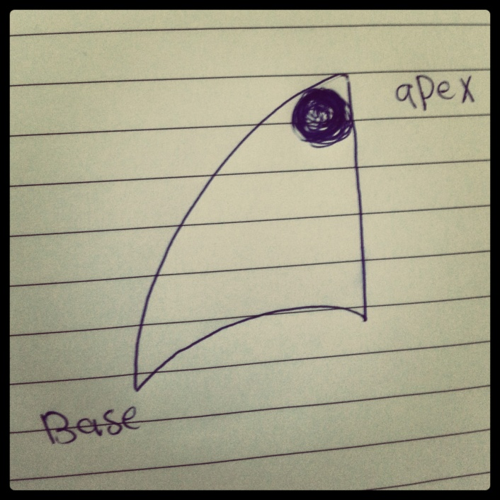

- And if the cavity is in the base it’s more likely to be malignant cancer

Now , if there is no ventilation but there is perfusion (V/Q = zero)
- The alveolar Po2= the Po2 in the blood = 40
- The alveolar Pco2 = the Pco2 in the blood = 45
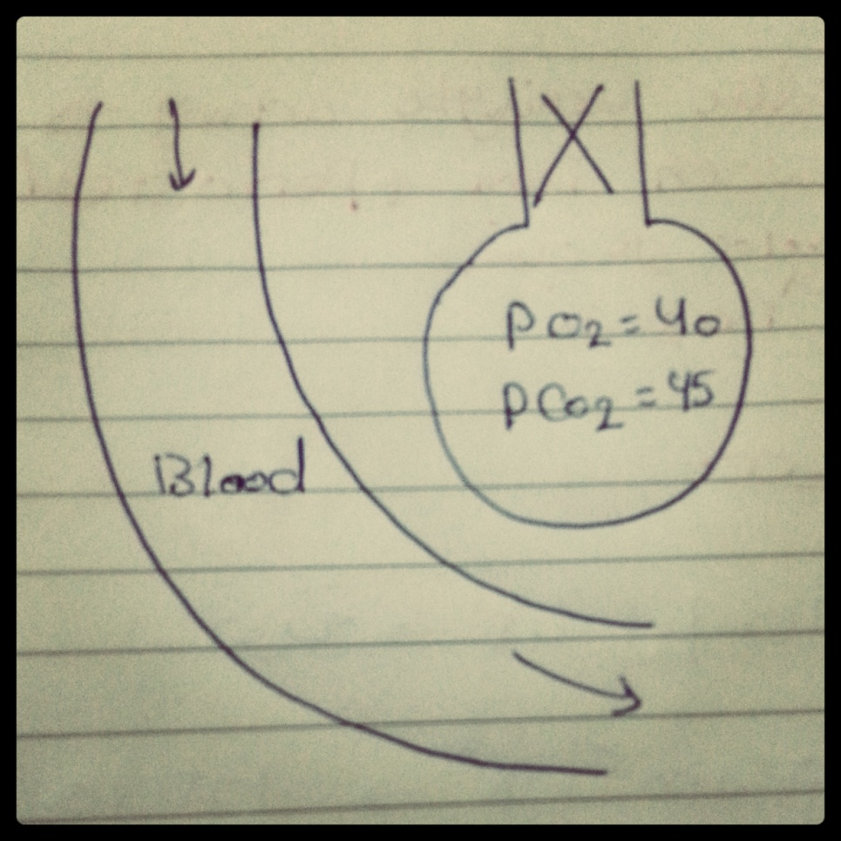

If the V/Q= ∞ :
- that means that there is ventilation but no perfusion , then :

- The Po2 = the Po2 outside= 150
- The Pco2 = the Pco2 outside = zero
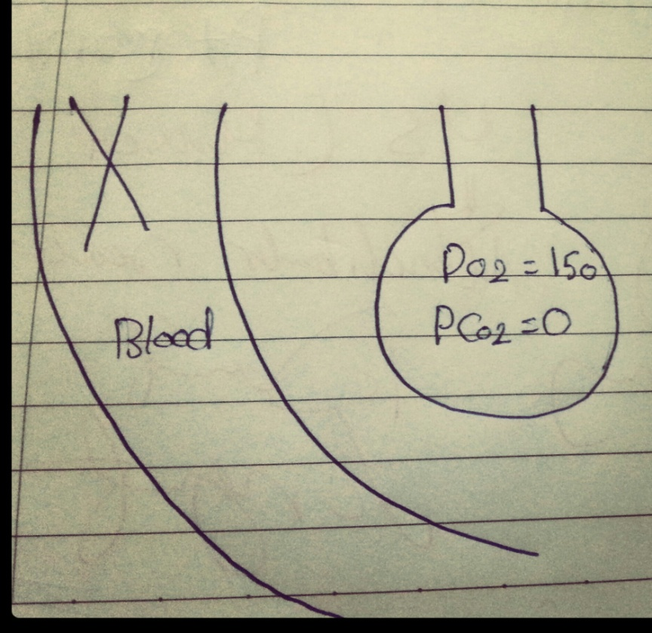

And now we are going to talk about the alveolar Pco2-Po2 curve ( if we said arterial instead of alveolar its almost the same)
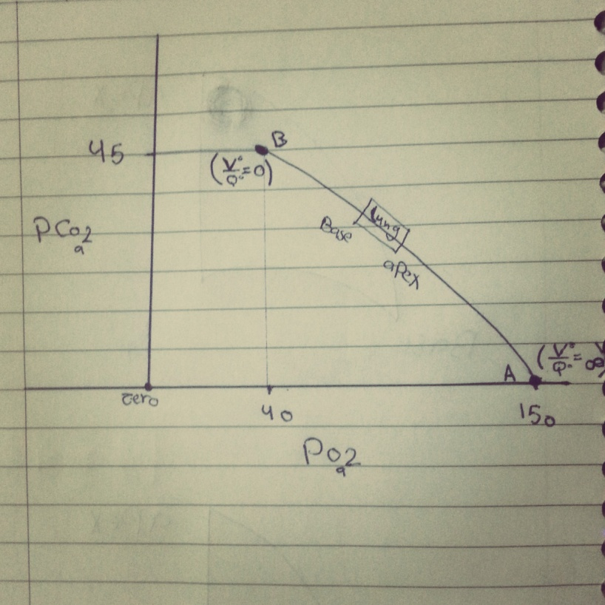

Point A (alveolar dead space) : V/Q= ∞ V : is alveolar wasted volume , and we said wasted because there is ventilation but no perfusion
Point B (physiologic shunted blood) : V/Q= 0
What do we mean by shunted blood ?
- It is the blood that goes to the lung but doesn’t go to the alveoli ; it is shunted from the arterial side to the venous side without exchange . thus, alveolar Po2= 40 and the Pco2= 45
Why did we say physiologic ?
- Because very small amount of blood is shunted almost 1-2% of the total amount of the blood
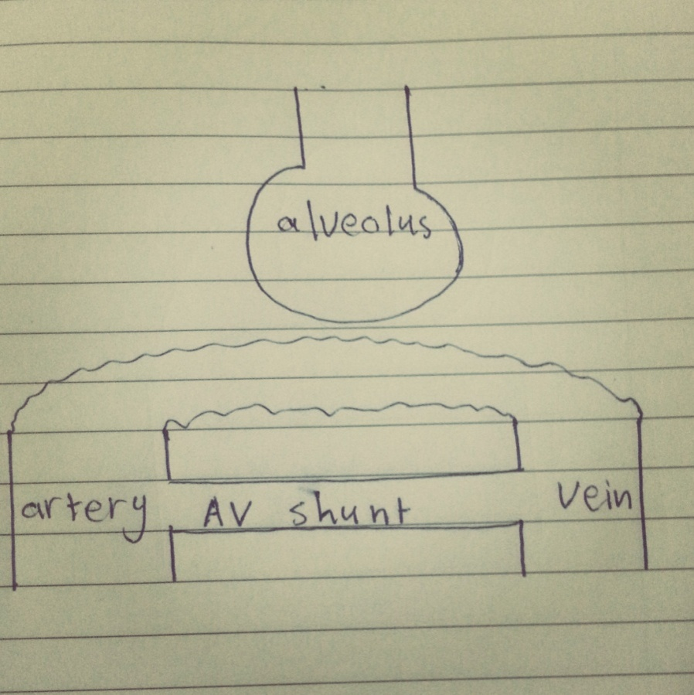
“The tube-like drawing above the AV shunt and connecting the artery with the vein is capillary “
Normally we consume 250 ml of oxygen per minute (this is normal oxygen consumption and this number is for memorization) and during exercise this number increases it may reach 5 L in very well trained athletes like marathon runners but in normal people like us it reaches 3-3.5 L
AND 3.5 L is called Vo2 MAX

Vo2 max : it Is the maximal oxygen consumption during maximal exercise (it increases from 250 ml at rest to 3500 ml during maximal exercise but in very well trained people its more- as we mentioned before it could reach 5 L-)
How much is the co2 production per minute at rest ?
“Lest suppose that we are only eating sugar and nothing else “
C6H12O6 + 6 O2 6 CO2
So logically, for every one molecule of oxygen that is consumed there is one molecule of co2 that is produced, and the answer for the previous question must be 250 ml …. But that’s not right (why?!!)
- Because we are not only eating sugar (pure carbohydrates) we also eat protein, fat … etc and they are not catabolised totally (they are not broken down totally)
In fact, when we consume one molecule of oxygen we don’t produce one molecule of co2, so mixed food consume 250 ml of oxygen but produce 200 ml of co2 (and this is the right answer)

Respiratory exchange ratio = Vco2/ Vo2 = 200/250 = 0.8
And now we are going to explain a phenomenon that happens in our bodies …
If we took an arterial blood sample (for example from the radial artery) we would assume that the Po2 In it = 100 (because the alveolar Po2= 100) but in reality Po2= 95 … why?!!!
- Because there is some sort of pollution, the venous blood is mixed with the arterial blood, and this phenomenon is called venous admixture
The blood that is entering the atrium is coming from two places (the apex and the base)
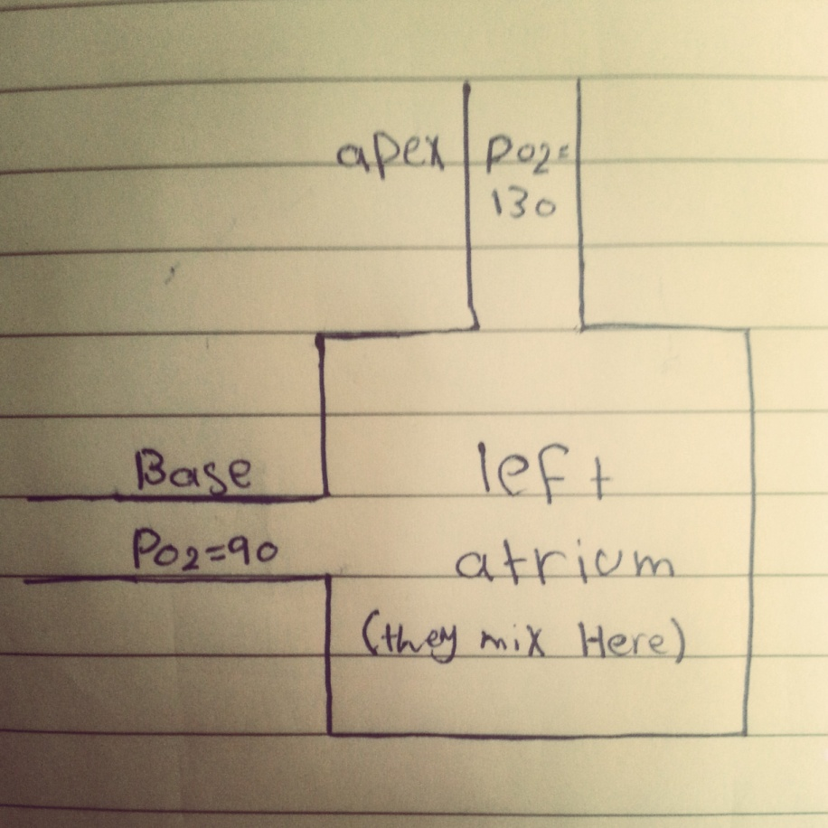

As we said before the perfusion at the apex < perfusion at the base ,
Let’s assume that apix : base = 1:3 , so :
130*1+90*3=400
400/4=95 (logically the answer must be 100 but in real life its 95 and we mentioned the reason earlier)
The hyper ventilated area (apex) was unable to compensate for the hypoventilated area (base) ; as we said before we are mixing two areas (hyper ventilated + hypo ventilated) , and when we mixed them they were not able to correct each other.

Oxygen is carried by the hemoglobin.
Oxygen-hemoglobin dissociation curve is sigmoidal

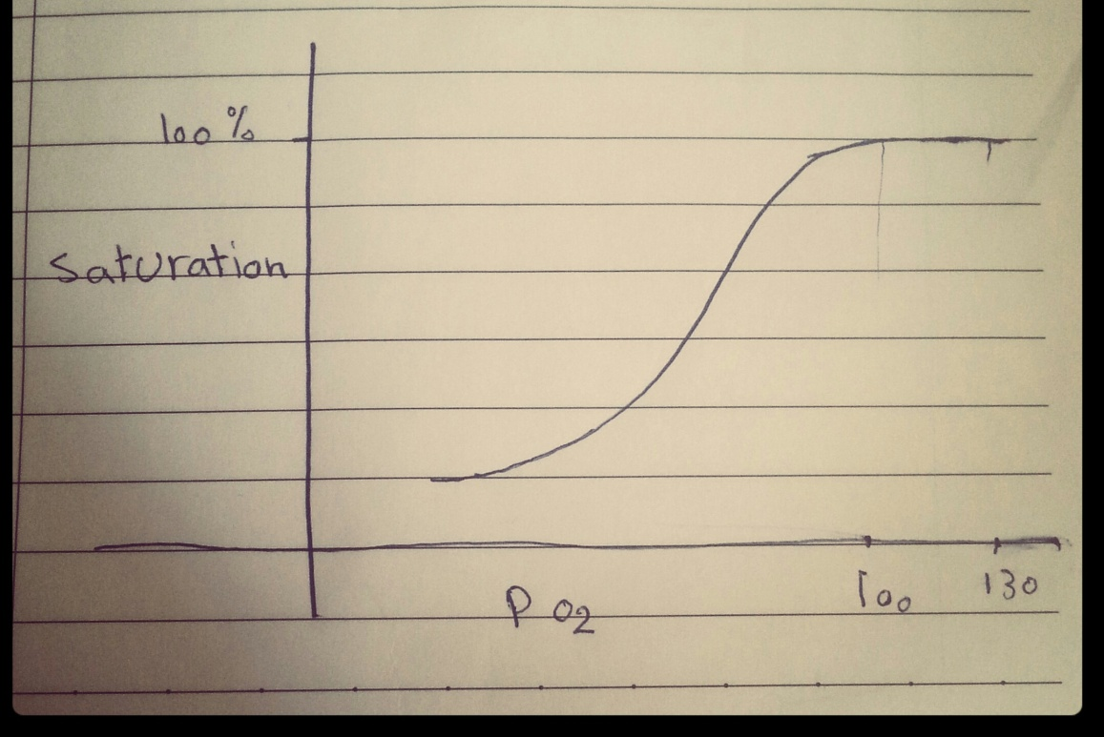

When the Po2= 100 the saturation=100%
And when Po2= 130 the saturation= 100%
Even if the Po2= 130 but actually we didn’t add any significant amount of oxygen that’s why the saturation stayed the same because it’s already saturated, so when the Po2 = 100 or Po2= 130 it’s the same

Why the hyperventilated lung wasn’t able to correct the hypoventilated lung?
- Because of the shape of the oxygen-hemoglobin dissociation curve but if the curve was linear : as long as we are increasing the Po2 the saturation will keep increasing and only then it can be corrected ( the answer is going to be explained further more in next lecture)

