Cerebral cortex and higher intellectual functions:
- Cortex of the brain:
- Outer part of the brain
- Contain the sulci and grooves
- Divided into 5 lobes:
- Frontal
- Parietal
- Occipital
- Temporal
- Insula (hidden lobe; between frontal & temporal)
- Also divided into:
- Primary cortex: First processing area (10% of processing) ex. Primary visual cortex processing of vision. If a lesion occurred in a primary sensory area loss of sensation in the area its responsible for (vision, hearing, somatosensory sensation)
- Secondary cortex: 2nd processing area (further processing giving a meaning to incoming info) ex. Secondary visual cortex 1. Connect the primary processing of vision with past experience 2. Secondary processing of vision. (Reminder: Cortex: processing with large storage of memory and no processing without memory, the memory store of the secondary cortex allows it to link the info to past experiences to give a meaning out of it.
- Association cortex: combining and processing of more than one information, producing higher order information (vision, hearing, sensation) that are used in higher order functions like personality and language
largest area in the cortex because of its importance in processing higher order functions.
- Histology of Cortex:
Longitudinal and stained section in the cortex it is divided into 6 bands. It is called Neocortex, some sections only have 3 or 4 bands called Allocortex.
- Neocortex :
- Most parts of the cortex.
- New areas (developed into the 6 layers)
- Main input: from thalamus
- 6-layered regions (differ in thickness and distribution of layers from region to another)
- Divided into 2 types:
first type Homotypical: all layers have the same thickness, except for layer 1 which is always thin, since it contains few neurons.
second type Hetrotypical: layers have different thickness
- Allocortex:
- in olfaction area and hippocampus.
- Older areas (not developed into 6 layers, only 3 or 4)
- Some info doesn’t pass by the thalamus, it goes directly to the allocortex part of the cortex
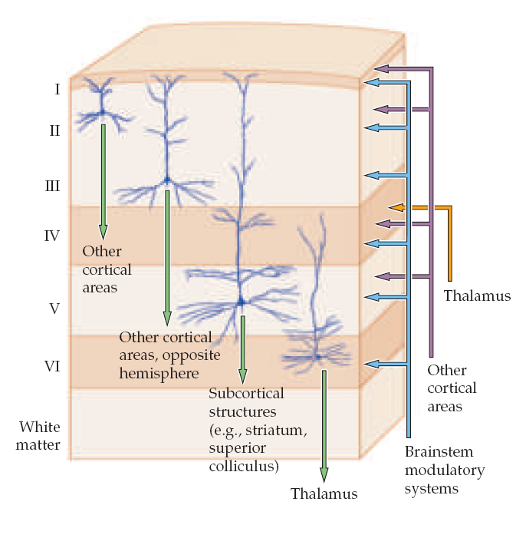
Back to Neocortex: Neurons have different types ( their names are not required); each type has a specific function, and each type of neuron exists in one layer usually, so each layer has a specific type of neuron. & Since “Form Follow Function” each layer has a specific function.
- Layer II & III output to different cortical areas.
- Layer IV input from thalamus.
- Layer V output to lower part of CNS & spinal cord.
- Layer VI output to thalamus.
- Layer I only for input of information from other cortical areas (doesn’t have much neurons)
- Input from other cortical areas also involve layers II, III, IV, V along with I.

- Major cortex areas which receive high input from thalamus Primary sensory cortexes (vision, auditory, somatosensory)
So, in sections from these areas: layer IV appears the largest.
- Major cortex areas which give to SC Primary motor cortexes ( corticospinal).
so, in sections from these areas: layer V appears the largest.
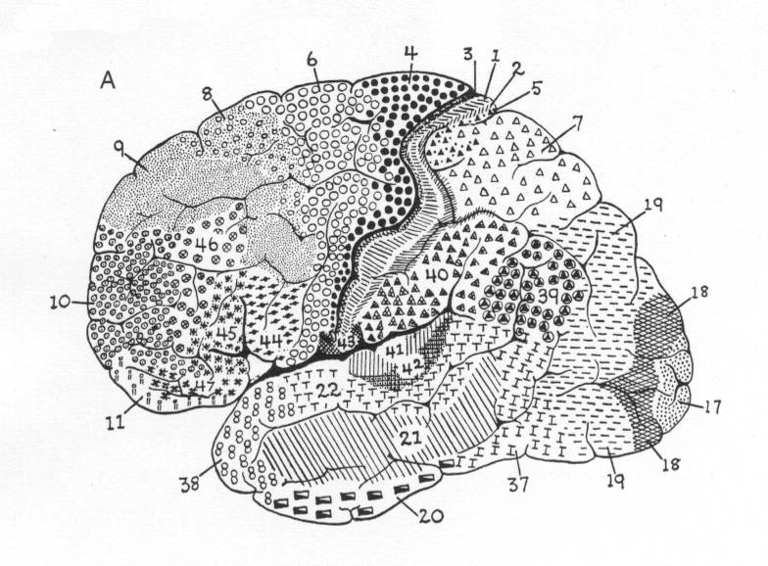
- Processing and association areas (from other cortical areas) are II & III so sections from these areas: layers II & III appear the largest.
Brodmann areas: distribution and numbering areas of the brain according to different function of different areas depending on types of neurons “Form Follow Function” by the scientist Korbinian Brodmann
Connections in cortex:
- Input from thalamus.
- Input from other cortical areas.
- between 2 areas near to each other.
- between 2 areas in different lobes or hemispheres (between hemispheres: by callosal fibers pass through corpus callosum)
- Input from other subcortical areas. (basal gangilia, cerebellum)
Neurotransmitters:
Communication Between Neurons is done by : synapses.
- Synapse: A specialized site of contact, and transmission of information between a neuron and an effector cell
- Neurotransmitter: is a messenger of neurologic information from one cell to another
- 2 types of synapses:
Electrical | Chemical
Mainly in the heart | Brain
No neurotransmitters | Uses neurotransmitter
Gap junctions | Synaptic space present
Direct | indirect
Faster | Slower

in brain: electrical synapse:
- Mostly in the hypothalamus (for quick release of hormones), neurons of hypothalamus have chemical synapsis with input or output neurons, and electrical between themselves.
- between astrocytes (glial cells)
- controlling the on/off of releasing hormones.
- No processing.
Action of a synapse depends on the postsynaptic receptor more than the neurotransmitter.
- postsynaptic membrane contains receptor proteins for the transmitter released from the presynaptic terminal.
- The effect of neurotransmitter on the post synaptic neuron depend on the type of the receptor
- 2 types of receptors:
Ion channels | Second messenger (G-Protein)
ionotropic | metatropic
Fast | Slower
No amplification | Amplification (needs low conc. Of neurotransmitter to work)
Short term effect | Long term effect (activate internal cascadesaffects DNA, gene transcription, changes the cell characteristics)

Ion channels:
- transmitters that open sodium channels excite the postsynaptic neuron.
- transmitters that open chloride channels inhibit the postsynaptic neuron.
- transmitters that open potassium channels inhibit the postsynaptic neuron.

Drugs and the Synapse
at the receptor
- Drugs either facilitate or inhibit activity at the synapse.
  - Antagonistic bind on the same site of the neurotransmitter . drugs block the effects of neurotransmitters
  - Agonist bind on the same site of neurotransmitter. drugs mimic or increase the effects of neurotransmitters
  - Allosteric modulation bind on other sites and can be activator or inhibitor
- A drug has an affinity for a particular type of receptor if it binds to that receptor.
  - Can vary from strong to weak.
- The efficacy of the drug is its tendency to activate the receptor .
- Drugs can have a high affinity but low efficacy.
Neurotransmitters:
- More than 50 chemical substances does function as synaptic transmitters. Divided by: Fast/slow.
- Fast Neurotransmitters:
- Act on ligand gated ion channels
- Only on chemical synapses because it’s a neurotransmitter( all NTs do chemical synapsis only)
- Mainly 2 fast neurotransmitter:
1. glutamate
2.GABA
Glutamate:
- Main excitatory neurotransmitter in the mammalian CNS (cortex)
- 95% of excitatory synapses in the brain are glutamatergic
- Precursor for the GABA (major inhibitory neurotransmitter)
- 2 types of receptor:
Ionotropic | Metabitropic
- More common  - Opens ion channels  - Fast synaptic transmission  - 3 types of receptors: 1.NMDAR 2.AMPAR 3.KAINATER  - all are excitatory  - (Na+ & Ca++ channels) | - Activate second messenger  - Slow synaptic transmission  - 7 types, excitatory/inhibitory

Although we have said that the action of the NT depends on the receptor of it ,here it is the same since
glutamate receptors are mostly excitatory ,we consider it excitatory NT.
Regarding the 3 types of the ionotopic receptors:
1.NMDAR: postsynaptic, mainly for Ca++
2.AMPAR: postsynaptic, mainly for Na+
3.KAINATER: presynaptic, works to enhance the signal by positive feedback; when it is bound to glutamate Na and Ca will enter the presynaptic neuron which will be excited and release more of the NT vesicles.
to end the effect of glutamate and remove it from the cleft it is taken by Glutamate transporter (protein)
found on glial cell membrane .

Glutamate and CNS disorders:
- Glutamate is found in all lobes and layers of cortex
- Stroke (the most common glutamate dysfunction)
Blockage of an artery Ischemia no nutrition no O2 no ATP no glutamate transporter increase of Glutamate release Over activation NMDA R & AMPA R increase Ca++ Apoptosis (cell death)
- This is called excite-toxicity (excitation to the point of cell toxicity and death) because of the over release of Ca++ it activated apoptosis.
- To prevent death: we give glutamate antagonist. Mainly NMDA or AMPA antagonist or a mix of them.
- Dysfunction of glutamatergic transmission may also involve in schizophrenia-like symptoms, cognitive dysfunction, Depression and memory impairment

