♥ We control pain by many processes:
- Opoid drugs (this will suppress pain)
- SRI (serotonin reuptake inhibitor) : cause opoid descends throw serotonin, so by increasing serotonin ,pain will decrease.
- NRI (norepinephrin reuptake inhibitor) : Locus coeruleus that makes norepinephrine ( in the descending pathway)

-Why most of pain killer are non inflammatory drugs?
Or how they reduce pain?
There are many types of Pain receptors (free nerve endings) that could detect extra pressure or temperature , but mostly they sense chemicals, so, when anti inflammatory drugs reduces inflammatory chemicals ,activation and modulation on the free nerve ending will decrease.

♥ Non traditional neurotransmitters

Neurotransmitters in normal cases : make a cell →put it in vesicles→ action potential → release → go to the post synaptic receptor.

But in non traditional neuron, one of the properties that was mentioned in the normal neurotransmitter will not exist.

- ♥ NO (nitric oxide)
- Nitric oxide is chemically considered a gas so it can't be put in a closed container or in vesicles cause it will be defused , that’s why when its synthesized by nitric oxide synthase it will defuse rapidly and make vasodilatation ,& because of that its considered a non traditional neurotransmitter .

- In brain, the same principle will be noticed, we have lots of nitric oxide synthase : (1-2-3) they exist out of CNS & in vascular endothelium , but one of them exist in CNS inside neurons. What happens to nitric oxide is as follows : activation of NO by NO synthase in a presynaptic neuron (it won't be in vesicles) → action potential ( Ca+ will activate NO synthase *cause its an Ca+ dependent* ,so, Ca+ channels will open & Ca+ will enter, so NO synthase will be activated making NO → NO will be released and defused to cells around but not to a postsynaptic neuron and do a certain function which is opening Ca+ channels).
-Note: NO is activated by Ca+ , and its function is to open Ca+ channel.
-Note: NO is a non traditional neurotransmitter cause:
1-it can't be put in vesicles.
2-will defuse to cells around, not to postsynaptic.

♥Applications of NO :
- extra Ca+ in brain will make cytotoxicity by increasing in glutamate that will lead eventually to stroke, & if these glutamate cells contain NO synthase , NO synthesis will increase cause of the existence of the extra Ca+, so , not just glutamate cells will die as a result of increasing NO but also other nearby cells will suffer cause NO defuses ,so the problem of stroke will become greater & non glutamate cells will die too. As a conclusion: in the cortex , glutamate containing cells will die as an end result of increasing in Ca+ , but in some conditions,all cells will die cause NO will defuse and kill not only glutamate cells.
- NO releases Ca+ which controls blood vessels, so it can control the blood flow during a certain function. For ex. Area 15 in the cortex is active so it needs blood, as a result, blood flow should increase in that area, so what happens will be as follows: glutamate cells will be activated→ Ca+ will increase → NO synthase will become active → NO is released now→ neurons around will work → open blood vessels → blood flow will increase.
- ♥ BDNF (Brain Derived Neurotrophic Factor)
-neurotrophic factor means: similar to frowth factor.
- its main characteristic : is that BDNF is a way for a postsynaptic neuron to communicate with the presynaptic one. What really happens is that the presynaptic neuron will send action potential to the post synaptic neuron → release a neurotransmitter → making an effect, & in some cases , if the postsynaptic neuron contains BDNF,after several activations, & in a conditional think, the postsynaptic neuron release BDNF → defuse to the presynaptic and give it a signal.
Note: BDNF is not necessary released by the postsynaptic neuron, it could also be released by the presynaptic neuron.
Note: BDNF is a non traditional neurotransmitter cause it can be release from postsynaptic neuron.

♥What is the way of BDNF?
BDNF will be released from postsynaptic neuron → it will attach to its receptor on the presynaptic neuron→ BDNF & its receptor will transfer throw terminals then axon then back to the cell body of the presynaptic neuron & give it signal to survive (signal of growth).
NOTICE that BDNF at the end won't go to axon in Pre. S cause this will be useless, that’s because other action potential will cancel it, rather it goes to the cell body & be as a reward to make it alive cause it gives earlier the post. S. neuron action potential .

♥Receptors:
-BDNF doesn’t work with ion channels or G protein receptors.
-BDNF has certain types of receptors, which are tyrosine kinase receptors.
-BDNF gives a signal of survive or growth more to the receptor.

♥Experiment:
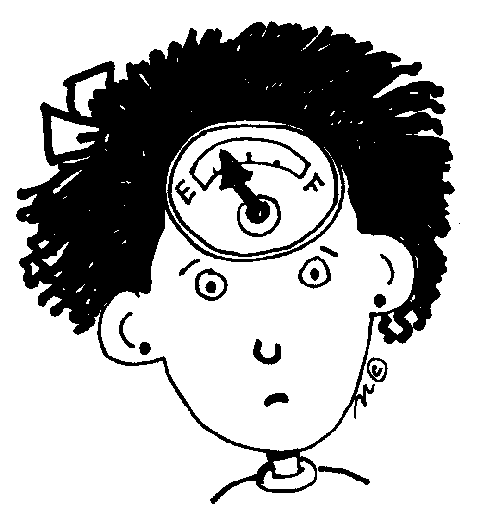
one of the most interesting experiment that was made to prove that growth factors exist in terminals not in the cell body of a neuron Is that : we plant a neuron in a way that leave a cell body in a place away from axons and terminals , if we put growth factor in the cell body , most neurons will eventually die, but if we put the growth factor in terminals , neurons will survive. This occur because there is no receptors exist on the cell body , but they exist on terminals.
Note: BDNF is a NGF (Neuro Growth Factor) but we consider it also a neurotransmitter.

♥Memory
-it has different classifications according to :
Types | Declarative: this type of memory consists of general type of info. Ex:the name of the Dr.  -it stored all over the cortex mainly secondary & association cortex. | Non-declarative: consists of things that we learn it & not as a fact. Ex.: classical condition – practice doing a filling- motor skills.
time | Short term | Long term
Other types | Explicit وعي | Implicit لا وعي

- To make a memory & store it , we must make repeating, so, the two neurons should work together several times to make a connection and make a memory.
- LTP (Long Term Potentiation): is the process of making a memory, & this term means that we have 2 neurons , at the first time, second time & third time there will be action potential & responses → the 2 neurons see that they will work together a lot and decide to make a stronger relations by anatomical and physiological function → these strong relations will be noticed as an action potential occur between the 2 neurons, and at the same time ,another action potential will occur between one of these 2 neurons with other neuron. → then there will be potentiation between these neurons for a long time, that’s why this process is called LTP.
- We said that LTP includes physiological & anatomical changes, one of the anatomical things is that there will be more spines.
- Spines are thorns exist on dendrites and cell body, they are the place of connection & synapses between two neurons.
- Why the extra activity between neurons is good in making memory?
When an action potential occur & lots of neurons work together after several APs, the post S. neuron may :
- Send BDNF to make growth and eventually making 2 synapses instead of 1.
- Even if there Is no BDNF, it makes more action potential for the same neuron→ more Ca+ will enter → Ca+ will make a signal growth for this neuron & enlarge the synapse.
-that’s why the extra activity for a certain limit is good to make a memory & make the relation between the 2 neurons functions more by spines & making more synapses.
- by this we conclude : the process of making memory is enhanced by repetition by making more connections & anatomical connections for long term by spines, and this is related to neurotransmitter that has a relation with Ca+ which is glutamate specially the NMAD receptor.

♥Memory without repetition
-making a memory could be occurred without repetition if the memory is connected to something else like fear throw the amygdala, or pleasure & reward throw limbic system for example.
- modulators in the cortex such as serotonin and norepinephrine modulate the function or open things directly related to Ca+, & even nitric oxide. These things could make a memory without repetition.

♥Loosing memory
-memory is stored in cortex by LTP process , but cortex won't be able all the time to make memory, so the hippocampus in particular & limbic system in general will take the charge of making the memory by LTP process (hippocampus and limbic system are the best way to make memory). If the hippocampus is gone, the old memory will still be existed but we won't be able to make new ones.

♥H.M
-He was a young man with epilepsy who make a brain surgery that results of removing -by mistake- the temporal lobe & hippocampus.
- as a result : he was cured from epilepsy , but lived 50 years after without knowing anything & forgetting everything after that surgery.
-he is the most person that teach us most of things about memory cause dr.s studied his case & make research for a long time during his life.
- he couldn’t know the president of his country & the day he is in.
-they taught him a skill ,& he was able to go his work and remember the way to his home, that’s because these information are not related to declarative memory , cause these skills are non declarative memory that is controlled by cerebellum.

The rest of the lecture was a topic presented By Dima Al-kilane, & u can refer to her slides ,cause as a dr. said he will bring us a question from her topic in the exam.

Good luck.♥

