Language is a complex thing, when we see a word the vision part will send to the language part . And when we hear a word the auditory will send to the language .
When we say a word we will remember it from the memory part of the vision that this word is “a table “ for ex , then it goes to the language then to the motor cortex and little to broca to produce the word
If we want to say a synonym to a word or relate to the word that we are seeing, we will see the word then remember it then go to wernick area then to broca , and at the end to produce the word !
If the broca is damaged , so wernick will be damaged too and vice versa because language is a complex thing (Language is not just talking or listening)
Prefrontal cortex has to do with personality, planning and control feelings
It controls our feeling by making inhibition for the unwanted feelings , and by this we will inhibit the unwanted behaviors ,, ex: you are tired and you don’t wanna attend the class ,but you have to ! So the prefrontal will inhibit that feeling to make you attend the class.
Also prefrontal has a big role in social interaction,, ex: a person called “phineas gage” he had an accident that a piece of iron entered under his eye and exit from his brain so it penetrated the prefrontal cortex >>> so his personality and motivation changed.
In fifties, people who has schizophrenia or has lots of fears, or high levels of anxiety, they had their frontal lobe extracted by surgery ,, so their anxeity will be better but their personality will be lost
Signs of damaged prefrontal:
- Lack of foresight (lack of reasoning and planning).
- Frequent stubbornness.
- Lack of ambition and lack of responsibility.
** He will have lack of ambition: because he won't understand the consequences for doing something,, ex: if he study he will pass.
Parietal lobe targets our attention to a specific thing,, if right parietal is lost neglection for the left side will happen.
** The source of attention is the prefrontal,, but parietal direct my attention to sth ,, ex : in the experiment of the monkey and the resin , prefrontal send information to the parietal that he is hungry so the parietal must focus his attention on the resin. So that part of the brain, which is prefrontal, determine what should I concentrate- on based on feelings and emotions (ex:feeling hungry) then give orders to the parietal to focus on the resin
If prefrontal is damaged >>> inattention
EEG:
We can extract further information from EEG by using computers and analyzing
*In evoked potential:
When I see sth, the occipital lobe will be activated more than the others because we are now processing vision
While I'm relaxed and recording EEG, and there is a feather touching my hand a certain area will be active each time the feather touches my hand.
So if we want to know the certain activity we must remove the background activity, how? By touching the hand several times (20 times for ex) then we tell the computer eliminate the alike/constant activities of the brain and keep the different ones (the ones that resulted from touching)>>> so the evoked potential is produced in this way.
By evoked potential we can know that certain representation of frequencies will be for a certain activity or movement,, like if I touched my hand a specific evoked potential will appear
According to the link between Evoked potential and a certain activity, the evoked potential is applicable clinically in hearing and touch examinations.
In Brain-machine interface, we can link the evoked potential with movements, ex: if a specific evoked potential appear so we will send order to do a specific movement
Other than evoked potential, we can do sth else in the EEG >> we can analyze the wave into parts (by calculating the repetitive peaks and calculate their frequency),, usually they are 4 types of wave forms
- Delta : the slowest , its frequency 1-3 Hz , no activity , mainly appears during full relaxation and during sleeping.
- Theta : faster than delta , 4-8 Hz , associated with drowsy and in not attended situation (not focusing on anything)
- Alpha : midwave frequency , 8-13 Hz , when we are doing sth not in a high concentration , also appear in a relaxation state when you are not thinking deeply in sth (ex: when watching TV)
Alpha wave locates mainly in parietal and occiptal (because both of them are always taking from visiual and hearing)
- Beta: the fastest , in concentration state and making hard calculations and decisions or multitasking and high processing.
** When I have to make a decision,, alpha and beta will be on frontal lobe ,However when I am concentrating my eyes to look for something , then we can find on both the frontal and occipital lobe alpha and beta waves.
** In decision making (either my eyes are closed or opened) ,, we will find beta on the frontal
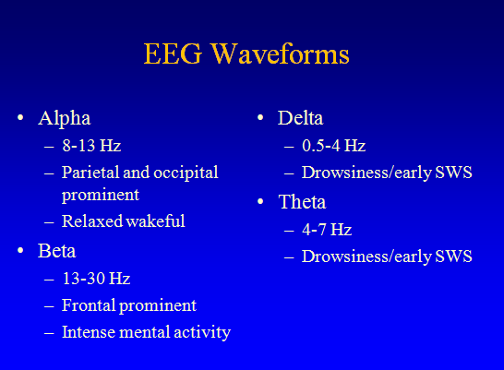
When we do the recording we will find mix of waves, so we send them to the computer to analyze and separate these frequencies.
Usage of EEG is in seizure and sleep.
But if I want to know the meaning of the EEG we need a computer for analyzing like in evoked potential
After separating the waves by computer, we can see that in the same wave type there are higher (bigger) waves and low waves.
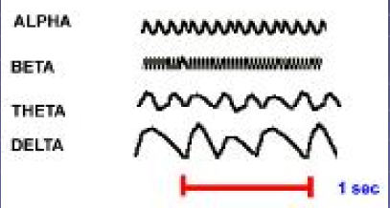

Brain Machine/computer Interface (BMI):
We record from brain and send these information to computer directly (not by moving or kinetics) ,while you're sitting just think of an order the computer will analyze it and then the computer will send an order to the thing we want.
A movie the doctor talked about was that people became lazy so they tend to sit in their homes and record from their brains and have a camera and a mike to control a robot to go to their jobs! Is it fictional or real? We did not reach a point where we can send a full big robot however we can send smth that's some sort of a robot ,for severe injured people or having severe allergy, they send robots(controlled by their minds) to attend the classes and interact instead of them.
Also a woman with an amputated hand can feed herself by controlling artificial hand by her brain
At 2008 a conference was held to announce about such things and say that they are applicable
So in BMI : we give order from brain by certain neurons and analyze the information to do the movement.
“eye motive” is the most popular machine that work on this principle ,, some of them can do and control 8 orders , others used for gaming … etc
The mechanism of BMI :
- Normal EEG (noninvasive) >> its limited ,,, single electrode was put on a certain area of the brain but if we want more accuracy we increase the number of electrodes on that area ,, but even though the sensitivity and accuracy of normal EEG is the lowest (( it need long processing time ))

**BMI is a very fast process ,, ex on experiment have been done : monkey was walking on a treadmill and by his brain he could control a robot in another country(japan) and make him walk before he move his legs on the treadmill in 6 micro seconds difference!
- For more accuracy(semi invasive) , we can penetrate the skin, skull and the dura mater and implant the electrode directly on the surface of the brain , so will be more sensitive >> it's called ECOG >> BUT it need a surgery like the girl that controlled the artificial arm by her brain
Also it's very good for complete paralysis people (the paralysis from the neck downward)
- The third way is the most accurate way (complete invasive) ,,,Because of the presence of sulci and gyri , we implant the electrode inside the cortex ,, it’s a very good way but has a disadvantage that a scar will appear on the electrode after almost 2 years and as a result of the scar the electrode won't be able to record well so now the electrode is useless and we should remove them and replant new ones.
In amputated limb we can implant robotic arm and it's easier because the nerves still exist and the order is already processed and is travelling in corticospinal tract so we record the orders from nerves and order the robotic arm to move however it will be much harder if the deficit becomes closer to the spinal cord.
**In blind person (due to trauma), he will use a camera and code the vision field and analyze it in the same way that the retina do it ,, then send it to computer (to make processing instead of thalamus in a normal person) then send orders to the implanted electrodes on the cortex(occipital lobe) , so will be able to see.
**Also in other experiment the camera send the signals to the tongue then the tongue send it to the cortex to semi cortical region which contain lots of sensations, so by this way the blind person could see big letters however that was 6 years ago and now we tend to use the non invasive method (not to invade the tongue instead from the outside) because non invasive electrode have more power in resolution processing.

-If we send the information to area 17 ,, the blind person will see as if he is seeing in his both eyes
Other applications, we can control the sleep or when we are playing a game or therapeutic or control devices …etc
One of the nowadays projects: Honda asimo control,, it’s a robot controlled by a person by EEG (this project since 2009)
If we want it for gaming (not for a complex orders) we can use small helmet for couple sensations only.
In 2003: the first successful experiment for BMI for robotic arm ,, it was applicable on a monkey >> by his brain he can control the robotic hand and take the food (monkey’s original hands are immobile only his head is moving)
*** The person that did most of all this work is ger mickalidis , brazalian scientist >> he did the monkey experiment and the experiment that the monkey controlled the robot in japan.
BEST OF LUCK ^_^

