The doctor started the lecture by explaining figure(76.5) which is not in the booklet, but I found it in Guyton.
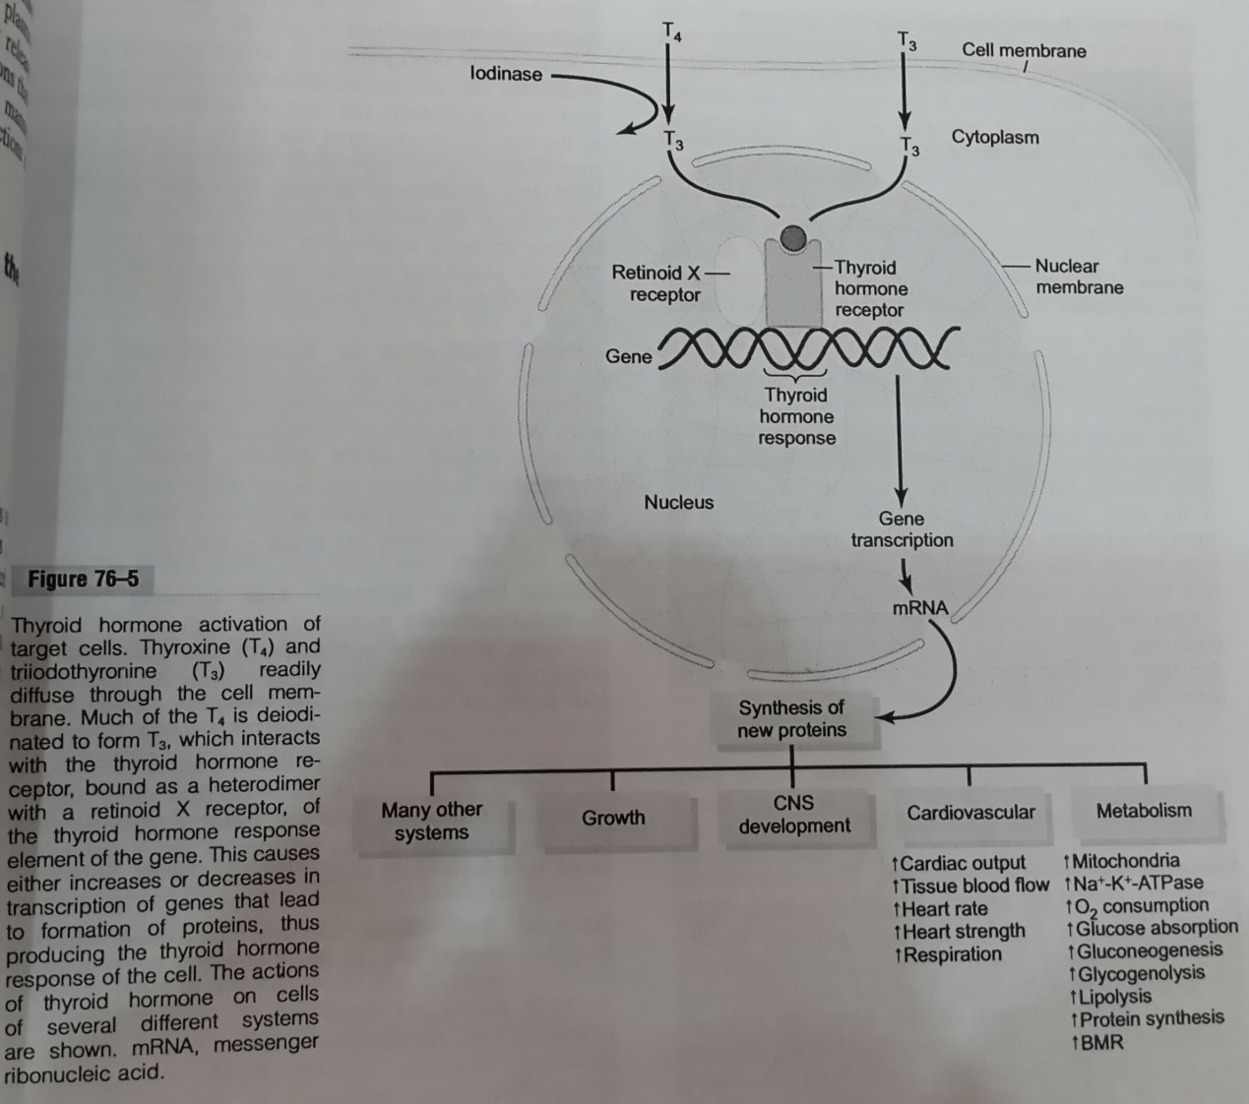
-Thyroid hormones :
Amino acid derivatives .
Diffuse into the cell membrane and the nuclear membrane.
Binding receptors inside the nucleus affects the DNA to produce a new mRNA .
Finally, physiological responses occur .
physiological responses/actions of the thyroid hormone:
- Metabolism: ↑mitochondria – (↑ Na+-K+-ATPase) - ↑O2 consumption - ↑Gluconeogenesis - ↑Glycogenolusis - ↑Glucose absorption- ↑lypolysis - ↑protein synthesis - ↑BMS (basal metabolic rate).
- Cardiovascular: ↑cardiac output - ↑tissue blood flow - ↑heart rate - ↑heart strength - ↑respiration.
- CNS Development: Even during fetal life , thyroid hormones are essential for normal development of CNS & skeleton.
- Growth and many other systems .

Page137/Table 9-8:
-The main stimulus for thyroid hormones is TSH (Which is secreted by the anterior pituitary gland).
Other stimulating factors:
- Thyroid Stimulating Immunoglobulin (TSI).
- Increased Thyroxin Binding Globulin (TBG) levels .
Inhibitory factors :
- Iodine deficiency.
- Deiodinase deficiency.
- Perchlorate ;thiocyanate (inhibit I- pump) “I- enters follicular cells by the same carrier with Na+”.
- Propylthiouracil (inhibits peroxidase enzyme).
- Inhibitory TBP.
- Decreased TBG levels.
Page 139:
Hormones that promote growth: GH - Insulin – Insulin like growth factor – cortisol – androgens – estrogens – thyroid hormones .
Although thyroid hormones are essential in normal amounts for growth , they are not essential for life.
Thyroid hormones deficiency will affect the growth .
Excess of thyroid hormones will not cause over growth like GH , this will increase catabolism of proteins & other nutrients.
Thyroxine at normal concentrations has a permissive effect on the action of GH on protein synthesis. In its(thyroxine) absence ,amino acids uptake & protein synthesis are not much stimulated.
NOTE :
This action is similar to the permissive effect of thyroxine on catecholamine
(adrenaline) in the fatty acid release.

Reduced thyroid activity during the childhood produces dwarfism with mental retardations (because TH affects the nervous system) , whereas reduced GH produces dwarfism with normal intelligence.
Page 141 :
Deficiency of thyroid hormones during:
childhood | adulthood
- Cretinism occurs (the case of being short. Dwarfs with mental retardations)  - Failure of skeletal, sexual and mental growth & development.  Nervous system is affected .  Skeletal system is affected.  (The entire growth process) | -Myxoedema occurs:  Patients look dull & can't think.  -Slowing of all bodily processes:  Tissue oxidations are depressed.  BMR falls.  Less heat production.  Body temperature falls.  -Skin is:thick ,leathery, puffy and yellow.  -Bone marrow:Suppressed (Anemia).  -Blood cholesterol increases.  -Appetite decreases.  -Intestinal movements lead to constipation.  -Heart ,respiratory rates & blood pressure reduced.  -Husky voice. – Hair: brittle ,sparse &dry.
Page 142/Table (9-9) :
Hyperthyroidism means: excess in thyroid hormones .
Hyperthyroidism is the opposite of hypothyroidism.
The most noticeable symptoms of hyperthyroidism(You can notice them from the first look) are: Exophthalmos & Goiter.
Page 146 :
Exophthalmos : protrusion of eye balls ,may be due to an action of an antibody against a protein of the extraocular muscles behind the eye. “Because of the high concentration of Thyroid Stimulating Immunogobulin (TSI) “.
Page 145 :
Goiter: Enlargement of thyroid gland.
Page 144/Table (15-5) :
Not all Goiters have high concentrations of T3&T4.
Simple non toxic goiter | Simple toxic goiter
Low amounts of T3 & T4. | High amounts of T3 & T4.

-By looking you can’t differentiate between toxic and non-toxic goiter .
-Usually, Goiter & Exophthalmos occur at the same time .

Page 147 :
Parathyroid glands:
4 small glands ,each weighs from 20-50 mg in adults.
2 left and 2 right.
Situated behind the thyroid. “Sometimes, during the thyroid surgery ,surgeons may remove Parathyroids by mistake .”
They are composed of two types of cells :
Chief cells | Oxyphil cells
-produce parathyroid hormone that normalizes blood Ca++ level.  -PTH functions on kidney tubules ,bone & intestines(gut) to normalize Ca++ level in blood. | -Play a role in metabolism ,but they don’t produce hormones.

** Normal level of Ca++ in blood is : 10-11mg/100ml plasma .
During life this level doesn’t change ,this means that the homeostasis of Ca++ level is very important.
Figure (23-7) :
The Dr used this figure from “Ganong”physiology text book :
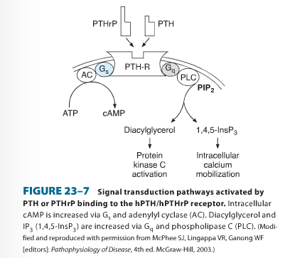
2 types of receptors for PTH:
1-produces cAMP after binding.
2-produces the 2 other second messengers (DAG & IP3) .
**This depends on the organ that is affected by the PTH.
-Parathyroid hormone related protein (PTHrP) is similar to PTH in the structure .
PTHrP: Binds with the receptor of PTH to produce ONLY cAMP .

Page 148/Figure (79-10) :
Oxyphil cells are not present in some animals and young people .
Page 149 :
We can detect PTH between the weeks 5-14 (wide range).

Page 150/Figure (36-7):
PTH affects :
-Bones: to normalize bone resorption for ca++ releasing into plasma.
-Kidneys by 2 actions :
1-Produces vitamin D .
2-Decreases phosphate reabsorption .
**Notice the relationship between phosphate and Ca++. “Increasing in one will lead to decrease the other “ .
-The main function of PTH is to normalize Ca++ level in plasma .

Page 152 :
Underactivity of parathyroids (Hypo-function of parathyroid ):
Reduced mobilization of Ca++ and phosphate.
If concentration of Ca++ in blood falls below 6mg/100ml plasma then “Tetany” occurs.
Death occurs if this decreasing continues .
The muscles of the respiratory system are the first to be affected by tetany , specially the diaphragm .
Page 153 :
Overactivity of parathyroids (Hyper-function of parathyroids ):
*↑PTH - ↑ Ca++ absorption throw intestine & kidney .
*Ca is released from bones → bones become soft & this leads to what is called:
Osteitis Fibrosa Cystica “softening of the bones & it’s different from osteoporosis”.

Page 156 :
Another factor that is important in the homeostasis of Ca++:
Vitamin D / Hormone D .
Vitamin D3 : from the skin .
Vitamin D is also available from several natural sources ,including; Cod , halibut liver and eggs and fortified milk .
Poliomyelitis is a viral disease but rickets in children is due to deficiency of vitamin D.

** Notes:
The page numbers refer to the page numbers in the “endocrine” booklet that is available in “Tla’a al ali”.
You have to memorize the content of the pages that I mentioned .

