now we know if we take arterial blood the PO2 will be 95 because Arterial blood mixed with Venous blood .
venous blood come from different sources :
- Some of cardiac veins empty their content directly in left atrium or ( in the left side of the heart)

- Some of blood that goes to the lungs never reach the Alveoli , this called anatomical shunt ( blood goes from artery to vein without going throw capillaries ) .

When you mix arterial blood with venous blood you expect PO2 to be less because oxygen-hemoglobin dissociation curve is sigmoidal not Linear (when blood comes from the lung apex where PO2 is 130 it mean PO2 is 100 in blood because hemoglobin is already saturated (it doesn’t mean 130 ))
It make sense that PCO2 will be more and PO2 is less but that is not happening because CO2-hemoglobin dissociation curve is liner not sigmoidal :
- PCO2 will not be affected
- If PCO2 increase and became 41 for example this will cause hyperventilation this will compensate the hypoventilated
So hyperventilated lung will wash out CO2 , the blood that have low CO2 and that have high CO2 they will compensate each other so PCO2 will come back to normal
But hyperventilated lung will not correct the PO2 in hypoventilated lung .
In addition PO2 have to drop very low to drive ventilation

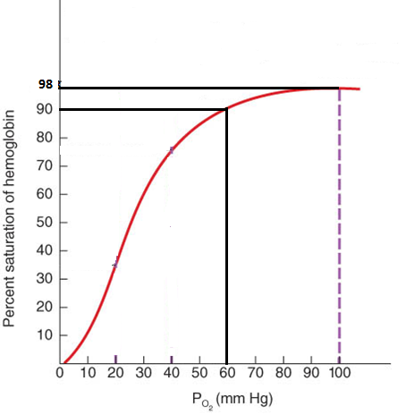

PO2 normally is 100
Respiratory center in the medulla only respond
when PO2 drop to lower than 60

any decrease in PO2 below 60 will significantly
affect the blood PO2 saturation (sharp decrease )
but from 100 to 60 deference decrease the saturation only by 8%
so when we take ABG we expect PO2 to be around 95 -100
if PO2 is above 90% then its considered normal .

But if we have a problem in the respiratory membranes (alveolar epithelium , interstatium , capillary ) there will be a problem in diffusion of O2 or CO2

DL = area/ membrane thickness * solubility of gas / √MW of the gas
DL (diffusion capacity ) : is how much of the gas will cross the membrane for 1mmHg in 1 min
If there was a problem in the respiratory membrane such as thicker membrane the diffusion will be lower , so O2 availability in blood became diffusion limited whereas in normal condition O2 is not diffusion limited
DL depends on :
- Area
The lung
- Thickness of the membrane
- Solubility
Gas diffusion co-efficient
- Molecular Wight
Diffusion co-efficient for
DL for CO = 17
DL (O2) = 17 *1/0.8 = 21
DL (CO2) =400
O2=1
CO = 0.8
CO2=20

This test can be used if we suspect that the patient have problem in lung membrane

An infiltration in the interstisum because of any disease (asbestosis, Colossus ,tuberculoses ,fibroses ) will affect diffusion of gases .

When blood enter pulmonary capillaries PO2 will be 40 then it will increase to 100 before reaching the end of the capillary , then blood will continue without any exchange of PO2
If the blood leave the capillary and the blood was fully saturated with O2 this mean that O2 is not diffusion limited otherwise if the gas cant reach 100% saturation it is considered diffusion limited .
The same thing apply on the CO2 within pulmonary capillaries .
When CO2 enter the capillary PCO2=45 , then after crossing 1/3 of the capillary length it become 40 and continue with no more exchange , if the blood exit the alveoli with PCO2 higher than 40 CO2 would be diffusion limited
Cardiac cycle takes 0.8 sec ( blood will take 0.8 sec to get in and out of the capillary )
What will happen if the cardiac cycle become 0.5 or the heart rate increase to 200 beat/min ???????????????
PCO2 will stay 40 because it would be fully exchanged but it will take more than 1/3 of capillary length.

How we know if a cretin gas is diffusion limited ???????????
If this gas reach the equilibrium within the alveoli it is not diffusion limited but if this gas leave without reaching the equilibrium this gas would be diffusion limited and this might happen because of :
- No enough time for exchange
- The membrane doesn’t allow the gas to pass freely
Diffusion for CO2 is 20 time more than O2 diffusion that means: if there was a problem in lung membrane most properly O2 will be affected before CO2.
In ABG test if we find PO2 is 70 and PCO2 is 40 that indicate an early stage of the problem ,but if the PCO2 is high PO2 is low this indicate that a lot of damage has occurred .
O2 is perfusion limited not diffusion limited ,that means if you want more O2 to be available for cells you should make more blood available for the lung
O2 consumption at rest is 250ml/min
O2 maximum consumption during exercise can reach 3.5L
What determine O2 maximum consumption ?
- Lung doesn’t provide more than 3.5 L of O2
- Mitochondria cant consume more than 3.5 L of O2
- Cardiovascular cant carry more than 3.5L of O2
7% of the body weight is blood .
If body weight is 70 Kg then the person have 5 L of blood ( 5000 mL=5*10^6 micro L) ,in each one micro letter we have 5 million RBCs, in each RBC we 280 million hemoglobin .
Cells 45% (hematocrit)
Plasma 55% ( 95%water )
Blood

Oxygen in plasma is dissolved while in cells its carried with hemoglobin .
Concentration of O2 in plasma (like any other gas ) follow henry low
Concentration (O2) = solubility(O2) * P(O2)
In arterial blood concentration of O2 is = P(100 )* S( 0.003) =0.3
In normal person each 100ml of blood contain an average of 15gHb (e.i each 1gHb can carry 1.34ml of O2 ) that mean each 100 ml can carry 19.5 ml of O2 represented as oxihemoglobin while 0.3 ml represented as dissolved O2 in plasma
Total O2 in 100 ml =19.5(oxihemoglobin )+0.3(dissolved )=19.8ml about 20 ml
The heart eject 5L blood / min = 50dL/min ( 50 * 20 = 1000 ml O2 / min )
At rest we use 250ml/min this means we use only about 25% of the available O2 ,so we cant say about venous blood that it is deoxygenated instead of partially oxygenated .
So if we want to extract all the oxygen from the blood we will have 1000ml of O2 instead of 250ml of O2 .

GOOD LUCK

