Silness-Löe Index

- Silness-Löe Index -
(Silness and Löe, 1964)
The measurement of the state of oral hygiene by Silness-Löe plaque index is based on recording both soft debris and mineralized deposits on the following teeth.
Missing teeth are not substituted.

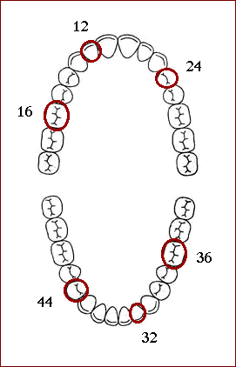
Each of the four surfaces of the teeth (buccal, lingual, mesial and distal) is given a score from 0-3. The scores from the four areas of the tooth are added and divided by four in order to give the plaque index for the tooth with the following scores and criteria:

The Plaque Index System

Scores | Criteria
0 | No plaque
1 | A film of plaque adhering to the free gingival margin and adjacent area of the tooth. The plaque may be seen in situ only after application of disclosing solution or by using the probe on the tooth surface.
2 | Moderate accumulation of soft deposit s within the gingival pocket, or the tooth and gingival margin which can be seen with the naked eye.
3 | Abundance of soft matter within the gingival pocket and/or on the tooth and gingival margin.

CALCULATION EXAMPLE:

The following example shows how to calculate the scores for the index.
Assuming a tooth with the following scores on the four surfaces

Surface | Scores
Buccal | 2
Lingual | 1
Mesial | 1
Distal | 2
Plaque Index = (2+1+1+2) / 4 = 1.5, according to the plaque index system this means the plaque index for the tooth is moderate accumulation of soft deposit within the gingival pocket, or the tooth and gingival margin which can be seen with the naked eye.
The indices for the following six teeth may be grouped to designate the index for the group of teeth: 16, 12, 24, 36, 32, 44.
The index for the patient is obtained by summing the indices for all six teeth and dividing by six.
For instance, if you have the following indices for the teeth :
Tooth | Index
Maxillary right first molar (16) | 1.5
Maxillary right lateral incisor (12) | 1.3
Maxillary left first bicuspid (24) | 1.2
Mandibular left first molar (36) | 1
Mandibular left lateral incisor (32) | 1.6
Mandibular right first bicuspid (44) | 1.3
Then the index for the patient will be
The index for patient = (1.5 + 1.3 +1.2 + 1 + 1.6 + 1.3) / 6 = 1.4

PLAQUE INDEX SCORES CONDITION
0.1-1.0 Good ORAL HYGIENE
1.1-2.0 MODERATE ORAL HYGIENE
2.1-3.0 POOR ORAL HYGIENE

