Sheet no. 6
Refer to slide no. 6
Written and corrected by : Nahla Eleiwi & Ahmad abu-anzeh

Fluoride
- Fluorine in nature :
We will start talking about Fluorine not Fluoride , and that’s because Fluorine is what we find in nature.
-Fluorine has an atomic no. of 9.
-It’s found in Halogens group no.(7) in the periodic table.
-Fluorine is not found in gaseous state at room temperature , it’s usually found combined with other metals and salt, so we have to isolate it first to get pure gas Fluorine.
-The gas is pale, yellow-green, has pungent smell & it’s poisonous.
-Fluorine is used in industries as example it’s used in Aluminum refining, refrigerant and cookware manufacturing, and pharmaceuticals (drugs as statins in general).
**Why is it important in dentistry to know the industries that use Fluorine?
To determine the sources of Fluorine, as example countries that have such industries may have contaminated water with Fluorine which may cause Fluorosis in the long run.
-It’s the 24th most abundant element in the universe, and the 13th in earth crust.
-It’s highly reactive , that’s why it’s always found combined with other elements and minerals.
-The main source of Fluorine is Fluorite (CaF2), although there are other forms such as Fluorapatite & Cryolite .
-Fluorapatite (Ca₅(PO₄)₃F) is important in Jordan, because it’s used to get out the phosphate, that’s why Fluoride is relatively found in high percentages near phosphate mines, although there isn’t any proved-evidence to confirm this .
- What is Fluoride ?
-It’s the ionic form of Fluorine.
-An inorganic, monatomic anion (F⁻).
-In terms of charge and size, the fluoride ion resembles the hydroxide ion.
- Fluoride in nature:
- Mineral form in earth crust (e.g. fluorite).
- Seawater (1.1 ppm).
- Fresh water (highly variable).
- Fish (0.2-0.4mg/100g).
- Tea: (0.1 – 0.6mg/100ml).
- Other foods might contain fluoride in very low concentrations.
- History of fluoride in dentistry:
It was found that fluoride has a role in dentistry before 100 years.
-story in slides 9,10,11, and 12.
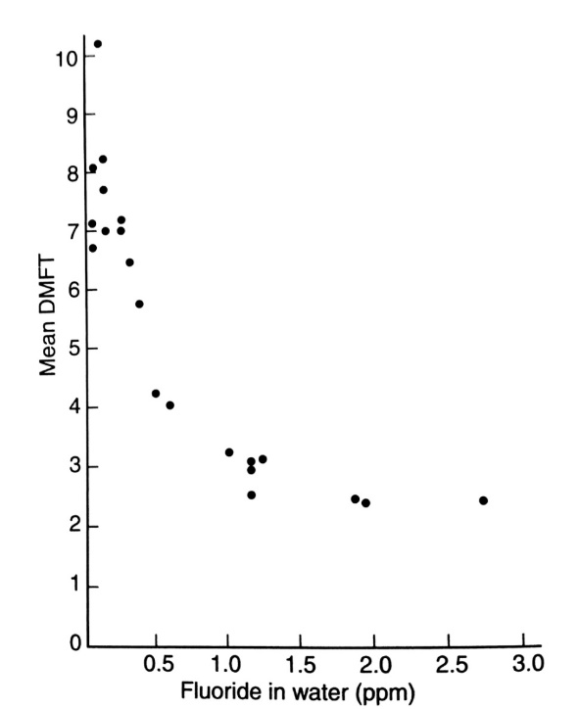
-we can notice that with increasing the fluoride level the mean DMFT decreases.
-The DMFT results are almost similar to each other, fluoride reaches 1, 1.5 , or 2, which means that there is no obvious difference in DMFT results after reaching 1ppm of Fluoride in water.
-Dr dean also noticed that enamel mottling increased with higher fluoride amounts.

- MOA of fluoride in caries prevention :
It was found that using Fluoride in high amounts before eruption of teeth wasn’t effective and not sufficient to prevent caries later on, moreover it’s less safer than post-eruption because it has systemic effect & can cause fluorosis.
While the more important is using Fluoride after eruption as it’s safer than pre-eruption, because as long as the teeth are erupted there won’t be a systemic effect of fluoride , instead it’s effect will be topical.
- Pre-eruptive (systemic) :
-Isn’t sufficient to prevent caries, it’s impact is minimal.
-Earlier work suggested :
pre-eruptive fluoride improves tooth morphology as it leads to more rounded cusps, shallower inclines, and more favorable fissure patterns which will lower the plaque accumulation.
Is incorporated into enamel to make it more resistant to the demineralization process, But more recent work demonstrated that fluoride incorporated during tooth development does not reduce solubility.
- Post-eruptive (topical):
1. Reduction of susceptibility to demineralization.
2. Encouragement of enamel remineralization.
3. Inhibition of cariogenic bacteria metabolism.
- Reduction of susceptibility to demineralization:
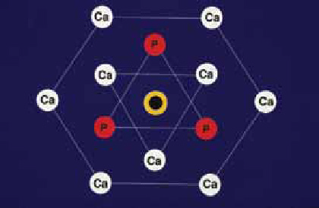
Enamel is the hardest tissue in the body, it’s constituted of 95% of minerals, the mineral bulk is composed of Hydroxyapatite crystals [Ca₁₀(PO₄)₆OH₂ ], & these crystals form enamel rods that extend from the DEJ to the surface.
-This is a cross-section of Hydroxyapatite crystal, the (OH-) group is in the middle of the crystal.
Conditions during tooth development and after formation frequently lead to mineral substitutions within the crystals. Ions such as carbonate and magnesium tend to replace calcium in the crystals, and so we will have carbonated HA-crystals which are more soluble, In turn, this facilitates demineralization upon acid attacks and makes remineralization more difficult.
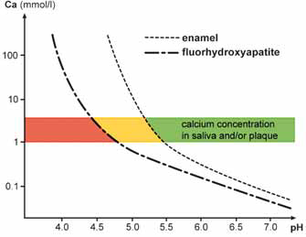
- -In the presence of Fluoride surrounding enamel, it replaces the hydroxyl ion (OH⁻), it will form Fluorapatite [Ca₁₀(PO₄)₆F₂], which is more resistant to demineralization .
-These substitutions occur in enamel surface (5-10 µm) and it doesn’t reach the subsurface, and only 5% of Hydroxyapatite that is found in enamel get replaced with fluorapatite.
-This process happens in a person with normal Fluoride level.
-Due to fluoride’s high electro-negativity and symmetrical charge distribution, the Fluorapatite is more stable than the hydroxyapatite and more resistant to demineralization.
-critical PH for the Fluorapatite is 4.7 , ( while it’s 5.5 for the normal enamel to be demineralized), which means that Fluorapatite is more resistant.
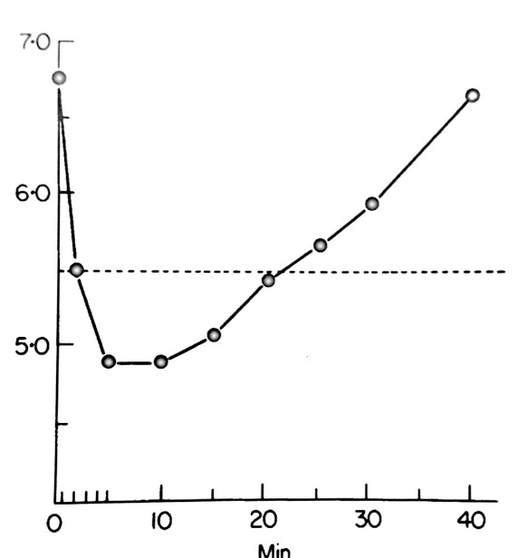
- Encouragement of enamel remineralization :
-At PH 7, there is equilibrium in calcium & phosphate between Enamel and the surrounding plaque fluid, but Acids produced by cariogenic bacteria in the dental plaque cause a release of H⁺ and a drop in pH. H⁺ decreases the OH– concentration and interacts with the phosphate ions in the plaque fluid, but when PH reaches 5.5 the calcium and phosphate ions concentrations in the plaque fluid are not sufficient to maintain the enamel in a stable equilibrium and hydroxyapatite crystals start to dissolve.
-After carbohydrates ingestion the ph starts to drop down from 7 & reaches 5.5 in less than 10 minutes, the tooth starts to demineralize, & then after 10 minutes the ph starts to elevate to reach 7 again.
- Same Slides 24-29
- The more drop in Ph , the more HF is formed.
- Fluoride supplements :
Drops or tablets are no longer used.
- Fluoridated water doesn’t require patient’s compliance.
- Fluoride in dental materials such as GI.
- Concentration of Fluoride in adult’s toothpaste is 1450 ppm , these methods will be discussed in more details in next lectures.

Good luck

