7  Dent-2011.weebly.com | Lecture No.
26/11/2015 | Date:
Dr.yazan | Doctor:
Sereen-G- alshaweesh | Done by:
Preventive II

University of Jordan
Faculty of Dentistry
5th year(2015-2016)
Price &Date of printing:

.........................................................................................................................................................................................................................................................
Hand Out
Slide
Sheet

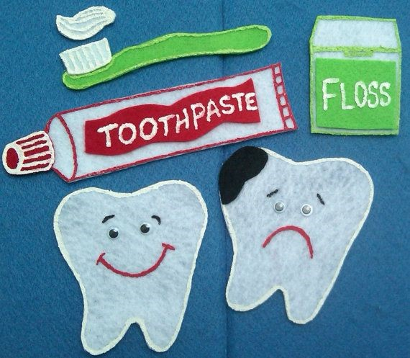
Designed by: HindAlabbadi

Oral cancer prevention :
oral cancer to some extent preventable disease (by preventing the risk factors & early detection).
- 500000 pt are estimated to have oral cancer every year , almost 1\2 million .
- Incidence in Jordan 1.5% in Men and 0.8% in Women ( incidence is a new cases every year).
- Oral cancer is 14th in all cancers in Jordan.
- Most oral cancers are preceded by noticeable oral lesion (potentially malignant lesion)
- Knowledge about molecular events(?) in oral cancer significantly improved in past few decades , so we know the genes which associated with malignant transformation , also there is a correlation between clinical appearance and genetic background .
- Oral cavity easily accessible for examination with little cost & effort , so we expect early detection of oral cancer in early stage which is not the case ! unfortunately we diagnose it in late stage .
- In Jordan ,45% of pt stage 4 and 35% are stage 3 (late stages) , together almost 75% so it will increase financial and physical cost for pt and care system.
- DR show a pic for pt has lesion she know about it before 6 months , but she didn't go for any dr due to psychological factor , she don't want to hear ..it's a cancer!!

So , why there is a delay in diagnosis of oral cancer?

- The disease isn't frequent , so no one expect to see it .
- The disease is asymptomatic in early stages ,also difficult to see specially red patches .
- Pt delay for treatment because they expect it's a bite or hypersensitivity by food .
- Some pts go for medical practitioners not to a dentist , although they don't know very much about oral diseases.
- Failure to recognize the lesion by health care providers.

Types of delayed oral cancer diagnosis:
- Biological delay.
- Pt delay .
- Practitioner delay.

All together contribute in overall delay of oral cancer diagnosis.

- Biological delay : defined as a time from genetic alteration to lesion can be seen by naked eyes .
Before cancer attack the pt , genetic alteration occur ,if these alterations accumulated we will end up with potentially malignant lesion ,if not treated ,it will become cancer !
*we can't do anything with this delay because it's part of disease process .
Newly , we can check the DNA in saliva , if there is specific micro RNA ,allelic imbalance , loss of heterezygocity so it will appear in saliva or blood and know the pt at risk !
Still a research not clinical application .

- Pt delay : time between pt when he notice the lesion to time when he go for the Dr .
Pt AVG delay = 2 to 3 months , even in developed countries.
Specially when the lesion asymptomatic .

Causes :
- Health care related behavior : behavior of pt for his health in general not only for oral lesion.
- Psychological factors : pt be afraid to ask about his lesion .
- Financial factor : not common in Jordan , it's more common where the dental treatment is expensive.
- Knowledge : very important factor , most pts don't hear about cancer that attack the oral cavity .

Researches results in Jordan :
- More than 1\2 don't hear about cancer in the oral cavity , 60% think there is no oral cancer .
- Elderly pt >40 years ,male pts, smoker and alcoholic they are least aware about oral cancer , although they are the risk groups.
- 1\3 pts don't know any risk factors for oral cancer ( smoking and alcohol are the main avoidable risk factors).
- 1\4 pts doesn't know any sign of oral cancer .
- 30% know one sign ( numb or red lesion or white lesion).
- 5% know all possible presentation of oral cancer.
So there is lack of knowledge about signs and risk factors of oral cancer.
- If pt notice a lesion 40% will consult a dentist ( this percentage may be not accurate because this study was given by dentists to their pts so it may مجامله )
- 30% consult Dr not a dentist , 20% use popular recipes like olive oil ,water with salt , طحينه!
- Smoker and male groups don't do anything just wait &see .(they are risk groups)

In Hind , Pakistan, Malaysia they have more awareness about oral cancer , because it's the most common cancer there .
In Hind more than 90% aware about oral cancer.
In Sri Lanka 95%
In America and U.K there is contrast but almost 56% and 95% .
Turkey 39% like Jordan almost 45% .

IN diagnosis clinic prevalence of potentially malignant lesion 2.8% , between 1000 pts have been diagnosed 28 pt have potentially malignant lesion ( PML).
Lesions were :
- lichen planus or lichenoid
- Leukoplakia
- Hyper plastic candidiosis , 4 pt
- Erythroplakia very rare one case .

PML are rare , may because of delay diagnosis and already become cancer !
In oral cancer prevention our concern is attitude of pts .
Almost all pt with PML they were unaware about the existence of the lesion, which is normal because the lesion asymptomatic , also when pt brush his teeth he will not look to soft tissue .
These 28 pts go for dental treatment before 6 months ago , but only 2 pt know about existence of the lesion by their dentist !! either the lesion not noticeable or the dentist doesn't look for soft tissue

Delay diagnosis also because of :
- Pts doesn't go to the dentist regularly , from the sample only 13.8% go regularly
- No one know about oral cancer screening ( فحص انسجة الفم ) , most of the pts think that oral cavity is only teeth.
- No one practice self examination for oral cavity .
- Also pts don't know that cancer happen after precursor lesion like PML.

Dr Yazan made a study about delay diagnosis by dentist and medical health care professional
They make diagnostic index: which lesions need further investigations, or more suspicious for malignancy?
52 photo showed for dentists and Drs , 26 photo are PML and easy to detect by a look .
The result was : no difference between Dentists & medical practitioners about knowledge of oral cancer .
Also when experience increase ( years ) , knowledge decreased ! because they didn't go through cancer cases.

Also in the same study , they notice if the student faced a case of oral cancer he will has more knowledge ,and early detection practice , he will routinely examine soft tissues and lymph nodes ,take history of smoking and alcohol intake, so better diagnostic ability for oral cancer and PML, and better referral .

There is also an important factor help in early diagnosis : attendance of continuing education forces ; means after graduation go for lectures and seminars , it can be helpful in early detection and increase knowledge .

So; the most important factor in early detection of oral cancer that a dentist or medical practitioner see a pt with malignant or PML while training ( while he is student).
- There is a correlation between knowledge & early detection practice .
- Also there is correlation between knowledge and diagnostic ability .
- In the same study that DR yazan made .. according to the knowledge about types of lesions that may become malignant ; dentists knowledge is higher in erythroplakia and leukoplakia than medical practitioners , but medical practitioners knows better about lymph nodes and lump of the neck as signs of oral cancer.
- Lump of the neck is late sign of oral cancer.

** dr answer a question: punch biopsy is an incisional biopsy but by special blades like a circle.

The DR make another study about oral cancer appearance :
He show pictures for various presentation of oral cancer like white patches , red patches , lump, ulcers.
Results was most of the pts think that lump is oral cancers although most of the lumps is benign! Like polyps ,ranula, papilloma.
90% think that polyps is oral cancer presentation.
3% think it's a red lesions.
10% think it's an ulcer .

** shape of the lesions have effect in pts behavior :
76% of pts go for dentists or DR if the lesion is lump.
37% go if the lesion is red lesion, although it's the most dangerous.
40% if the lesion is an ulcer , although it may already cancer !
dr said ulcers least lesions in motivation of pts to go for treatment , but percentage is different story !

high % consult Dr and dentists if there is a pain , although early lesions is painless !

Dr say another percentage
if it's lump 60% go for drs
if it's red lesion 29% go for drs.
But 70% go for relatives and internet or wait and see or use homemade remidies.

Also the DR make study for knowledge of dental students:
-There is increase of knowledge every year.
- no difference between 4th & 5th year students by knowledge and diagnostic ability .
- but there is difference between basic and clinical .

Many pts try to search about oral cancer in YOUTUBE , but most of it irrelevant ,so pts have misleading results.

Between 300 video only 10 video is helpful.
Also they check the views they found these useful videos the least attractive !

GOOD LUCK

