University of Jordan
Faculty of Dentistry
Fourth year – 2nd semester 2014-2015

Prosthodontics 2

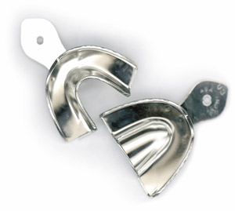

Hand Out
Sheet

Slides

04/03/2015
Nisreen elsalem
18
Mohamed massarwi
Doctor:
Date:
Lecture No.
Done by:

Designed by: Hind Alabbadi

In this lecture I used our 3rd year sheet as a reference cause the lecture almost the same and the poor quality of the record .
Todays lecture will be about design principles for class I and class II :
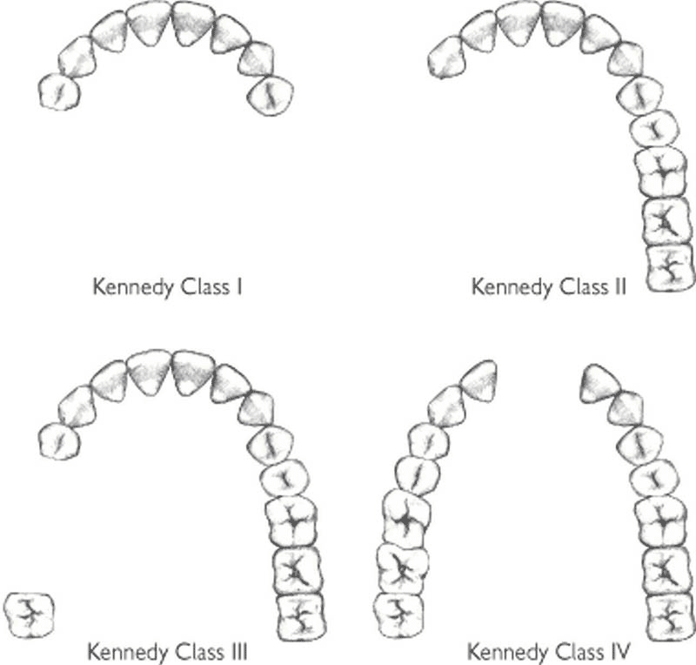
In each design we should start in a systemic way first of all we start with the OUTLINE of the saddle areas . in the outline we should know :

1.the kennedy classification of the case .
2.the primary abutment teeth are determined (the teeth adjacent to edentulous area ) .
3.the number of guiding planes (Two of more parallel vertical surfaces of abutment teeth Control & limit movement of RPD)
4.the most appropriate anterioposterior tilt is determined , the anterioposterior tilt is determined according to :
-appearance (esthetic)
-retention .
-interference .
In anterior tilt usually we expose the distal surfaces of primary abutments :minimum preparation for guiding planes . also we expose the lingual sulcus (elimination of undercuts ) for the placement of the major connector .

Then after we finish the outline we move to the SUPPORT :
In class I& II we have dual support its tooth and tissue support the problem of the dual support is tissue compressibility cause in case of dual support we should follow different impression technique and different design .
Factors influencing support are :
1. Contour and quality of the residual ridge :
more developed ridges provide more surface area and so better support .
2. Extent of residual ridge coverage by thedenture base:
we aim for maximum coverage, since more coverage means the load per unit area is less.
Think about the feet of the camel as an example; they are wide and therefore will not sink in the sand.
3. Type and accuracy of the impression registration :
the more accurate the impression is, the better the fit will be.
The fit of the denture reflects the accuracy of the impression already taken
4. Accuracy of the fit of the denture base .
5. Design of the partial denture framework .
6. Total occlusal load applied :
there are certain factors we can control to reduce the occlusal load and accordingly match the support we have provided.
we will talk about certain factors we will control to reduce the occlusal loads and consequently reduce the loads on the ridges .

Type and accuracy of impression registration :
We have two types of impression :
-anatomic.
-functional (mucofunctional)
In ANATOMIC form the surface contour of the ridge when it is not supporting an occlusal load .
The FUNCTIONAL form of the residual ridge is the surface contour of the ridge when it is supporting a functional load .
many dentists believe that certain regions of the residual ridge(s) are more capable of supporting dentures than other regions. Their impression methods are directed to place more stress on primary stress-bearing regions with specially constructed individual trays and at the same time record the anatomic form of other basal seat tissues, which cannot assume a stress-bearing role. The form of the residual ridge recorded under some loading, whether by occlusal loading, finger loading, specially designed individual trays, or the consistency of the recording medium, is called the functional form. This is the surface contour of the ridge when it is supporting a functional load.
The OCCLUSAL LOAD :
1)reducing occlusal loads .
2)reducing the saddle movement under occlusal loads .

We can reduce the OCCLUSAL LOADS by decreasing the size of occlusal table using narrow teeth , canine and premolars instead of premolars and molars , leaving a tooth off a saddle .
Also a more coverage we have the fewer the load .

Reducing the SADDLE movement under occlusal loads by
-mucofunctional concept .
-sufficient support .
Now support mainly provided by the rests , rests either may be mesial or distal on the abutment tooth , mesial rest is preferable more than the distal cause in distal rest we create :
1)class I lever system .
what are these systems ?
-Lever systems have three classifications
-in levers always think of a rigid fulcrum, a resistance, and a force.
the first classification is a see-saw
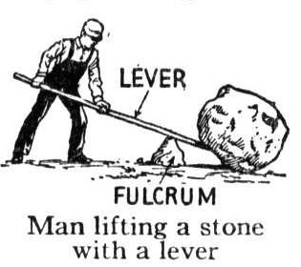 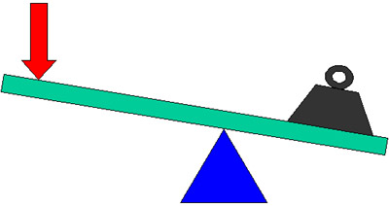
in which we have a fulcrum in the middle , a force on one side and resistance on the other side .

in classification 2
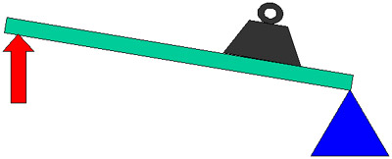
we have the same components (fulcrum , force and resistance ) , but the fulcrum would be on the side , the resistance is in the middle and the force on the other side
* if the resistance and force were flipped we would have a class 3 lever system
(below is an image from the internet the effort represents the force and the load represents the resistance )
2)distal displacement of abutment tooth , Distal drifting of the terminal abutment opening of the mesial contact point = food impaction = caries = periodontal disease .
3)we get less alveolar bone support , The alveolar bone utilized for support lies distal to the primary supporting element .

And the advantages of mesial rest are :
1)creation of class II lever , the occlusal forces will deactivate the lever action .
2)mesial displacement of the abutment causing enhancement of the mesial contact point .
3)more alveolar bone for support .
4)stress breaking effect .

Now we will talk about guiding planes :
Most effective when:
1. Parallel to each other.
2. Directly opposing each other.
3. More than one common axial surfaces.
4. Prepared on several teeth.
5. Cover a large surface area.
6. use short guide planes , the advantage of being short :
-a stress breaking effect
- being more conservative in preparing the tooth
- staying away from the gum and not irritating it ; as if it was long it will extend all the way to the gum .
- since teeth are moving in their sockets under the loads ( even though it’s as minimal as 0.2 ) , If the plate was extending for a long distance it will cause locking of the tooth and preventing the tooth from distributing the load on the periodontal ligaments and the physiological movements that should happen .

Now we move to the clasp axis :
*If we had a vertical load on the denture :
1- what’s the component that will prevent it from sinking towards the tissue ? rests and coverage.
2- what’s the component that will prevent it from moving away from tissues? clasps.

If we consider the fulcrum in the picture, the movement will be rotational, if there was a force anteriorly what will happen ?
- the major connector will sink anteriorly causing trauma to the tissues and sub-gingival area.
So we need components on the teeth anteriorly that will prevent the denture from moving away from tissues , these components are rests two rests , one on each side ( the red rests not the pink one “direct rests”) and they are called indirect retainers.

The doctor mention a kind of major connector called the lingual plates as it provide a kind of indirect retention but it would not replace the rests on anterior teeth for indirect retention , so as a conclusion lingual plates provide indirect retention but there must be preparations on the teeth under it (not on primary abutments teeth but on canines which are considered secondary abutments), and if we turned the plate we will see a bulge in it where engaging rests are seen. this is called +ve support.

the doctor ask about the reciprocation and bracing :
reciprocation : The means by which forces acting on one part of a RPD are counterbalanced, counteracted negated by another part of the RPD .
Bracing : The resistance to horizontal forces from mastication and the tongue .

Finally the doctor explain about ALTERED CAST TECHNIQUE :

Free end saddles are liable to be displaced under occlusal pressure (anteroposterior rocking around the abutment tooth, which acts as a pivot). This is as a result of the displaceability of the mucosa. The altered cast technique is employed to try and prevent this by taking an impression of the mucosa under controlled pressure. The metal framework is constructed on a cast produced by a mucostatic impression material, usually alginate. Baseplates are then constructed in self-cured acrylics on the framework in the saddle areas, these are close fitting. Impression paste or a medium viscosity silicone paste is then applied to the fitting surface of the self-cured acrylic. The denture is then inserted in place, held in place by the framework only, no finger pressure is applied as this would lead to over displacement of the mucosa. Border moulding is then carried out as the is impression material is setting
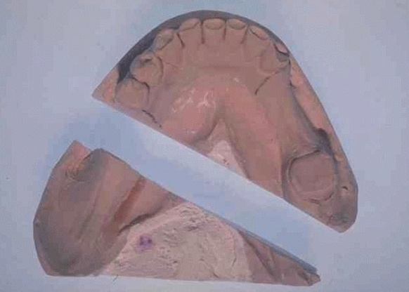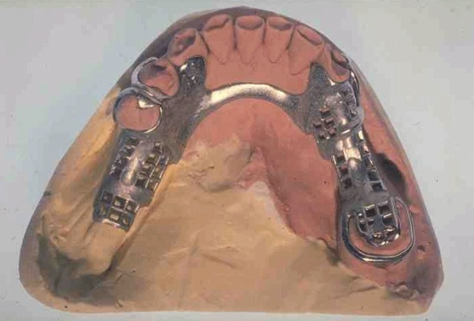
2) New free end saddle has been poured up in stone on the original cast .

1) A cast has been sectioned prior to pouring up of the free end saddle on the right hand side of the mouth.

In the laboratory, the free end saddle areas on the master cast are sectioned off. The denture is then positioned on the model and the new saddle areas are poured. The resulting model represents the free end saddle areas under conditions, which mimic functional load. Denture construction then continues as normal. The distribution of loading of the free end saddles is improved and denture is more stable.
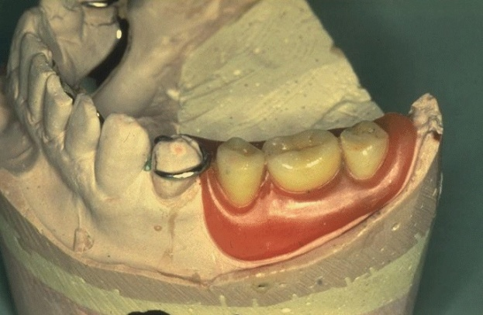
3) Wax try-in constructed on the new free end saddle .

