Sheet no. :8

Refer to slide no. : 4 and 3 Dr.Nisreen

Written by: Batool Hiari and Haya JadAllah
Corrected by : Haya JadAllah and Batool Hiari

Please refer to the slides,,
Last week we talked about designing bounded saddles , today we’ll talk about class I and II.
Slide#1
Basic design are the same :
O: outline determine the edentulous area , classification, primary abutments, guiding plane and the tilt “surveying and appropriate tilt”
Slide#3
Bilateral edentulous , class I.
Primary abutments are LR 5 and LL 5.
Guiding planes are on distal surfaces of the abutments.
Anterior tilt ,,,
Slide#4
We make anterior tilt in order to expose the distal surface of the primary abutments “reduce undercut ,so more preservation”, and the lingual sulcus “reduce the lingual undercut”.
Pic A “on the left” : after the anterior tilt , the distal surface of the abutment is nearly parallel
Pic B “on the right” : lingual undercut is due to the bulge of tissue lingually, and we reduce/eliminate this undercut by the anterior tilt “ just like the way we reduced the labial undercut by posterior tilt to avoid interference”.
Slide#5
In that undercut, the major connecter “plate or bar or whatever” , that’s why exposure is necessarily to avoid interference , the denture will be placed easily.
**tilt means that the patient will place the denture with a tilt that we made on the cast.
Slide#6
In the last lecture the support was purely from teeth, while here it’s different and that will change the technique of impression and other considerations.
Here in class I and II we have dual support “tissue and teeth” support, so our first aim , whether in techniques of impression or with the components, is to minimize the difference in compressibility between the soft tissue and teeth.
Slide#7
Factors influencing support (in general):
Contour and quality of residual ridge.
Distant of coverage especially when we talk about type I and II. “we need max coverage”
Type and accuracy of impression.
Accuracy of fit of denture base, the more it’s fit the better the support
Design of partial denture framework “components , the best choice of major connecters…”
Total occlusal load applied,,
Slide#8
The picture on the left shows maximum coverage, while the one in the right there is a limited coverage, it’s not well extended.
Slide#9 and #10
Type and accuracy of impression registration, we said last time that we have to types of impression : anatomic and functional.
Anatomic : we use it when there is tooth support, bounded saddle, no problem we use spaced tray and we use any media that give fine details.
Functional: the aim is to reduce the difference in compressibility between the soft tissues “edentulous area” and the teeth. Here we make compression on the edentulous area as it’s loaded, that means when the patient wear the denture , the area will be loaded, so in any further load or underfunction it will not sink because it’s already compressed.
Example on that, is altered cast technique.
Functional impression is achieved by :
1-altered cast technique. 2-close fitted tray on the edentulous area. 3-apply more pressure on the edentulous area. 4-lack of perforations on the edentulous area. In order to increase the pressure. 5-consistency of the recording medium.
Slide#11-14
Occlusal load as we said, is one of the factors that affect the support.
We need it to be as low as possible.
Coverage is needed to be maximum “it’s the fitting surface” , it’s not the same as the occlusal table which we need it to be minimum.
Think about it as an entrance “the occlusal table of the teeth” and a base, When the base increases , the load will be less per limit area. And as we minimize the entrance “decrease in the occlusal table of the teeth” also the load will be less.
Reducing the saddle movement, that’s by:
1- the technique of compression “mucofunctional concept”, as we said it’s already loaded , so it won’t move for any force.
2- sufficient retention and support, especially on terminal abutments.
Slide#15 and #16:
For the sake of exam, always start with the basic design, then I see if anything is missing or if I need extra component on secondary abutment, DON’T MISS THE BASICS.
when we say direct support we mean on the primary abutments. And here we have two options: 1-DO rest. 2-MO rest.
It’s better to chose support on MO, as a system when we put I-bar and guiding plate then we’ll call this system RPI.
Advantages of MO rest :
1-increase the bone support : in the case of DO rest, the bone support starts from the distal portion of the LR 5 and backward. While in the MO rest , the bone of the tooth’s socket is included, so the distance “bone support” increases.
2-prevent distal migration, imagine that force is being put on the margin of the tooth, it’s like we’re doing extraction of the tooth, because all the force are distally and nothing is supporting the tooth. While in the case of MO rest, all teeth located mesially are supporting the tooth, and they “the teeth mesial to the MO rest” will enhance the contact and will distribute the load, so prevent terminal/distal tipping of the tooth.
Slide#17:
The only advantage for the DO rest is simplicity, because there is already a guiding plate distally, and the rest will emerge from the same minor connecter.
While in case of MO rest, extra minor connecter is needed “one for the guiding plate and the other for the rest”. So it’s kinda a disadvantage that we need an extra component in the case of MO rest.
The Lever System :
When the fulcrum is in the middle , and there is a load on one side and resistance on the other side,, this is class 1 lever.
here, DO rest, it’s a typical class 1 lever, the fulcrum is in the middle ”the triangle” , the load is one side “the arrow” , and resistance on the other side “the tip”. When load is applied “the arrow direction”, the tip will start to move outward vertically because we will have rotation around the fulcrum, so there will be a force on the tooth, “activation to the lever system”.
Slide#18:
Distal displacement of the abutment tooth, and less alveolar bone because as we said , it’s distal to the tooth.
Slide#19:
We said that we need additional minor connector in MO rest.
Creation of class 2 lever system = deactivation of lever system.
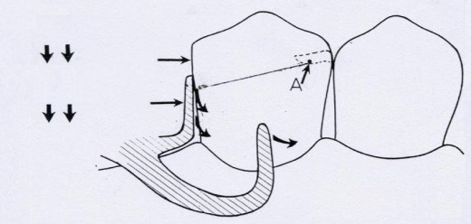 here, MO rest , it’s a typical type 2 lever, the fulcrum on the mesial side not in the middle, “the triangle”, the resistance “the tip” is in the middle.
So when a load is applied, the clasp tip will move mesially, and as it moves mesially, there will be deactivation “disengagement from the undercut”. Active means when the tip moves from the undercut toward the bulge, but here there is no bulge. Here only what happen is disengagement “no vertical forces on the tooth, deactivation”.
Slide#20:
The same.
Slide#21:
Stress breaking effect, it’s the same principle of class 2 deactivation, when the fulcrum is on the margin “not in the middle” and when there is load there will be disengagement of the clasp this is called stress breaking effect “the force is not transmitted to the tooth”. This is achieved by using MO rest.
The doctor said that she has reservation at the term mesial “MO”, because in the case of class IV it will be distal even though it’s RPI system, so to be more precise, it’s “the rest” away from the edentulous area.
Also, guiding plane play a major role in stress breaking effect , the contact of it must be short on the tooth (1.5-3mm max), so as we apply load, there will be disengagement, and by that , no force will be transmitted to the tooth.
SO, the RPI system “the rest+guiding plate+I-bar” will make stress breaking effect (NOT ONLY THE I-BAR, IT’S THE WHOLE SYSTEM) as the plate is disengaged from the prepared surface that it used to be in contact with, so the guiding plates should be short so that when we have any force on it, it will sink slightly in the undercut area causing displacement, else there will be no stress breaking effect “it will keep contacting the tooth if it was long”.
Slide#22:
Disadvantages of long guiding plates :
1-it will transmit a lot of horizontal forces to the tooth, as the tooth is locked, no disengagement and no stress breaking.
2-more preparation is needed, I need to prepare parallel surface all the way through, we may cut ¼ of the tooth in order not to have any undercut.
3- not hygienic ; it will be away from the gingiva.
4- prevent the physiological movement in the socket, there is a little bit of movement in the socket so locking the tooth will be harmful, because there is a little bit compressibility in the periodontal ligament, and this compressibility will be eliminated if there is something rigid all the way through.
Slide#23:
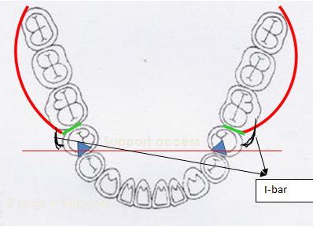in this picture, imagine that we added I-bars as in the picture, and now we have RPI system.
Pay attention, any clasp should come either from the edentulous area or from the major connecter.
Up till now, we finished the basic design “support and retention”.
now , we have options for the major connector of the lower, but to chose one, we have to start with priorities. For example, if it was not hygienic and rarely to be used it should be our last choice and only used if there is a strong indication for it.
We always start with the lingual bar, if there is enough depth.
Also consider the number of the remaining teeth. E.g. if there is only 4 to 4 , or 5 to 5 left , we can use plate because we need maximum coverage but the bar is not wrong in this case .
Slide#24-28:
You have to consider all the movements.
we finished the basics ,major connecter ,retention and support now we have to consider indirect retention.
In the pic “slide 24” consider that we have the tips of the I-bar on the lower right and left 2nd premolars, so we have the clasp access “passing through these tips”.
-When we talk about indirect retention ,we talk about anterio-posterior movement away from the tissue ,In the pic “slide 24”, it’s a rotational movement “as arrows indicate”,, and so far we don’t have anything that prevent this movement
Note:we may have lingual plate which only aids in indirect retention but it doesn’t replace the indirect retainer ,we must have preparation below this plate on 2 anterior teeth ,and on the lingual plate itself we will have rests.. this is because the plate is inclined ,and the tooth surface also inclined (inclined on inclined surfaces will not give good support ,and with force it may cause a little bit of slippage) ,but with rest seat preparation is parallel so it’s impossible to move.
>>so u can’t depend totally on the lingual plate in indirect retention ,if we don’t have rests then it will slip ,and it will invade in the tissues if you have a lingual bar cause we don’t have anything to hold it anteriorly
-I need 2 preparations, the farther we place them from the edentulous area ,the more effective retention we will have ,but also you have to consider esthetics ,it shouldn’t be showing.
-Common design is either on the canine “ledge distally or inverted v if u have prominent cingulum” or on the premolar “mesially”
-whenever we want to talk about indirect retainer we should have: prosthesis on one side, clasp access, and component on the other side, so the rests that are placed at the level of the access is not effective, it will disengage its place with the prosthesis.
-Class I & II differ from class III in that we need indirect retention.
By having the indirect retention ,we finish the design of class I ,the only thing we still need to talk about is reciprocation.
-Remember that there’s no retention without reciprocation “which hold the tooth in the opposing direction to the retention”
-Reciprocation may be arm “reciprocal arm” or plate.
-In RPI system we have the guiding plate from one side ,and the minor connector “which present mesially holding the rest” from another side (so as if I’m holding the tooth from 2 points) this is enough for reciprocation , so RPI as a system already have the reciprocation component .
*If you decide to put the rest distally “in this case” ,you will not have this reciprocation because the minor connecter is at the same side of the plate ,so the tooth is not anchored in it’s place in 2 spreaded points ,, and in this case “because we have I-bar not c-shape clasp” the reciprocation will be by extending plate opposing to the I-bar.
- I-bar doesn’t have an internal component like c shape clasp which we get the reciprocation from the reciprocal arm.
-with I-bar either we will add a plate in the opposing surface ,,or we will have RPI system
(for the sake of exam if u have RPI system u have to write that reciprocation come from guiding plate distally and minor connector mesially “in this e.g.”,, so you should identify the retainer “clasp, plate, minor connector..”
And the location of reciprocation only mention whether it’s palatally or buccaly depending on the location of the retention and tooth angulations )
-reciprocation is come from a rigid component that makes contact with the same retention distance as long as the clasp is moving out before disengagement
-it’s not wrong to add a plate for reciprocation in RPI system , but why to add an extra component? and make coverage of the gingiva if I have enough reciprocation, we need simplicit. But if the rest is distally I have to add a component for reciprocation , because reciprocation come either from a component that covers the other surface or at least 2 separate points, thus in the case of DO rest, I have to extend a plate.
-why we don’t need indirect retention in bounded saddle? Because we have retention and support on both sides but in free end saddle there’s no abutment posteriorly.
Slide#29:
We talked about bracing ,when the denture is fully seated ,and we have horizontal forces, any component behind the denture “either teeth or slope of the ridge” will do bracing and prevent the denture from moving horizontally.
Slides#30+31: revision
Slide#32-35:
-Class II represent a combination of both types I and III(unilateral bounded).
-We start like type I with: outline, primary abutment, classification II, tilt anteriorly, RPI system (so the half with the free end saddle is exactly the same as type I, mesial rest, i-bar , reciprocation provided by guiding plates and mesial minor connecter ).
-it resembles type III in that it needs cross arch stabilization, so we chose a point on the opposing side by bisecting the area “we may put it on premolar and molar or molar and molar ” ,we put double aker ,if the edentulous area is extended then we choose 2 spreaded points (e.g. we put a rest on tooth #4 and another one on #7 )
-remember that there’s no prosthesis in one side
-by now we end the basic design by choosing the major connector.
-The remaining thing is the indirect retention.
-Why we need indirect retention? If we draw clasp access and we imagine aterio-posterior movement aroung this access, there’s nothing to prevent this movement. So we need a single indirect retainer “while in bilateral free end saddle we needed 2 indirect retainers”.
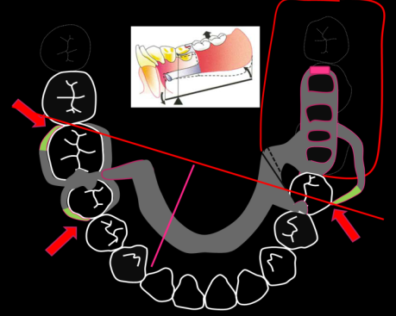we need something to be (perpendicular) and farthest from the edentulous area, we do preparation on premolar or canine “because we should consider esthetics, and especially the lower anteriors which are tiny and any preparation will expose the dentine.
Slide#36:
this slide represents altered cast technique,
-If you remember we do preparation ,special tray ,then secondary impression and master cast, we draw the design on it “metal frame”, and send it to the lab to fabricate it and send it to us, we do metal try in in patient mouth and be sure that everything “e.g. clasps” are on its place and once we are satisfied, if we decide to do functional impression but in metal try in “if you didn’t consider it before or even if you considered functional impression before and you want to be sure that the edentulous area is properly compressed” we do the altered cast technique.
Note: Functional impression may be considered before altered cast by making special tray close fitted , consistency of the material a little bit high or decrease perforation on edentulous area
-altered cast technique is done by putting acrylic in the saddle part of the metal “whether its mesh or ladder” ,like making a tray but only in the edentulous .
-in the pic. you can see the fitting surface but with the impression material on it “tray with impression material on it”
-it’s done on the same visit in the lab
-pressure will be purely from the impression material because the metal is fitted on the tissues with only little space for the acrylic “this space was done by tissue stop”
-in this space we will have acrylic tray and impression material, the presence of those materials in limited space already will do compression on the tissues, so when we put it in the patient’s mouth I will not compress this area, because if I do so this may lead dislodgment of the rests present anteriorly, and everything will be wrong.
so what I will do is only to be sure that rests are on their right position “I will put my fingers on the rests engaging their place ,because I don’t want anything to change”
-pressure only will be done on the rests, and the material will do its job by compressing the material enough (the same principle when we do close fitted tray and we put a material on it).
Slide 37+38:
-after impression and border molding ,then we cut the cast in the edentulous area only “because it’s impossible to put the metal now with the impression material on the cast” ,so that I can locate the metal easily again on the cast, then we pour it ,so that the cast will be formed from 2 pours (the original one “master cast” from the secondary impression and the second that we did on the metal try in “its imp. to know the stage”)
-we call this technique altered cast because we alter the cast by cutting from it and adding, and it is an example of functional impression.
Slides 39-41: revision
-main differences between types III & IV as a category “here we talk about type IV when its short ,we treat it as bounded” and types I and II
Types III&IV | Types I&II
Bounded saddle | Free end saddle
Tooth supported | Tooth-tissue supported
Anatomic impression | Functional impression
We don’t need indirect retention in type III but we need it in type IV | Need indirect retention

-We decide the base type dependence wither we expect reline in type II and IV (that’s what dr. said but in slides its I and II)because whatever you try with diff. techniques, over time there will be resorption ,so we choose ladder type rather than mesh type.
Back to slide “design principles for class III & IV”:
Slide 52 :
-in class IV the same basics: outlining, primary abutments, posterior tilt to expose the mesial surfaces “don’t memorise M & D know the principle because in the previous case it was the distal”.
Slides 53-58 :
-support, if we consider it as long span “e.g. 6 missing ant teeth”,we put the rests distal and we do RPI system , but if you consider it as bounded “e.g. 4 missing ant teeth” we put the rests mesial.
-so here we choose the RPI system but with diff positions and we will gain the same advantages “more bone support” and reciprocation from minor connector an guiding plate “exactly the same”
-RPI system is NOT a mesial rest ,the imp. thing is that the rests are AWAY from the edentulous area
-the I-bar clasps anteriorly in real life and if u have undercut and do the tilt there’s no need for them ,it’s impossible to come out “but in the exam you have to put them”
-never choose U shaped as the major connector “last choice in the list” ,the only indication is if we have extended tori ,because there is reflection ,it’s not extended
-we may choose, in our case, the anterio-posterior ,if the edentulous area is more extended we can choose the full coverage
Slides 59-62 :
-now we finish the basic design ,we should think about anterio-posterior movement.
-we have I-bar on the upper right and left forth teeth, and we have clasp access passing there.
-we need indirect retention posteriorly because we don’t have anything to prevent the movement away from the tissue.
-we put the retainer as far as possible “the 7th is better than the 6th”
-before talking about the indirect retention ,we need retention and rests posteriorly as a basic design “like the principle of cross arch stabilization” because the edentulous area is located much anteriorly thus I need retainers and rests posteriorly, the support anteriorly is not enough alone, also remember that we will use anterio-posterior major connector that extend posteriorly and we need components to hold the post portion of it.
-the distribution of these components is imp. because I don’t want to use more components and I want to get benefit from these components to do indirect retention.
-But you consider in your real life, if you have an undercut, and you got it after the tilt, there’s no need for the anterior clasp., because this undercut will aid in retention.
-the design in “slide#61” is not effective ,and the indirect retention here will not work ,to make it accurate we have to put clasps on the 6 and rests on the 7 distally (double aker and distal rest on the 7 ) “slide#62” , we can put the distal rest on the 6th but as we said the farther the rest ,the more effective it is.
-the design in “slide#61” the rotation will occur around the tips of the clasps “the posterior ones” and we have nothing behind them to prevent this movement ,so the clasps will dislodge with the prosthesis.
((rests if present on the clasp access or toward the prosthesis it will not act as indirect retainer,,so the distribution is imp. clasp access in the middle, indirect retainer on one side and the prosthesis on the other side))
Slide 63:
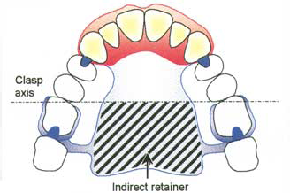
some people may choose to put the indirect retainer on the 6 like the pic. above, but because we said that the farthest the retainer, the better the efficacy we put it in the 7
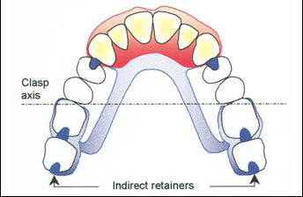
-in the pic. above the real indirect retainer is the most distal one “the farthest from the edentulous area” ,the rest distal to the 6 aid also in indirect retention because its opposite to the edentulous area
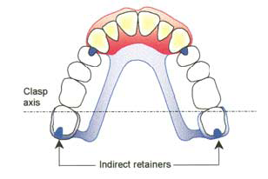
-as you can see what I’ve actually did is that I bring the clasp access nearer to the edentulous area, and the indirect retainer is farther, because I want the arm between the clasp access and the indirect retainer to be longer.
-also as a part of indirect retention “like lingual plate in free end saddle” we choose full coverage major connector, because the area under it is hard not compressible ,so it aids in indirect retention but doesn’t replace the indirect retainer. It may simplify the design by decreasing the number of the clasps because I have something to help in indirect retention, so in the pic. below may provide enough retention if we choose full coverage “not anterio-posterior”
Note: in the pics we have the rests putted mesially which is not true
In the lab exam: -be sure if you make upper or lower cast.
-put details in the table, the retainer position is imp “MB , DB ..” but the retainer is not with these details “e.g. palatal reciprocal arm, palatal plate” and in RPI u should say if its mesial or distal minore connecter with the plate

GOOD LUCK

