"The single denture"

Last time we start talking about the single denture , and we cover different clinical situation . Today we gonna to continue.
we talked about the aim of prosthodontists, and it's not only about the replacement of what missing ,it’s also to preserving what is present .
The purpose of the single denture :
  - -Mandibular canines are retained four times longer than other teeth
-The next in line are the mandibular incisors,and usually we see the patient with only lower anterior teeth remaining and everything else missing, and this is common to encounter.
-We talked about the single denture, and we said it’s a complete denture which is opposed by natural teeth, fixed restoration or removable partial denture and we gave examples about natural teeth, fixed restoration opposing complete denture and we talked about this situation briefly, we want to cover it more extensively today. For example (pt’s comfortable with upper one but complains of the lower one).
- We said there’s challenges; biological and biomechanical .
The biological challenges in the single denture are: caries , periodontal disease and residual ridge resorption .
The biomechanical challenges, because once you extract your teeth you get resorption , the maxilla narrowing down and get smaller and the mandible widening up , so you will get class 3 jaw relationship.
And also, we said in this situation you can get displaceable flappy tissues in the maxilla .and also we get supra-eruption of teeth and we get problems with the dimension at the prostheticteeth compared to the natural teeth .
-And also we said,there’s a discrepancies btw the strength of the natural teeth and the complete denture teeth, so you get fractures on your denture.

Biologic principles | Biomechanical principles
Dental caries | Morphological changes in denture foundation.
Periodontal disease | Jaw relationship extremes.
Residual ridge resorption. | Excessively displaceable denture-bearing tissue.
 | Wide tooth dimensions (compared to synthetic teeth)
 | Discrepancy in strength of teeth
 | Fracture of the single denture

The aim of the treatment should be known before you start and you need to think for your single denture pt. what you need to try to achieve for them is to achieve establish proper occlusaldistance, bilateral complete centric relation contacts and try to direct the forces along the long axis of the teeth and try to avoid any interferences in any other movement (this is applies for both complete denture and single denture but it’s more difficult to achieve these rules in single denture)
The dr. shows a pic . for a patient from the last lecture and said :
He come to us with complete set teeth of lower and edentulous of the upper and we said how to treat plan this case, we don’t go ahead and give him a denture we need to modify the lower arch and establish proper occlusal plan before we give him the complete prosthesis, and we do that in the try in stage where we can assess which teeth need to be grind and we grind them from the cast and then we grind them in the chair side, and then we can give the pt. the final prosthesis.
And we said places we get a pt. with edentulous upper and lower which needs fixed restoration, we need also to plan the case properly at the try in stage but also you need to wax up the posteriors teeth or the teeth which needs fixed restoration, and at this stage you can level the occlusal plan and get him the proper occlusion try to do, and then you can finish the restoration.

Today we will take about how to treat plan the single denture opposed by RPD.
Dr shows a pic. and he said :
This situation is very common & very tricky.
The pt comes with completely edentulous upper & partial edentulous in the lo
(Remember the lower canines are the most commonly retained teeth)

Dr ask, what is the treatment plan for this case
We start with stabilization phase:perio, caries, endo, then we assess him prosthodontically and then we can give him:
1.Upper complete & lower RPD
2.Implant in upper with overdentare
3.Overdentare in the lower
4.Implants in the lower with fixed, or
5.we can extract the lower remaining teeth and construct CD for both arches

Kelly in 1922he follow six pt over 3 years (All pt's have upper edentulous & lower partial with bilaterally distal extension) and give them upper complete denture & lower RPD
He noticed:
1.Resorption in the distal extension area
2.Because there's occlusion from the lower teeth in the upper denture, there's a resorption in the anterior maxilla
3.Lower Anterior teeth extruded upwards (supra-eruption)
4.Down growth of the maxillary tuberosity
5.Papillary hyperplasia in themin palate
All these changes that is occur in those pt's are known as "combination syndromeoranterior hyperfunction syndrome

Saunders come & he follow pt's with the same situation (upper complete & lower RPD) & he noticed:
1) The occlusal plan is inversed, going downward
2) Anterior guidance repositioned anteriorly, so the pt become habitually class 3 & he lose the vertical dimension
3) The pt will develop denture fissuratum due to the extended flanges
4) Poor prosthesis retention in the upper
5) Periodontal disease in the remaining teeth

outRefere to the hand-out for more detailed photos
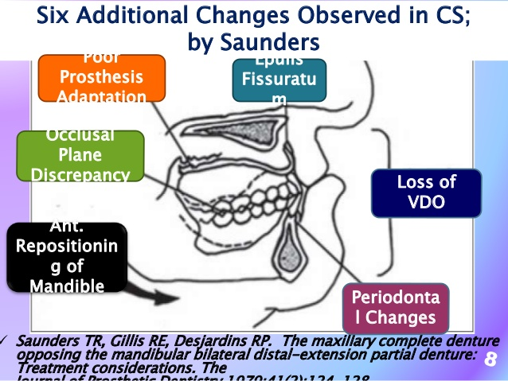

So how to treat this case:
(This treatment options are applied for both patient with combination syndrome and patient we expect to have the syndrome)
A: Classical concepts (by Kelly)
B: Modern concepts

Classical treatment options :
1.Upper complete denture & lower EPD
clinically give him
a) Balanced occlusion Posteriorly
b) You need to make minimal occlusion in the anterior teeth (which is not useful because if you don’t give him occlusion in the anterior teeth the teeth will supra-erupte)
c) And you need to keep doing regular reline in the distal of the RPD .

In the combination syndrome what are the symptoms the patients complain of? (VIVA QUESTION )
1) Loose upper
2) Not showing his anterior teeth anymore (appearance)

How to treat them?
Relining of the lower denture
Kelly advised when you get this supra-eruption in the tuberosity, you need to do surgical removal to it, so you can extend your denture to the retro molar pad area. After this procedure you need to reline the upper denture also .
2) he second option is to extract the lower teeth
(Not very recommended) unless they are indicated for extrac
3) the use of the roots of the mandibular anterior teeth as overdenture abutment (acceptable option)

4) Preserve the last distal tooth, because this will avoid all the problems you will get from the bilateral distal extension. (Even if you preserve remaining root, this will prevent the resorption & solve the problem)
Also sometimes the maintenance of upper anteior overdenture abutments can prevent the overloading of the anteiror maxilla
Case below is done under dr. motasum supervision's for Dania Jibreel))

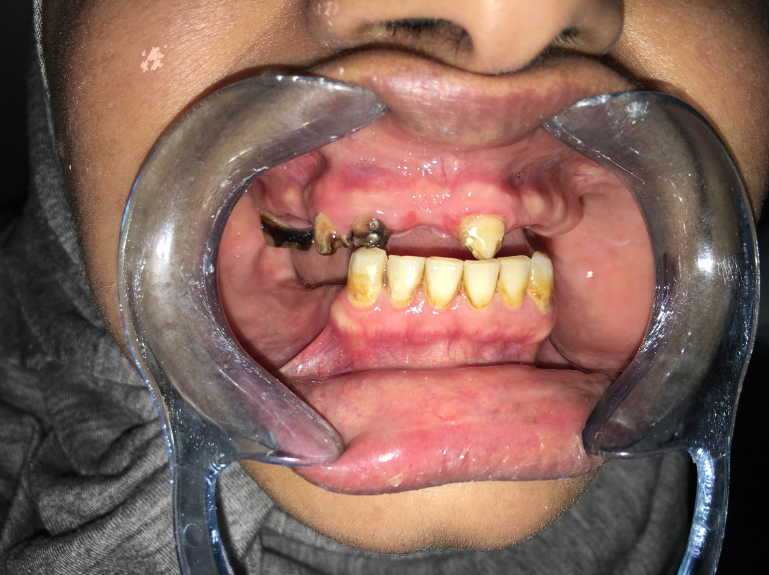

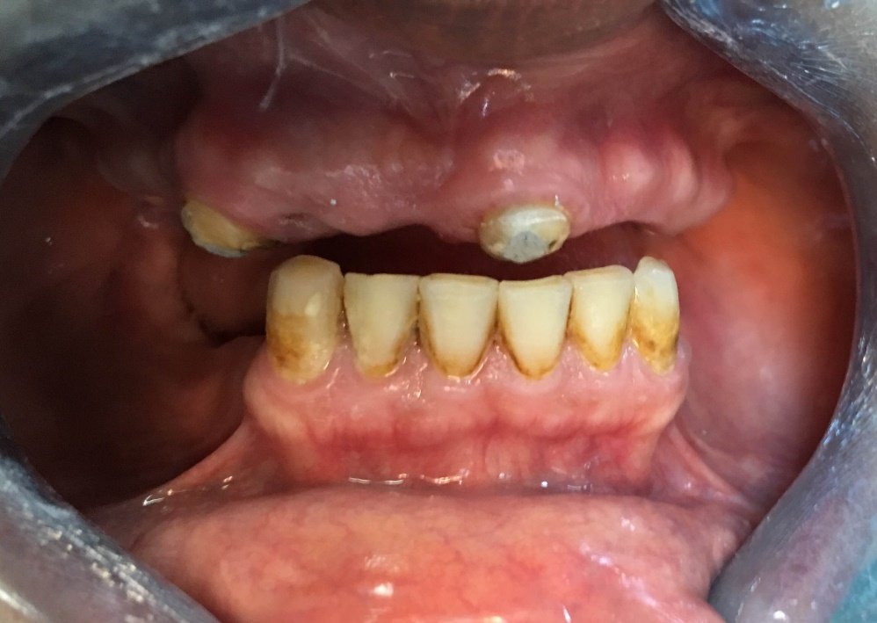

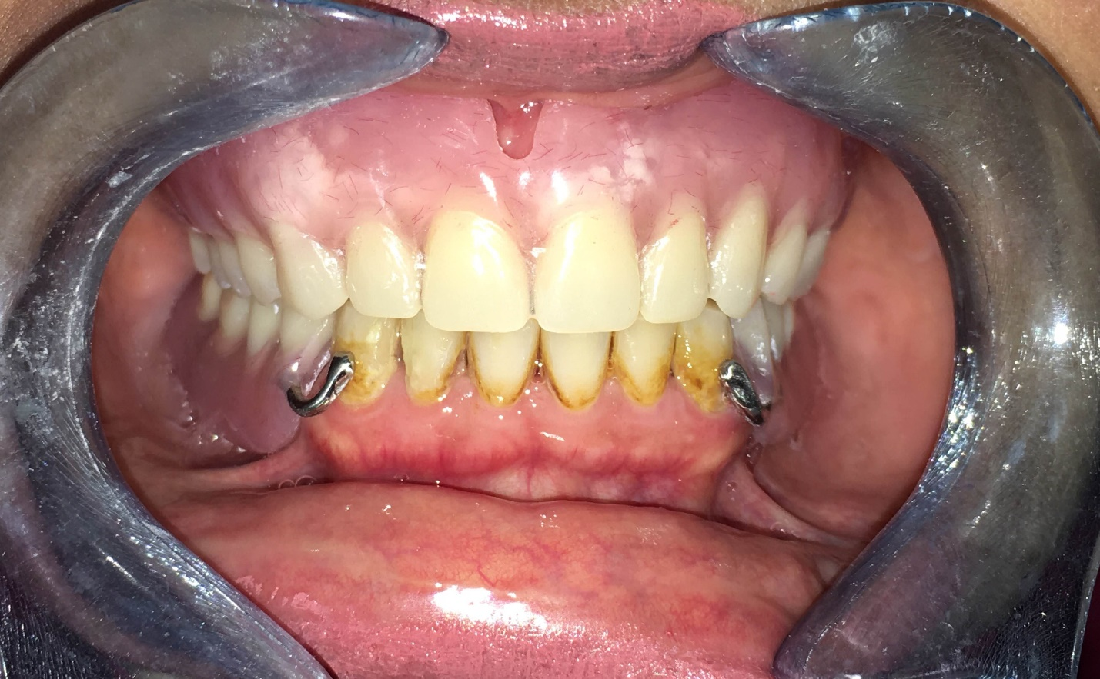

Modernconcepts:
- Why they come?many reports & reviews they notes in the absences of natural posterior teeth support, if you get the pt. RPD distal extension bases they don’t really provide the support lost, why ?Because the mucoperiosteal is slightly compressible, so when he bites down he doesn’t really establish by his posterior support. So the resorption still happen & the problem will still occur.

The limitation of the distal extension RPD :
1) When you get pt. with distal extension RPD, he will get greater bone loss when he compared with pt. without RPD.
2) More caries &perio disease with distal RPD (due to more plaque retention)
so, because of the poor outcome of the class 1 RPD, they decided to do something else.

A) Implant for the distal support, or
B) Short dentalarch concept

A : You put two implants in the back & you just put a bridge .
B : what do we mean by short dental arch ?
The pt. can function with 20 occluding units (from second PM to the second PM without 6 & 7)

- A scientist in 1992, he got pt's and followed them in Netherlands& he did not replace any of posterior teeth (6 &7) by implant or RPD, he noticed: the patients functioning fine, no aesthetic complain & they were happy.

So, what is the benefit of the short dental arch concept?
1) To decrease the cost
2) Less maintenance is needed, so the oral hygiene will be focused in fewer teeth
3) The treatment will be much less invasive

Note :it's not necessarily to be from second PM to second PM , you should think in it in term of units, you need 20 occluding unit for ex. Central opposed by central is one occluding unit, but one molar opposed by one molar is two occluding unit, PM opposing a PM is one occluding unit.

Note: short dental arch concept applies to patients who are 40 years ago or above, not for young people
{The older you get the shorter the dental arch can be}
a lot of study showed that not all the patients will accept not to have posterior teeth, so you need to discuss this with your pt. from the beginning .

Note :short dental arch concept not only for teeth, but also applies to implants

Note :the disadvantage for the short dental arch compared to the benefit is less, and it is still agood treatment options.

وفي نهاية هذه السنوات التي جمعتنا سوياً زُملائي على مقاعد الدراسة أتمنى للجميع النجاح في المرحلة التالية من حياتنا مبارك لكم هذا الإنجاز العظيم أطباء المستقبل ♥♥
زميلتكم/ ختام حمد الداوديه
SENIORS2017

