**Biometric Approach in Designing Complete Dentures**

As we previously studied , to obtain an impression we need a tray . what are the uses of an impression tray ?

* A carrier to hold the impression material
* It puts tissues where they should be (main function ); gains support from tissues through the tray .
* When placed in the mouth the empty tray should satisfactorily restore the facial contour.

Since we all know that final impressions are taken by custom made trays we can make modifications to the primary ''conventional '' trays making bite blocks that can be used for taking the final impression .

**RESTORATION OF FACIAL CONTOUR**

There are several methods of ensuring that the facial contour is properly restored:

1. If the impression is to be taken within a record block, the block should be modified to establish the lip form and buccal contour.

2. If a conventional impression tray is used, it should be built out with impression compound until the facial form is restored🡪 through border molding procedure .

3. use measurements of the average pre-extraction buccolingual breadth/width of the alveolar process to define the positions of the lips and cheeks and to construct what we call ‘biometric’ trays. These restore the pre-extraction form of cheeks and lips so that the correct shape of the sulcus can then be recorded with a soft impression material 🡪 whenever we say "metric " we mean measurements ,so it’s a tray that depends on measurements that will be discussed further more in this lecture .

** we depend on the tray to act as wax rims in a matter of restoring support for the edentulous patient .

-in dentate people , support for lips and cheeks is obtained from teeth . that’s why these measurements rely on the pre-extraction position of natural dentition since these are the main providers of support for these tissues .

* How do we know where were the predecessors for an edentulous patient ?
* Neutral zone technique
* Pre-extraction records if available
* Anatomic landmarks ;palatal gingival vestige & incisive papilla .
* **Palatal gingival vestige : a raised fibrous ridge on the palatal surface of upper residual ridge ; it distinguishes the palatal mucosa from the vestibular mucosa that can be used as a guide in positioning maxillary teeth** . " it's a remnant of lingual gingival margin " . the more the period of edentulousim the more it is shifted labially.

**P**.S ; it is constant in position however due to the pattern of bone resorption labially it appears to be shifted with time .



Another landmark is **the incisive papilla** ; if you divide it into two halves from the middle of it about 8-10 mm will be the central incisor . and from the posterior border of the incisive papilla if we do a horizontal intersection with the ridge there'll be the mid-part of the canine .



* The palatal gingival vestige and the incisive papilla both work as estimating landmarks for pre-extraction dimensions of the ridge .
* Going from the incisive papilla labially towards central incisor was bone before losing teeth and this tells us the pattern of resorption which is important to be compensated through the denture .
* If we take a cross section through gingival margin palatally/lingually corresponds to the palatal gingival vestige after extraction of these teeth .
* The whole idea of the biometric approach depends on the palatal gingival vestige in addition to other landmarks in our measurements buccally/ labially from the vestige to measure the buccopalatal width of the natural teeth that were lost .
* The average distance anteriorly is 6 mm at the incisors , at the canines 8 mm , at the premolars 10 mm and at the molars 12 mm (each from the palatal gingival vestige ) .
* Primary impressions in this approach are conventional using either compound ,alginate or any other material that is used for primary impressions . the difference is in the fabrication of custom trays , these aren't fabricated the way we do instead fabricated through the biometric approach .-🡪

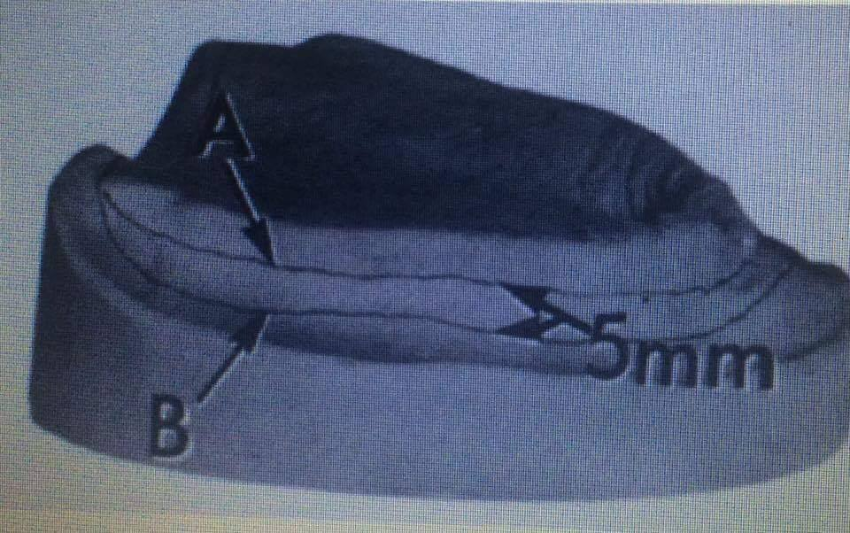

The B line resembles the anatomic depth of the sulcus , the A line is drawn 3-5 mm shorter than the B line ''full depth of the sulcus ''.

( in the conventional method we go 2 mm shorter from the full depth and fabricate our denture according to that ) .

* If we want to make some measurements from the gingival vestige through a caliber but we need something solid on the cast so what we do is filling the whole sulcus area with wax, up to the A line .
* the following figure represents a cast filled up with wax " the darker part in the sulcus region " and we can see remnants of lingual gingival margin . we start measuring from the gingival vestige anteriorly 6 mm will be the incisors and we place a dot , canines at 8 mm , premolars at 10 mm and 12 mm for the molar region . We connect the dots together bilaterally resulting in a line that is the guidance for fabrication of the tray up to it . The resultant tray differs from the conventional method by not being only shorter but wider as well and it depends on resorption pattern ; the more the resorption the wider the acrylic tray's borders since we are compensating the resorption through it's borders" bringing back the support that was there before loosing the teeth " .
* The wax that is filling the sulcus allows us to place our dots to be able to draw our guiding line .

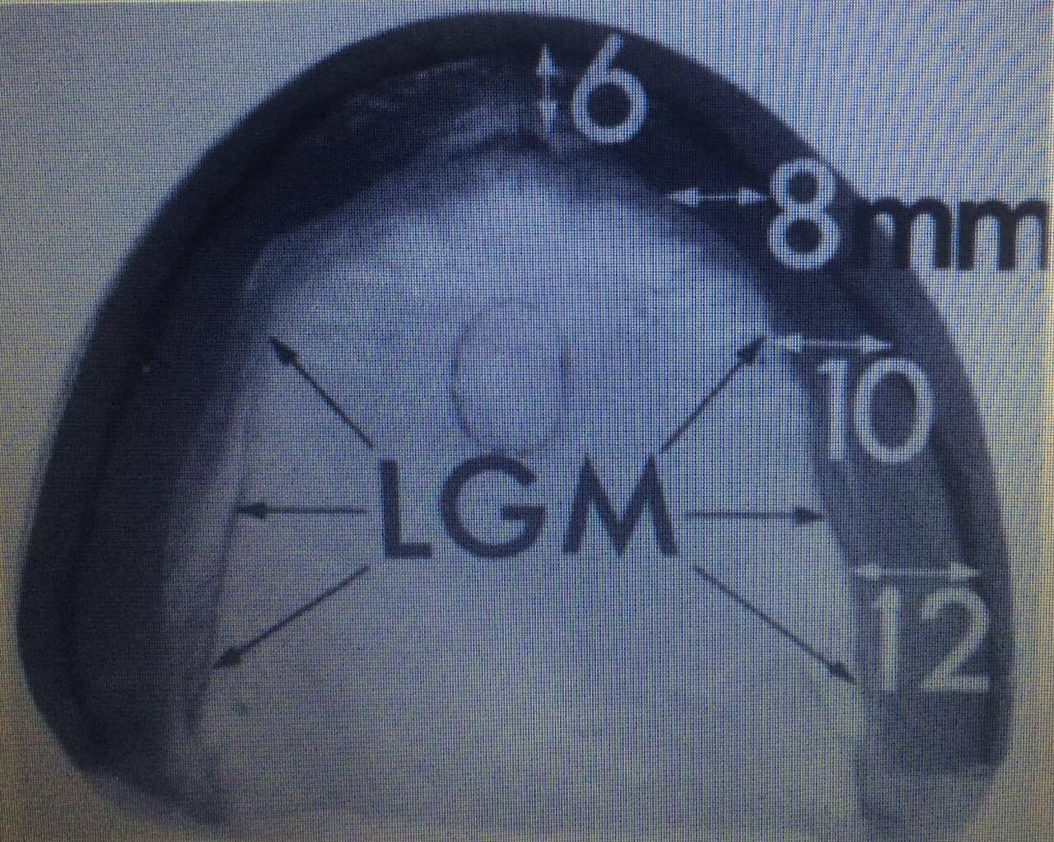

* After connecting the dots , we lay on the cast wax spacer "before making the acrylic tray " for the impression material that's going to be used
* Make a tray so that the outer surface of the periphery lies on the line marked on the wax ledge.
* The doctor discussed two clinical cases ; one with a severely resorbed ridge and the other with a well developed ridge . the tray of the well developed one was thinner and the tray of the resorbed one was thick . in the end we got the support needed for both cases either from the remaining bone or from the tray's borders .
* Bite registration step we put wax to have proper support.
* Through this procedure, I got to this result in the final impression step. That was for the maxilla, this is how you construct the tray for the maxillary arch.
* You try the tray in the patient’s mouth.
* Do we perform border molding? No, not in the biometric way. Where does the retention come from? The collapsed cheeks, once you put this thick border tray, it will push the cheeks outwards, and as a reaction the cheeks will collapse inwards holding the tray in place. It’s already to the full functional depth, we only need a thin layer of the impression material you’re already using, and if there are minor spaces it will close it.
* Doing border molding a 1 cm thick border, you’re just overextending it everywhere.
* This technique will give you great results if the tray was done properly. If it’s not, it’s a procedural error. We must make sure of the tray, the clinician and the laboratory must make sure of the measurements. Otherwise it will not be retentive. And thus, we need border molding.
* We must only do border molding for one area, **the post dam area; to achieve a palatal seal**. Once you do the border molding for the post dam area, the tray should be retentive and holds itself in place and we’re only taking the final impression to achieve details.
* Then we proceed as in the conventional way.
* Wax rim is only for the centric relation.
* We take the secondary impression and the bite registration in one step. After you obtain the impression, you add wax to the base plate and take bite registration. So the tray acts as a special tray and a base plate.
* The final result does not differ from the conventional way; you can’t differentiate between both dentures. It’s just a different approach to fabricate a complete denture. Some people follow this way solely and not do any border molding; you’re only saving a step. What’s better? Both are the same.
* Instead of a tray, you have a base plate that acts as both. You take the impression and the bite using the same acrylic.
* You may read on google that the biometric approach is for completely resorbed ridges. That is wrong, the biometric technique has no indications and the result doesn’t differ from conventional.
* “Steps of construction from the slides.”
* In clinics, we do border molding. In theory, yes the special tray could work as both.

Moving on to the mandible

We started talking about the difference in bone resorption between the mandible and the maxilla and we depend on it for the biometric trays, in the maxilla the resorption happens buccal and labial and accordingly we made our measurements.

The mandible has a different pattern of resorption and we have to reflect this into our biometric tray. We do rough estimation of resorption and areas that need support. Labially we have more resorption and as we move to the middle, the resorption is almost equal, that’s why the thickness of the tray will be almost equal labially and lingually. As we move posteriorly, we have more resorption lingually but at the same time we have mylohyoid attachment which is different according to the ridge's resorption. If you make the denture quite thick in that area, it will cause irritability to the tongue or total intolerance to the whole denture and we don’t want to restrict the tongue space.

Buccally, we have the buccinator's attachment that we need to support. Its fibers slope towards the ptergomandibular raphe so I have to support it there, and that’s why we’re making the tray thicker buccally, near the buccinators.

Anteriorly, we’re supporting the mentalis. **So we have muscles that guide us during fabrication of mandibular biometric tray, thicker labially due to mentalis and buccally due to buccinator.** Also, we make it thicker on the buccal because we have the buccal shelf which is a primary supporting/bearing area hence make sure that the denture extends to the buccal shelf area and not under-extended.

There are no real landmarks; labially make sure it’s sloping forwards or anteriorly and as you move posteriorly, in the molar area make it thicker. We should check intra orally that it's fully extended over the buccal shelf region and it should be retentive on it’s own**. In the mandible it’s stable rather than retentive.**

**Done by :**

**Dareen Mashaqbeh & Dalin Mohammad**