prosthetic options in implant dentistry
Treatment modalities and strategies in dental implants:
1-Treating fully edentulous patients
*most common
*most the problem in CD found in the lower arch because the resorption is more in the lower +the effect of the tongue in the lower

2-Treating partially edentulous patients
Single crown or bridge ,Ant. or Post. area .
Indication :congenital missing teeth [mainly the lateral]/hypodontia
Or missing due trauma/caries
3-Orthodontic cases
In case of missing last molars orthodontics can insert short implant or move the teeth posterior if there are proclination in the centrals
4-Maxillo-facial prosthesis
where the patients lost their eyes,ears,finger or nose.
For any reason cancer/accident
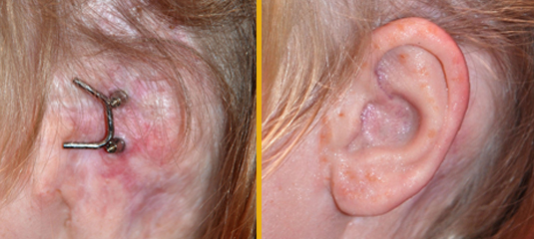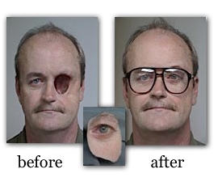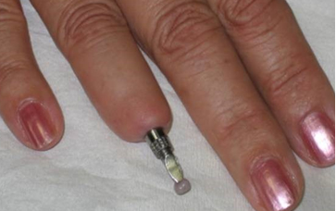
***centric relation differ from one to other even in identical twins .
There are 3 types for prosthetic attachment in overdenture :
Attachment[mechanical device for fixation and retention].
1-Bar attachment
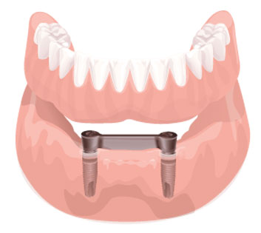
A bar countered to connect abutment root/ implant together ,metal or plastic
Purpose :splinting the abutment +retention /support.
Demand more oral hygiene from the patient .
2-Magnatic attachment
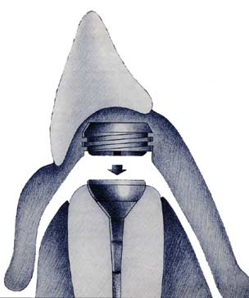
For handicapped patient with limited interarch space,[for easier placement].
One of the poles cemented in prepared cavity in endodontically treated abutment and the other attached to the denture base .
No activation is needed[magnetic].

3-Stud attachment
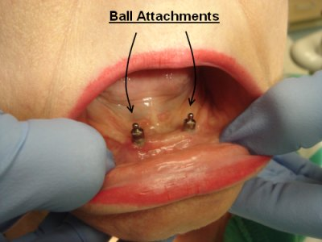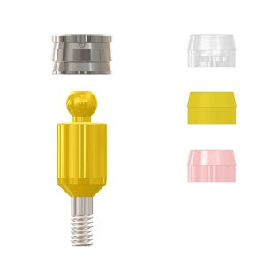
Ball and socket type of attachment in which one component is attached to an abutment or implant and the other element is retained in the prosthesis.
consists of metal or rubber.
You can make activation if its too loose or deactivation if its too tight.
We don't prefer to put implants with ball attachment in the pre-maxilla (canine to canine area) because this area is prone to over growth of soft tissue so we prefer to put a bar attachment with at least 5mm from the gingival margin to the lower part of the bar so that space doesn’t require soft tissues
There is removable CD the one that we make it in the clinics ,and there is fixed overdenture[CD supported by implant/root+attachment]
Overdenture can be long arch prosthesis from 2nd molar to 2nd molar OR short arch prosthesis from 2nd premolar/first molar to 2nd premolar /molar in the other side ,with both types retention come from attachment [bar/ball/magntic].
If there is a good quantity and quality of bone we go for 6 fixtures "which is called implant supported prosthesis=long arch prosthesis "
If there is sever posterior bone loss we can go for short arch prosthesis, In patients that don't have enough bone in the lower, we can insert 2 implants between the intermental foramina then we can construct an overdenture retained by one of the attachments.

***patients always lose their posterior teeth before the anterior because the anatomy of the posterior.
As a first line of treatment you should take in consideration:
- The condition of the ridge, that the patient comes with compromised retention and support[specially in the lower].
- Patient acceptance and desire, the patient wants a fixed supported prosthesis and due to psychological problems he refuses to wear a removable complete denture[15%of patient refuse CD for psychological reason].
- Lack of Support, stability and retention.
- Age
So what are the options of treatment?
- Pre-prosthetic surgery.
- Treatment of fully edentulous patients full mouth rehab fixed bridges[if there is good quality and quantity of the bone] or fixed partial dentures.
- Short arched fixed prosthesis extends only to the 6 or to the 5 if it wasn't cantilever.
- Implant retained overdenture (ball attachment or bar or magnetic).
Should the implant prosthesis be fixed or removable? That depends on the bone quality and quantity
If the lip is dropped down and there is no support for the lips we go for removable complete denture because its flanges would support the lips or we can put semi-flanges to give more support to the lip.
If there is a defect in the palate[cleft] we go for implant retained ovedenture by free attachment ball and socket or magnetic or bar attachment,[NO removable CD].

Indications in general for overdenture:
- When there is no enough bone for fixed bridges.
- When there are anatomical contraindications or close to the vital structures (especially the inferior alveolar nerve in the mandible and the maxillary sinus and nasal cavity in the maxilla).if there is atooth near the sinus or the nerve we keep the tooth as remaining root and use one of the attachment to make overdenture.
- Financial considerations.

This lecture was short 27 min
Good luck all
Hadeel jaser

