Prosthodontics Sheet no.19
Dr.Mahmoud Imeiry
Done by: Eathar Usama
Note: during most of the lecture the doctor was explaining figures on slides which we were not given! I tried my best to catch up with what he was mentioning and I added some figures from the internet. I hope they are right and help make this lecture comprehensible.

“Implant-Supported Abutments”
If a fixture is properly placed in a proper angulation connected to an abutment in the same angulation the forces would be directed along the long axis of the tooth.
There are different types of abutments; the metal abutments are the most commonly used.
They come in different angles in relation to the implant below;
- Zero angle “straight abutment” which is preferable.
- Angulated “angulated abutment” 5°-25° (not exceeding 25° otherwise high forces would be exerted on the tooth). Angulated abutments are used with angulated implants to straighten the visible part of the tooth in an attempt to make it look more aesthetic at the expense of exerting more forces on the tooth; this would only cover the main problem which is the angulated implant.
Therefore the fixtures in implants should be straight and parallel to each other from the first place (a principle similar to the bridge abutments preparation) using “surgical guide”; which is comprised of holes containing titanium cylinders parallel to each other on estimated implants positions, bone is removed using burs through the cylinders, and the end result would be parallel implants.
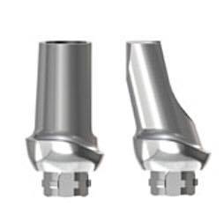
Angulated abutment
Straight abutment

Implants should be:
Vertically, the fixture depth gingivally should be lower than the adjacent tooth CEJ level by 2-3mm.
Horizontally, a missing tooth between two teeth, we draw two lines one labial to the mesial tooth and the other labial to the distal tooth, the implant should not be placed labial to these intersecting lines, otherwise we either need to redo the implant or place an angulated abutment, the latter would negatively affect stress distribution and esthetics.
- Single-tooth abutment:
- Metal prefabricated abutment/ ready-made (straight or angulated)
- Ceramic abutment
- Plastic abutment (to be casted afterwards)
- Cylindrical abutment
- Telescopic abutment
- Temporary abutment

- Prefabricated metal/ ready-made abutments
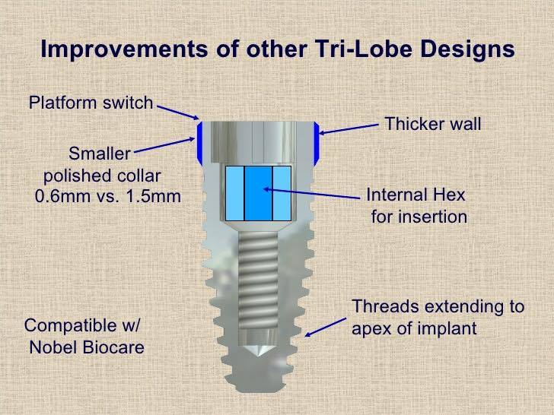
Parts:
- Threaded fixture. Rough surface then a shiny smooth part called polished collar not necessarily present in all implants and they come in different amounts of area coverage depending on the patient’s gingival level, starting at the gingival sulcus level to be surrounded by soft tissue.
- Implant insert.

- Metal abutments shouldn’t be used for a patient with thin gingival biotype; for it will show.
How to connect a crown to an abutment?
In conventional prosthesis we use cement to hold it in place, in implants the crown can be held in place by either cement or screws.

- Screw-retained abutments:
Vertical-screw retention or horizontal-screw retention
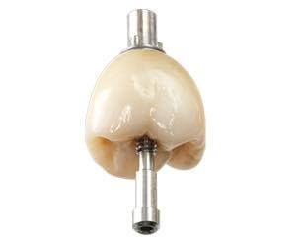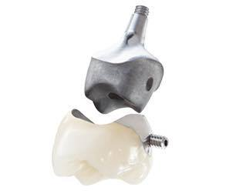
Wax up casting a crown containing the screw nut with it

Advantages of screw-retained crowns:
- Retrievable, the crown can be easily removed then returned back to its place, unlike the cement-retained ones in which we expect crown fracture during removal.
- Controls gap, in cement-retained crowns the technician places a die spacer to create space for cement, in screw-retained there would be intimate contact between the crown fitting surface and the abutment with no separating medium, leading to less chance of microorganisms’ leakage.
- Predictable failure, when high forces are applied on a screw-retained crown the weakest and breakable part would be the screw which is replaceable, unlike the cement-retained crowns in which the crown itself, the abutment or the screw holding the abutment to the implant might get fractured.

Disadvantages of screw-retained crowns:
- Mechanical failure; multiple screws breakage, or the screw nut keeps getting off.
- Access holes visibility; when working on a posterior tooth, upper 7 for example we can only put an occlusal screw which might lead to aesthetic complains
- A specific tooth angulation might force us to do labial/buccal screw placement (this concept is advanced and beyond this lecture).
- Contamination, no matter how precise you are, you can’t reach a 100% intimate contact between the abutment and the fitting surface of the crown, leading to micro gaps and micro leakage sometimes, but of course less than that associated with cement-retained crowns. A 100% intimate contact leads to ‘cold-welding’ making it really hard to remove the crown.

- Cement-retained Abutments
-All screw-retained abutments allow cement-retention, and NOT vice versa.
Advantages of cement-retained abutment:
- Simple procedure, no added work
- Passivity, the prosthesis is fit passively; active fitting indicates an undercut presence preventing full seating. Passive fit means no horizontal movement hence no bone resorption, whereas in screw retained-abutments with no perfect fit they are screw fixed with persistent active function.
- Angulation, where vertical screw retention leads to compromised aesthetics.

Disadvantages of cement-retained abutment:
- Irretrievable, temporary cement in implant-supported abutments is equivalent to permanent cement in natural dentition, so using permanent cement in an implant-supported abutment renders the prosthesis completely irretrievable.
- Cement excess, implants are hard to be cleaned compared to the natural dentition; because the soft tissue surrounding the implant is fragile, and its attachment with the polished collar surface is not real “hemidesmosomal attachment”, hence excess cement peels off that attachment exposing bone, and it can be so extensive causing permanent inflammation “peri-implantitis” and loss of the implant.

- Dr.Imeiry prefers screw retention, but there are not enough studies showing preference.

- Ceramic abutments
Indications:
- Aesthetics
- biocompatibility
- Thin biotype
- Angulated abutments to a certain limit
- The vertical position of the implant
- Some people refuse using metal.
The first two indications are closely related to ceramics in all dental applications.
It can come in this cylindrical form:
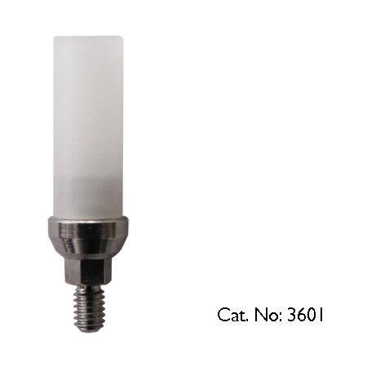
- The implant insert is always metallic except for ceramic abutments where the insert is ceramic too.

- Plastic abutments
The abutment and the crown are casted as one unit.
Indications:
- Limited occlusal space (the minimum occlusal space is 5mm) to achieve adequate retention.
- Optimum control of emergence profile.
- Angulation control, through addition or removal of wax.

- Telescopic/prepable abutments
They come as one unit or two units with an occlusal screw (covered afterwards by composite). It can be prepared and adjusted as needed; adjust angulation, polished collar surface presence and its amount, thickness.
Prepared on a surveyor then trimmed and shaped using special burs.
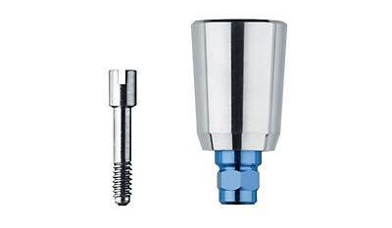
The reason why this type in particular is prepable/ adjustable is its high thickness 3-4mm and very small occlusal hole compared to the other thinner types 1-2mm with which we should be really careful while making adjustments not to perforate the abutment and not to prepare more distally than mesially for example.

- Temporary plastic abutments
They can last for weeks to months. It’s useful in anterior area specifically. We can place composite temporary crown instead of it.
Occlusal screw-retained abutment.

- Two-piece abutment:
- Bar retention
The occlusal screw that holds the abutment to the fixture also has a hole to hold a metal cap to the remaining units using a screw. Then a bar is welded into the caps, so when we need to remove the bar we unscrew the caps. A special metal cap (which is the female part of the denture) is placed within the denture to meet the metal cap, and a metal sheet also within the denture to ‘click’ with the bar
- More fixed.
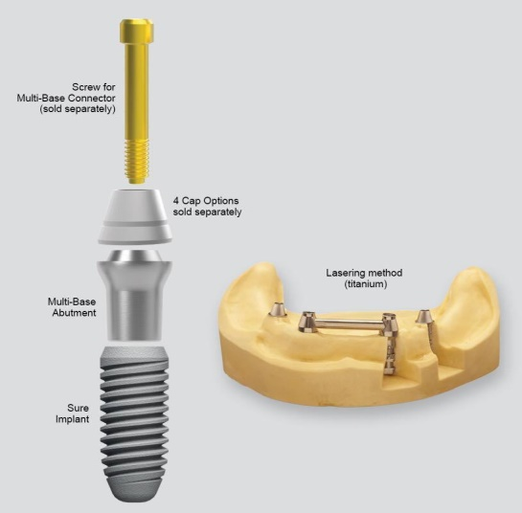

- Ball and socket
The abutment itself is a screw connected to a ball, and a socket unit within the denture.
- Accompanied with less technical problems
- Easier to clean
- Easier to make
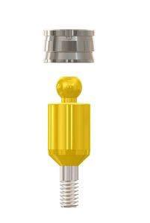
- Suprastructure:
The prosthesis design can be:
- Single-tooth
- FPD or RPD
- Implant and tooth-supported
- Implant and mucosa-supported (like RPDs)
- Full-mouth
- Short-arch
- overdenture

- The most challenging case is replacing an anterior single tooth; because it’s an aesthetically demanding area, with more bone resorption and recession, fenestration, mobility and thin gum area.

- implant-retained fixed prosthesis
Advantages of implant-retained fixed prosthesis:
- More aesthetic
- No movement
- More acceptable for the patient

Indication:
Good bone with recently extracted teeth

Disadvantages of implant-retained fixed prosthesis
- Irretrievable
- More costly
- Hard to be cleaned

- Hybrid prosthesis:
Intraforaminal , for example we put 5 implants in the anterior lower arch and a metal framework is screwed on them with free end saddle with no implants. It’s less ideal than the fixed prosthesis.
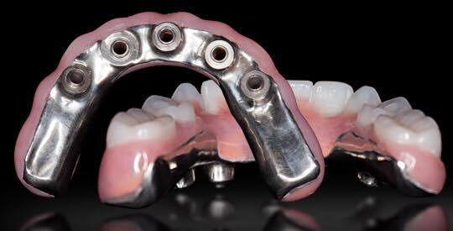

- Overdenture
In cases of ridge collapse where we can’t use fixed prosthesis, either overdenture or hybrid prosthesis can be used.

Best of luck

