Special impression techniques

- Topics to be discussed :

- Pick up impression technique
- Functional (dual ) impression technique
- Neutral zone impression technique
- Flabby ridge impression methods:

a)conventional b)splint c)open window d)selective displacive technique e)unemployed ridge technique

- Unemployed ridge technique
- Flat ridge/Admix technique

Amount of space needed for each impression material : *IMPORTANT NUMBERS*
- Alginate : 3mm-6mm
- ZOE : *0.5-1 mm if mucocompressive
*1.5-2 mm if mucostatic
- The thickness we use for ZOE is 1-1.5 mm
- Rubber material : 2mm
- Compound : not less than 2mm
- Impression plaster : 1.0-1.5mm

** any decrease/increase in these spaces result in distortion of the material .

- Two major points should be discussed before going into further details ;
      - Mucostatic impression VS mucocompressive impression

- Mucostatic : registers the tissue in the anatomical form , which means at rest ; the denture will be perfectly fitted on tissues & occlusion is less than ideal "at the relax stage we're not concerned about perfect occlusion " .

- Mucocompressive : at rest there's no perfect adaptation to the tissues ,its retentive & stable but not 100% fit however under function there's perfect occlusion and perfect fit .
-Techniques ,impression materials and the tray aid in obtaining either mucostatic or mucocompression .
-in bounded saddle dentures , support is mainly obtained from the teeth and the anatomic impression is alginate for the primary and silicone for the secondary .
-in free end saddle dentures it's a different scenario . " discussed in the dual impression technique "
      - Tissue stops

the technician is asked to make tissue stops to provide space for the impression material , if there was no stops you can make them using green stick (make 2 anteriorly and 2 posteriorly ).

-Provides space for the impression material
-Should not be on the tooth that will be prepared /abutments since enough thickness of material is needed on these areas for adequate recordings .

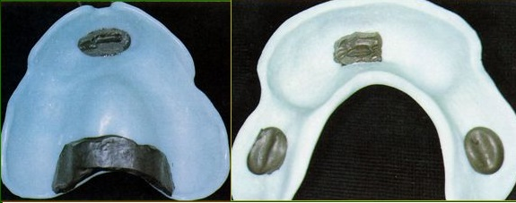

- Pick up impression technique

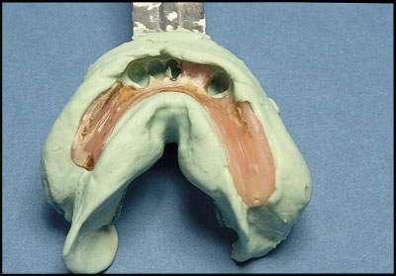
-For dentures repairing purposes ( when the clasp for example is broken we don't have to make a new one ).
-Used also When a patient extracts a tooth that wasn't previously extracted
- Clinical steps :
Place the denture inside the patient's mouth Select a large stock tray (to accommodate the arch & the denture together ) Make an alginate impression for the denture inside the patient's mouth once the material sets the denture gets stuck in the impression that is taken and it will be picked up along with it after pouring the impression, the denture will be seated on the model finally repair whatever needs to be repaired .

- Functional (dual ) impression technique
REMINDER functional impressions are taken through 3 techniques ;1- Mclean 's dual impression technique
2-hindels ' dual impression technique
3-applegate's altered cast technique

- Used in free end saddle dentures since support is obtained from parts with different compressibilities , mucosa which is recorded by a mucocompressive material and teeth that are recorded by a mucostatic material .

- Clinical steps :
Impression compound is firstly loaded on a stock tray to record the free end saddle ONLY and then we do the border moulding the same tray is taken out and an adhesive is applied to it in order to be covered with alginate all-over
- Impression compound has given the mucocompressive impression and alginate has given the mucostatic one .
- Overall alginate impression is the impression for completely edentulous patients in which alginate is applied over another impression material , it's also called alginate wash ( not preferred to use this term ) .

- altered cast technique
-at metal try in stage ,performed on the secondary cast .
-we make sure of the metal framework fit then we ask the technician to apply acrylic on the free end saddle area representing a tray . ( it's like having a tray of two components acrylic on the free end saddle and metal surrounding it ) check it's overextension just like any other tray do border moulding take the impression
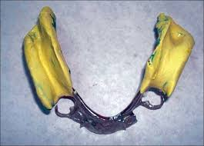

back to the secondary model , cut the free end saddle area of it and reseat the framework on model beading &boxing then pouring it we end up with a new cast that has an old part and another new one
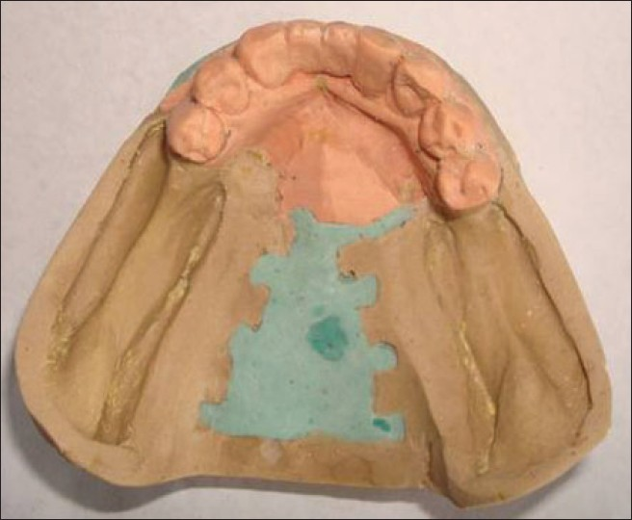

-the free end saddle in this technique is mucocompressed and teeth area mucostatic .
- Advantages of altered cast technique
- better support
- more accurate
- redefine the extension of the free end saddle area
- equalization between forces on teeth and forces on tissues(difference between them range between 0.1-0.5 mm )
-when the denture is fully seated tissues are compressed within their physiological limits ''tissues aren't relaxed '' and upon complete function ,forces of occlusion on the free end saddle and teeth are equal . if this wasn't done and we had a mucostatic impression the denture would sink in the free end saddle and it will be dislodged anteriorly .
-what keeps the denture in its place at rest are the clasps .

- reduce stress on abutment
- Disadvantages
- there'll be functional load on the soft tissues all the time even at rest .
- Forces will be directed more towards the mucosa and the underlying bone leading to more bone resorption .

- REMINDER dual impression technique is done for the primary impression and altered cast technique is done in the metal try-in stage .

- neutral zone technique

- Neutral zone : it's the zone where teeth are set , where the forces exerted by muscles of the lips and cheeks are equalized by those of the tongue .
- Net force in this zone equals zero .
- Teeth are more stable in this zone .
- If teeth are set more buccally ,forces from the cheeks will be more , pushing the denture towards the tongue and the denture will be displaced and vise versa .
- used with the lower denture
- that's why border moulding is important in recording accurate depth and width of the denture.

- indications :
- post –extraction changes which makes it impossible to determine the position of teeth accurately .
- patients with flabby ridge
- patients who haven't worn a lower denture for many years and tongue has expanded into the denture space .
- used in very atrophic ridges .
- in mandibular resections . '' due to tumors or changes that occur in neuromuscular parts , so we can't put teeth accurately ).
- Patients with parkinson's disease (muscles in these patients are hyperactive that will keep pushing the denture until it's dislodged)

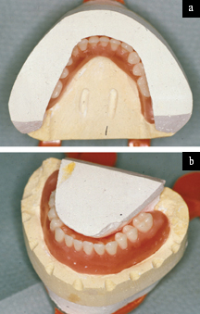

- Advantages :
- Aids in providing better retention &stability
- Aids in providing better esthetics ( good support for lips /cheeks)
- Aids in providing better phonetics

- Disadvantages :
- Technique sensitive
- Requires a cooperative patient "since it requires additional steps to be done by the patient ".
- Increased chairside time
- Increased laboratory cost

- Clinical steps :
This technique done by 2 methods 1-occlusal rims 2-making neutral zone impression technique / more accurate.
- Occlusal rim technique

-in jaw registration stage
-make Primary &secondary impressions as usual , until you reach jaw registration stage ( upper &lower recording blocks).
-determine the vertical dimension at rest and at occlusion ,do mounting as known and then set the upper teeth only .
-place the upper wax denture and the lower wax rim in the mouth trim from the lower wax rim ( for example if it’s width = 1 cm trim 3mm from inside , 3mm outside ) ending up with a very thin wax rim .
-apply tissue conditioner on the wax rim from where we trimmed ;on the inside&the outside re-place it in the patient's mouth and then ask the patient to talk , swallow , move tongue , touch the lips by his tongue ,to count from 1-10 or to say the 'O' letter .
- by these movements we are having the tissue conditioner that was placed to be trimmed in the mouth after initial setting of tissue conditioner , wax rim is articulated and lower teeth are going to be set "using the vertical dimension of the upper not by using maximum intercuspation " according to the resultant neutral zone "results from the trimming process" re-set the upper teeth according to the lower ones to obtain the maximum intercuspation .

- Neutral zone impression technique

-all steps are done as known until we reach the occlusal record blocks for the upper we have the teeth set . and for the lower occlusal block wax is removed from the block and acrylic will be covering it representing the vertical dimension / 2 columns of acrylic or green stick can be placed on both sides posteriorly and a zig-zag wire is placed on the block to retain the material .
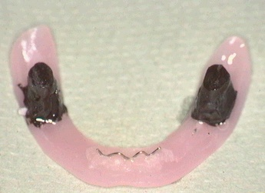

-place tissue conditioner over the resultant lower occlusal block and ask the patient to perform the previously discussed movements the block will be trimmed now according to the surrounding muscles and structures lower teeth are set re-set the upper teeth according to the lower ones to obtain maximum intercuspation .

** the difference between the occlusal rims technique and the neutral zone technique is that the latter we remove the wax rim replacing it by only acrylic or green stick to get to the neutral zone .
-in neutral zone technique the teeth were trimmed lingually and positioned in a way that accommodates the neutral zone , so there is an adequate space for both tongue and cheek however if teeth were set in the conventional technique any movement will displace the denture since teeth weren't modified according to the case .

-NOTE in order to set teeth precisely we use indices made of plaster or even rubber to determine the space available for the teeth (refer to the picture inserted in page 7 ; indices are the white plaster areas surrounding the teeth to guide us in the setting process ) .

- Flabby ridge impression methods :

-the presence of a flabby ridge requires a mucostatic impression , if the impression was mucocompressive the tissues will get distorted and the denture will be completely different from the patient's own ridge .
- Conventional method if the flabby area is small we relief it in the tray to record this small area by a mucostatic impression and the rest will be under mucocompression .

- Splint method if the flabby area is moderate- severe, we apply impression plaster by using a brush on the flabby area and we keep applying layers of plaster till we get a thickness of 2-3 mm in order to fix it in it's place in order to take the impression . Then by using a large stock/special tray take the impression and plaster will be stuck within the impression material and finally pour it ." the flabby area will be mucostatic not touching the denture at rest & under function load will be distributed on the remaining parts of the ridge and the flabby area now slightly comes in contact with the denture "
-Open window technique make a window on the special tray at the flabby area then make the secondary impression ,remove any excess material that gets from the window , reseat the impression inside the patient's mouth then by using a large stock tray we take an impression allover ending up with an impression that has the first impression that was taken previously and the window area.
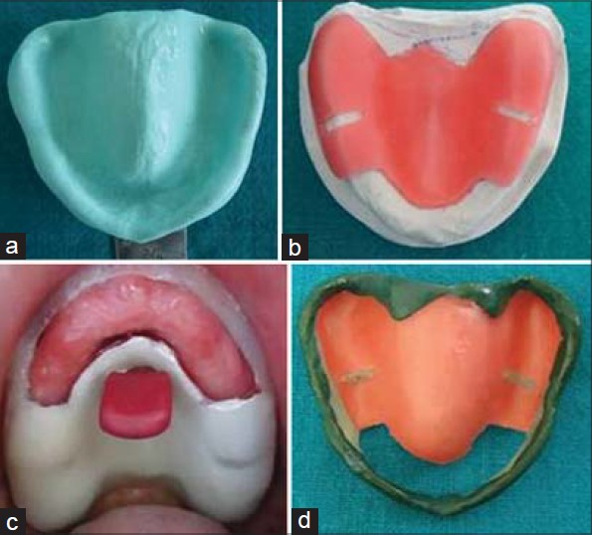

- Selective displacive technique
-take Primary impression with alginate
-Pour it and make a special tray with space of 2mm
-In the lab make a compound impression by the special tray & place it on the cast .
-In patient's mouth bring the special tray that is filled with compound ,reheat the borders and correct it according to the patient's mouth own anatomy then use cobia pencil to locate the flabby area, re-seat the impression so that the area marked with the cobia pencil will leave its mark on the compound
-heat the compound except the part over the flabby ridge area .
-take the compound impression , push it gently and make border movements
the unheated compound acts as a splinting material to keep the flabby area in position .
in this technique there's pressure on all parts of the ridge however the load on the flabby area is less than the other areas " remember that the pressure applied is within physiological limits " .

- Unemployed ridge technique

-Crest of the ridge is the part mostly affected by resorption once this occurs there'll be a space between the crest of the ridge and the overlying denture , with time this space will be occupied by soft tissues in a cord-like manner .

-The main point of this technique is obtaining a mucostatic impression over the crest of the ridge and a mucocompressive one on the sides of the ridge during the secondary impression hence providing further stability of the denture .

- Clinical steps :

-Make a Special tray and load it with green stick .
-Remove the green stick material from the crest's area .
-Take an impression with ZOE all over the tray thus making a mucostatic impression for the crest of the ridge and mucocompressive impression by green stick for the rest.

- Flat ridge/admix technique

- Mix 3 compound cakes with 7 green sticks while applying Vaseline on the fingers to get a new material with a new consistency characterized by being more rigid than the green stick and less than compound .
- This technique aims to stretch the corrugated tissues while the impression is being taken .
- Tissues get corrugated due to resorption of the underlying bone.
- Provides better support and no trauma to the tissues since if the denture was placed on corrugated tissues these will be trapped underneath which is painful in addition to traumatizing them.

- Impression techniques are available for patients with microstomia "the doctor didn't explain them he just mentioned this " .
- CAD/CAM impression technology "the desired area is scanned and the denture is ready with no need of having impressions '' .
- External impressions

