Sheet num#
Dr.Mahmoud
Written by: Bara'h Ghaith

Last lecture we talked about occlusal scheme in complete denture ,
mentioned that we have 3 types :
1.balanced occlusion , 2. Monoplane occlusion , 3 . lingualized occlusion .
Mentioned before balanced occlusion , factors that's affecting it : condylar angle , incisal angle , occlusal plane , cusp angle , compensating curve .
Started with condylar guidance and talked before about , slope of the curve , median wall and inter condylar distance
Inter condylar distance : once we have a wide distance , it require short cusps and wide fossa ( e.g : I have two mandibles , one is narrow , the other is wider , the condyle of the working side rotate in the same amount in the fossa in both mandibles , the condyle on the non functional side translate forwards , the angle of the wider mandible that made between the horizontal distance of the condyles and this movment is lesser than the angle of the narrow mmandible )
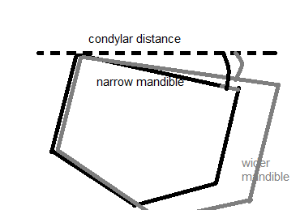
So if the patient has a wide mandible and he did lateral movement of the jaw , the teeth is going to be separated in low angle , so he need a short cusps , unlike narrow mandible which needs longer cusps.

2. incisal guidance : it is the angle between the tip of the lower incisors and the tip of the upper incisors and the horizontal plane , this angle in complete denture made between 5-10 , but in natural dentition it varies .
Patient has deep bite , he will had huge incisal angle , the opposite with reduced over bite , the pt will have low incisal angle
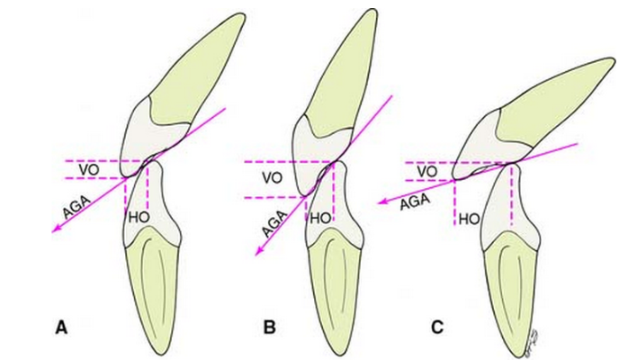
While if the over jet increased the incisal angle decreased , and vise versa . so if you are asked to reduce the incisal angle , you either should decrease the over bite or increase the over jet . the over bite in complete denture is 0.5-1.0mm maximum to decrease this angle and the over jet is 1.5-2.0mm , let's suppose that I have a high incisal angle , then I must replace this increased angle with long cusp posteriorly to not allow the rapid separation of the posterior teeth " christenson phenomenon " while the anterior teeth still in contact ( to maintain balanced occlusion ) , shorter cusps preferred to prevent rocking between upper and lower denture and attrition of the teeth .

3. occlusal plane :
Remember that the occlusion is parallel to camper's line ( ala-tragus line ) , this plane has an average angle of 10 degree , not more than 10 . Why we don't do a horizontal occlusion parallel to Frankfort's plane ? to allow the mandible when it comes downward-forward movement to touch the upper teeth ( making a balanced technique ) and prevent sudden separation of the teeth . one of the guide line of the occlusion is to set it away from the parotid gland papillea 3.3mm , if the occlusion is too high it will cause inflammation to the papillae due to cheek bite , while if it was too low it will cause tongue bite

4. compensating curve : it is one of the most important factors that can be controlled during teeth setting , it has the same principle of occlusal plane , when the pt moves the mandible forward , the posterior teeth set on this curve will continue to remain in contact , thus avoiding disocclusion.
( if you want to get a cusp angle 45 degree , that is not found in markets , you can achieve that by controlling the compensating curve and the occlusal plane , so I have a cusp angle 33 degree and the occlusal plane give us another 10 degree and with a little control of the compensating curve , you can achieve 45 degree angle , it's called " effective cusp angle" )

5. cusp angle : means the buccolingual cusps and it's inclination . the cusp angle considered as a factor that connect the condylar and incisal guidance , let's assume that I have a condylar guidance 70 and the incisal guidance 5 , the cusp angle is something in between these two numbers , assume it is 25 to get a balanced occlusion ,"should be measured according to the formula" .
If I worked with 45 incisal angle , I will have to correct the occlusal plane , compensating curve and need facebow transfer and inter occlusal record , just to get a balanced occlusion , and this will be a complicated procedure , so this will be easier if I use a low incisal angle .

Factors that causes loss of balance in balanced occlusion :
1.lateral premature contact ( loss of stability ) ,we should have bilateral balance in complete denture , unlike natural dentition and fixed treatment which is unilateral .
2. very wide occlusal plane ,( the teeth has been set more labially an buccally ) , the denture will be out of balance ( more force from the cheek ) , and it will loss it stability
3. incorrect placement of the teeth ( should set the teeth in curve line instead of horizontal line )

Monoplane occlusion ( means single plane ) : according to this concept the teeth are flat mesiodisatally and buccolingullay in order to minimize the tipping forces , used in pt with sever rigde resorption to reduce the horizontal forces that dislodge the denture ,
this type of occlusion has impaired mastication because of poor food penetration .
It is not balanced – due to flat teeth – in protrusion , there will be separation between the teeth posteriorly and we called it Christiansen's phenomena , someone called Serz!! In his trying to make it balanced , he added a ramp posterior to the last tooth in the arch , ramp provide tripodal effect of the contact ( one anterior and two posterior )
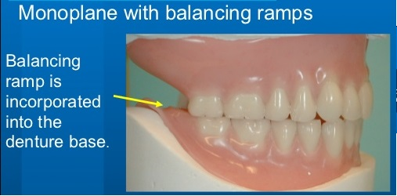

Lingualized occlusion : the maxillary lingual cusp articulate with the mandible occlusal surface and there is a tunnel buccally between the buccal surfaces to just allow the lingual cusps to be in contact , "the maxillary teeth have large cusp lingually with small cusps buccally , the mandibular teeth are flat or semi "
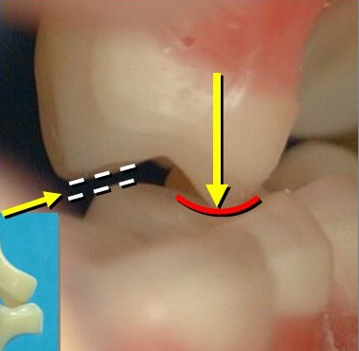
there is no cusps in the lower teeth , the upper will not push the lower teeth once slide on them ,so it won't push the denture forward , and this type of occlusion allow long centric occlusion , e.g: pt with Parkinson disease can't get a proper centric occlusion, and pt with muscles disorder better to have a wide area for contact

advantages :
1.penetration of the food is easy
2. reduce the lateral forces
3. reduce the incidence of cheek bite ( buccal tunnel )
4. acceptable esthetically
5. allow free gliding

Requirement of balanced occlusion :
1.esthatic acceptable
2. adequate function
3. the artificial center occlusion coincide with the centric relation
4. free saddle , this allow the denture to move in its place without dislodgment or rocking
5. 0.5-1.0 mm overbite , 1.0-2.0 mm overjet
6. bilateral balance occlusion
7. proper teeth selection
8. teeth setting in the neutral zone or according to the degree of resorption
Let's assume that the teeth set on the buccal crest of the ridge , then the pt bite laterally on the right side , the denture will dislodge from the other side , so teeth setting should be on the crest of the ridge and the posterior teeth of the mandible set slightly lingually , while the upper teeth set buccally according to bone resorption pattern
9. reduce the contact area in order to decrease the forces ( don't make wide occlusal plane )
10 . there is no Christensen's phenomena

Confirmative and reorganized occlusion :
Confirmative occlusion : to make the occlusion of the new restoration in harmony with the existing contact

Used in :
1.existing of Ideal or normal occlusion ,
2. No TMJ problems ,
3. Not too many teeth are going to be restored

Reorganized occlusion : in case that you can't confirm , so you provide an occlusion that is more ideal

Used for :
1. Increase vertical dimension is wanted
2. TMJ problems ,
3. Over erupted teeth
4. Chande in appearance is wanted
5. History of occlusal failure of existing restoration

