- Sheet #6.
- Refer to Slide #2
- Done by : Razan Zuhair
- Corrected by : Dana ayman
Slide 2 :
There are many classifications available for classifying edentulous arches , but the most common one is Kennedy classification .
Kennedy classification which depends on
1) The frequency of edentulous spaces, “ NOT the length or the number of missing teeth “
2) where the saddle is “ the location of these spaces “ .
Beckett's system of classification depends on the type of support , is based on whether the denture base is tooth-borne, tissue-borne, or a combination of the two.
Slide3 :
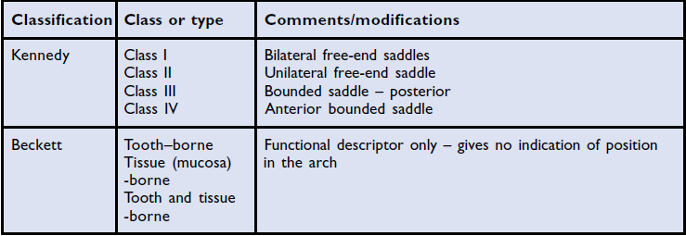
Slide4 :
- A: class 1 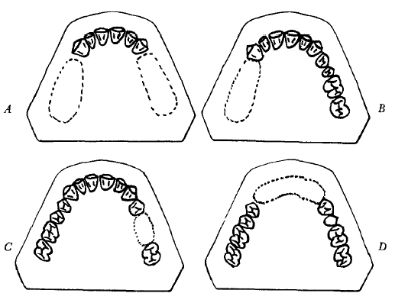
- B: class 2
- C : class 3
- D : class4
Slide 5 :
We will take class 1+2 together as one category and class 3+4 as another, since they share many similarities. These 2 categories differ mainly in
1)type of support
Class 1+2 ” dual “combination btw teeth and tissue
Class 3 teeth
2)Impression technique ..
3)need for indirect retainers ..
4)need for relining in future ..
Slide 6 :
Components of any RPD :
- Supporting elements e.g. rest
Support : resistance of movement toward the tissue
Retention : Resistance of movement away from the tissue

- Retaining elements e.g. clasps , but it doesn’t mean it is the only mean.
- Connecting elements : major and minor connectors.
- Anti-rotational components : indirect retainers.
- Denture base and flanges. We have already talked about them last lect . “ Metal , acrylic .. and the differences between them “
Slide 7 :
Principles of design :
- In any case we have to design the Outline of the saddle area , and determine the classification type
- Determine the support , because the rests are different ( anterior or posterior , mesial or distal )
- Determine the retaining elements
- Connect and unit the saddles by connectors
- Indirect retainers if needed
- Re-assessment
RPD requires simplicity , so if there is any component that we can omit , it will be better
like if there’s an undercut we can omit the clasp ^^ .” less components , easier to use by the patient , healthier and easier to maintain . “
so we make a basic design then we re-assess it
- Occlusion you have to consider .
Planning occlusion two types : Confirmative or reorganized
in complete denture “ occlusion reorganized “ because we don’t have anything from the patient to use so we use special basics and guidelines to make the occlusion
otherwise in confirmative few units but the occlusion is clear in patient , we have an occlusal stability and when we make an prosthesis or When we take a primary impression , we must study the case on the articulator ; because if there is enough unit of natural teeth , you have to keep the same contact with or without the prosthesis we should keep the same contact -not like the complete denture – so the occlusion should match and confirm the patient’s occlusion
** when do we make a reorganized occlusion in RPD ??
When there’s no occlusal stability or clear contacts such as class 1 we don’t have an contact posteriorly ,
Also the bite of anteriors not clear enough because of (attrition , wear..etc)

Slide 8 :
keep in mind Simplicity in RPD is the most important thing ^^
Slide 9 :
Always we have a primary cast , then survey it and draw the design on the cast as well as on the prescription sheet.
The study casts should be articulated.
The picture here is class 3 modification 1
Any case involves :
- Determining The classification
- outlining the saddle areas
- The primary abutments.
- Surveying the path of insertion “The guiding planes” .
- The anterior posterior tilt.

Slide12 :
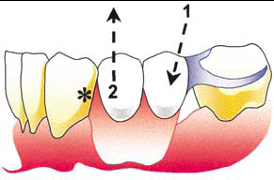
This is an example to show you the importance of the tilt ; when we make the path of insertion (1) different from the path of displacement (2) which is representing occlusal forces or under function while the patient eating sticky food , we will provide retention by engaging the distal undercut (*) , and omit the clasp on canine to become more esthetic , more preserve and avoid interferences .
slide 13 :
Outling class 3 mod 1 , blue color represents guiding planes . we start from the most posterior tooth ( 7 ) . support provided by rests
notice that the third molar is not considered in the classification .
slide14 :
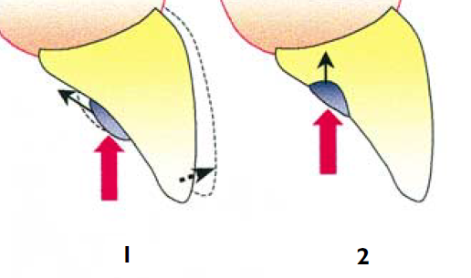
here , we prepare (2) in order 1- not to interfere with occlusion 2) to direct the forces down the long axis of the tooth( axial more favorable than lateral forces). 3) more comfortable, less irritating to the tongue 4) more hygienic (margins tend to accumulate food easily)

rests are mainly for support , but they can do other functions like indirect retainers in class 1 , 2 and 4
Slide 15 :
here the rest in bounded saddle usually rests adjacent to the edentulous teeth .
“molars and premolar have occlusal rests , while canine has a ledge .” don’t forget to name the rests in the practical exam !!
Slide 16,17 :
NoW we already made outlining, support , then we need retainers ( anterioly “Ibars” posteriorly “C clasps “.. we also need to determine the location of retention
Roughly we should already made a surveying in the cast to help us finding the undercuts .
Generally buccal undercuts in upper and lingual undercuts in lower . we suppose that we have lingual undercuts so reciprocation will be buccally .
* don’t forget to name the reciprocation ( Mesiobuccal or distolingual
Slide 18 , 19 , 20 :
- The difference between bracing and reciprocation :
- Bracing occurs only when the denture is fully seated then any part going to resist the lateral forces called bracing , while the reciprocation works when we start to remove the denture. (active) ** when the patient try to remove the denture here the retention takes place as we said it’s the resistance of movement away from the tissue , the property of retention here : the retentive clasp is opposed by a rigid component which maintains contact with the tooth as the retentive arm moves over the bulbosity of the tooth, displacement of the tooth is resisted, the retentive arm is forced to flex and thus the efficiency of the retentive element is increased. This principle is known as reciprocation. It is thus apparent that reciprocation is required as the denture is being displaced occlusally whilst the bracing function, as mentioned earlier, comes into play when the denture is fully seated.
- Effective reciprocation can be achieved either : by a clasp arm contacting a guide surface of similar height to the 'retention distance', or by a plate making continuous contact with the tooth surface as the retentive arm moves through its 'retention distance'.
- ** If the reciprocating clasp is placed on a tooth without an adequate guide surface, it will lose contact with the tooth before the retentive arm has passed over the maximum bulbosity of the tooth and fail to provide effective reciprocation.

Extra notes
CROSS-TOOTH RECIPROCATION is the
mechanism by which lateral forces generated by a retentive clasp arm passing over a height of contour are
counterbalanced, counteracted, or negated
by a reciprocal component passing along a reciprocal guiding plane

Reciprocal Component

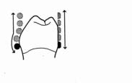

Height of Contour
of abutment tooth
Retentive Clasp Arm Guiding Plane of
abutment tooth

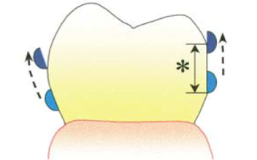
reciprocal arm against prepared guiding plane , 1) it keeps the tooth in its place by preventing the lateral forces 2) prevents clasp deformation by having one path of insertion 3) reciprocal arm is a rigid component because when the clasp starts to move away from its place , the only way to get out is to engage the undercut and to flex within the proportional limit ( already known ) this is the retentive property which appears when the clasp starts to flex
Active reciprocal component because it works when the denture is being displaced occlusally , while bracing works when it is fully seated
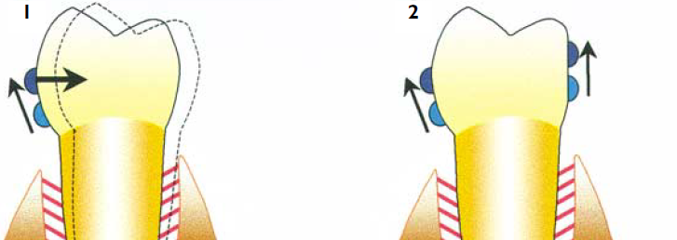
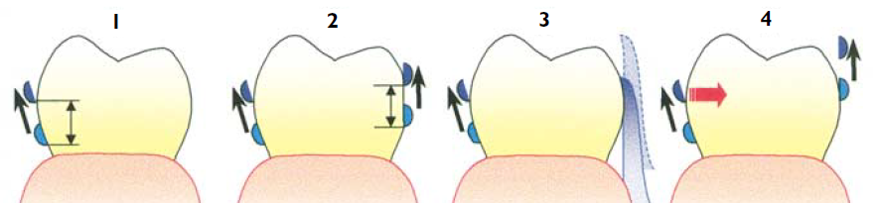4 : it has no any efficiency because when it starts moving from its place , it will run away from the tooth.
You must take in consideration the position (2) , they must be almost at the same level which is called retention distance . only the retentive tip is below the survey line.
Slide 21 :
The most important thing Bracing is active only when the denture is fully seated.
Bracing is : The horizontal forces are resisted by placing rigid components of the denture (bracing components) against suitable vertical surfaces on the teeth and residual ridges. Parts of a denture resting against the stippled areas will resist the forces whose directions are shown by the arrows
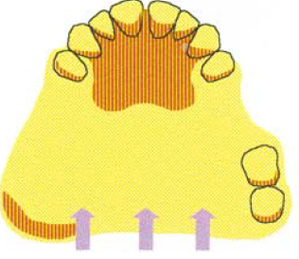
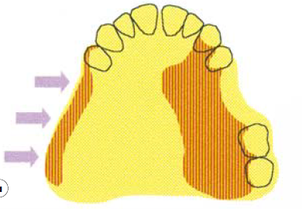these lateral forces hit the ridge ( vertical wall not flat surface ) , the shadowed area will prevent the movement ; this is called bracing.
So, bracing is a rigid component against vertical wall on the tooth surface or on the ridge, that provides resistance to lateral movement when the denture is fully seated. For example , in chewing stroke , the denture is in place and many lateral forces are acting on , the bracing here will going to work . when we start removing the denture , the retentive and reciprocal arms become active and this is a reciprocation.
Note : the bracing can be made by any component even the minor connector can do the job.
So far we talked about the outline , support (rests) , direct and indirect retention , Now we will complete the design by adding minor connectors( slide 22).
Slide 23 :
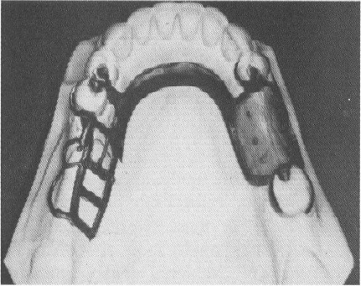
This is ladder-like minor connector, provides excellent attachment of acrylic resin bases, minimizes warping of bases resulting from the release of inherent strains in compression-molded acrylic resin.
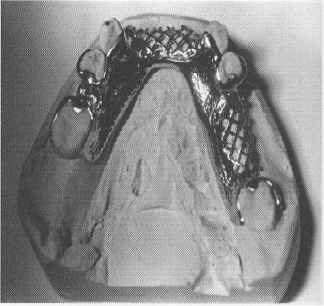
This is mesh pattern minor connector , more rigid since it has more metal components, but the bulk of the connector itself may contribute to weakening of acrylic resin base.
The last thing to be added is a major connector to unite all the components together.
Be attention in the exam whether the arch is upper or lower , because it makes difference especially with major connector .
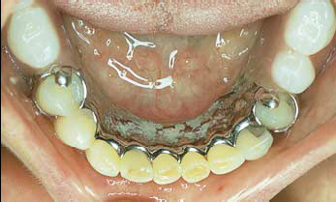
Lingual plate major connector ( lower )
Between the major connector and other components : minor connectors.
In addition to the connection , Minor connector can do bracing , stability and reciprocation depending on its position .
- Slides 25,26,27 : of Selecting the Major Connector as a revenge the dr didn’t read them but she said “ you have to study them “.
Selection of the type of connector(s) is based on four factors: mouth comfort , rigidity , location of denture bases , and indirect retention. You have to know all these factors to select the proper major connector.
Slide 28,29 :
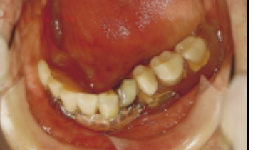
Labial major connector
Slide 32 :
shows the final design , green color represents the retentive tip .
To know exactly where is the retainer , you have to know where is the undercut . because the retainer not necessary to be located labially or lingually . but often in the lower it is lingually ( lower teeth are tilted lingually ) and in the upper buccally .( remember that there is an exception ).
Slide 34 :
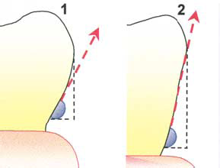Here , in 1 +2 the undercut exactly the same , the difference is in the vertical distance that the retentive arm must pass through , in (2) it is longer and the flexion is acute , so less retention , while in (1) the flexion is gradually , more resistant when it is going to be displaced , so more retention . The undercut not only buccally-lingually , also mesially-distally . if the undercut is adjacent to the edentulous area , ring clasp is indicated.
Slide 35 :
Now we will going to talk about indirect retention .
Here we need prosthesis from one side fulcrum in the middle and and a component from the other side
When we talk about any movement , we always use the term fulcrum which extending between 2 points .
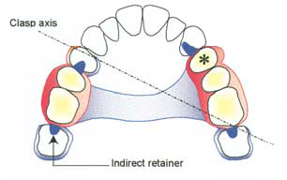
this is a fulcrum (clasp axis passes through the retentive tips of the clasps) , if the denture moving away from the tissue in this side (arrow) , the rest on the other side will provide indirect retainer. So in class 3 we don’t need indirect retainer since it is already provided.

Always remember the simplicity in the design ; if one component provides more than one function , it will be better .
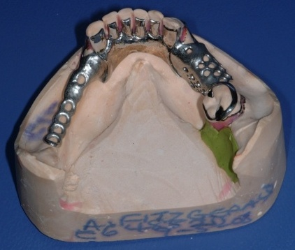class 2 mod 1
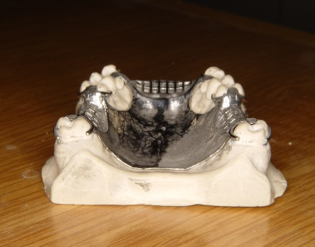class 3 mod 2 (look out on the molars posteriorly ).

Slide 37 :
The path of insertion must be different from the path of displacement to minimize the components.
Very important thing to start thinking about is to expect all the movements in all directions , because my design must resist any movement . if I need to remove the denture away from the tissue and toward the tissue , I will need clasps ( retainers ) and rests , respectively. ( vertical movement ).
Rotational movement
Rotation laterally toward the tissue on the same side needs support ( rest ) , on the other side the denture tends to be displaced away from the tissue, so here clasps are needed. Clasp’s main function is retention but in this case it does support ( indirect support , not the original function).
Always you should start deciding the direct movement on the same side .
Rotation laterally away from the tissue on the same side needs retainer ( clasp ) , on the other side the denture tends to sink toward the tissue , so here rests are needed . rests originally do support but in this case they provide indirect retainers.
Slide 38 :
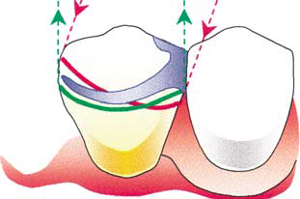2 survey lines , one on the zero tilt , the other on the alternative tilt . red color represents the path of insertion , green color represents the path of displacement. If the denture is prepared to be inserted in an angle (red line) , it will not be displaced vertically (it will become locked ) and thus I will not need the clasp to be retentive in relative to the path of displacement , but still I need some retention for path of withdrawal so I will put the retentive tip relevant to the red line only. In addition there is another advantage to put the retentive tip above , to prevent trauma .
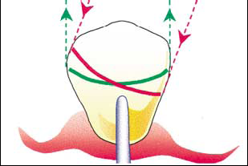
Slide 39 : the path of insertion the same as the path of displacement , if I put the retentive tip of the clasp relevant only to the path of insertion , there will be no retention because there is no undercut to take advantage from . so the retentive tip must be in the crossover area ( common undercut for both ).

Slide 41 : , class 3 without modification ; slide 42 , outlining and guiding planes ; slide 43 support (rests) ; slide 44 shows the fulcrum and any expected movement ; slide 45, retainers , the question mark (?) means if it’s a short span you can omit this clasp anteriorly that will help us esthetically and if there’s any undercut can help us also .
Slide 46 : , we put retainers on the other side as indirect support .
Slide 47 : , we put rests on the other side as indirect retainers .
Slide 48 : we connect them by the major connector . it is very easy to choose it if you know the indication of each one . slide 49, these are the retentive tips .
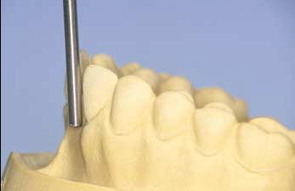
Slide 50 : this is class 4 which doesn’t have any modifications .
We’re gonna do a posterior tilt because we have a labial undercuts area sothat will help us esthetically and the acrylic material will extend to an area which can’t be reachable without this tilt . (black triangle)
Slide 51 : AGAIN when you have an anterior edentulous area with labial undercut , use it to minimize the components that are needed. without tilt , I will either make it straight ( there will be a gap , not retentive ), make it very short ( also not retentive nor esthetic ) or make the flange away from the tissue and that’s doesn’t make sense . so I will give the cast a posterior tilt . with this tilt , the path of insertion will be different from the path of displacement , and the patient will insert the denture with an angle while the function occurs vertically ,thus when the patient eats a sticky food , then it becomes impossible to get the denture out . by doing so, I take an advantage from the patient’s labial undercut and pass up any unneeded clasps, plus it is more esthetic .

Class 4 bounded saddle “next time she will talk if it’s not bounded saddle” is any tooth adjacent to the edentulous area .
To be continued …

THANK YOU

