♥ Anatomy of maxilla & mandible ♥
First of all, why do we have to know the anatomy of maxilla & mandible?
To make a denture, cause we are dealing with environment surrounded by tongue , cheek & other different structures.

As a revision, we have 3 denture surfaces that have relations with certain anatomical land marks :
1-fitting surface … the relation between ridges of maxilla & mandible-the surface toward tissues
2-occlusal surface…between upper & lower jaws
3-polished surface …. Tongue & cheek attached with this surface

♥About fitting surface:
1-stress bearing area (supporting area)...the area where the denture will set on.
2-peripheral or limiting area … is the area where the end of denture will reach

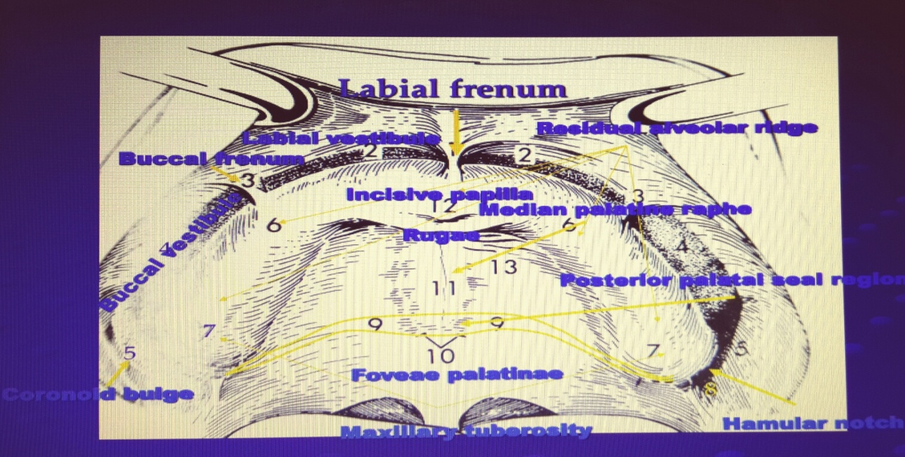

♥This is a picture from the internet for the main land marks of maxilla:

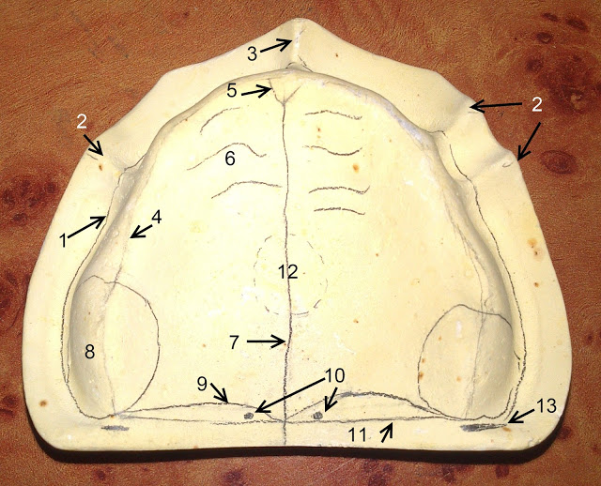
1 - Oral vestibule
2 - Buccal frenum
3 - Labial frenum
4 - Crest of residual alveolar ridge
5 - Incisive papilla
6 - Rugae
7 - Median palatine raphe
8 - Maxillary tuberosity
9 - Anterior vibrating line
10 - Fovea palatinae
11 - Posterior vibrating line
12 - Torus palatinus
13 - Hamular notch

♥NOTES:
1-vibrating line is part of the soft palate , that separates the movable from non movable tissues on the soft palate. The importance of this line is that its considered as the posterior border of the denture, so, it’s a limiting structure.
2- fovea palatinae are 2 orifices for minor salivary glands that by them we could easily locate the vibrating line. Another way for locating the vibrating line is by drawing a line between the 2 hamular notch.
3-coronoid bulge is called so because its relevant to coronoid process.
4-maxillary tuberosity ..is the most bulgy area at the end of maxilla , & posterior to it there is the hamular notch
5-posterior palatal seal area … when we draw a line between the hamular notch, we will have the vibrating line, one is posterior & the other anterior, between the 2 lines we will have the posterior palatine seal area. Its called seal area because its an compressible area , where denture sink there cause of the softening of the tissues, that’s why when we remove the impression we hear a voice of suction that result from the negative pressure there . seal = retention .
6- we should relief these areas: incisive papilla ( cause it contains a nerve) - medial palatine raphe(cause its thin area)
7-distobuccal area for complete denture: coronoid process & massiter muscle

♥ A picture for negative impression:
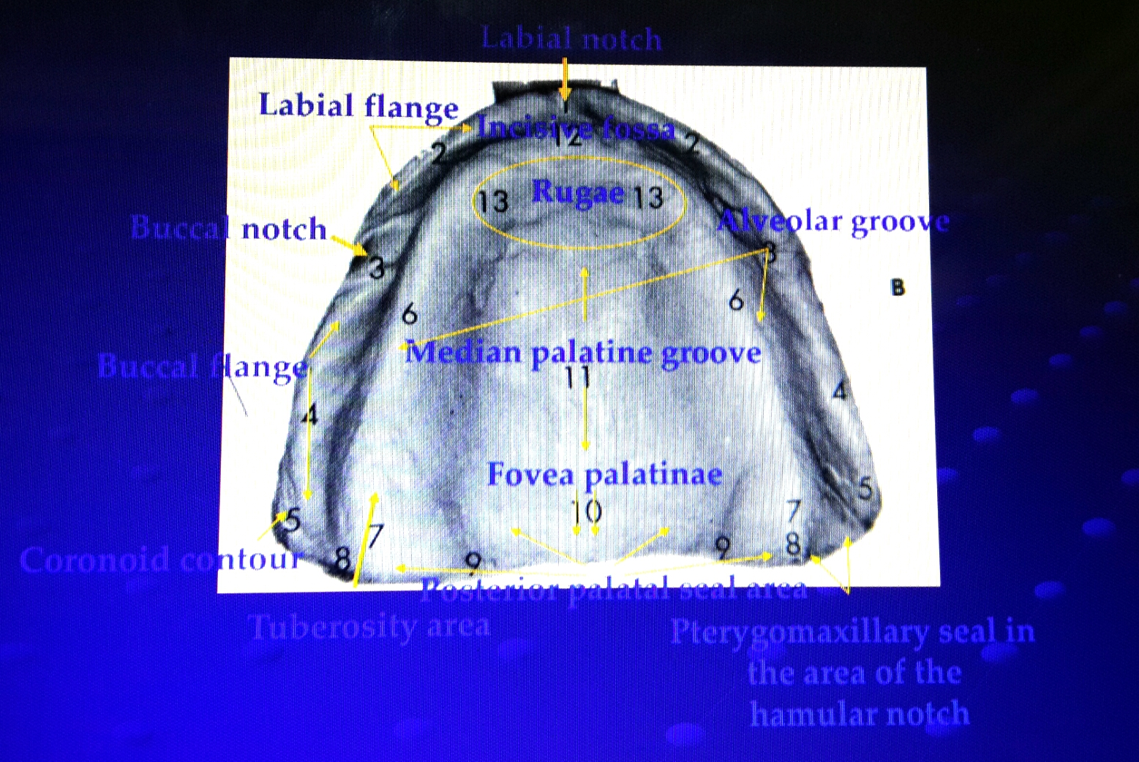

Supporting structures: it should be hard like a bone cause the denture will set on it
Bone is covered by a mucous membrane ( mucous membrane is composed mucosa- could be stratified or keratinized or non keratinized- & sub mucosa -that could be lose or dense , contains glandular tissue or fat & has a nerve supply-).
Note: the thickness & consistency –how firm is the tissues- of the submucosa determines the support .

♥ Tissues may be:
- Firmly attached to bone … this type of tissues withstand the pressure & give support – ex. The palate & the stress bearing area- .
- Loosely attached to bone … this type is easily displaced & affects the stability & support – movable – so, these tissues are limiting structures - like the depth of the sulcus- .
- Thin … easy to be traumatized – ex. Medial raphe in maxilla

♥ Stress bearing areas in maxilla are:
1-horizintal portion of the hard palate
2-rugaue area
3-residual ridges – the only one that get resorbed in maxilla-

♥ This should be a home work :
What are the factors affecting the form & size of supporting bone?
- Length of edentulous
- ….. complete :P

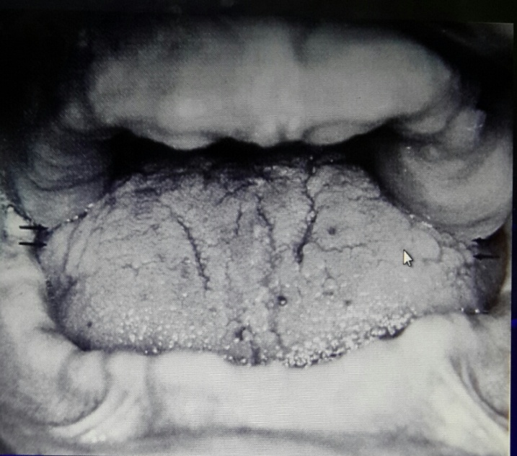
♥-The space between upper arch & lower arch called : interarch space.
-in this picture , the space is limited because of the enlargement of maxillary tuberosity & retromolar pad area which is a result of loosing teeth for a long time.

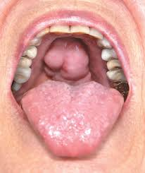

♥-torus palatinus: its an extra bone in the palate , exist in 20% of population. The problem in this case is that there will be no sealing, so we are unable to make a denture.

♥ NOTE : Buccal frenum is wider than labial frenum , because its under tension of 2 muscles > buccinator & orbecularis oris.

A-maxillary tuberosity
B-pteregomandibular raphe
c-retromolar pad
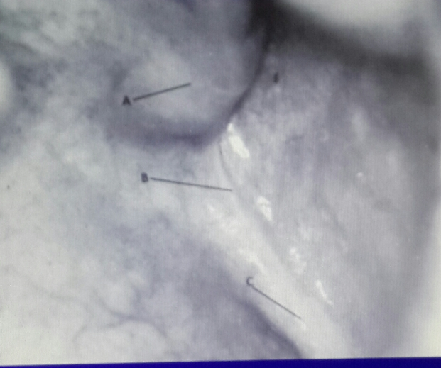
-we order the patient to open his mouth widely just to see the pteregomandibular raphe, that we shouldn’t extend the tension to it , cause its delicate & may get a trauma.

♥ The mandibular:
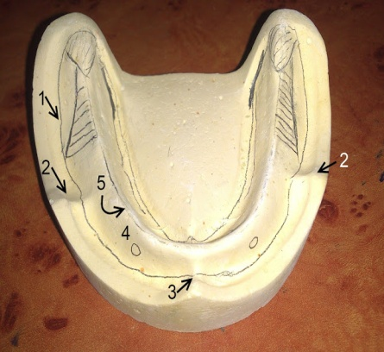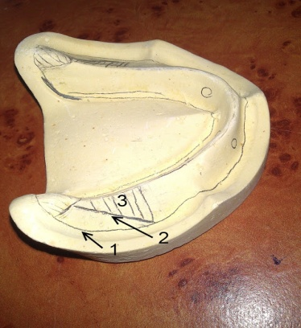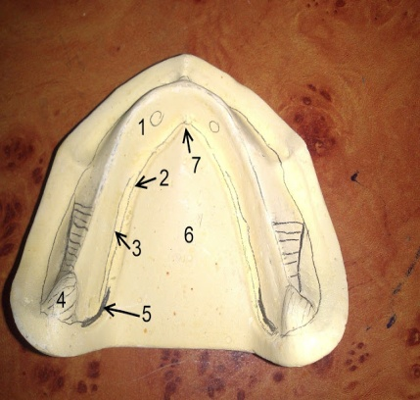
1 - Labial vestibule  2- Buccal frenum  3 - Labial frenum  4 - Mental foramen  5 - Crest of residual alveolar ridge | 1 - Labial vestibule  2 - External oblique ridge  3 - Buccal shelf of bone | 1 - Torus mandibularis  2 - Lingual vestibule  3 - Mylohyoid line  4 - Retromolar pad  5 - Lingual pouch  6 - Tongue  7 - Lingual frenum

♥ Notes:
-buccal shelf: is the primary support area in the lower jaw, but the residual ridge is the secondary support area, unlike the maxilla.
-retromolar pad in mandible matches the maxillary tuberosity.
♥ Home work : why the buccal shelf is the primary support area in the lower jaw not the residual ridge?
Cause the residual ridge is a cancellous bone so, easier to be resorped , but buccal shelf is a cortical bone which can withstand more pressure .

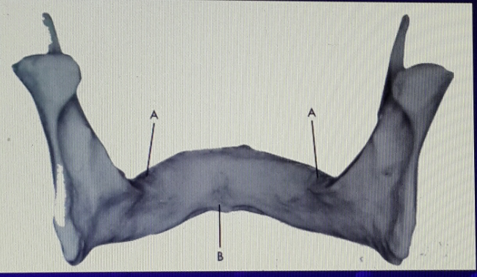
♥- in this picture, there is a sharp edge called (mylohyoid ridge) , & below it there is an (undercut ), cause under a sharp area there must be a flexible material.

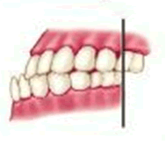

♥Over time, resorption occur & maxilla moves posterior & superior, but in mandible , resorption mostly occur from inside, eventually , the shape looks like class 3 .

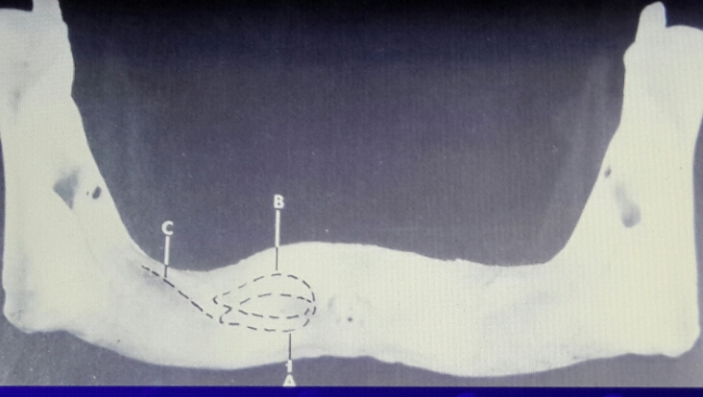
♥ -Functional movement (B) is what determines the border of denture not when the patient is at rest (A).

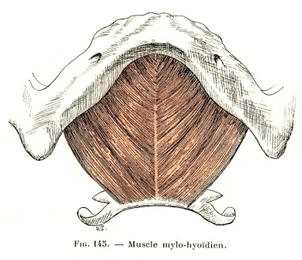
-♥ mylohyoid muscle is important because it determines the extension of the denture.

♥
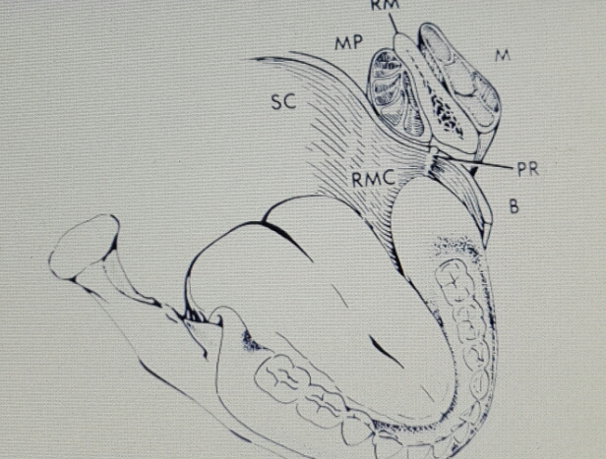
M > Masseter muscle
PR> pteregomandibular raphe
B> Buccinator
RM> Ramus of mandible
MP> Medial pteregoid
SC> superior constrictor muscle
RMC>Retro Mylohyoid Curtain

Done by: Haneen AL-Khateeb Enjoy studying….bye bye♥

