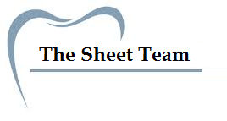
Title of Lecture: Making impression

Date of Lecture:29-9 - 2014

Sheet no: 3

Refer to slide no. : new lec

Written by: lubna abu rumman

Last time, we talk about land mark and this will help us to talk about primary impression making; when you take the impression u should be able to know the land mark that have to record in primary impression .
We have anatomical landmarks which are very critical since they define the extent of the coverage (denture).
In complete denture we have 2 impressions: primary impression (stage one), secondary “definitive “(stage two). They are totally different in 1- procedure 2- kind of tray that use 3- impression material 4- objecte of dentue ( the cause that lead us to make it .
 | Primary imp. | Secondary imp.
Impression material | Impression compound ,impression plaster , alginate( should be modified by using green stick ). | ZNO eugenol ,….  * we will talk about them in next lec.
Tray | Stock tray : metal , plastic | Special tray
Objective “ the aim of making it” | to record the entire denture bearing area and then outline the available support for the denture. It gives a general idea about the area to be covered with the denture. | To maximize support, retention and stability.

Home work : 1- what is the difference between support, retention and stability ?
2- factor that effect or maximize “support, retention and stability” ?
We said that the complete denture there is 2 phases: preparatory phase & construction phase.
Preparatory phase :
There should be healthy tissues before taking the impression. How to achieve this?
You shouldn’t take impression immediately when patient “with denture” come to ur clinic , you need to wait until the tissue heal ( because tissue is under pressure caused by denture itself ).
- Optimize the present denture with tissue conditioners. If the patient already has a denture (but the patient need to get a new denture because there are problems in the existing one), we try to improve the denture because the patient can’t stay for long time without using the denture. (we can’t ask the patient not to use the denture to get healthy tissues), you have to adjust the existing denture & its circumference to make it harmless for the tissues, we can use tissue conditioner for that purpose. ( dr said that she not prefer going to make cut with presenting denture , you should make a new denture and make editing on it ).
Tissue conditioner: is a soft material (as soft as silicone) that we can use for lining the denture plus it can reduce trauma on the tissue. ( it is reversible; you can remove it easily ).
- Encourage the patient to leave the denture out as much as possible at least 24 to 72 hours . Because the pressure made by the denture affects the tissues, we need the tissues at the stage of primary impression to be at relaxed position. “ you advice Patient should keep the denture out after 9 clock.”
- Instruct the patient in oral and denture hygiene and how to massage the denture bearing area. If there is no good hygiene then you expect calculuses to be formed and occurrence of inflammation in tissues.
- Prescribe any necessary preprosthetic surgery “ e.g. : Torus palatines ”.
Tray selection : the tray that is used for primary impression is stock tray
The tray should be (requirements of tray):
- Rigid
- Biocompatible (not toxic)
- Accommodate appropriate amount of impression material.
- Extend to anatomical landmarks
- Can be modified. Because may be the size is good and it is suitable but it needs little modification, so the easier the material to be modified the more handy to be.
There are 2 types of trays: metal and plastic.
advantages of metal trays :1- not disposable , can be sterilized. 2- have wider range “ than plastic ”.
Advantage of plastic trays : 1- can be modified
Impression materials:
Classification of impression materials:
# generally there is: elastic materials and non-elastic materials (according to the nature)
#non-elastic materials:
- Impression plaster: these days it’s rarely to be used.
- Impression compound: we all used it in the lab and noticed the properties of this impression; we saw how this impression was rigid at the beginning and then became soft with hot water then became rigid after sitting.
- Zinc-oxide eugenol:
- Impression waxes: nowadays we don’t use it is not dimensional stable
# Elastic materials are of two types: hydrocolloids & synthetic elastomers. (we took it last year )
- Hydrocolloids: (hydro: refers to water) two types of hydrocolloids: reversible which is agar and irreversible which is alginate.
- Agar: the tray that is used for this has two tubes..
- Alginate: we should use green stick to reach full depth , should have margin to fix it , also it is fully extended and it is kind on tissue.
Synthetic elastomers: polysulfide, polyether and silicones.
** The dr. will give us a table that contains all impression materials and their properties including differences between them. You can keep this with you and read it anywhere (while you’re in the bus :P ) . This will help u to memorize them; it’s easier than reading it from a book.
** The dr. said you don’t have to worry about polysulfide and polyether .
Impression compound
*properties of impression compound
* Impression compound is a thermoplastic material; with temperature it becomes plastic, soft and moldable.
* has a high value of coefficient of thermal expansion, so we pour it as soon as possible !! ** I will check this information and till you if it wrong.
* poor thermal conductivity: in lab , we cut it into pieces to increase thermal conductivity .
* Large temperature drop from softening temperature to room temperature
*it doesn’t give nice surface details.
What is the material that should be pored immediately ? ALGINATE .
When we compare impression compound with alginate , the impression compound have more dimensional stability.
** main composition for impression compound: 1 - resin and waxes “make it more flexible ”
2- talc “make it bulk and rigid “ 3- stearic acid (which is a lubricant).
Every clinical step have laboratory step .
**we use plaster of paris for pouring primary impression, why not stone or die stone? We use the gypsum product according to the requirement, and in primary we just want to know the extent and to make a special tray, so we don’t need fine details, so there is no need to use a more expensive material and harder to trim, I need the study model just to make a special tray and it will be kept as a record for the patient, and all the work will be done on the secondary cast. We don’t need the primary cast to be highly resistance to scratches, corrosion … etc.
**requirements for model materials
- Dimension accuracy:
- Adequate mechanical properties according to the procedure or stage I want to do ( primary not as secondary cast )
- Strong to resist accidental fracture,
- hard to resist abrasion
- Fluid at the time it is poured: very important ; to get the details and reduce air bubble.
- Compatible with all impression materials: gypsum product is mainly compatible with all impression materials.
** Gypsum: present in nature as calcium sulfate dehydrate, we do calcinations to it, the processing differs according to the type.
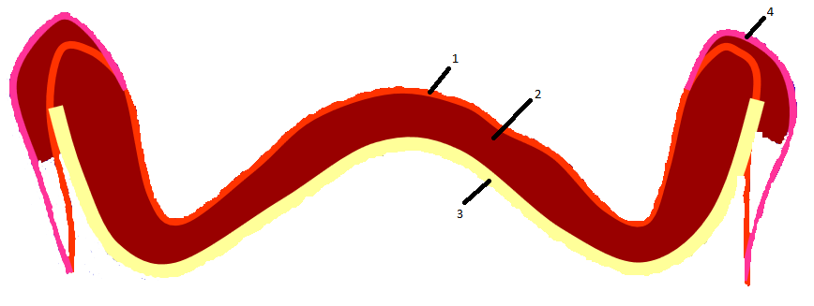
Yellow (3): tray, orange (1): palate, in between (2) the impression compound and the pink line (4) reflects the extent made by the impression compound. You can notice that impression compound will be overextended.
- In the lab we make special trays using light cured acrylic resin. And after that we make sth called border molding .

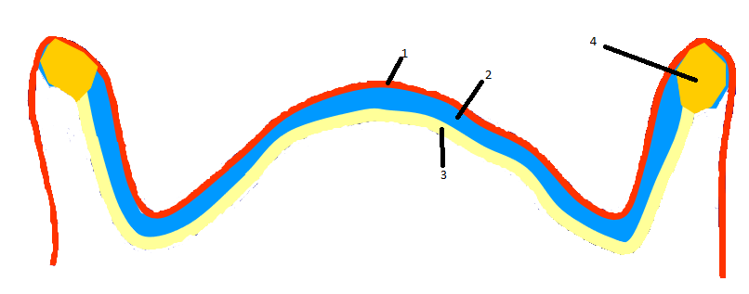
Orange (1): tissues, yellow (3): tray, in between (2) thin layer of Zn-O eugenol (secondary impression) and on borders dark yellow (4) color reflects green stick.
Factor that lead to prevent over extension :
- Special tray which is fit on patient mouth
- Metal that used ( low viscous)
- Border molding.
Thickness of ZNO eugenol is less than alginate , mailnly .5-1 mm foe ZNO EUgenol and 3 mm for alginate.
In second impression there are 2 tyoe of tray : closed fitting and space special tray
Alginate , silicone >> we should use space- special tray
ZNO euginol >> should use close fitting tray.
** the impression should match the oral cavity land mark .

** the graph: this graph shows the effect of pressure and the effect of compressing the tissues. When compressing tissues the thickness will change. if the tissues are subjected to pressure then after 10 minutes the thickness will be half of its original thickness, if we release the pressure delayed recovery will happen. That’s why if the patient is using a denture, we ask him not to use the denture at least for 72 hours before taking impression. so we can take the impression while the tissues are in relaxed position, and even at this stage there will be delayed recovery so it won’t return to its original thickness instead 80% of the original thickness. But if u keep the pressure to the last minute; the patient kept wearing the denture until he’s in the clinic then take it out to take the impression be sure the impression will be wrong because the tissues are not in relaxed position.
Impression techniques
There are different techniques that are associated with the material to be used.
- mucostatic : alginate ,impression plaster (no pressure )
- Mucocompressive : for example we use impression compound which compresses the tissues
- Selective mucocompressive: combination of materials, for example we have flabby anteriorly we don’t want to make pressure so anteriorly I use alginate or light body silicone and posteriorly I use compound. (mixed or combined)
How you can know if the impression will be mucostatic or mucocompressive?
**The amount of pressure depends on:
- Viscosity of the impression material. You can determine if the impression will be mucostatic or mucocompressive according to the viscosity of the material you take the impression with. High viscosity material will be used for mucocompressive.
- Distance to the escape way : impression material at full depth of sulcus . pressure will be less than pressure on the mid palate
- Closeness of the tray to the mucous membrane: There are 2 types of trays: close-fitting tray (no space between the tray and the cast; when u make the special tray u don’t leave any space between the cast and the tray and that’s called close-fitted special tray), if u put a layer of wax on the primary cast and then put the acrylic resin in this way you will get spaced special tray
** Reaction of mucous membrane to the pressure depends on: (will the pressure cause trauma to the tissues?) these factors determine the technique to be used
- Firmness of the mucous membrane. If the mucous membrane is firm then pressure will have no effect on it.
- Thickness of the mucous membrane. More thick mucous membrane means better dealing with pressure; thick mucous membrane will absorb the pressure.
- Availability of bone support. More bone support means that pressure will be tolerated.

** to produce a successful impression: To achieve a successful impression, the following concepts should be adhered to:
- The tissues of the mouth should be healthy.
- The impression should be suitable for the stage we are aiming to.
- The border must be in harmony with the anatomical and histological limitations of the oral structures. The material shouldn’t make over extension, for example you can use Zn-O.
- A physiological type of border-molding procedure should be performed by the dentist or by the patient under the guidance of the dentist. Border molding is very important to achieve good impression.
- Proper space for the selective impression material should be provided within the impression tray. The choice of the material and the space of the tray; we can’t use alginate for close-fitting tray because alginate is thick (if we want good details at least we need 2-3 mms) so we have to know the properties of the material to know how to deal with it to have good impression.
- Selective pressure should be placed on the basal seat during the making of the impression.
- The impression must be removed from the mouth without damage to the mucus membrane of the residual ridges.
- A guiding mechanism should be provided for correct positioning of the impression tray in the mouth.
- The tray and the impression material should be made of dimensionally stable materials.
- The external shape of the impression must be similar to the external form of the completed denture.

** l hope it benefit .
Ask me for any problem .

