***Festooning* :  
 is the process of carving the denture base to simulate the contour of the natural tissues surrounding the artificial teeth.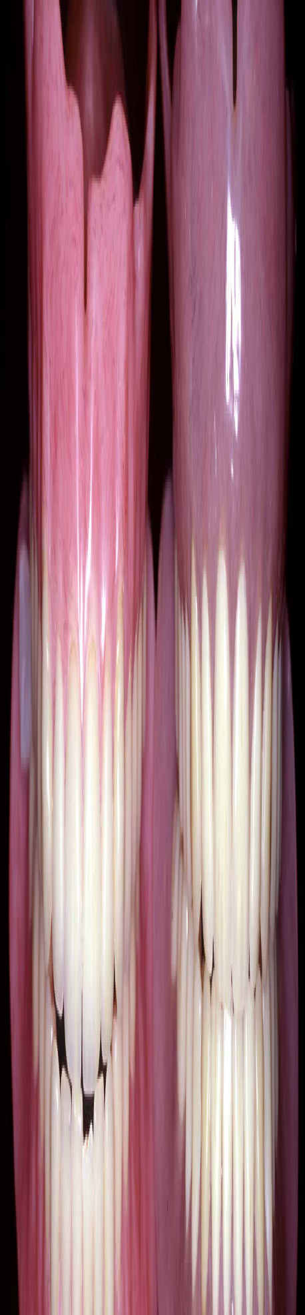 So, if you remember *we have three surfaces in the denture:* polish surface, occlusal surface and fitting surface..**  
**\*-we used the fitting surface to reproduce the master cast by the secondery impression ..  
*-occlusal surfaces we determined it by bite registration and adjustment of the wax rim then we made the sitting of the teeth accrodingly .  
*- part of the polish surface is done by the adjustment of the wax rim , buccal support and labial support , and other steps in the bite registration ..BUT most of it we will use it for festooning and this will be after the sitting of the teeth and before the denture try in .**

***Sheet no. :* 11**

Refer to slide no. : 1 "F**estooning"** * written by:***-** Maram abu ghazaleh  **  
 ** corrected by: rowa'a hamadneh

|  |
| --- |
| **so festooning is the process where we carve the "polish surface" to simulate the contours of the natural tissues surrounding the artificial teeth.** |

**\*- we have gingival margins , interdental papillae and around the root we have root eminences(projections) and between them there are depressions..  
so in festooning we will carve the wax around the tooth ..  
*- festooning should reproduce natural gum patterns around the teeth ..and smooth appearance..**  
  
  
- ***polish surface are determined by : (*The polish surface is divided into three parts: )**  
  
**1-width of the Borders (already determined when taking the secondary impression at the time of functional movements of the patient(border molding) to simulate the width and depth of the sulcus . So the width of the sulcus or the flanges was determined in the secondary impression stage.  
 .so we will not work on it .  
2- bucco-lingual position of the teeth : is part of the polish surface and its determined at the time of adjustment of the wax rim   
3- fullness of the wax and its** **curvatures buccally and lingually ..** **This part till now we didn't determine it.**  
  
 ***polished surface affect the :***-  
**1- aesthetic (#1 factor that affects the aesthetics that's why you have to try to compensate for the lost structures with appropriate aesthetics mimicking the natural appearance.)  
  
2- retention and stability of the denture: because part of retention depends on the muscular adaptation around the dentures .. if you don’t carve the width of the flanges and thickness of the polished surface appropriately; for example if you over supported the denture and the thickness was very large or if you reduced the space of the tongue and make it thick lingually, there will be no space for the tongue and every time the tongue moves the denture will also move. The same applies if the buccal fullness of the denture is exaggerated, the denture will not be stable and the border seal will be broken**

**. Part of the retention of the dentures is actually physiological through the adaptation of the muscles with the surfaces of the denture !!  
3- phonetics : (many of the letters depend on the palate surface ,** **mainly the thickness of the wax of the palate is very important to carve and the lingual flanges too ) ..**

|  |
| --- |
| **So ..Festooning stage is not only important for aesthetics but also for phonetics and for the stability and retention of the denture.** |

**\* Festooning is a purely clinical or technical step. The slides contain figures for the general technique and some important tips for the carving of the polished surfaces of the denture, but what we will do in the lab is actually the real scenario which might be a little bit different.**

* ***general practical steps in festooning :***  
-**contours are full (convex) buccally; but concave palatally and lingually   
1-..buccal wax above the first molar it should be vertical to concave  
2-the palatal area should be thin(minimal thickness) not compromising the strength of the denture at the same time because acrylic is weak and you can't make it too thin, otherwise the denture will break. Why? because the palate has minimal resorption ..and if made thick will affect speech .. ( so after extraction of teeth the resorption in the hard palate is** **actually minimal.)  
3- palatal area between canine and 1st premolars affects the escape of air so it should be slightly concave .if its carved too deep then sound "S" will be like sound "SH"..((Remember in the lab we left a space between the maxillary canine and premolar "primate space")**  
4- **The mandibular lingual surface should be as thin as possible but without touching the thickness of the borders which we determined during the functional movements of the tongue when we made the border molding (you asked the patient to move his tongue and by this way we mold the green stick in place then we took the secondary impression) .. so when carving the polished surface on the mandibular denture lingually you don't touch the thickness of the flanges (it's a prohibited area).. you have to make them as thin as possible to allow a space for the tongue to move easily.**   
  
  
***\* There are two parts that we are going to carve during festooning:***  
**\*\* the area of the polished surface around the teeth that are** **directly adjacent to the teeth -: its called the art portion (we will work on it )  
1-its purely esthetic(carve it to look more aesthetically pleasing for the patient because natural teeth look like this.)  
2-should be done with minimal carving because excessive carving dose not look natural ,dose not look nice and also accumulate food and it would be difficult to clean .  
  
**The other part is called the "anatomical portion" of the polish surface which is away from the teeth .. this part has functions rather than aesthetics such as phonetics ; stability and retention of the denture.**

|  |
| --- |
| * **- Around the teeth, called art portion of the polished surface, purely aesthetic, slight projection mimicking the root, but without excessive carving.** * **- The border part is called the anatomical portion and is shaped not to lose the original width of the impression** |

- **the basic technique is the same,*$  
*- add more wax then we cut back the excess wax >to Uniform the thickness around all the teeth .  
*-always you have to use Lacron carver and hold it with finger support at 45 degree to the tooth surface ..  
  
*- expose all the clinical crown of the teeth because it is better esthetically (clinical crown :the crown that is visible clinically because the gingival margin should be curve at the CEJ .so we cant see the anatomical crown that is below the CEJ)  
  
*-What you actually do is you add excessive wax and then you carve it back which is easier than to work on the already existing wax because it may be thicker on some teeth than the others. So you soften wax, add it then carve the excess together to be homogeneous and while carving you have to hold the Lacron carver or whatever instrument you are using (45 degrees) to the tooth to form the gingival margin. You have to expose all the clinical crowns of the teeth; naturally the gum doesn't cover the crown and it's a little bit above the cement-enamel junction, so for better aesthetics you have to expose all the clinical crowns. After that, draw triangles for the root eminences above the teeth and then carve the areas between the triangles and this will make the triangles prominent. Don't bring wax and add it only on the root area because it will be too prominent..Draw triangles and carve the areas in between.**

|  |
| --- |
| - **Excess wax is added to the labial and buccal surface along cervical collars of teeth, then cut back to the outer border of the cast, then the small end of wax knife is held at 45 to the tooth surface to form the gingival margin**  **Expose all clinical crowns (better aesthetics**- |

**\*- to make the root eminences visible ,we carve the depressions in between the roots to make them prominent with depressions less prominent .**

|  |
| --- |
| **(some dentists make eminences around the incisors but the doctor finds this not very acceptable because the root eminences for the upper incisor are not so prominent). If you start making the root eminences from the canine and go posteriorly, that's fine, and if you make root eminences for the incisors that's alright. Always do minimum carving; we don't want the roots to be very prominent because it's ugly and it collects food debris which causes plaque accumulation and hygiene will be very difficult.** |

**\*- you have to avoid forming undercuts especially in the lingual of the mandibular area because this will accumulate food ..**

|  |
| --- |
| **From inter-proximal area draw triangles for the roots, then carve the wax between these triangles, so that roots are emphasized, then round the triangles to make them less prominent.**  **- Avoid forming undercuts, especially lingual of mandibular, this will accumulate food** |

**\*-**   
**\*-There are instruments that you'll be using .. wax knife, Lacron carvers, stone knife, burs (for stippling of the gingiva later on), ready-made palate (sometimes if you want to make the palate thin as minimum as possible you can remove the palate which is already made in the temporary base that you have and stick this ready-made palate and use it as the final palate).*-*\*-the gingival margin should be smooth , rounded and nicely shaped.  
  
*- premolars and molars area: the gingival margin should be more oval than circular (anterior teeth are circular , posterior teeth are more oval )  
  
*- to create the inter dental papilla , you have to carve all excess wax away from the gingival margin by 2 mm ..!!  
  
*- to make the root eminence of the canine we draw two line(slightly convergent ) without sharp angles around the canine then remove all the excess wax ..you have to show these lines to make the projection**

|  |
| --- |
| **To clarify the technique more: First place a sheet of wax around all the teeth (note it's excessive covering part of the crowns) and then carve it all the way exposing all the clinical crowns. It will look like half circles around the teeth and slightly more oval around the molars. Not only the roots should be a little prominent, but also the marginal gingiva which is (2-3 mm) following the gingival margin. After carving down to the cement-enamel junction or whatever exposing the clinical crowns, draw a line 2-3 mm away from the gingival margin (it will be half circled around the incisors around the canines draw two slightly converging lines a little bit more triangular) then carve down the wax between the lines so that inside the lines will be prominent.  Carving should not leave sharp angles; it should be smooth and homogenous. You can also carve down in the inter-dental papilla and frenum area. Continue back in the molar area (gingival margin in premolars area is higher in level than the molars). Draw an oval area containing both molars of the maxilla and then carve all the wax away from the line to get prominent marginal gingiva around the teeth and you have to be careful not to make it too prominent, so you have to know the anatomy in order not to have excessive carving otherwise it will 1)accumulate food that will be difficult to clean and 2)it's not aesthetically pleasing.** |

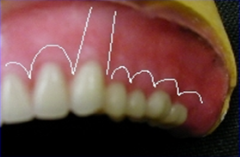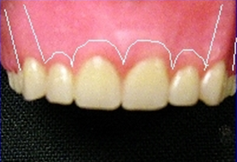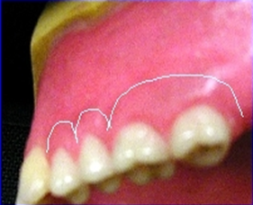  
*-**Carving the triangles** : its old technique that does not give the natural appearance..  
 **\*- you have to know the anatomy of the teeth ,for example the crown of the incisor is taller than lateral incisor ,so it appears at the different levels ..  
  
*- the margin of the canine is at the level of the central incisor *- the root of the canine is inclined distally   
  
*- The same applies for the mandible (half circles around the incisors, on the canines lines go distally, half circles around the premolars and molars).**  **\*- lingually in the lower denture we remove all excess wax ..but in the lab remove all the wax and only conserve what is around the teeth because the record base is already thick .  
  
*- palatally in the upper denture you remove all excess wax and hold the Lacron carver at the 45 degrees > draw the gingival margin >then expose the clinical crown palatally> remove the excess wax .**  
 ***\*- the transition between the teeth and the wax that holding the teeth on its places with the record base should be melted down to be smooth and as thin as possible..*  
  
*- we have preforme palate that has Rugae area and stippling that you can fuse it with the rest of the denture >>this will not be doing because it is really skillful technique!!**  
**\*- *any excess of wax that you don’t remove it will be transformed into acrylic , so its easy to remove any debris of wax rather than trimming* !  
  
*-- After finishing the festooning, clean all the wax on the teeth so as to make flasking and packing to have to have acrylic instead of wax.  
  
*-you can use dental floss to clean the area between the teeth to make sure that there is no wax !  
  
*- you can use brush to remove excess wax !**.. **You can also make slight stippling in gum!   
  
*- You have to try the dentures inside the patient's mouth (a purely clinical step). You have to check everything that has done in bite registration of wax rim, check the support, the position of incisors, incisal plane, occlusal plane, upper, lower, phonetics, patient's approval, occlusal and vertical dimensions, freeway space, horizontal relationship..** **Then you send the denture for processing in poly-methyl methacrylate**.(PMMA) **\*-But before you do this you have to make sure that the post dam area is carved properly in the cast. If your denture extends to the mobile surface of the soft palate, every time the soft palate moves (when breathing, talking and swallowing) the dentures will fall.  
*((Note: the hard palate is not compressible and not mobile but the soft palate is compressible and mobile ,,( the post dam area is carved to provide a posterior seal) !***

|  |
| --- |
| **So the denture must end before the movable part of the soft palate starts where we have a demarcating mark which is the vibrating line.** |

**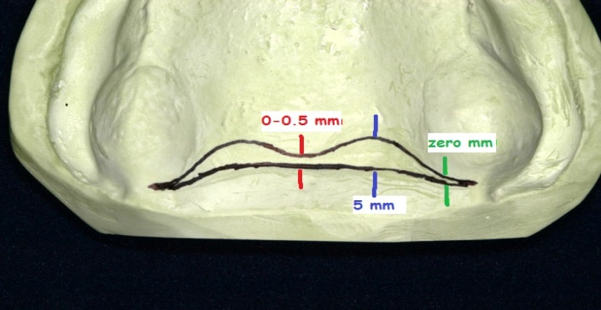  
* To locate the post dam inside the patients mouth:  
1- You can ask the patient to say a long "ah" and you can see the vibrating line (the part where the soft palate starts moving).  
2- Or you can ask the patient to close his nose and blow air so the soft palate will move.  
  
*- To locate the post dam area which has an average dimension that differs from one patient to another the best technique is to locate the vibrating line and then with palpation you can estimate roughly the depth and width of the post dam area. It looks like a butterfly . In the middle of the area the width is (0-0.5mm) and near the hamular notches it becomes zero.  
-The average maximum width of the post dam area which is located on each half of the palate might reach up to 5mm. Some patients have narrower width and others have wider width, so this is something you have to identify by using a burnisher and palpating the area anterior to the vibrating line and see how much the tip of the burnisher will sink (sometimes the whole part sinks and other times just small part).  
*- The depth is different; it's around (1.5 mm) and in the middle it becomes (0.5 or zero). And remember that this is average and it may differs from one patient to another, but generally it doesn't go more than 1.5 mm.** 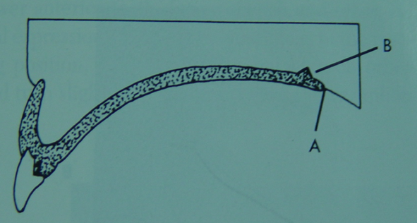

|  |
| --- |
| **\*- Actually this figure is not right. *-the part that is in the circle should be eliminated !** |

**\*-Maximum depth must be in the vibrating line and then sloping anteriorly. In other words: maximum depth you go is 1.5 mm vertical on the vibrating line and the anterior area sloping towards it and gradually it becomes zero anteriorly.   
 *\*-*** **Eventually you will have a step in the end of the denture which has more acrylic that compresses the denture at the post dam area at rest. This compressing should not be excessive so as not to have necrosis and stenosis of the tissues. By compressing this area what you achieve is negative pressure inside the denture, posterior seal and excellent retention. That's why sometimes when we make try in for the denture or during the adjustment of the wax rims we might feel that the denture is not retentive, it's fine if you have taken your impression properly because still you didn't carve the area of the post dam and still there is no step of the post dam on the fitting surface of the denture.**

**\*- We return the trialed dentures to the cast and then we soak them in water to facilitate the separation between the casts and the mounts of the articulator .The indices we carved before are used to relocate the casts on the mounts because later on we'll make laboratory remount and selective grinding, so we'll relocate the casts and the dentures after the processing on the articulator to do the adjustment of occlusion.**  
  
**\*- Separate them by tapping slightly on the cast. Then place the cast and the wax dentures inside the flasks to make molds.  
  
*- Flasks are usually brace. They have different shapes and sizes but normally we have standard and minimum dimensions.  
It has two halves: upper and lower. It also has a cover or lid.  
 *\* So the basic parts of the flask are*:**  
**1) upper half.  
2) lower half.  
3) cover (lid).**  
  
**\*- Keep the denture on the master cast and place it inside the lower half of the flask and there has to be some space around the cast to make mold around it. Make sure that in the area between the distal ends of the lower cast and the rims of the flask there is no undercuts so as not to trap the mold and to be able to remove the cast from the flask later on.**  
 **\*- Place the second half (upper half) of the flask. Rims should be in intimate contact and there should be a space of (3-6 mm) above the occlusal table of the teeth because we will put the third pour of stone and it has to cover the occlusal surfaces of the teeth.  
*-If there is no space this means that your cast is thick and you have to trim the base of the master cast.  
  
*- Coat the flask with a separating medium (e.g.: Vaseline) and coat the casts and wax dentures too.  
  
*- The position of the teeth is determined before and the fitting surface of the denture is also determined by the cast, so now the final step in the production of the denture is about replacing the temporary base and the wax which is around the teeth by poly methyl methacrylate (heat cured poly methyl methacrylate).**  
  
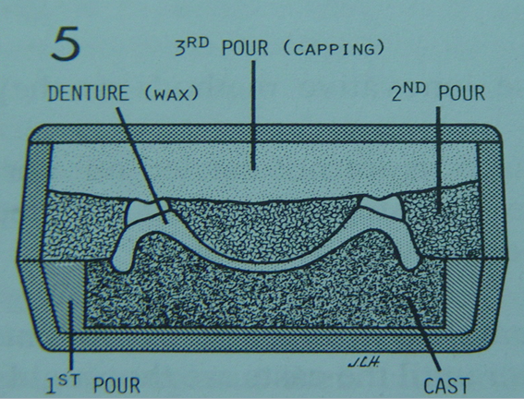**\*- After placing the cast and the trialed wax dentures inside the flasks, create a mold of three layers of plaster and stone around the teeth. When the stone dries, open the flask..teeth will be fixed in the upper part and the cast fixed in the lower part of the flask. Then make wax elimination and removal of temporary base, add acrylic, process it and let it cure.**  
**\*- Basically, we need a mold around the denture to hold the cast and the teeth in place while replacing the temporary base with heat cure poly-methyl methacrylate. We will make three pours around the cast and teeth. First pour will be made of pure plaster to be easily separated from the master cast, we need it only to hold the cast on the lower half of the flask   
  
(in the slides the first pour is made of stone but it must be of plaster because it's weaker and easier to be separated from the master cast)  
  
  
  
*- Pour the plaster and make sure that the level of the land area of the cast is flushed with the level of the pour (which is made purely of plaster of paris) and with the rim of the lower half of the flask.  
  
*- Tongue area should be smooth and filled with plaster too.  
  
*- After the first pour dries, apply a layer of separating medium, mix the second pour which is 50% plaster + 50% stone, then place the second half of the flask and add the second pour which should cover all the surfaces of the denture and the cast "except" the incisal edges of the anterior teeth and the cusp tips of the posterior teeth.  
(in the slides the cusp tips of the posteriors are not visible but they should be visible)..  
  
*- After the second pour dries, add a separating medium and then add the third pour which is made of pure stone (very accurate material), then cover it with the lid of the flask. The third pour should be stone because it surrounds the most important parts of the occlusal table (incisal edges and cusp tips).  
  
*- After the third pour is set, place the flask in boiling water for 4-6 minutes, this will soften the wax around the teeth (and if the temporary base is made of wax it will also be soften). We don't want the wax to evaporate, just to melt and be soft.  
  
*- Take the flask out of the boiling water and open it.  
  
  
*- The lower part of the flask contains the first pour and the master cast fixed in it. In the upper part, teeth are tightly fixed in their exact position we made during the setting of teeth . the temporary base is made of wax or some other material (e.g. chalk).  
  
*- Remove all the wax and clean the cast and the flask.  
*- Dry it. You can also brush it; teeth are fixed in their place and will not move.**

|  |
| --- |
| **- *The upper part of the flask contains the teeth. - The lower part of the flask contains the cast.*** |

**\*-Now if we place the upper part on the lower part of the flask !!**

**We will get a space which contains the temporary base & the wax space which will be packed with acrylic later on to produce the final denture base keeping the teeth in their place & the exact relationship correct .  
*- Add a separating medium because we don't want the acrylic to stick on the cast and to facilitate the separation of the denture later on.  
  
Actually, the cast will break while separating the denture but in spite of that it is recommended to use a separating medium. Apply two layers of the separating medium on all the surfaces of the pours and the cast "except" around the teeth because we want the denture base to stick to the teeth  
  
*- If you are using acrylic teeth with acrylic base, there will be some kind of chemical bonding between them. If you're using porcelain teeth or if the base was made of a material other than acrylic (poly-methyl methacrylate), the chemical bond will not be achieved, so you have to do some mechanical retention. Even with acrylic teeth and acrylic base you can enhance the retention and the chemical bond by making some grooves on the exposed part of the teeth which will be covered with the denture base.  
   
  
Now it's ready for the next lecture which is about packing ! =D**