This lecture will be about obturators and it's considered part of maxillofacial prosthesis.
It's defined as Prosthetic appliance constructed to be used intraorally, to replace congenital or acquired missing part in the palate.
*Disadvantages or problems of them:
- Bulky; a part of the prosthesis will enter inside the defect part to close it.
- Frequent adjustment; in acquired defect, frequent surgeries sometimes are needed followed by frequent modifications to that appliance due to tissue changes.
- Crusting of the defect; because the appliance may exhibit pressure on the peripheral defect area .
- Psychological (reminder of cancer );in case of acquired defect like cancer in the palate , as the patient wear it and remove it he remember that he has cancer , he's not able to forget .
*Classification of obturators:
According to the origin they are classified into:
1-for acquired defect 2-for congenital defects
Why we construct obturators? To close the defects and to restore the palatal form ;the most important thing of restoring the palate is :
- to return the pronunciations (speech )
- helps in mastication (the movement of the tongue against the palate helps in mastication, formation of food bolus and swallowing )
- Sometimes we can gain support from that part.

*Classification of the obturators according to the location of the defect ; it can be labial or buccal , hard palate or soft palate defect , uvula , or pharyngeal defects.
Congenital defects are either cleft lip and palate; cleft in uvula, soft palate , hard palate , and in cases reaching the lip.
The cleft could be unilateral or bilateral. And that obturators will seal the defect wherever it is
(picture for the obturator ) with pharyngeal part , when the patient breathe it allow the passage of air down and when the pt eat , it doesn't allow the food to go up to the nasopharynx.

There are 3 main types of obturators of acquired defects:
- Immediate or surgical
- Interim or transitional
- Definitive or final obturators
Immediate or surgical obturators
This type is fabricated before the surgery, a contact is done between the surgeon and prosthodontist about the case, once the surgery is finished, insertion of the obturator is took place.
(we take primary impression. With help of surgeon , we determine the area of resection and its borders, we mark it on the cast , we don’t trim the cast at that area, because the aim now is only to separate the nasal cavity from the oral cavity so we take the exact shape of the original palate that the patient still already has.
***If there's congenital defect in uvula, we construct obturator for it, but if the posterior defect is acquired, we don’t close it by immediate but in palate area we do immediate …
***we don’t put teeth in the defect area except in the anterior region for esthetics , and that teeth should be out of occlusion in order not to exert load to the surgical area.
*why do we make immediate obturators :
- Maintain the function : there it is appreciated when the patient is coming out from surgery with lost part of palate but with retained function .
- Hygienic : separation between the oral cavity ( surgery area)and the nasal cavity which contains many types of bacteria will help to preserve good clean and healthy tissue.
- Psychological : when the patient can't accept himself with lost part inside his mouth.
*Advantages of immediate obturators :
1-Close the defect .
2- Aid in mastication and speech.
3-Retain palatal form and normal appearance (when the defect including all the palate and part of the alveolar ridge which will compromise the soft tissue support –cheeks and lip- and so , compromised appearance ).
4-Recovery time becomes faster due to absence of contamination.

Sometimes we do skin graft, that doesn’t mean we close the cavity with graft , instead we line the cavity with that graft because when we remove large part and put graft , it won't take the normal shape of the palate, or with function it could be separated .

*Advantages of skin graft versus not using graft :
- Creating lateral wall which will engage the prosthesis.
- Facilitate the retention.
- Help in support.
- More flexible than tissues produced by spontaneous recovery.
There were two cavities with the same classification, one lined by skin graft and the other left to heal by itself. With graft ,the opening is smaller , scar band is keratinized and gives support , makes undercut that can be engaged by the prosthesis and gain retention , tissues are able to accept larger force so better stability. As we said that teeth should be out of occlusion in order not to disturb the healing process. The immediate prosthesis should be worn 7-10 days until healing is taking place
Interim or transitional obturators :
They can last for few weeks to months according to patient case , we should take record for the patient , inspect and monitor the cavity until it becomes stable then we can move to definitive one.
It should be worn for 2-4 weeks usually , the doctor evaluate the case if needed to be worn more or not , some patients keep wearing it and refuse to change it, but ideally for 2-4 weeks after surgery.
Impression making :
We can use putty to support the upcoming light body , or any relatively rigid material , so we have 2 options : *either putty and then light body which will give me fine details , * or we put compound at the area that we inspect the defect and that will cover the defect in large area then we take alginate wash ; we can't take it all alginate because it's not supported and has high tearing probability, we can't remove it from the defect area , and it has more dimensional instability.
We take the impression and close the undercut with leaving some to use it as sort of retention. We make heat cured base as the final base ,then jaw relation , try in and insertion .we try to preserve the teeth , if we put a wrought wire clasp we will face many problems; *since it's supported by soft tissue , it can make stripping to the gum. *it leads to MOVEMENT for the tooth since there is no bracing for it. When we have a patient with deep sulcus and undercut , we gain retention by ACRYLIC WING and we spare the teeth for rests or any component in the final prosthesis.
Teeth in transitional obturator are in occlusion because we need function now (out of occlusion only in immediate )
There was a picture of obturator which has labial wing of acrylic plus clasps , because in that prosthesis we need more retention than the ordinary RPD due to its bulkiness (heavy ) and the supporting tissues are compressible that's why we need more retention.
This patient is feeling comfortable with his transitional one which was fabricated 10 years ago but he need periodic monitoring , relining for the defect area .this kind of patients usually hate frequent visits to hospital , so they got adapted to their prosthesis.
Definitive obturators :
Ideally Co-Cr or titanium which is lighter and helps in that cases.
*Design : since we can make Co-Cr ,should we rely on Kennedy classification for the design ?
Any prosthesis inside the patient mouth needs support , retention and stability from the oral cavity . same principles here but it's more difficult to find sources to give me that 3 .. sometimes the patient have fewer number of teeth left in his mouth
We begin with the patient like any other RPD ; perio treatment , restorations , crowns if needed…etc
We take Aramany classification ;that's what we should depend on for designs . there are class 1, 2, 3, 4, 5, and 6.
We determine the design for each case according to its condition , but we should preserve the main principles like : major connector should be rigid , the occlusal rests should transfer the forces along the long axis of the tooth , the guiding planes should aid in bracing and stability , retention should be within the physiological limits ; means that
1* when the tip of the clasp is engaging the maximum bulkiness, the reciprocal arm should be contacting the tooth at the same time, to prevent any tooth movement .
2*according to the material used to engage the undercut ;gold and wrought wire need deep undercut , Co-Cr needs .025cm undercut .if we use Co-Cr and insert it in deeper undercut that will affect the periodontal health.
3*when there is no function, the clasp should be passive , no load exerted on the tooth.

***Class I : one side only not crossing the midline ;the design will be linear or tripodal .
Linear means that all remaining teeth should receive rest and clasps .
we determine the proper design according to : *remaining teeth and *size of the defect (if the size is big we should go for linear ), when there are 3 teeth are missing we can go for tripodal. *The configuration of the arch also affect the choice .
***Class II :not crossing the midline , almost like Kennedy class II
**Design : like class II ; we need RPI system on the abutment , we need indirect retainer and clasp on the other side .
***Class III : quadrilateral distribution .. all teeth are present and the defect is in the palate .
***Class IV : both sides are affected , no choice except linear design (all teeth should receive rests and clasps) .. in some cases we need to put clasps to gain retention on molars buccally and on the adjacent premolars lingually to achieve stability in the design.
***Class V : shape and design are like 1 Kennedy (bilateral free end saddle area )
***Class VI : like class IV Kennedy (unilateral crossing the midline ) , not very common to have cancer or surgery in that anterior area , usually it presents due to trauma.
There was a picture with very large defect , reaching the floor of the orbit ,they made for that defect hollow obturator (the part of prosthesis that will enter in the defect area was hollow not solid) because if it was solid it would be heavy .the technician made it by putting a line then filling with sugar or salt and cover that line .after completion of processing ,they made 2 holes ,fill it with water so all salt or sugar are washed out then that 2 holes are closed using cold cure acrylic.
The dr. showed some pictures Of multiple cases
There was patient with shrinkage in lower lip and limited mouth opening and the upper teeth were occluding on the lower lip and made a scar on that lower lip. No tray could be inserted so the dr. used putty and adapted it on the lower teeth ,then she used the putty as tray and put light body wash to capture fine details . The prosthesis was made with addition of acrylic labially to give proper support to the lower lip.
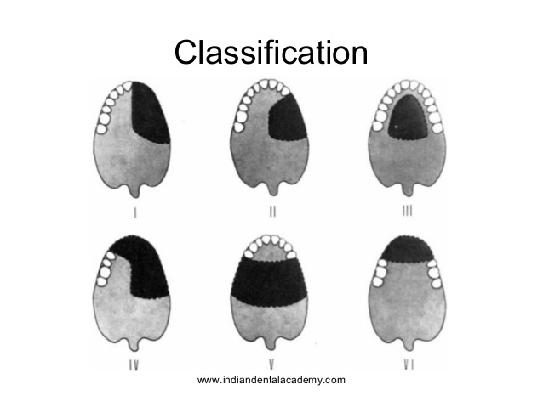

Best of luck For you Colleagues…
20 DAYS LEFT TO BE
DOCTORS NSHALLA
=) =) =)

