Sheet no. : 4
Refer to slides no. : 2 for Dr.Heyam
Written and corrected by: Eathar Usama and Ayyan Abu Hawash
Head and Neck Pathology
“Diseases of The Salivary Glands”
We have three major salivary glands and numerous minor salivary glands, the major ones are:
1.Parotid.
2.Sublingual.
3.Submandibular.
Minor salivary glands throughout oral mucosa.
The salivary glands’ function is production of saliva, which has to do with the digestion process. The enzyme present in saliva is Amylase.
Diseases that can affect the salivary glands are divided into:
A. Inflammatory diseases
B. Neoplastic diseases
Before discussing diseases we need to know the term “Xerostomia”:
- Dry mouth due to decreased saliva, also tongue papillae are lost, because of this
sometimes it might be associated with fissuring and ulceration in the tongue.
- It’s not a disease, it’s a symptom that indicates the presence of a disease and an
underlying cause.
- It affects about 20% of population over 70 years of age.
- If we have a patient with Xerostomia we need to know the cause.
- It has many causes: (Dehydration)
1. Diseases in salivary glands, in which it doesn’t secrete enough saliva; like
Sjogren’s syndrome.
2. Radiotherapy, if there’s irradiation in the area, salivary glands would be
affected.
3. Drugs, a lot of drugs cause Xerostomia like diuretics (because they lead to
dehydration), antihypertensive drugs, analgesics and loads of other drugs.
-Xerostomia clinical features:
1.Dry mouth.
2.Atrophy of tongue papillae.
3.Fissuring. A tongue with dryness and fissuring is called ‘geographical tongue’.
4.Ulceration as a complication.
-Xerostomia can cause the following complications:
1.Dental caries; bacterial accumulation.
2.Candida; fungal infections.
3.Difficulty in swallowing and speaking, which is evident with fasting.
A.The inflammatory lesions that can affect the salivary glands
Sialadenitis: inflammation of the salivary glands.
-infections can cause inflammation but anything that causes injury will end up with
an inflammation.
-Some of the causes are:
1. Trauma
2. Viruses
3. Bacteria
4. Autoimmune diseases
2)Viral Sialadenitis ‘Mumps’
‘Mumps’ is the most common viral Sialadenitis, it can affect any gland but mainly the parotid gland so it becomes enlarged due to inflammation so;
Viral infection Inflammation Enlargement of the salivary gland.
-Enlargement occurs due to production of mononuclear inflammatory
cells/interstitial chronic inflammatory cells; mainly lymphocytes and plasma cells.
-It’s a paramyxovirus (a genera of a family of viruses containing mumps,
influenza viruses…etc.).
-Chronic inflammation: an inflammation that persists for a long period of time.
Chronic inflammatory cells: any inflammatory cell other than neutrophils
(like lymphocyte, plasma cell, eosinophil, macrophage, mast cell…etc.)
-Mumps is NOT a chronic inflammation although the predominant cells are the
mononuclear cells/chronic inflammatory cells.
-It’s self-limited in children.
If it affects adults it becomes more complicated and serious, and it might be
complicated by pancreatitis or orchitis, and orchitis in turn can cause sterility.
So, mumps is a minor disease in children but it’s considered as a major one in
adults.
-Mumps has a vaccine called MMR (the triple vaccine; Measles, Mumps and Rubella), so if we find a patient with a swelling we can ask if she/he had received the MMR childhood vaccine.
It depends on the age. Now most of the people take this vaccine. The WHO trend is to take two doses of measles, either as one dose of measles and one dose of MMR and this is applied in Jordan, or as two doses of MMR. Some people give one dose of MMR, it’s enough for mumps and Rubella but not enough for measles.
Mumps outbreaks have arisen in the UK because of Wakefield’s research; an unethical research that was done by a British doctor stating that MMR can cause autism, so people stopped giving their children MMR vaccine.
3)Bacterial Sialadenitis affects mainly the submandibular gland. The submandibular gland is smaller and its ducts are narrower than the parotid gland’s, that’s why it’s easier for bacteria to block it.
-Many bacteria can cause it like Staph. aureus and Strep. viridans.
-There must be predisposing factors for bacterial Sialadenitis to appear like:
a.Sialolithiasis: stones affecting any salivary gland. If there is a stone in a
salivary gland duct, accumulation of saliva takes place, this provides a good
medium for bacteria to grow leading to bacterial infection.
b.Impacted food or impacted debris cause obstruction of ducts, any
obstruction leads to accumulation of saliva providing a good medium for
bacterial growth.
c.Injury.
d.Decreased saliva (Xerostomia).
4)Autoimmune Sialadentitis = Sjogren’s syndrome
-Sjogren’s syndrome: is an autoimmune disease causes destruction of the lacrimal and salivary glands by immune mechanisms, when destructed they will stop secreting their secretions leading to dry mouth and dry eyes, this is the underlying mechanism of this syndrome.
-Most of the autoimmune diseases come in association, i.e. when someone has an autoimmune disease he has a predisposition to it, they usually come in groups, an example is when a patient has sialadenitis, diabetes, rheumatoid arthritis and
systemic lupus erythematosus (SLE) at the same time.
-We have 40% chance that the patient has Sjogren’s syndrome alone, and 60% chance of association with other autoimmune diseases, like SLE, scleroderma and most commonly rheumatoid arthritis, so if a patient came with a dry mouth and eyes we ask if he has features of rheumatoid arthritis.
Another inflammatory lesion is
Mucocele: (Muco:mucus and Cele:cyst) which means: a cyst containing mucus.
*It’s the most common inflammatory lesion of the salivary glands.
-Mucocele arises due to blockage or rupture of a salivary gland duct, if ruptured it will be dilated like a cyst containing saliva and inflammatory cells, and the most available inflammatory cells inside these cysts are macrophages, which act in the presence of a foreign body. Leakage of saliva into surrounding connective tissue stroma takes place.
-It affects mainly the lower lip because it’s a minor salivary gland and its ducts are very tiny and easy to rupture or block leading to accumulation forming a mass or “a fluctuant swelling”. Fluctuant; because the cyst contains fluid.
-{Slide no.17} The figure shows how it looks under the microscope:
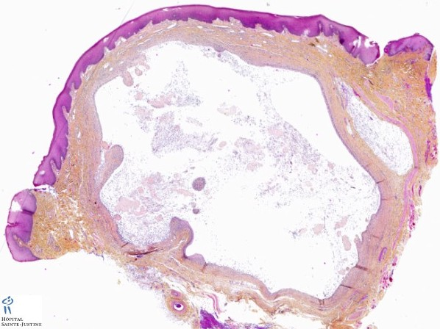
A cyst containing fluid (represented by the white space; because when we examine a histological section under the microscope using chemical materials like stains, fluids will be lost so they appear as a space) and few inflammatory cells mainly macrophages trying to engulf the accumulated saliva.
B.Neoplasms that affect the salivary glands:
-Salivary glands have so many types of neoplasms, around 30 benign and malignant ones, it has the highest variance in tumors among other human body parts.
-Less than 2% of all human malignancies or tumors are of the salivary glands, so they are really rare, that’s why a patient with a swollen parotid gland is more likely to be affected by mumps than by a neoplasm.
-65-80% of tumors arise in the parotid gland, 10% in the submandibular gland and the rest arise in the sublingual and minor salivary glands.
So the bigger the size of a gland, the greater the chance for it to develop a neoplasm.
-When it comes to malignancy, the smaller the size of a gland, the higher the malignancy possibility (except for minor salivary glands tumors):
if a tumor is present in the parotid gland there’s a 15-30% chance for it to be malignant, so the majority is benign.
40% chance for submandibular tumors to be malignant.
70-90% chance for sublingual tumors to be malignant, which is the most dangerous.
Minor salivary glands tumors have a 50% chance of malignancy (an exception. They’re the smallest but their malignancy is not the highest).
*Note: sadly, you have to memorize the percentages mentioned above.
We only need to know about two tumors out of thirty; the most common benign tumor and the most common malignant one:
Pleomorphic adenoma
(Pleomorphic: has variable forms or shapes.
Adenoma: a benign neoplasm that either looks like epithelial cells or originates
from epithelial cells).
* It’s the most common benign tumor of salivary glands, and the most common
tumor of both benign and malignant salivary glands’ tumors.
- The patient comes with a painless tumor that is slow growing and mobile with a
swelling (mumps is painful unlike this tumor). Usually benign tumors are soft
whereas malignant ones are hard; because of the infiltration process.
- Pleomorphic adenoma mainly arises in the parotid gland, but it also affects other
glands.
- Its macroscopic features:
When a surgeon resects a tumor of this kind, its cut surface is:
1.Grey-white in color.
2.Rounded and well-demarcated masses, meaning that we can draw a line
surrounding the tumor.
3.Rubbery.
4.Surrounded by a capsule even if it was a thin or incontinuous one but there is a
capsule.
- Its histological features:
It has a pleomorphic histology; it’s a mixture of epithelial cells and myoepithelial cells swimming in a stroma, this stroma might be hyaline, myxoid and even sometimes bony stroma.
**Q: Pleomorphic adenoma is a mixture of epithelial and mesenchymal (myxoid) elements, the ratio between these elements varies from one tumor to another, does this affect the tumor’s behavior?
NO, it does not. Despite the ratio of histological elements, all tumors in pleomorphic adenoma behave the same. For example: if it was all made of epithelial element or all made of mesenchymal element, in both cases it will have the exact same biological behavior.
Q: If a tumor has more epithelial element, does it have a higher chance of recurrence?
No, the biological behavior is exactly the same.
{slide no.25} In the following histological section, the nests in between are a mixture of epithelial & myoepithelial cells swimming in blue myxo-chondroid stroma (chondroid: cartilage). It undergoes cartilaginous differentiation and maybe some bony differentiation.
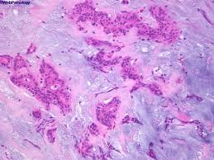
{Slide no.26} Here in the following figure you can see some cells with an obvious nucleus, these are cartilage cells (chondroblasts).
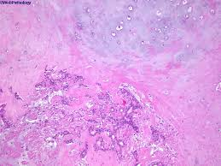
So its name "pleomorphic" is derived from its histological features, it has a
mixture of epithelial and myoepithelial elements swimming in a hyaline, myxiod
or bony stroma (with ossification).
- Treatment: complete surgical excision.
We remove the tumor even if it is benign; because it might become malignant.
- Can recur if not well-excised. The tumor should be excised with the surrounding margins providing safety margin. If a surgeon is doing the excision procedure and wants to make sure that he has removed everything, he can send a ‘frozen section’ to a laboratory during the surgery.
Although benign tumors can be easily inoculated, we need to do excision, because under microscope we find very small extensions that may lead to recurrence.
- If the surgeon applies inoculation only, there’s a 25% chance of recurrence, but when wide resection is done, there is only a 4% chance of recurrence.
- The problem with pleomorphic adenoma is that although it’s a benign tumor, it can recur or transform to a malignant one. If the tumor was left for 15 years without treatment there is a 10% chance of transformation. It transforms to highly malignant tumors or very aggressive neoplasms; either to ‘adenocarcinoma’ or ‘undifferentiated carcinoma’ they're very aggressive with a less than 40% survival chance if present in salivary glands.

Mucoepidermoid Carcinoma
(Muco: mucus columnar mucin producing cells that produce mucus.
Epidermoid: epidermis squamous cells.
So it's a mixture of squamous, columnar epithelium and intermediate cells in between).
* It’s the most common malignant tumor of the salivary glands.
- It arises mainly in the parotid gland, like pleomorphic adenoma.
- Constitutes 15% of all salivary gland tumors.

- Its macroscopic features/Grossly:
1.Hard.
2.Infiltrative.
- Its microscopic elements/Histologically:
1.Squamous elements.
2.Mucus elements.
3.Intermediate cells.
-Any malignancy is divided into high, low and intermediate grades according to its
differentiation:
Low grade: it’ll invade locally and recur in 15% of the cases and rarely
metastasize. The problem here is with recurrence more than it’s with metastasis.
High grade: recurs in 25% of cases and only 50% chance of 5 year survival.
-{Slide no.30} Histological view:
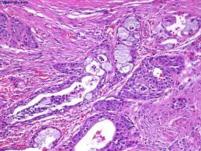
Squamous cells, mucus secreting cells (the white spaces) and on a higher power we notice some cells with features of both squamous and mucus secreting cells.
Best Wishes

