Sheet #1
Written by:Asma Al-Abbadi
Corrected by: Khitam AL-Daoudeyeh

Comprehensive overview in radiology
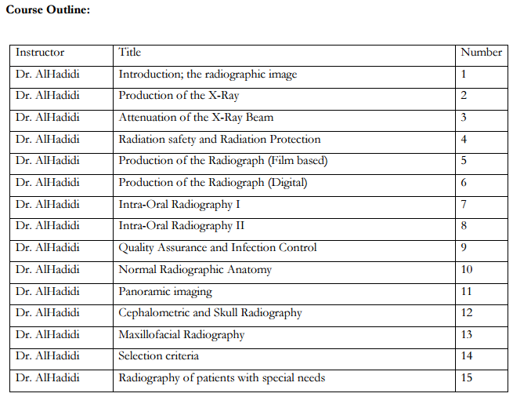

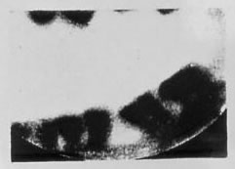
Development of Dental Radiology :
first bitewing

-first intra-oral radiographic picture & it was in same year that X-rays were discovered

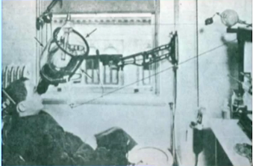
-first radiographs problems were the high voltage wires all around which might harm the patient more than the X-rays itself !

Intra-oral radiographs are small pictures ofstructures in the oral cavity which is a very small, confined and sensitive place with certain anatomy , so you can’t simply use a large film & put it where ever you want , so small radiographs must be used correctly to get good pictures showing the anatomy of the whole tooth that you want see , with the tissue and bone around it.
The angles for taking these radiographs , and the exact place of the x-ray film are the major factors affecting the quality of the radiographic pictures and these factors are called geometry
#better bitewing
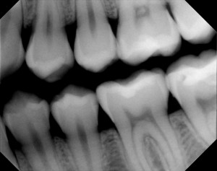

#Panoramic imaging : are extra-oral imaging, so it’s not confined in a small place , and more comprehensive ,showing more structures of both arches and the adjacent tissue in one image , technically the machine spin around the persons head to take the image , with certain physics for this motion.
* when it was first invented , the patients were spinning not the machine !!

Types of Intra-oral radiographs ..
-Periapical radiographs : which shows the apex and the surrounding structures

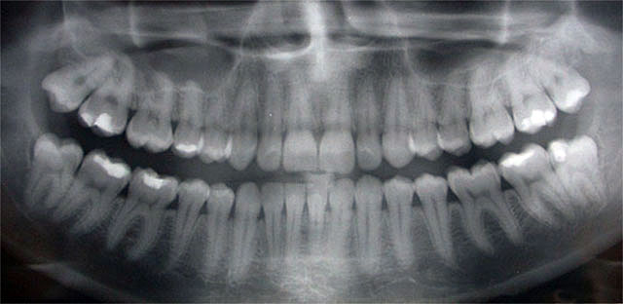
-Bitewing radiographs : which shows maxillary & mandibular teeth in the same picture &to take it the patient must bite on sth , & from here comes its name.

Types of Extra-oral radiographs ..

-Panoramic radiographs

-Cephalometric radiographs: Wider field of view
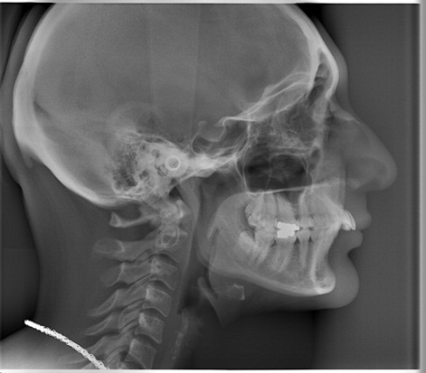

Later on… the 3rd dimension became necessary for surgical objectives , teeth planting and TMJ problems .. so new types were invented ..
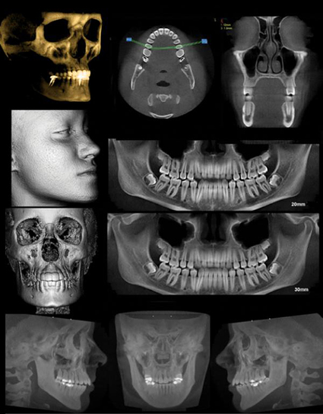
-Cone beam CT :a Low dose machine that gives 3 dimensional pictures .

Starting with the basics ..
it’s all about the nucleus & the electrons around it .. the atoms is the start of all the physics here , it determines the type of radiation , the different types of x-ray production , the machines of dental x-ray and their components , the types of elements that x-ray tubes are made of ,things that affect the x-ray beam and so indirectly the quality of the radiographic image ...

Interaction with matteris very important because it determines two things:
- The quality of the image
- The damaging effect of the radiations on the human’s body

All these things will help us to:
-understand the physical principle of how X-ray images are formed.
-be able to troubleshoot quality problems. (& this is the main objective).
-understand the technology of the current system and provide background for the new system in the future .

X-ray production starts with the X-Ray Tube which is an aiming device used to take the radiographic picture after you place the small film inside the patient’s mouth .
Inside this tube x-rays (the electromagnetic radiation) are produced .

The effect of radiation on the health of the patients & the Dentists :
This can be discussed based on the Natural Background of radiation i.e. we in general, just by living our natural life, are exposed to certain level of radiation , & in some areas of the world the level is higher than in the rest , such as in India , Colorado… because the level of Radon in the soil is higher.

We’ll start the with the Atom ..
a nucleus with electrons around it , in special orbits, each orbit have a certain energy & patency for a certain number of electrons.
This arrangement is what makes the atom stable , and X-rays production is all about making the atoms unstable to force it to return to its stable arrangement, so it depends on energy & energy levels .
Types Of Radiation , depending on the mass of what carries the energy.
- Particulate Radiation : particles with complete masses.
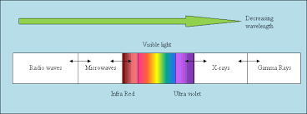
α,β, Proton & neutron,, they are outside the typical maxillofacial diagnostic radiation & more in nuclear medicine and other things we will learn in our 5th year.

- Electromagnetic Radiation : act more as a wave .
-This is what we need to care about right now –
They act as wave which mean that they as any wave must have Wave length &Energy with an inverse relationship between them; shorter waves are associated with more energy, just like the X-rays .

So energy = constant / λ

Another way to classify the radiation is from the patient’s point of view :
- Ionizing : electromagnetic or particulate radiations that are capable of interacting with atoms causing the removal of one or more electrons producing ions ,they change the stable state of the atoms in cells or in DNA ….etc
- Nonionizing

How do X-ray Tubes produce X-rays ?
“two similarly charged ions recoil” that is simply what x-rays production based on !
- “Bremsstrahlung”Radiation : the most common in diagnostic radiology.
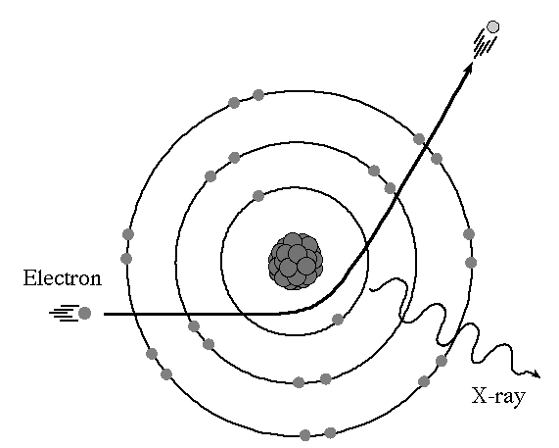
A German word which means braking radiation, Just like a very fast care that suddenly Press down the brake !
An electron from the tube attacks an atom somewhere else in the tube , then electrons begin to recoil which will make a change in the kinetic energy & the direction of the electronaffected by friction forces ,, & then net will come out as x-rays.
- “Characteristic” Radiation:
The electron have a characteristic energy which is exactly equal to the energy of the orbit of electron that I want so it’sjust enough to knock out an inner shell electron , , making the atom unstable
, and outer shell electrons will shift to a closer orbits to fill the place of the missing electron that have been knocked out , in their way they will lose energy in the form of X-Ray.
This type of X-ray will come out also with a characteristic energy equals to the difference between the two orbits’ energies (outer & inner shell orbits)
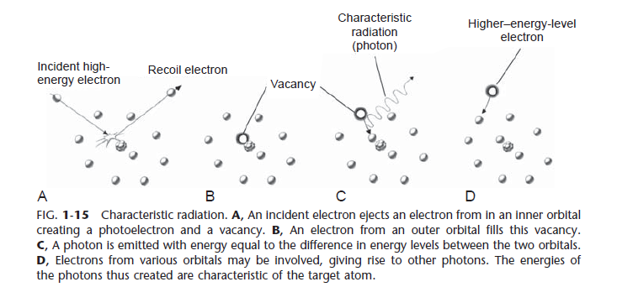

So Bremsstrahlung Radiation are a little more Randomcause the friction force will differ depending on the number of electrons around the atom.
also the energy is not characteristic depending on the energy of the electron and the atom itself, So it might be enough to take the electron all the way to the inner shell or it might be just enough to take it the outer shell.

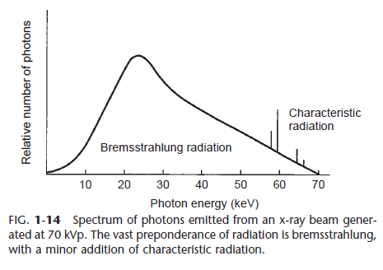
Bremsstrahlung Radiation is a continues spectrum cause it’s a statistical event i.e. no one know the exact minimum or maximum energy! , we can just guess the mean, whereas the characteristicRadiation is a well-known event that we know its exact energy .
Bremsstrahlung it’s the most common x-ray in the diagnostic radiology NOT the characteristic one.

