Radiology sheet 7
Done by: Tala Ghishan
Corrected by: Leen Musharbash
-Last time we were talking about resolution, about what is the real practical difference between 600dpi, 300dpi,150dpi and we saw at the end of the spectrum that there might be some differences but as long as you are within workable limits which is 300 dpi you are as good as 600.
-Is there a difference between PSP plate and solid state device (CCD)? The literature says there is not a lot of differences eventhough the resolution of a CCD is higher that resolution of PSP but in reality as we said there is no major difference.
-Now is there a difference between image quality of film and a PSP? Theoretically speaking the resolution is determined by focal spot of the machine and pixel size of the receptor, now what's the pixel size of the film? Silver and there's is nothing smaller than silver so theoretically speaking the film image is supposed to have a better image quality. But in the end as we said the weaker link is our eyes, the film is way too good for our eyes.
- In all of the situations above we are assuming that we are taking the image ideally but what if something goes wrong in the film image (too dark or too white…) what do I do ? I shall repeat the image since there is nothing that can be done, but this is not the case in digital imaging because it can do something known as decoupling, meaning that usually the process and end product are coupled to each other but in here we are decoupling them, not to infinity but we are increasing the margin of error by being able to play with contrast/brightness/filters.
-Note: Remember that shades of grey are made up of number that can be added up or subtracted or even multiplied. If you apply the same for all the numbers it will give you a specific result and if you apply 15% for the top values it will give something else to the image.
- Concerning brightness you are adding up or subtracting ALL values, so the peak will be shifting to the left or to the right while adding up or subtracting to SOME values this will change the contrast, we are focusing on only one side of the spectrum.
- Color inversion is switching between black and white colors.
-Embossing (sharp filter) in here instead of giving grey values you can choose blue values for example number 117 used to give a certain grey value but now it represents a turquoise color, some people are more comfortable looking at colors useful in endodontics especially while determining working length using a very small file because the image would be more sharp. However there is no scientific basis for this.
-Over exposure in films always means black but that’s not always the case in digital imaging.
-you must always be educated about your patient if he was fat or not, if you're imaging molars or centrals you should not wait for the end product and then fix your mistakes.

Intraoral Radiographs.
Intraoral radiographs are divided into periapical, biteweing, occlusal.
Nomenclature:
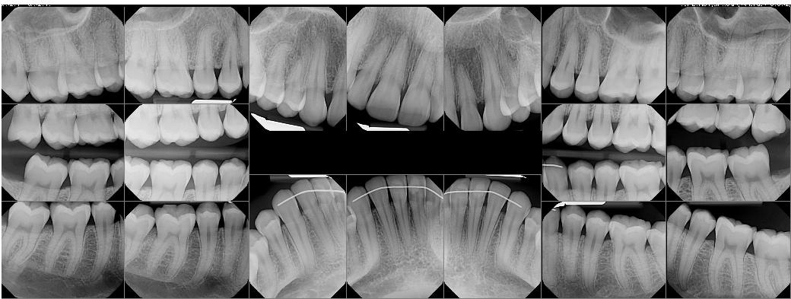
We have a set with 18 squares, these 18 squares constitute of what is known as full mouth series.

Full mouth series is the most detailed intraoral radiograph exam that you might prescribe to your patient, this means that not every patient that enters you're clinic will do it.
-Anterior set is dedicated for anterior teeth. The ones in the center are called central projections and the ones on the right and left of the centrals are called lateral canine projections since they are dedicated for laterals and canines
-Posterior set is dedicated for posterior teeth. We have molar projections and then we have premolar projections.
Both anterior set and posterior set are periapical radiographs. Then we have 4 bitewings two on each side.
Performance criteria:
1-Image quality: is the radiograph clear enough to be good diagnostic tool or not
Density of radiograph (adjust (mA) , (kVp) the highest kilo voltage used in producing a radiograph).
Positioning : every position has set up and holder.
2-Image mounting: Image mounting: it means that once I look at the picture I must be able to recognize it if it is central or laterals or right or left …etc

Periapical Radiograph
For a radiograph to be called periapical, all apices and 0.25 inch (2-3mm) of the bone beyond the apex must be seen. Why is this important? Because the apex itself is a good anatomical structure and while taking a radiograph you are trying to locate something or diagnose or to put the surgical plan so I have to be able to see all the boundaries surrounding apex.
- Projections:
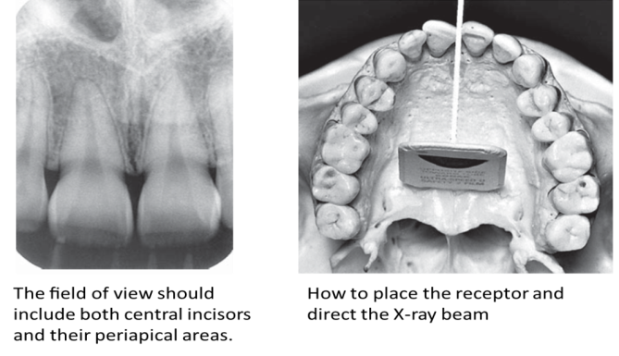
1-Central:

-Center of central incisors must be between the embrasures of two centers.
-this projection must be cover all central incisors and as much as possible from the laterals
- The contact between centrals incisor must appear open (mesial surface of right central and mesial surface of left central) these surfaces must not be superimposed to detect small carious lesion.
Note: Open contact in here is different than what we learned in cons lab, it doesn’t mean that the contacts are anatomically open it means that there is no overlapping between teeth to be able to differentiate between surfaces. Conclusion open contact in radiology is actually a good thing.
- In clinics we have instruments known as XCP and they are color coded blue for anteriors, yellow for posteriors, red for bitewings, green for endodontics.
If you want to take an xray for an anterior you choose all the blue colored parts and you assemble them and in this way we are avoiding distortion.
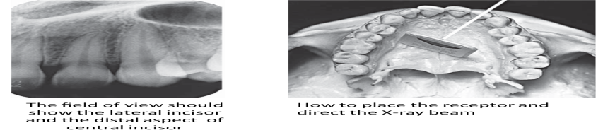
2-lateral:

It must be centered between lateral and canine.
It covers lateral incisors,canines and sometimes the premolars (the most important thing is distal surface of lateral incisor and mesial surface of canine, these two surfaces are important because they don’t appear in any other radiograph unlike other surface than can be seen in more than one radiograph.)
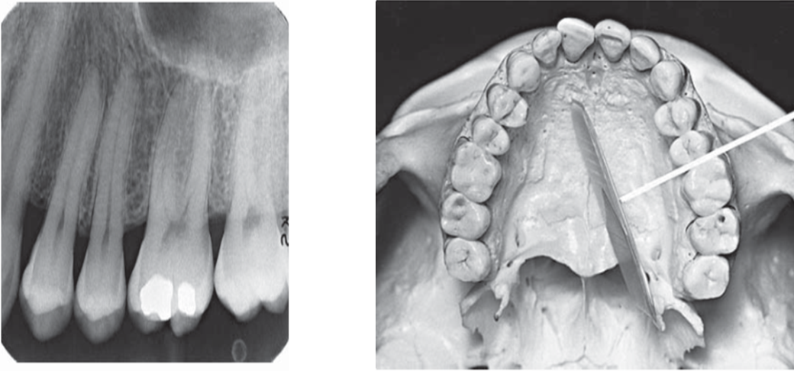
3-Premolar projection:

It is very important for the distal surface of the canine to appear.
All premolars must appear since it’s a premolar projection, molars are not that important.
We have to have two open contacts, 1-the contact between canine and first premolar, 2-the contact between two premolars.
Color code for XCP in here is yellow.
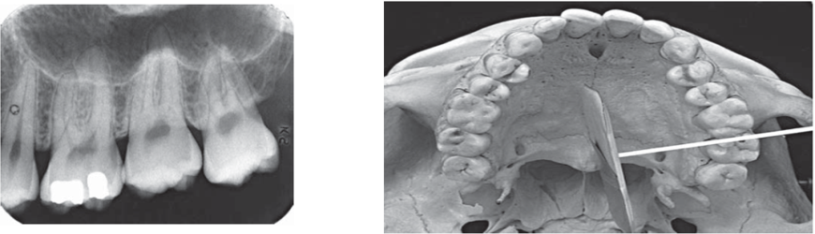
4-Molar projections

These are the hardest to take since you have to position the film distally, the challenge in here is to get the most distal surface of the most distal tooth in the arch and we have to have an open contact between first molar and second molar.
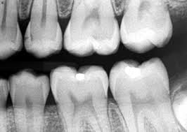
Bitewing Radiographs

They are intraoral radiographs where we see both maxillary and mandibular teeth; vertical angulation for caries detection in a bitewing radiograph is 5 degrees.
It's one of the most common radiographs and is easily taken.
Occlusal plane must be parallel to the receptor.
We have two types:
- Premolar bitewing: as any premolar projection the distal surface of the canine must appear and the premolars and anything extra.
it’s the same as periapical but the only difference in here is we don’t look for the apex we are only concerned with coverage and open contact between canine and 1st premolar and between 1st and 2nd premolars.

You have to favor maxillary open contacts over the mandibular, why? Because when taking periapical for the maxilla it will be taken at an angle because we have the palate and the palate determines how steep I'm going to be and so there will be more distortion than mandibular periapical. Conclusion, I have a better chance of finding carious lesions in mandibular periapical than maxillary periapical, and that’s why it is more important to have an open contact in maxillary bitewing radiograph because if I missed the carious lesion in periapical I'll still have a chance to detect it in the bitewing.

- Molar bitewing: same rules apply but we have to go more distal, open contact is between 1st and 2nd molar and again you favor maxillary open contact for the exact same reason.

Note: We have something called horizontal bitewing and vertical bitewing.
Usually biteweings are horizontal but sometimes we flip it so that the longer part is apico-coronally and not mesiodistally, why do we do this? To see the crystal bone level which is 2-3mm apical to the CEJ and this is very important in the treatment of a patient with periodontitis.

