So far in all the X-ray images we took, we have not seen the TMJs or any parts of the skull. Intraoral X-rays comprise 80% of the radiographs we take, however; most comprehensive treatments will need more detailed imaging.

In panoramic radiographs, the machine (Both the film and the source) will rotate around the patients head, thus it is not static like the intraoral radiograph. This movement was engineered in way so that its sharpness focuses on certain anatomical structures. These anatomical features are the maxilla and maxillary teeth, along with the mandible and mandibular teeth since these are the structures we are interested in. These areas will have a better sharpness and image quality than those which lie buccal and lingual to these structures. This means I am trying to get rid of superimpositions as much as possible. Superimposition result from the fact that we are trying to capture a 3D structure on a 2D film, which means structures will overlap and superimpose. This motion we talked about will decrease the superimposition.
We will start by collimating the X-ray beam into a slim vertical narrow beam by placing a thin slit on the diaphragm. This beam will capture the image starting at one side and progressing to the other in a certain motion which would keep the structures I’m interested in focused.
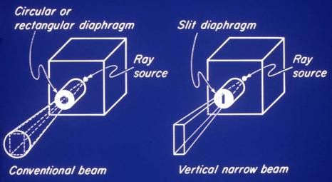

Things we need to know about panoramic imaging:
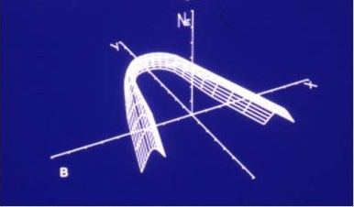
1- The area in which these focused anatomical structures lie is called a focal trough. Here we can see a statistical 3D graph which shows the sharpness of each point in the image. The sharpness started at zero then as we moved lingually, the sharpness increased till it reached the maximum, then it started dropping again. This gives us an image where the cheeks are not shown, the buccal and lingual sides of the mandible are relatively sharp, and its center is extremely sharp. Then it went into zero sharpness again. Any structure which fits the focal trough will give an image with good quality.

2- The parallax: the image is captured from a position posterior and inferior to the patients head. The source of the beam is below the structures captured and therefore all the structures are projected upwards. This can be simplified by picturing using a flashlight, if you place your hand above the flashlight, its shadow will be projected upwards. Moreover, since the source is below the structures captured, the projected image will have a false reading since the structures will be positioned higher than they actually are! For example, an inferior dental canal which is positioned more buccaly or lingually will appear on a different height vertically on the panorama, therefore the person measuring the height on the panorama should always be conservative. (Their location on the panorama depends on how deep they are)

3- Ghost imaging: Lets imagine how the panoramic image is captured, at time = 0, the film is on the patients left and the source is on the patients right, a photon is released and passes through the right and left rami, however; at this point, the left ramus is captured since it is closer to the receptor, but since a photon was attenuated while passing through the right ramus, a ghost image will be projected. So when you are capturing an image of the left side, you are also creating a ghost image of the right side, and this only occurs in the areas that the machine rotates around twice. The machine starts at the right side and progresses towards the left side, it does not rotate around the patients head (semi circular movement), and therefore the anterior area is only captured once and thus does not ghost. (All posterior areas will produce ghost images)
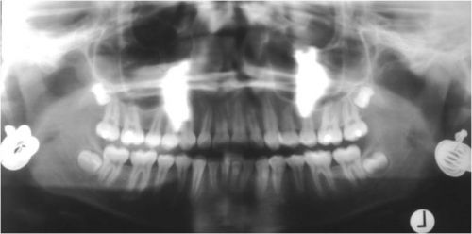
Here we can see a patient who forgot to remove her earrings before taking the panoramic image. The radio-opaque structures in the middle are the ghosts of the earrings. While the panorama was capturing the left side, the right earring produced its ghost image and vice versa. (Each structure will produce a ghost image on the opposite side)

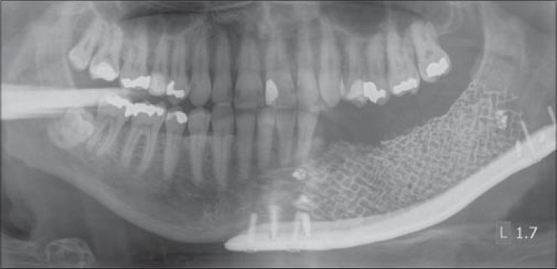
Here we can see a reconstruction plate (a piece of metal), it is placed for patients after we remove part of their mandible. As you can see, its ghost image is very similar however it is on the opposite side, has less sharpness, and at a higher position (since whatever is closer to the X-ray source will appear at a higher position).

Why are we interested in ghost imaging? Since many anatomical structures will result in ghost images.
Ghosting is part of physics it’s not something you can get rid or go around, it’s one of the things that you have to learn, you have to learn where the ghosts are and how do they look like so that you’d know that it’s not a disease.
So let’s go back to focal trough, focal trough is important because engineers have told us to put the thing that interests you in the focal trough area in order to get it in the appropriate sharpness. So the machine doesn’t know where the maxilla nor the mandible and has no interest to the third molars or the sinuses, there is a place into the machine; where I’m going to let place my patient so that when the machine takes the radiograph the maxilla and the mandible would be in the right place in the focal trough. So, a good panoramic image quality depends of course on everything we have talked about like filtration, collimation, developing , fixer… but more important that all these is how you put the patient inside in referral to X, Y and Z.
So, in this lecture we’ll talk about how you put the patient inside the machine. The machines have a localization guide; either a bite block (something that you bite on) or a subnasal rest (something that you rest your nose on) or a chin rest. So you ask the patient to fit into the machine and bite on this groove or rest your chin or nose, by this you make sure that the patient is not too far nor too close to the machine; not too forward nor too backward. When it comes to biting sometimes the patients get too excited and instead of biting on the groove they bite all the way which makes the patient’s head positioned too much anterior, if it is too much anterior into the machine, anterior teeth would be minified. ( we have already made clear that when we decrease the distance between the object and the film magnification decreases and when I photograph the anterior area the source is coming from behind and the film in front so when moving interiorly I’m getting close to the film thus minified picture would occur). So if the patient is positioned too posterior to the machine we ll get too wide teeth. Another thing that’s really interesting is that you’ll get more ghosting,(we already said that posterior teeth will ghost and the more you have posterior structures the more ghosting you have) POINTED TO RAMUS GHOST IN A PICTURE.
Now, we have finished talking about the positioning from the front and the back of the machine, now let’s talk about it from above and below , the ala-tragus line should be parallel to the floor if the head was positioned too upward or too downward there will be problems associated. If there was excessive downward tilt it’ll be called a smiley face radiograph. (pointing to a picture)When the patient’s head is too downward positioned there’s a possibility the condyles will not appear, and if the patients head was bigger there’s a chance the chin will not appear as well. So when it comes to upward and downward positioning we’re risking projecting some structures outside, secondly we notice that the overlap between posterior teeth is a bit more than expected. Now the other way around if the patient tilted up his face there will be a frown, again condyles and chin might not appear because the patient is too upwardly positioned another thing is (pointing at a radio opaque line which is the hard palate) so when tilting up the head the picture of the hard palate will be parallel to the apices of the teeth, so I’m covering the apices of the teeth with something that is of cortical bone nature that is mostly radio opaque so that would create a problem.
Finally, let’s talk about right and left positioning, when tilting right and left one part of the face would be too anterior into the machine and the other part too posterior into the machine. So the part that is too anterior into the machine will be minimized and the one that is too posterior into the machine will be magnified. This is very important because there are some diseases that are associated with one half of the face being bigger than the other half.
Slumping affects the radius of the cervical spine that will be present in the radiograph. So the x-ray is coming from below, and instead of passing through a straight path it’s passing through an oblique path through that cervical spine, so the problem is that I increased the thickness and I do that I’m increasing attenuation (pointing on a white band at the middle of the radiograph that appeared due to slumping).
So, now after the correct positioning of the patient from all directions, he needs to swallow and let its tongue to be in contact with the palate, WHY? 1) Because he can’t swallow while taking the radiograph (its considered a movement) 2) in order to kick out the air inside the mouth. As we were saying, more structures will lead to more radio opacity and fewer structures will lead to radiolucency, a lot of radiolucency is actually covering all the apices of the teeth. This artifact is known as Residual Air Space.
Swallowing while taking a radiograph is one sort of motion, the patient cannot move while the machine is taking the radiograph, why? Because we already have made it clear that the machine is just engineered to take a radiograph, doesn’t know anything about anatomy so if the patient moves the machine will not follow his movement to capture the moving part, usually this occurs when the patient sneezes. So motion is bad.
Pointing at a radiograph with a residual air space.
Pointing at a radiograph of a patient wearing a denture
A radiograph showing something that looks like a fracture, so what you do is you go and takes history and when not finding any clue of a fracture you re-take the radiograph correctly thus it would be an artifact.
Apron
So having an apron on the patients shoulder while taking a radiograph is a debatable thing, in the UK and Europe they advice people not to take it because they found that they are using the apron in a wrong way so retakes are causing an increase in the dose more than the does that the apron is decreasing. So in UK and Europe in general its not indicated in the US some states encourage some don’t. Here in Jordan we don’t use it. IF you need to use it you have to use it in the right way; it needs not go up the beginning of cervical spine because shoulders would appear. Lead makes more attenuation than the bone so if the Lead made superimposition on any anatomical structure we’ll not find it and this is not acceptable.
Jewelry, glasses, removable dentures, removable retainers, earrings should be removed. Hearing Aids could be kept in order for your patient to hear your instructions.
- Pointing at a picture with a patient wearing glasses,earrings,acrylic dentures… those are removable things you can take them out, (pointing at plates, those you can’t remove and you have to live with).

