Radiology sheet #12
CRC #5
done by: Layth Alhajja and Fatimah Abu-Shaikhah

Cysts and Benign Tumors

This sheet includes the slides and last year sheet (:
The doctor put Cystic lesions and benign odontogenic lesions in the same seminar because of the similarities between them, which include:
- Well defined margins
- Presence of cortex (in most cases)
- Most of them are radiolucent
- They affect the surrounding structures by: expansion, displacement and horizontal resorption
But they differ from each other in some aspects like:
- The cysts are unilocular usually, while benign tumors are multilocular or multi-lobulated at least
- Pattern of expansion; Cysts expand in a hydrostatic way (like a balloon), benign tumors expand in an undulating border (because its border has cells capable of proliferation and every cell is in a different level as far as expansion)

CASE 1
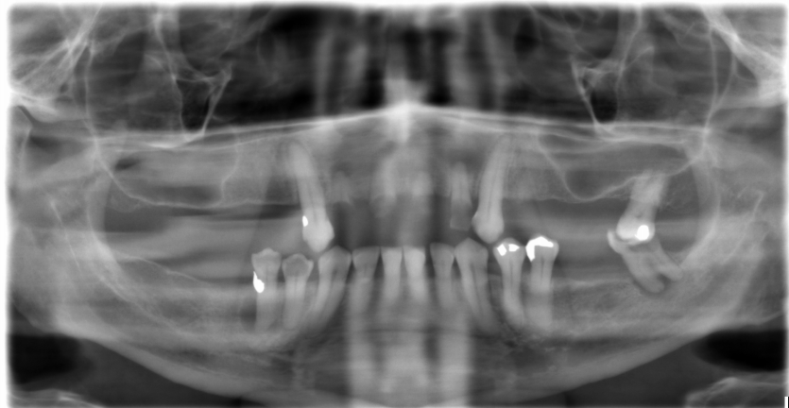

It's a panoramic radiograph, there’s bilateral pneumatization of the sinus, radiolucency in lower right 5 and lower left 7, it’s a cystic lesion due to deep filling and marginal leakage.
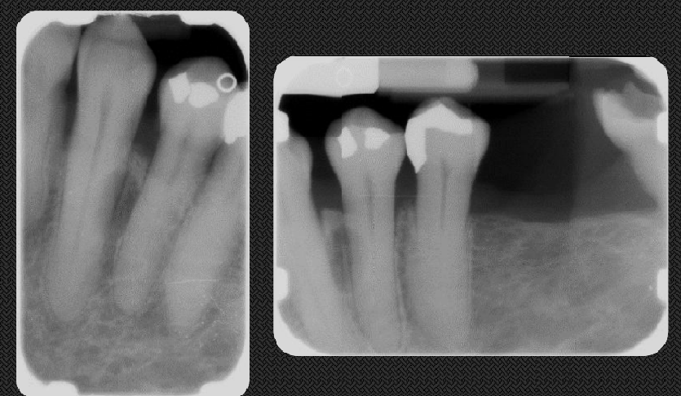
These radiographs for the same patient, we can see hypercementosis in the roots, there is an oval well defined radiolucent lesion, between roots of 3&4 covering the middle third of root, almost 3mm in diameter, the lesion is lingual according to the Parallax technique, not causing resorption or displacement of the associated teeth, it’s either:
- a lateral periodontal cyst
- or radicular cyst
The next step is to do a vitality test, if vital it's lateral periodontal cyst and if non vital it's a radicular cyst, but we know it’s vital because lamina dura is intact and periodontal ligament within normal limit.
Note: if there’s any sort of displacement it will displace the roots causing the crowns to be closer, which is not seen in our case here.
CASE 2
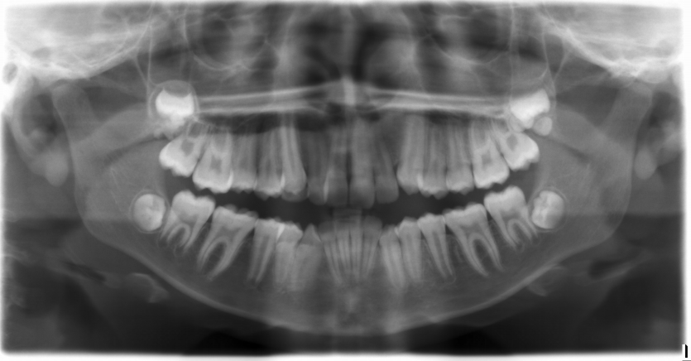

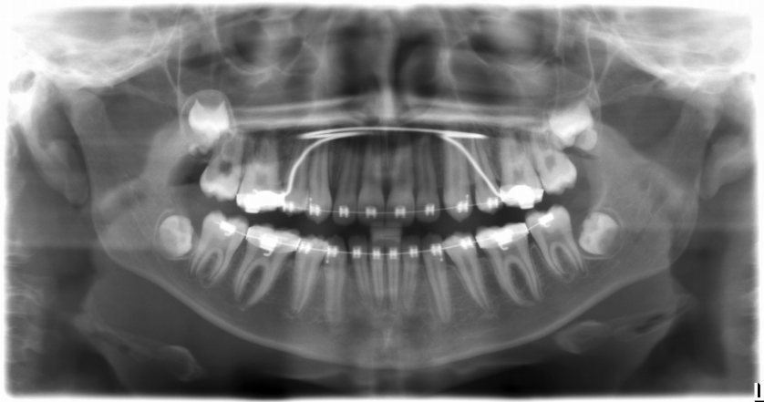

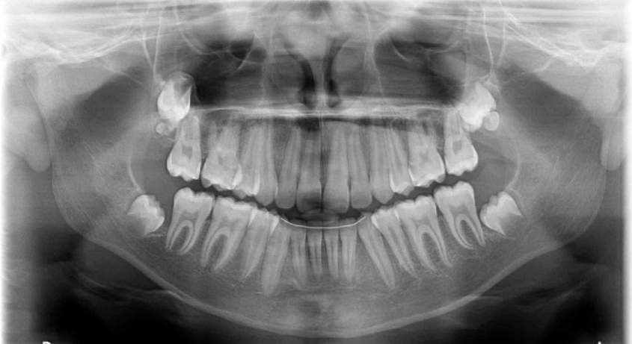
These three sequential panoramic radiographs for a 14 year old male, he is doing an orthodontic treatment to extrude the canines, we can see impacted 8s, the upper impacted 8s have odontoma in their follicles, this is our differential diagnosis which compatible with the location, lesion appearance (target-shape) and the age of the patient, odontoma is a dental hamartoma so it’s not unusual to appear in multiple areas, here we have 2 compound odontomas (the doctor said she’s not really sure about the left one, it maybe a complex odontoma)
Note: in this case we don’t really need to extract upper impacted 8s, you can leave them and take radiographs periodically, but it’s safer and we prefer to extract them because if they erupt, there will be communication then secondary infection which is danger because it’s close to the sinus, and it’ll become harder to extract them later (the cut off age for extraction is 27).
Note: odontoma is part of spectrum of diseases begins with complex odontoma, ends in supernumerary tooth
Question???
Someone asked why this is not one of these calcified lesions like calcified cystic/benign odontogenic tumors? Due to 3 reasons, the age of the patient, there’s a bilateral lesion in our case and it’s not a feature of a benign odontogenic tumor, and these lesions are reeeeeally uncommon.

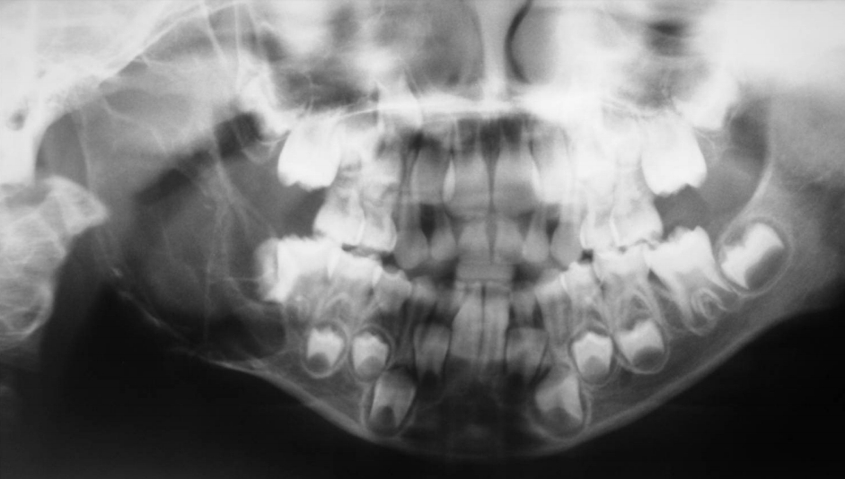
CASE 3

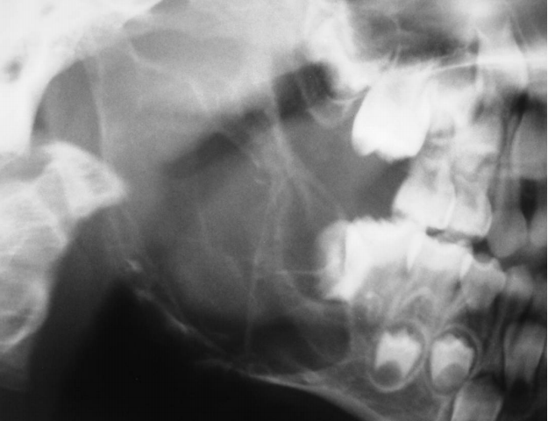
It's a panoramic radiograph for a young patient (5-6 years old), with well defined partially corticated expansile radiolucent multilocular lesion on the right side of posterior mandible, that extend distal of the developing follicle of the 5 and apical to the 6 all the way to superior one third of the ramus, it’s an odontogenic (above the canal) benign (well defined) tumor (multilocular), the molars are displaced anteriorly
DDX in order:
- Ameloblastic fibroma
- CGCG (central giant cell granuloma)
- central hemangioma (needs MRI imaging to confirm)
What If this appearance of the lesion was found in an older patient? My DDX will be in order:
- Ameloblastoma
- CGCG
- Myxoma
- Keratocyst
We didn't go for Aneurysmal bone cyst because it’s far more expansile and it's multilocular.

Note: we could do blood tests to rule out brown tumor

CASE 4
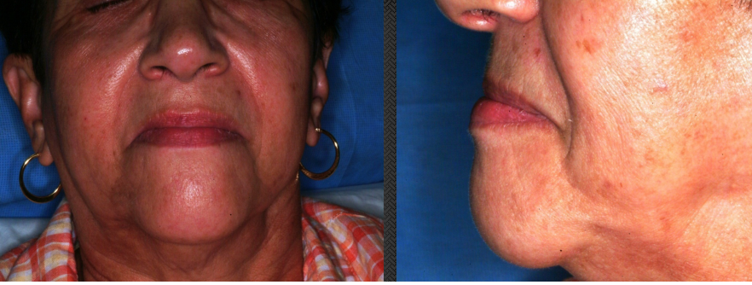
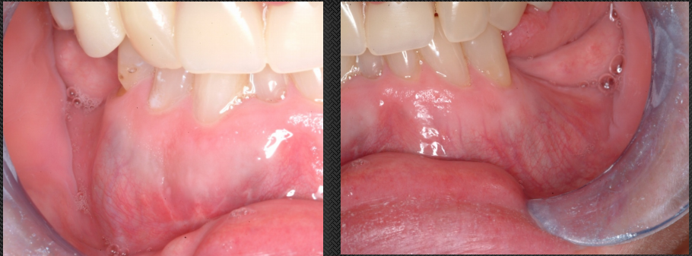

A 63 year old female came to clinic with swallowed anterior chin area; like she’s a class 3.
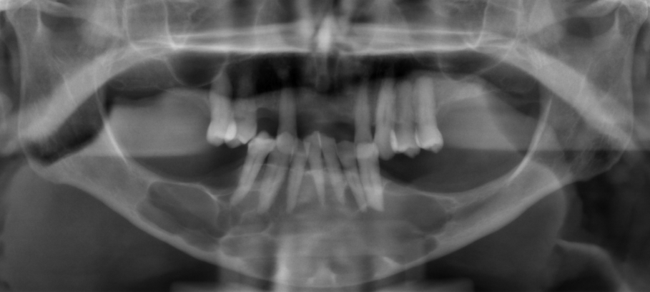
You can see a well defined, corticated, expansile radiolucency in the anterior mandible that extend the right molar area to the left premolar area with a scalloped superior border, it’s (7*5 cm) in size, causing remodeling in the superior and inferior cortices, displacement of the associated teeth and sharp horizontal root resorption on the lower left 5.

DDX in order:
- Ameloblastoma
- CGCG
- Myxoma
- Glandular odontogenic cyst (it’s rare but it’s the right answer in this case)
Note: the doctor said her first choice for this case was CGCG actually, because of the site and the pattern of resorption (should be more aggressive in case of Ameloblastoma)
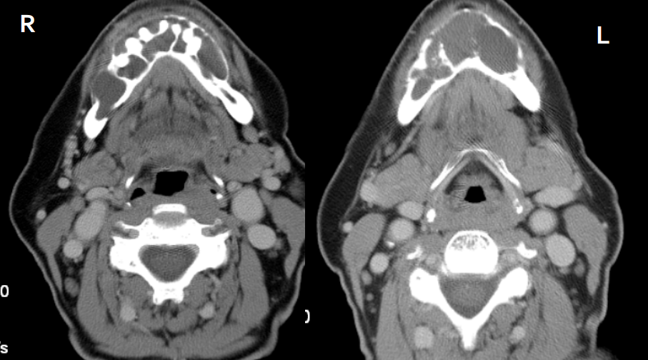
Axial cuts of soft tissue window CTs going through the anterior mandible, the left one is on level of the hyoid bone, the right one a bit higher up going through the roots of the teeth, we see expansion, the septi of the cyst, remodeling and thinning of the buccal cortex of the mandible especially on the right side.
We use this kind of images to see if there’s any peripheral soft tissue involvement (especially in case of Ameloblastoma).
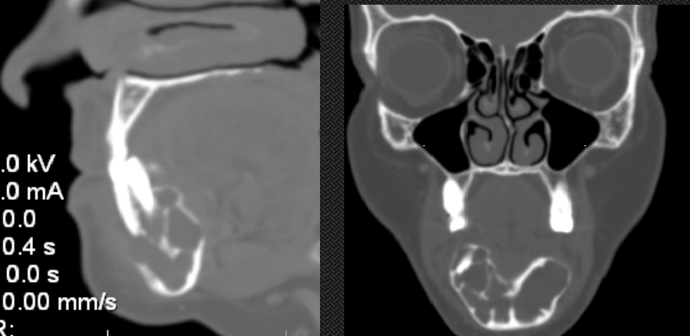
Sagittal cross section (right), Coronal cross section (left)

CASE 5
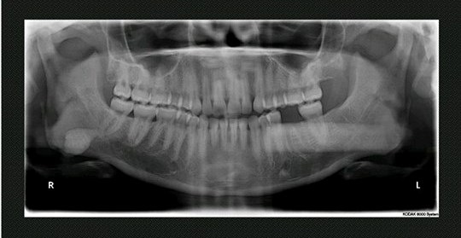
DDX: Osteoma, because its non-odontogenic in origin (below the canal) and this lesion looks like cortical bone, on the right side there’s the ghost of the Osteoma.
Question???
Someone asked why this isn’t a supernumerary or an impacted tooth?
It’s not a supernumerary because it’s below the canal and not an impacted tooth because the wisdom tooth already erupted.

CASE 6
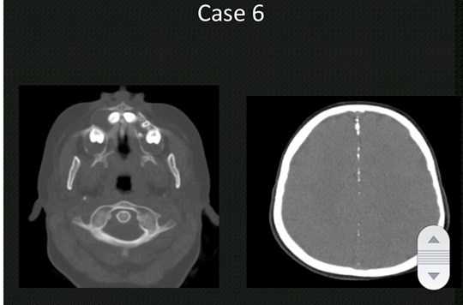

Multiple axial images, one goes through the brain where there's calcification of falx cerebri, and one goes through the maxillary alveolar process, we can see well defined, corticated, and expansile radiolucent lesion causing displacement of the teeth.
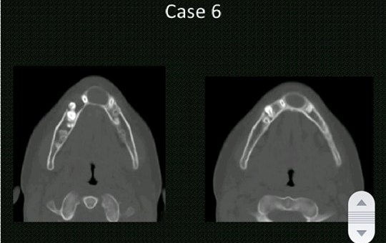
Two axial images through the mandible on different levels, we can see more of those unilocular lesions we have seen in the maxilla, DDX: Keratocyst associated with Gorlin goltz syndrome.
Note: Keratocysts aren’t expansile in normal situations, but they are more aggressive when associated with Gorlin syndrome
Warning: this is a good exam case

CASE 7
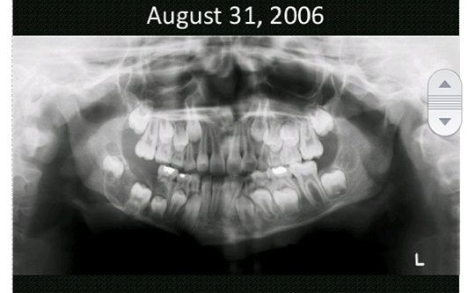
A panoramic radiograph for a girl (8- 8.5 years old) fell during gymnastics, there are no fracture lines but we can see a well defined corticated radiolucent lesion that is about 3*2 cm, causing displacement of the developing teeth in addition to root resorption, DDX not in order: Ameloblastic fibroma, Ameloblastic fibro odontoma, Adenomatoid odontogenic tumor
Note: the lesion itself caused the tooth to be impacted, so we can’t say it’s a dentigerous cyst, because it forms around an already impacted tooth

CASE 8
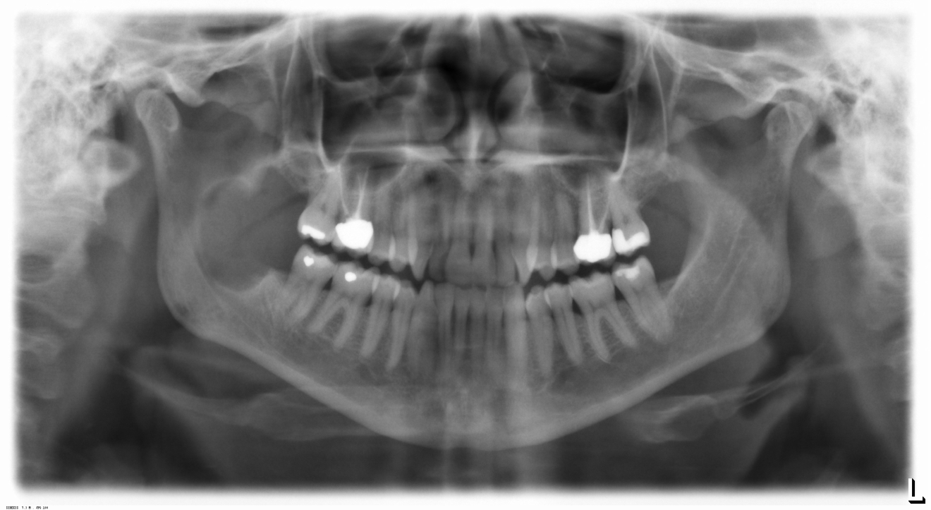
A right mandibular well defined, unilocular, corticated radiolucent lesion, extending from the distal of the 7 all the way to the superior 1/3 of the ramus, causing minor displacement of the canal.
DDX: Keratocystic odontogenic tumor; it’s not Ameloblastoma because it’s not ugly in behavior or aggressive and I can’t see expansion.
The doctor skipped CASE 9

CASE 10
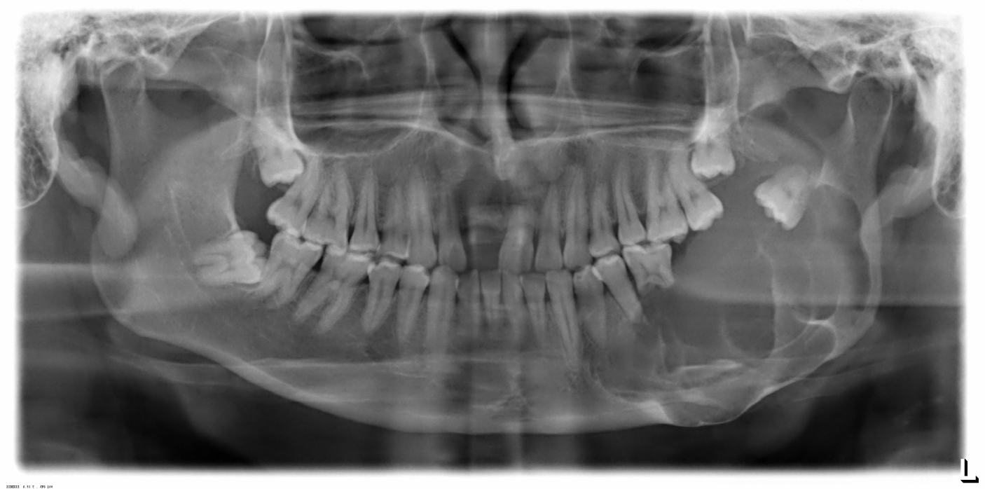
A well defined, multilocular, corticated radiolucent lesion, extending from distal of the canine all the way to the condylar neck, causing displacement
This is a quintessential example of what an Ameloblastoma looks like, anything that looks like that, Ameloblastoma will be on the top of the list, so DDX: Ameloblastoma (for sure), Myxoma (مجاملة) :P

