Done by : aisha alyasi
Sheet no.3
Today we will continue cases that related to developmental and congenital anomalies
Case 1
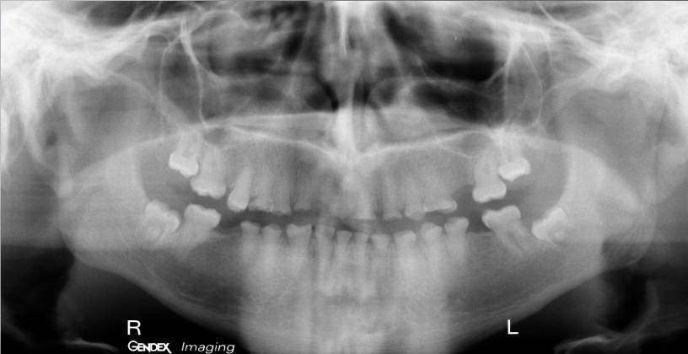
-Type : panoramic radiograph
-Radiographic findings : 1. Attrition on the lower and upper teeth
2. pulpous crowns
3. obliterated pulps
4.blunt small roots
-Diagnosis : dentogenesis imperfecta
-Note : we cant tell which type it is because we need clinical examination to see if the patient have osteogenesis imperfecta → sings and symptoms (blue sclera , multiple fracture …)

Case 2
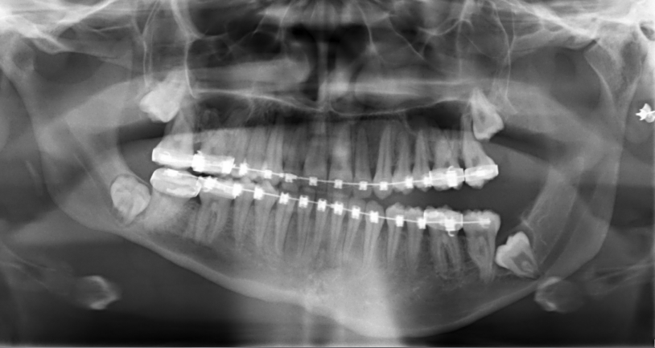
-Type : panoramic radiograph
-Radiographic findings : 1. Occlusal slant
2. asymmetry
3. braces
4. open bite
5. absent of curve of spee
-Note : we exclude that the patient tilt his head upon taking the x-ray because 1st we cant create open bite by just changing the patient position and the 2nd clue is the actual vertical height of the rami
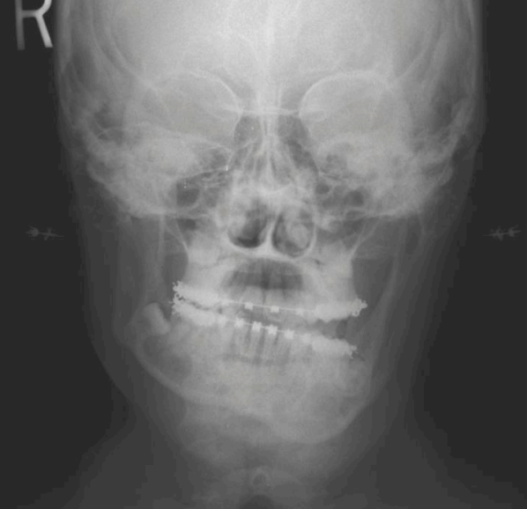
-Type : 2D radiograph PA (most of the radiograph are PA because of modern x-ray machines design from posterior to anterior , and only specific projection like town view is AP and they are very few views that interested of anterior parts)
-Radiographic findings : 1. Similar vertical height of the ramus
2. open bite
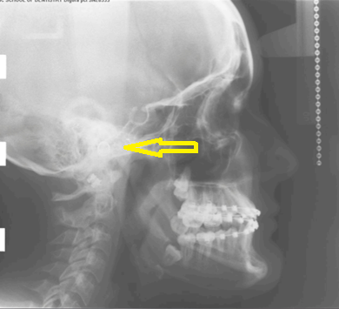
-Type : cephalometry
And image confirm that the patient does not tilt his head because the ears rods markers are coincidence , and there is a major discrepancy between that lower border of the mandible
We exclude hemi facial hyperplasia because there is growth in both maxilla and the mandible so in this case we will have only tilted occlusal plane without open bite
-Diagnosis : asymmetry case (mandibular issue) it could be :-
- Hypoplasia :
      - Shape of the ramus become obtuse angle
      - In the most cases there is no open bite
- Hyperplasia :
      - Increase the vertical length of the ramus
      - Open bite
      - A lot of excess bone
So in this case it is a condylar Hyperplasia and to make sure we can :-
- Ask about the history if it a progressive disease
- Bone scan (functional imaging) : that show the activity within the tissue so it help us to know if it active or stable so that we can decide the surgical approach

Case 3
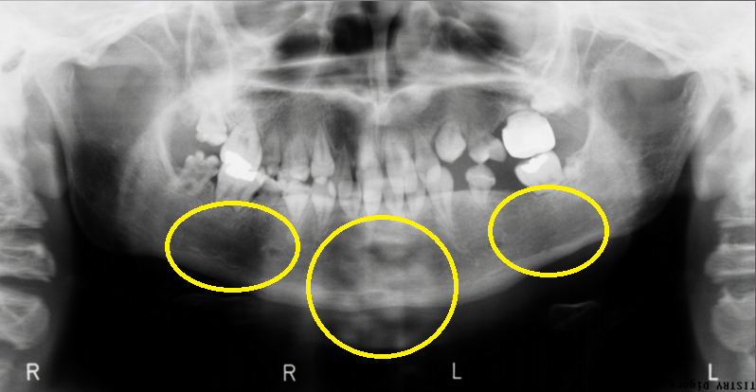
-Type : panoramic radiograph
-Radiographic findings : 1. Dentition with rootless teeth (generalize)→so we think of dentinal dysplasia radicular type
2. the crown of the lower right 7 is pitted
3. deficiency in the whole bone : this child had a history of rhabdomyosarcoma and he takes radiotherapy that included the whole area that cause growth interruption
-Diagnosis : dentinal dysplasia radicular type

Case 4
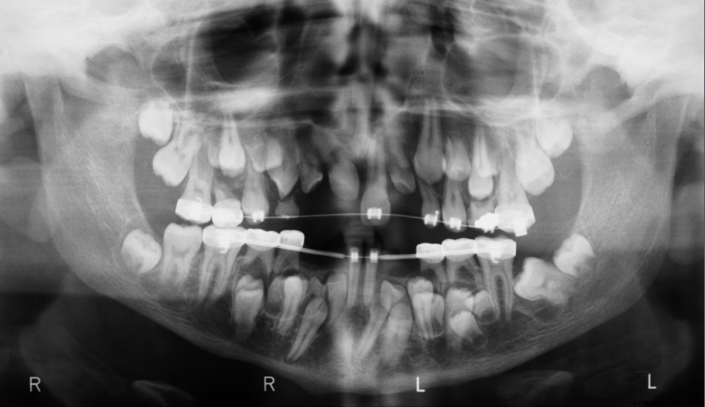
-Type : panoramic radiograph
-Radiographic findings : 1. Multiple supernumerary most of them are impacted→affecting the eruption and the exfoliation
2. unerupted teeth
3. multiple retained primary teeth
-Diagnosis : cledocranial dysplasia
-Note :
- supernumerary teeth indicate gardner syndrome or cledocranial dysplasia
- gardner syndrome have colorectal polyps that have a 100% chance of turning into colorectal cancer
- the ortho specialist and surgeons decide to take out what they think is not savable and put bracet on what they think they could retract into the mouth

Case 5
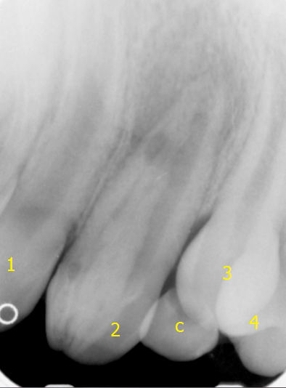

-Type : periapecal radiograph
-Radiographic findings : 1. Tooth within tooth
2. apical disease
-Diagnosis : dens and dente
-Note : enamel organ invagination into the crown of already existing tooth it create that enamel line pit that communicate with the outside

reconstructed panoramic correspond to the orange line around that curve

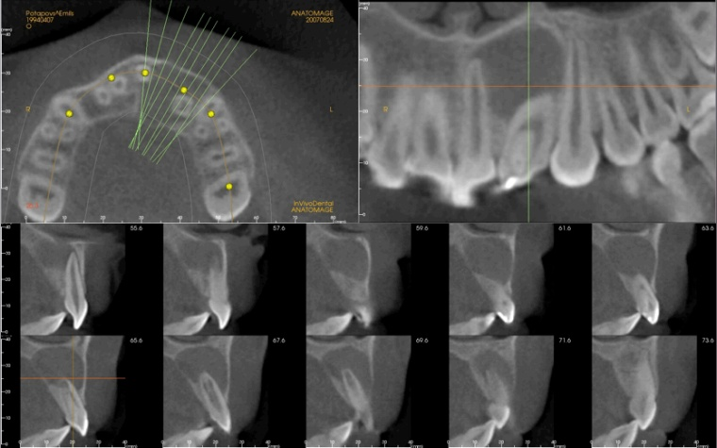
Cross sectional radiographs correspond to the green lines
Axial cut : the cut that we are go from up to down
This his cone beam and his cross sectional radiographs shows dramatic radiolucency and bone lose more than the periapecal radiographs
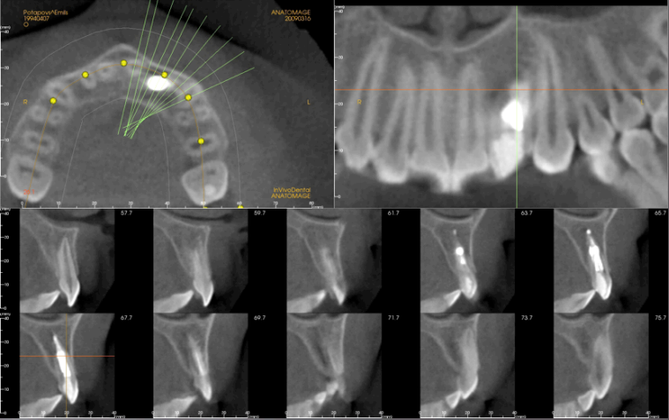
Follow up after the endo treatment that include both orthograde and retrograde fill
Case 6
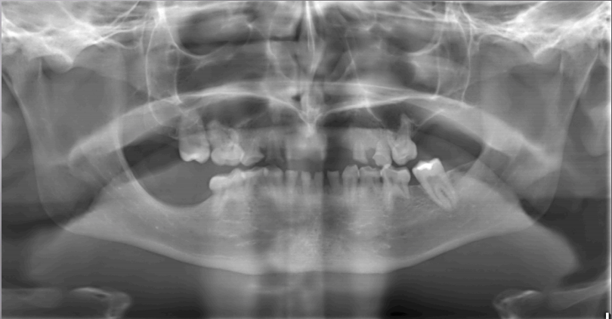
-Type : panoramic radiograph
-Radiographic findings : 1. Primary dentition without successors (congenitally missing)
2. No source of developing teeth
3. 6s
4. bone resorption due to upsent of developing teeth
-Diagnosis : ectodermal dysplasia
-Note : they need long term treatment and complicated , at childhood they need prevention and stainless steal crowns to increase the age of existing primary dentition and if they couldn’t they have to wear a complete denture and the complete denture change or reconstruct frequently to get to the actual size of the jaws as the child growing then we get into the stage of sever grafting and multiple implants

Case 7
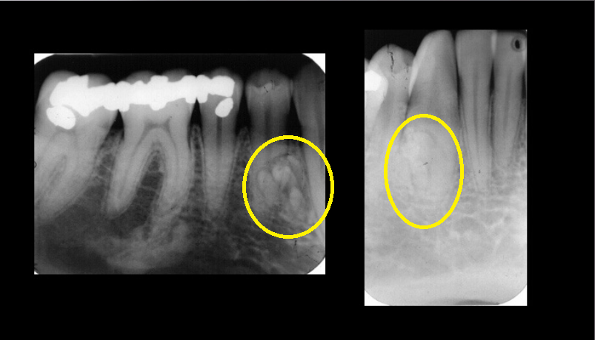
-Type : on the left side premolar projection , on the right side lateral canine
-Radiographic findings : 1. Opacity between the canine and 1st premolar (mesially) , less than 1cm and irregular in shape
2. opacity under the 6 → differential diagnosis of something like that depends on the vitality of the tooth , if it non vital so it can be sclerosing osteitis , but on this tooth we don’t think so because of normal periodontal space and lamina dura so it can be sclerotic bony island which is nothing
-Diagnosis : odontome
-Note : we have two kind of odontome compound or complex , and according to SLOB technique it located lingually and its risky because of the lingual nerve

Best wishes =)

