2-10-2014 , Lec.3
Dr.firas
By Razan zuhair

We are going to talk about the hand instruments
, One of the important thing in operative or restorative dentistry is the removal part of the tooth structure and the restoration (restorative material).
- We carve the tooth , remove the diseased part from the soft tissue and we replace it with a restorative material . In the past they used to use the hand instruments not the rotary one but this technique is extremely difficult and time consuming ,because the tooth structure is hard and difficult tissue to cut . Production of the rotary instruments make the preparation or the cutting of the tooth structure much easier ,faster and much more convenient to the patient .
- G.V black “ father of modern dentistry “ is accredited with the first acceptable nomenclature for , classification of hand instrument and Classification of dental carries.
Hand instruments design:
- Most of the hand instruments are composed of 3 parts :
  - Handle: labeled as C in the picture. Part of the instrument where we grip the instrument.
  - Shank: labeled as B in the picture, joins the handle with the blade or nib (working end) .
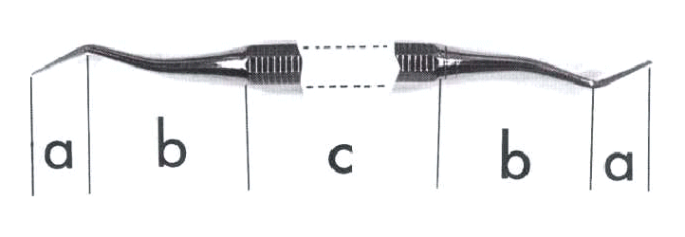
  - Blade (if the instrument is a cutting instrument) or nib (if the instrument is a non-cutting instrument). Labeled as A in the picture. Also we called it the working end , the functional part that do the job
( The rest of the parts for accessibility or for hanging the instrument.)

Hand instruments are manufactured from two main materials:
Stainless steel :stainless , rust free or doesn’t rust It does not corrode with sterilization, washing and processes we do
but softer its cutting efficiency is not as high as the carbon steel ,so we can’t make cutting edges because it will become dull very easy .
carbon steel :It’s very good, harder and can maintain the sharpness for the longer period of time so the cutting efficiency is high, however it tends to corrode with use (it’s not a rust resistance as a stainless steel ).
It’s disposable (used as a single use) because once the instrument lost its cutting efficiency, you can’t use it anymore, so you have to dispose it and use one that cuts efficiently.
Sterilization is a very important factor in our work we have to sterilize our instruments . so instruments should be able to sterilize or we use it once only and throw it away .
The best method in sterilization is using the autoclave ; machines with a compressed water vapor , work in a high temperature for sterilizing the instruments and resist all the pathogens specially hepatitis (which resist boiling) .
Instruments categories :
Cutting and non cutting hand instruments
Cutting such as ( chisel , excavator .. )
Non cutting such as ( condenser , mirror , probes ,explorer ..etc)
Hand instruments are classified according to function , manner of use , design of the working end , shape of the shank .
Function : like “scaler , excavator”… scaler scales , excavator excavates
Manner of use : hand condenser , finger spreader . one is using by hand , other by finger .
Working end : is the active part of the hand instrument , spoon instrument or sickle scaler because the working end shaped like a spoon or a sickle .
The shape of the shank : it can be straight or one angle or two angles , contra angle
(( if I need a shape that reach the distal ends of the tooth so I need an instrument with two angles or contra angle , I can’t use the straight one . ))

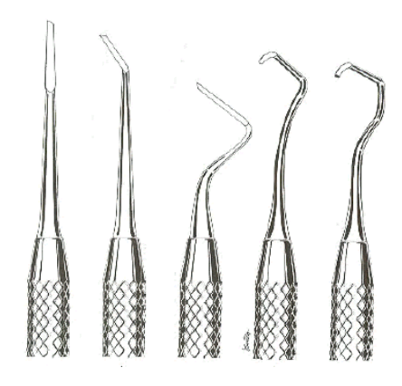
- straight : the shank does not has any bending
- mon-angle : has one bend
- bin-angle : has two bends
- triple-angle : has three bends
- quadrangle : has four bends

Extra info.
Why it’s important to have different angles for the shank rather than having straight instruments?
- It depends on the site where you want to perform the procedure.
We have four different axial walls (buccal, lingual, mesial, and distal) for upper and lower jaws so you have to have different angles in order to accommodate for the site you want to work on.
- The entire instrument that we use for cutting should be balanced.
Balance is that the cutting edge of the blade should lay with (0-2 mm) distance from the long axis of the handle, which helps in giving more control over the instruments.
If the cutting edge is more than 2 mm away from the axis, tends to have uncontrolled cutting movements which tend to cause rotation and damage.

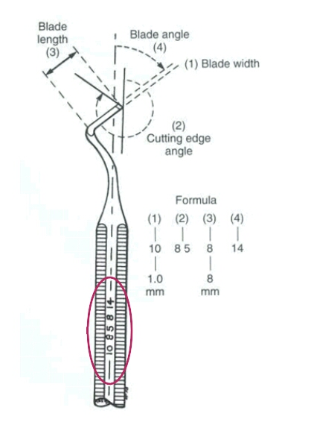
  - We have 4 numbers written on the instrument :
    - First number from the left : indicates the blade width ( the doted line )
The number 10 in the picture indicate ten tenth the mm which is 1 mm (10/10 = 1 mm)
    - Second number: indicates the cutting edge angle.
Sometimes the cutting edge of the blade cuts with a specific angle so it doesn’t to be perpendicular to the blade itself.
The cutting edge angle is from the projected angle of the blade to the cutting edge of the blade.
    - Third number : indicates the blade length
    - Fourth number: indicates the blade angle which is from the doted line to the long axis of the handle.
- The whole circle is not 360 , it’s a centigrade from 0 – 100
Hand non-cutting instruments:
  - Dental mirror : examination instrument
It’s an intra-oral mirror used intra-orally. It’s a small circular mirror attached to a handle. We can’t work without it even if we are working direct , it’s not only for vision but also allows the operator to:
- Retract the cheeks and tongue … retraction if we are doing class 5 in the lower 6 protects the soft tissues , the cheek and also if we are working on the lingual side retracts the tongue and protects the floor of the mouth because these are very sensitive tissues
- Retract light onto the teeth where light fall on the mirror and the mirror reflect it to the teeth so you can see well. One of the important function of the mouth mirror.
- Observe the maxillary teeth and distal aspects of the mandibular teeth indirectly ( which can’t be seen from direct vision )
- Good clean unscratched mirror affords the best visibility.
- Explorer: the instrument that have many shapes (curved , straight , bin angle , multiple sometimes it has single end or double ends .… “angled to see something in the distal part of the teeth”
It’s also called a probe and is a sharp pointed instrument used to:
- Explores something from it’s name .
- Assess the integrity of surfaces of teeth and margins of restorations if there’s a defect or not .
- to detect decay , carries in the fissures : any softness in the surface indicates an abnormality like caries
- Clean the fissures.
- Detect Margin of restoration if it’s adapted well in the tooth structure or overfilled or under filled .
- Assess hardness in dentin treatment: In caries removal, once you start to remove caries, you need to know the where and when to stop, the guideline is the dentin. If there is dentin, you have to stop cutting the teeth.
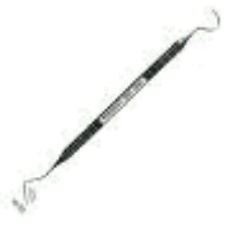

- Cotton pliers or tweezers :
Have a serrated end to grip and hold cotton rolls and pellets.
It has different shapes, some come with lock so you can hold the specific thing you want to hold and just lock it in the tweezers so you have more control.
Used to:
- hold cotton rolls and pellets for isolation
- convey small items to and from the operating field
Mirror, probe and tweezers are called basic examination set.

- Periodontal probe :
3mm
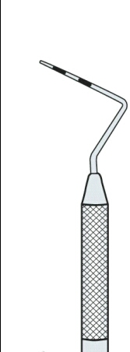
It’s a graduated instrument, doesn’t have a cutting end, and have a very tiny end.
9mm
It’s marked every 3 mm
Used for:
6mm
- Measure the depth of the periodontal pockets : it’s an abnormality when the gingival sulcus start to be more than 3 mm , so you have to go around the gingiva and measure the depth of the sulcus in all the tooth
- It differs than explorer Since it’s a graduated instrument with flat or round ball end not pointed not sharp, you can use it to measure things like the depth of the cavity (sulcus) or pockets in periodontal patients .
- Articulating paper : highlight occlusal contacts and the distribution of occlusal forces. That is, it marks those points on the teeth where the teeth contact during biting and grinding. While putting a restoration and the patient felt the highness of it , we try to use this articulating paper and ask the patient to do centric or eccentric movement .
Centric : point of maximum intercuspation
Eccentric : movement in different directions.
It has a holder because it’s a very thin so that it is easier to control
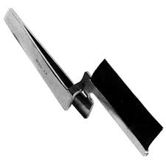

Hand cutting instrument :
the operator to manual remove decay as well as smooth and finish the tooth structure to be restored back to it’s normal function .
instruments that use for cutting wither cutting the tooth structure , removing decay or finishing the restoration .
one of the main cutting instruments is the excavator used to excavate things , depries , carries or decay
it comes with different shapes such as spoon excavator shaped like a spoon the one that commonly use and the edges of the spoon are sharp because it is a cutting instrument . we can use it for carries in deep cavities , here the tactile sensation is better than the rotary instruments

2.Chisel : is used to cut the enamel margin of the tooth preparations , forms sharp line point , line angle , point angle at a place of dental groups
It can be curved , angled , working end sharp and bevel .
We use it To remove part of the tooth structure , to finish the preparations , to prepare line angle or point angle ..etc
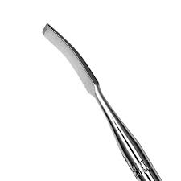

If you want to be a good dentist , hand instruments can be very useful to finish the cavity preparations after using the rotary one

Restorative hand instruments:
Allow the operator to place, condense and carve a dental material to the original anatomy of the tooth structure. Function: to be able to handle , put ,carry , shape , condense the restorative material in the cavity
1.Amalgam carrier :
amalgam manufactured from tin alloy silver , mercury mixed with some additions like copper zinc ( capsulated , soft ) so this material should be carried from the mixing device to the cavity by amalgam carrier which is a
hollow slender It has a well at one end where you can pack freshly mixed amalgam and also has a plunger at the other end where you can push and get the amalgam into the cavity, so this instrument is used in this way:
First you fill the well with amalgam (put it on the mix and pack it with amalgam), then you take it to the patient’s mouth and put it above the cavity and press the plunger and then it goes into the cavity.
Some instruments have double ends; you can fill both sides which is useful if you have big cavities.
Many shapes of carriers but all for one principle .
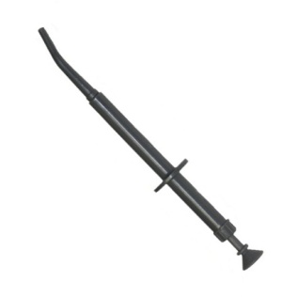
2.Condenser :
Condenses the material inside the cavity (the second step after you put the amalgam into the cavity) to make sure that the amalgam is properly filled and it’s filling all the spaces and irregularities in the cavity , and take the shape of the cavity . when you condense the amalgam you push the excess mercury toward the surface and become soft , we should remove the excess mercury because that can lead to mechanical failure and bad results we only need it to bond the materials together so we don’t need this excess of mercury .
Condenser should be with flat ended and round in cross section
As you see in the picture, there is different shapes and sizes of the condenser (different cross sections: circular, oval, rhomboid), to match the different shapes and sizes of the cavities.

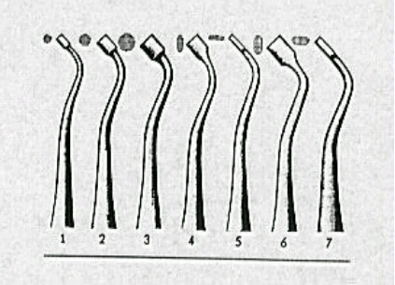
- Before you start you filling, make sure that you have the condenser that fits into your cavity (some cavities are too small that you need to find a compatible condenser that is slightly smaller than the cavity size because it has to be completely in.
- The larger the condenser that you use, the less condensation pressure because it spreads in a wider surface area , so smaller condenser tend to condense with large condensation pressure .

Also the condenser should suits the quality of the amalgam , spherical amalgam needs less condensation pressure ,so we use large condensers .
- Burnisher :
when you burnish something you pressurize to adapt to something , also Used to smooth the surface of freshly placed amalgam restorations.
Burnishing is the last step of amalgam restorations. Pass with force on the margins of amalgam to press the amalgam reaching the margins or walls of the cavity
It has different shapes: pointed not sharp, egg-shaped, football, T-shaped, beaver tail.
I can use burnisher before carving and after . I do precarving with large burnisher , remove the excess material and adapt the margins before carving . after , we use it for smoothing and adapting the amalgam to the tooth

Carving instruments :
After you placed the amalgam filling, you need to make sure that the filling looks like a tooth so you need to carve it and cut it back to the shape of the cusps, fissures and grooves. So it’s an instrument that used for carving to reach the original morphology of the tooth structure . we don’t carve composites so we usually use it to carve amalgam , we build composite with layers finish and polish it before setting so we don’t carve it but amalgam is a plastic material during working before it set .
The major property of amalgam that can be formed easily and we use it as a direct material so we are going to deformed it to facilitate putting it in the cavity or to be filled in the cavity , then at the end of the working time it become rigid.
Carvers should be sharp to cut the enamel ; with different shapes
Discoid (circular) – cleiod (claw shaped) : used for occlusal carving of amalgam restorations
Hollenback carver the most commonly used : long with sharp pointed end and with sharp edges used for carving the occlusal, proximal, lingual and buccal surfaces of amalgam restorations. It has two ends and you can carve amalgam, composite and wax with this carver
Amalgam knife to remove the excess material to an acceptable area.
Plastic instruments :
Used to handle plastic materials with a paddle shape that used to carry dental material to the prepared tooth structure ,on the other end nib which resemble a condenser. flat It’s not sharp end it’s round
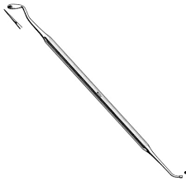

Other instruments such as :
Spatulas : instrument that is flat , very thin used for mixing with different shapes and sizes
- Alginate for taking impressions needs large spatula for mixing it.
Seizers : to cut things , that can cut metals also stainless steel for temporary crowns .
Dap and dish : that we use it in different purposes to put a liquid material or to put amalgam inside it .
Amalgam well we use it after we mix the amalgam and before we carry it on patient’s mouth.
Hand instruments we handle them using different techniques
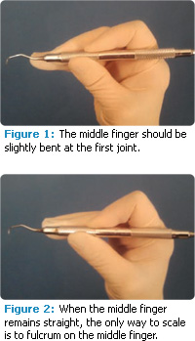
There are 4 types of grasps
1.modified pen grasps

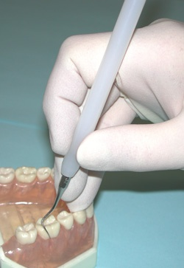
2. inverted pen grasps

3.palm thumb grasps
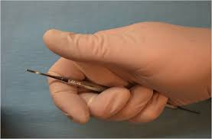

- Modified palm thumb grasps ; the same thing of palm and thumb grasp but you set your finger on the same tooth not on the adjacent one.

Conventional pen grasps is not an acceptable instrument grasp

Safety issues:

  - Hand instruments can cause mechanical damage of hard and soft tissues .
  - Very important of hand instruments specially cutting instruments to be sharp , and sharp instruments can cause lots of damage if we’re not using them probably
  - The closer the cutting edge to the handle, the more control you have over the instrument. You make sure it doesn’t slip because you work on vital structures (soft tissues, tongue, cheeks) so you need to be careful not to cause injury to those structures.
  - Slippages can cause lots of damage also when we are not doing a finger rest , finger rest prevents slotting instruments in patient’s mouth
  - There is a continuous risks of laceration of tooth and soft tissues from blades of hand instrument to minimize this risks use appropriate grasp , a finger rest , guards all the time for maximum control so always use appropriate grasp
  - Use a finger rest to be able to move when a patient move
  - Mirror to guard or to protect the soft tissue . insure visibility all the time , you have to see where you are cutting and what are you doning.
  - Isolate the operative area using a proper dam when ever possible . Isolating the working end will give you great adventure , save your time and you will be more comfortable by using them
  - Hold near the shank to give greatest control
  - Patient should wear a protective glasses “protect your patient so you protect yourself”
  - Be careful not to drop instruments , Don’t exchange instruments or things on the top of patient’s mouth
  - Keeping instruments sharp all the time will give you less effort in cutting . sharpening instruments are done by using stones and other things keep oil on the instruments while sharpening them to prevent damage also try to keep the angle of the instrument.

Keep Calm
AND
GOOD
LUCK

