Resective osseous surgery
Today we will talk about Resective osseous surgery
certainly before we decide to do any procedure or any thing underlining bone surrounding the teeth we deicide the type of flap that carry on ,we must know the type of flap regarding the patient If we do modified widman flap ,…what are the objects of this flap? It is an access flap that is no remove of junctional epithelium
undisplayed flap it is not access flap,, it is the flap that remove the pocket wall( it is analog of osteoplasty)
Remove the excessive gingiva (it is the surgical gingivectomy)
In certain cases when there are tori or excessive bone build up( lingual , labial)and insufficient oral hygiene or irrigating his lingual part we remove a flap and we decide to do gingivoplasty
we open undisplayed flap and do osteoplasty we have decide to remove this much of bone we open undisplayed flap and do surgical gingivectomy to reach bone and do osteoplasty. in such cases when there are a pocket six or seven mm (intrabony pocket :the base apical to the crest of the bone )so we have bone resorbtion apically or may be interdentally or interproximal or proximal or surround tooth structure.
we open flap then decide to do (reduce the bone : osteuctomy )or (reshape the bone :osteoplasty) we must before do procedure we must know the outcome( which mean the prognosis is good or no) if the prognosis not good no need to operate or do surgical flap
we must know about some Definitions
osseous defect is a concavity or deformity in the alverlar bone involving one or more teeth (it happened from migration of bacteria )
osseous surgery is defined as recontouring and eradication of angular boney defect and crater
recontouring : osteoplasty
eradication : osteoctomy
when it is called angular boney defect ?
when the resorbtion of bone happened interproximal area (mesial or distal )
crater when happened interdental bone resorbtion confide to lingual and facial wall
It is all the procedures designed to modify and reshape defects and deformities in the bone surrounding the teeth
Morphology of bone defect
It is important , before any Osseous Surgery to determine the morphologic classification of any osseous defect
There are scientist do a classification of bone defect
How we determine bone defect ?
By 3 steps :
1_ probing (we put the probe inside sulcus and we can sensate the bone defect but we can't tell that 1 or2 or3 or 4 sided
2_ radiographic materials ( by use sliver points easily bend inside the cavity so it take the shapes of the defect but still don't tell about exact shape of bone defect
The common 1 is cuttapercha when we have 7 or more mm pocket we put it instead of probe and talk x-ray and to follow the nature of defect
What is best accurate way to asses the amount loss of bone and morphology ?
3_ visualization of the defect at the time of surgery (but it is not mean during the operation we open flap then asses so we have rules we must check mobility- furcation involvement – number of pocket
The classification of boney pockets based on remain number of walls
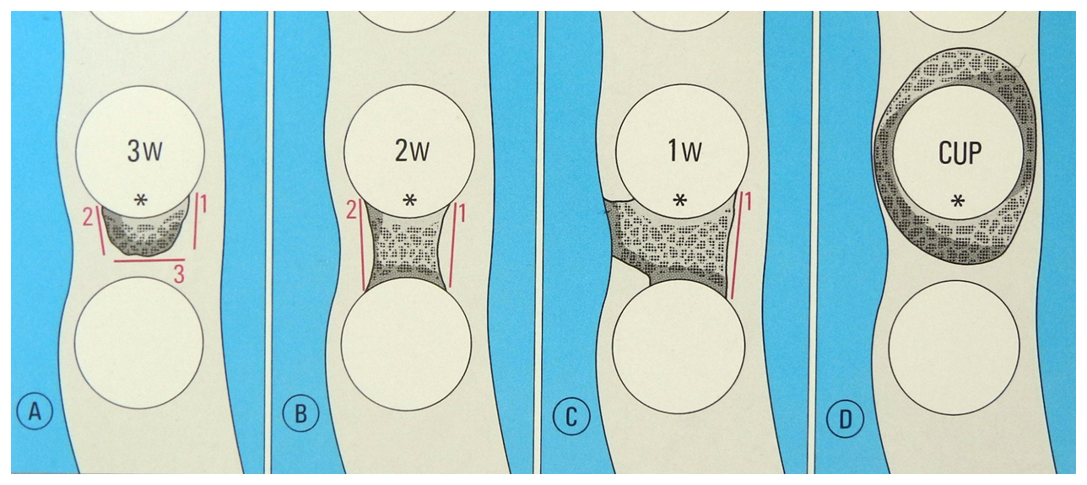
A_ 3 walls intact (buccal _ lingual and mesial) 1 wall defect (distal ) :
Most common defect and easily be treated ,why ?
Because the walls are narrow and deep so we can regenerate bone by scaling and ohi
B_2 walls intact (buccal_lingual)2wall defect (mesial _ distal) most revenant type with excellent prognosis because it is not deep If deep it needs bone graft
C_ 1wall intact (lingual ) 3 walls defect (buccal _ mesial and distal )
The prognoses is poor
The part that include in mid exam is only the biological width
The normal width is 1.97 mm
Physiologic dimension of the junction epithelium and connective tissue attachment above the level of the alveolar crest
Normal relation of the gingiva to the tooth and bone
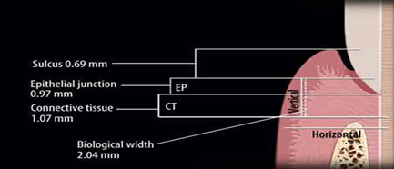
2 mm biological width (epithelium junction +connective tissue attachment )
Normal relation of gingiva to bone that the gingiva attend to scalloped from cej
The gingiva attend to more convexity when attached to root specially in anterior teeth due to anatomy
Achieve physiologic contours in the bone during surgery that parallel the anticipated post surgical gingival form
If we don’t achieve the normal relations of gingiva ,we will have at end wrong healing which means wrong junctional epithelium so we end in pocket
Good luck

