**Fast review**

**normal PH of the body(7.2 -7.4)**

**\*humans body has four important buffers**

**-Bicarbonate : most important ECF buffer**

**H2O + CO2 🡨 🡪 H2CO3 🡨 🡪 H+ + HCO3 -**

**-Phosphate : important renal tubular buffer**

**HPO4-- + H+🡨 🡪 H2PO 4 -**

**-Ammonia : important renal tubular buffer**

**NH3 + H+ 🡨 🡪 NH4+**

**-Proteins : important intracellular buffers**

**H+ + Hb 🡨 🡪 HHb**

**\*The most important buffer system is bicarbonate , because it is regulated by renal and respiratory systems**

**60-80 mmol/day of non-volatile acid is elemenated by kidneys like phosphoric acid , and these non-volatile acids are generated from food.**

**The best pH for any buffer system is around its pKa.**

***Respiratory Regulation of Acid-Base Balance***

**[H+] alveolar ventilation pCO2**

**-**

**\*the feed back gain for this regulation =1.0 to 3.0**

**feedback gain is the correction over error which means for ex: in blood pressure regulation , the mean arterial pressure = 100 if it rises to reach 120, this rise is going to be detected by baroreceptors -receptors that detect any change in blood pressure - and is going to be decreased to reach for ex: 105,**

**correction = 120-105 =15**

**Error=105-100=5**

**Gain = 15/5 = 3**

**Note :when ever gain is higher the control system is better for ex : in the last previous example if:**

**Correction = 19.99999 and error = 0.00001 then gain=19.99999/0.00001= almost infinity... this indicate that this system is perfect .**

**Note : the error is never going to be zero**

**Note :renal regulation is better than the respiratory regulation because it 's gain is very high although it is slower than the respiratory .**

***Renal Regulation of Acid-Base Balance***

**H2O + CO2 🡨 🡪 H2CO3 🡨 🡪 H+ + HCO3 -**

***To reduce the acidosis state* according to the equation we increase HCO3- or decrease CO2 ,in respiratory regulation we decrease CO2 but in renal regulation we increase reabsorption of HCO3-,thus we increase [HCO3-]. On the other hand ,to reduce the state of alkalosis we don’t need to reabsorp HCO3- .**

**Note: sometimes our body Produce new HCO3- to titrate extra non-volatile acids that are produced.**

**Note: Kidneys conserve HCO3- and excrete acidic or basic urine depending on body needs ,in other words when there is acidosis state kidney secrete very little HCO3- -almost zero- , if there is alkalosis state kidney secrete a lot of HCO3- .**

**Reabsorption of bicarbonate (and H+ secretion) in different segments of renal tubule**

**Note The concentration of ions in the proximal tubule is the same like the concentration in the plasma .**

**Note : HCO3- is mostly absorbed at the proximal tubule 85% .**

**Note: For each HCO3- reabsorbed, there must be an H+ secreted. this is HCO3- that filtered not the exctra .**

**Mechanisms for HCO3- reabsorption and Na+ - H+ exchange in proximal tubule and thick loop of Henle**

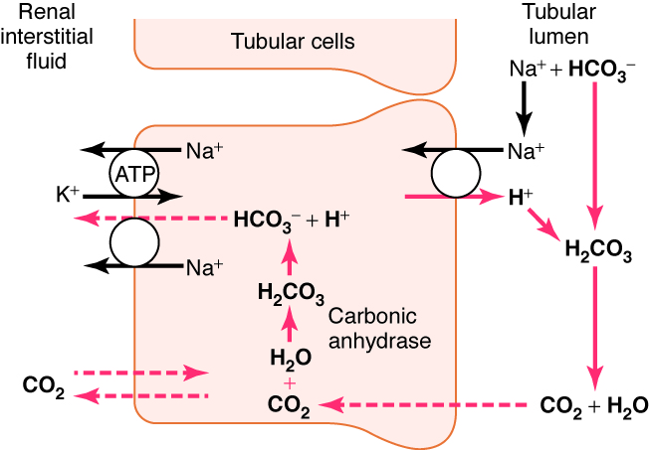

**A)By counter transport Na+ is going to be reabsorbed ,on the other hand H+ is going to be secreted.**

**B)H+is going to bind bicarbonate H2CO3, and H2O+CO2 are produced by the activity of carbonicanhydrase enzyme .which found at the brush border.**

**C)CO2 is going to be reabsorped becouse it is lipid soluble .**

**HCO3- do not absorb like this .. they need carrier**

**As we see here the bicarbonate that was absoed is the same one that was filtered there is nothing new but in coordinance with hydrogen secretion .**

**Note : the tight junction in the distal tubule and the collecting duct is really tight so it can maintain the gradient of pH (7.4 intracellular and 4.5 in the tubule-minimal pH- ) .on the other hand at the proximal tubule the minimal pH at this segment of the tubular lumen is 6.7 and it is l7.4 in the cell , even though we cant say that there is a gradient between the tubular pH and the cellular pH , because its not that functional gradient and this is due to the tight junction which is not really tight but instead of that it is partially open and as a result , this junction at this segment of loop of henle can not keep the pH gradient .**

**Note: the Dr mentioned that the intercalated cells have what is called hydrogen pump ,just like the pump in the stomach,H+ is pumped and because the junction is tight so they can create PH difference....,,?**

**As we said that the minimal pH in the tubular lumen is 4.5 so *its not logic to test a urine specimen and find out that the pH is 3***

***Regulation of H+ secretion.***

**\*Increased pCO2 increases H+ secretion 🡪 respiratory acidosis**

**\*decreased pCO2 decreases H+ secretion 🡪 respiratory alkalosis**

**\*Increased extracellular H+ increases H+ secretion 🡪 metabolic or respiratory acidosis**

**-metabolic usually deals with bicarbonate**

**\*Increased tubular fluid buffers increases H+ secretion 🡪 metabolic or respiratory acidosis.**

**How to define alkalosis and acidosis(metabolic vs respiratory)**

**pH is lower than 7.2 🡪 acidosis**

**pH is higher than 7.4 🡪 alkalosis**

**-then determine whether it is metabolic or respiratory by the following steps :**

**-pCO2 very high 🡪 respiratory acidosis pCO2 very low 🡪 respirator alkalosis**

**HCO3- very high 🡪 metabolic alkalosis HCO3- very low 🡪metabolic acidosis**

**Renal Compensations for Acid-Base Disorders**

**Acidosis:**

**- increase H+ secretion**

**- increase HCO3- reabsorption to titrate hydrogen**

**- production of new HCO3- to titrate acids**

**Alkalosis:**

**- decreased H+ secretion**

**- decreased HCO3- reabsorption**

**- loss of HCO3- in urine**

**In normal conditions acids are secreted then unite with buffers then buffers are absorped.**

**If there is acidosis we have to bring new bicarbonate but we cant produce new bicarbonate we only can reabsorbed what is filtered , but we can produce bicarbonate in ammonia and phosphate buffers ,bicarbonate buffer is just the absorbtion of what is filtered.**

**Importance of Renal Tubular Buffers**

**Minimum urine pH = 4.5**

**the maximal [H+] of urine is 0.03 mmol/L**

**the kidneys must excrete, under normal conditions, at least 60 mmol non-volatile acids each day.**

**Buffering of secreted H+ by filtered phosphate (NaHPO4-) and generation of “new” HCO3-**

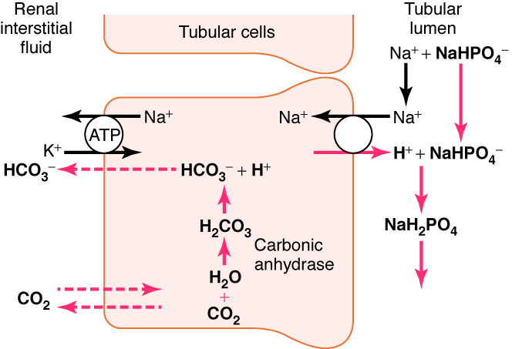

**-Disodiumphosphate Na2HPO4- is filtered then hydrogen ion is secreted whether in exchange with sodium or there is a hydrogen pump after a while , then hydrogen ion binds to phosphate in exchange with sodium .**

***The hydrogen came* from the dissociation of carbonic acid which was generated from H2O and CO2 ,then this bicarbonate acid dissociate as we said and produce H+ and newly formed HCO3- that can titrate the extra acid that was produced .**

**\*Phosphate buffer pK = 6.8 which a little bit better than carbonate buffer pKa=6.1 .**

**\**Phosphate normally buffers* about 30 mmol/day H+ (about 100 mmol/day phosphate is filtered but 70 % is reabsorbed)**

***\* Phosphate buffering capacity* does not change much with acid-base disturbances (phosphate is not the major tubular buffer in chronic acidosis**

**NaHPO4- + H+ 🡪NaH2PO4**

**Look at the figure slide #19**

**Phosphate and Ammonium Buffering In Chronic Acidosis**

**-in case of acidosis u can notice that we have an increase in phosphate buffering capacity .**

**-when you compare ammonia with phosphate buffer ammonia buffer has much higher increase when there is acidosis. But why?**

**-Because there will be an induction in the activity of glutaminase enzyme ,what is the glutaminase enzyme ?**

**-glutaminase is an enzyme that metabolizes and as a result of this metabolism ammonia is produced and this enzyme is induced by acidosis .**

**-Production and secretion of NH4+ and HCO3- by proximal, thick loop of Henle, and distal tubules**

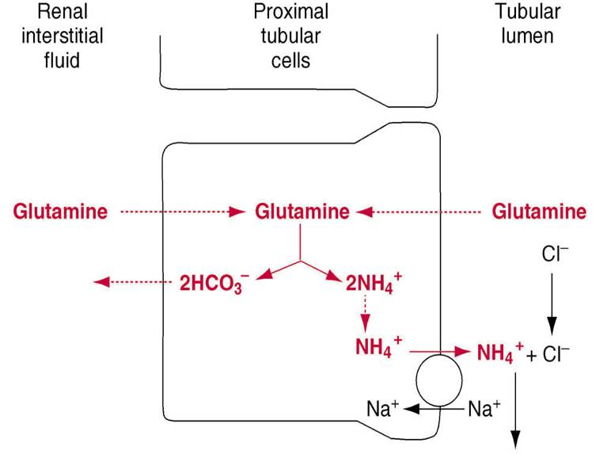 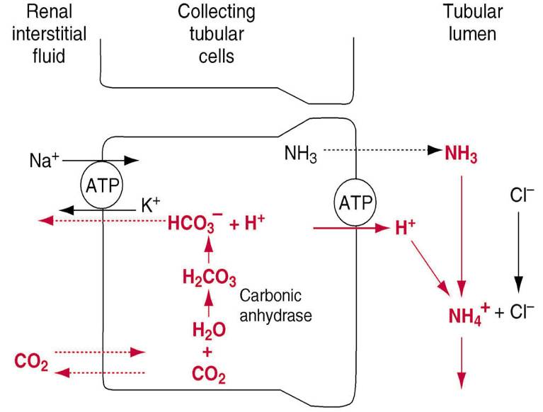

**A)Glutamine comes into the proximal tubular cells whether from tubular lumen or from renal interstitial fluid and by glutaminase its going to dissociate into 2NH4+ and 2HCO3-(new bicarbonate).**

**B)ammonia is lipid soluble , so it gets out side and binds H+ to form ammonium NH4+**

**In acidosis *glutaminase* is induced , production of ammonia increases , buffering capacity increasing for ammonium , so there is enough ammonia to titrate H+.**

***\*\*Renal Compensation for Acidosis***

**respiratory acidosis**

**PH<7.4**

**pCO2 high, as a renal compensation 🡪level of bicarbonate is high**

**Renal Compensation for Alkalosis**

**respiratory alkalosis**

**PH>7.4**

**pCO2 low , as compensation 🡪 excreation of bicarbonate 🡪 level of bicarbonate**

**Classification of Acid-Base Disorders from plasma pH, pCO2, and HCO3-**

**Acidosis : pH < 7.4**

**- metabolic : HCO3 - **

**- respiratory : pCO2 **

**Alkalosis : pH > 7.4**

**- metabolic : HCO3**

**-respiratory : pCO2**

**Renal Responses to Respiratory Acidosis**

**Respiratory acidosis means that there is low pH, high pCO2, high HCO3- as compensation**

**When pCO2 increases H+ secretion increases and as a result of that kidney completely reabs. HCO3-, but still there is excess H+ which is going to be titrated by phosphate and ammonia buffers.**

**This process of H+ titration include formation of new bicarbonate, this new bicarbonate will provide negative feedback on pH to increase it.**

**Renal Responses to Metabolic Acidosis**

**Metabolic acidosis means that there is low ph ,low pCO2, low HCO3- as compensation.**

**When HCO3- decreases HCO3- filtration decreases and as a result of that kidney completely reabs. HCO3-, but still there is excess H+ which is going to be titrated by phosphate and ammonia buffers.**

**This process of H+ titration include formation of new bicarbonate, this new bicarbonate will provide negative feedback on pH to increase it.**

**Renal Responses to Respiratory Alkalosis**

**Respiratory alkalosis means that there is high pH , low pCO2, low HCO3- as compensation.**

**When pCO2 decreases , H+ secretion decreases and as a result ; kidney will decrease reabsorption of HCO3-, so there is excess HCO3- ,this will increase excretion of HCO3- and decrease H+ excretion. This will provide negative feedback to decrease pH.**

**Note :no bicarbonate is produced.**

**Renal Responses to Metabolic Alkalosis**

***Metabolic alkalosis* means that there is high pH ,high pCO2 , high HCO3- as compensation.**

**When HCO3- increases HCO3- filtration increases and as a result there will be excess tubular HCO3- ,this will lead to reduction in HCO3- excretion . HCO3- excretion will increase and H+ excretion will decrease. This will provide negative feedback to decrease pH.**

**Note :no bicarbonate is produced.**

**Summary**

**Note :CO2 normal range 30-40**

**HCO3 normal=24**

**In this question notice that there is an increase in HCO3- so we conclude that there is metabolic alkalosis but in metabolic alkalosis CO2 must increase , but here its is decreased so there is respiratory alkalosis as well.**

**Note: if aldosterone increases tubular K+ secretion increases, ,as a result K+ is low 🡪 K+ is exchanged with H+ so H+ is excreted 🡪metabolic alkalosis as a compensation of low K+.**

**Note : overuse of diuretics aldosterone antagonist has the same effect like lasix**

**Too much lasix 🡪too much depretion in the extracellular volume🡪angiotensin II increases till we reach metabolic alkalosis.**

***Micturition :*The action of urination***

**\*Micturition depends on the level of urine in the urinary bladder .**

**\*urinary bladder has to sphincters 1- internal urethrosphencter (smooth muscle ,involuntary ) 2- external urethrosphencter(skeletal muscle , voluntary )**

**\*urinary bladder is supplied by**

**1)sympathetic nerve 🡪 thoracolumbar🡪supply detrusor muscles**

**2) parasympathetic nerve🡪 craniosacral**

**3) spinal nerve 🡪 pudendal nerve 🡪supply external urethral sphincter**

**Inside urinary bladder there is stretch receptors ,so whenever the bladder is filled by urine the stretch increases, impulse transmits to the lumbosacral areas ,to the micturition reflex center, the impulse comes back to the urinary bladder through parasympathetic and makes more and more contraction .**

**Notice that the *process of micturition* is automatic ,eventhough it is controlled by the cerebral cortex whenever it is fully mature at age 2 years**

**\**Micturition controlled* by the CNS is achieved by T4.**

***When urinary bladder is filled* ,with the contraction of detrusor muscles the internal urethral sphincter is relaxed , thus a little urine reaches the external urethral sphincter ,this makes the person feel the desire to urinate.**

***At normal condition* he/she can go to bathroom and urinate normally ,otherwise this process is suppressed by cerebral cortex ,through micturition reflex center. After a while the micturition reflex is going to be cut ,but it will come back whenever the bladder is filled with more urine and the stretch increases .**

**With more urine in the bladder the level of micturition contractions increases as well as they are going to be more frequent .** 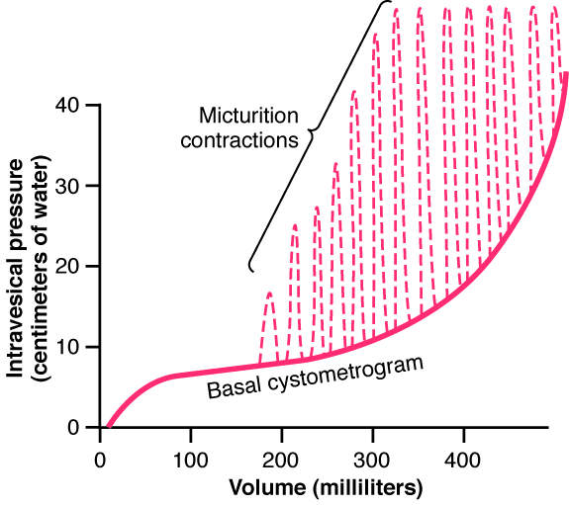



**Sorry 4 being late …. Plz if u find any mistake don’t hesitate to tell**