18/5/2014
Saliva
The doctor gave us 17 slides and he mentioned everything in them with some extra notes , So I added the notes to the slides instead of copying them all over again ..
- no need to refer to the slides :D
- Slide 1 is the title of the lecture ^^
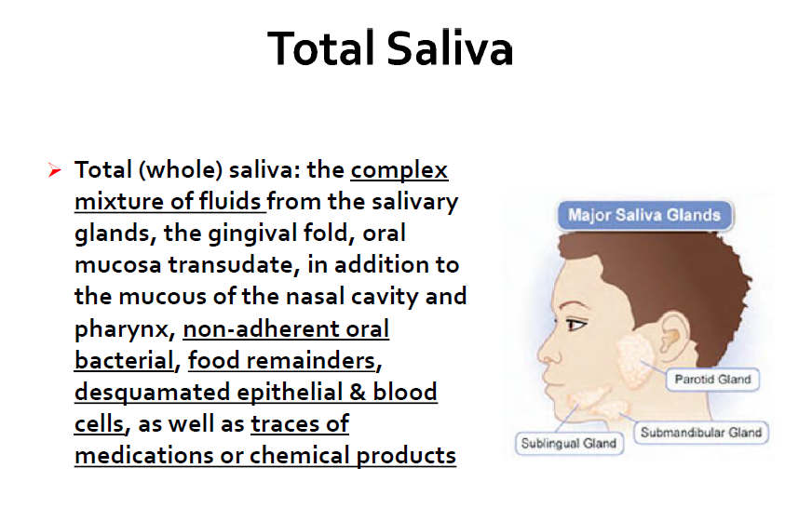
Slide 2 :
____________________________________________________________
- Oral mucosa transudate secretions that come from the mucosa.
- Anything in the blood may also appear in the saliva “ things in the blood go through transpiration process “
* transpiration y3ni el ashya2 btersha7 mn el blood lal saliva ..
Slide 3:
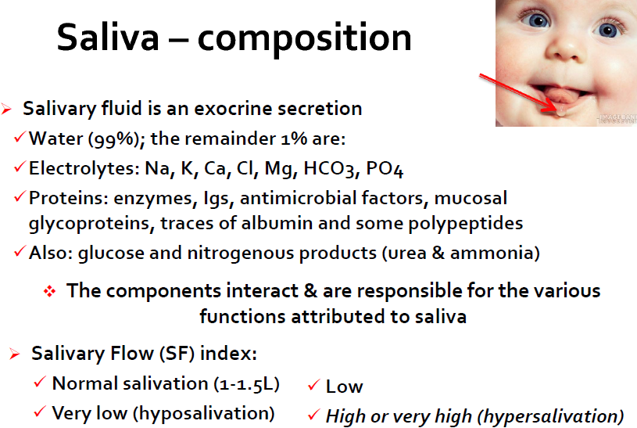
- Saliva is composed mainly from water and the remainder are electrolytes , proteins ..
- Immunoglobulin’s IgA is present in all the secretions and the only Ig that may present in the secretions normally .. In saliva IgM and IgG are also present .
- Albumin also comes from blood , that’s why it appears in small amount “ traces “
- Urea is synthesized in the liver then transported to kidney by the portal vein which means it goes through systemic circulation , once it reaches the intestine it will be degraded by bacterial urease to ammonia and this is dangerous to people with renal failure because they will have increased levels of ammonia which is toxic .. same story with oral cavity , it has bacterial urease also .. and same story
fits here with people with renal failure.

Slide 4 :

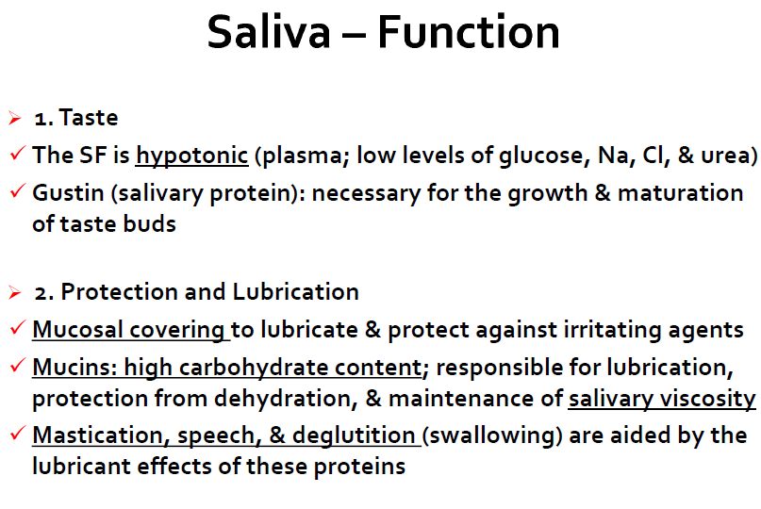__________________________________________________________________
- Functions of saliva :
Starting with taste ; saliva works as a solvent .
Salivary flow should be hypotonic “ same composition of plasma but with lesser amounts which makes it easier for us to differentiate between the food we taste “ ..
- Mucins are proteins that have multiple types from 1 to 7 , increasing the carbohydrates contents on these protein make saliva more viscous .
- As long as viscosity is increasing , it makes mastication easier.

Slide 5 :
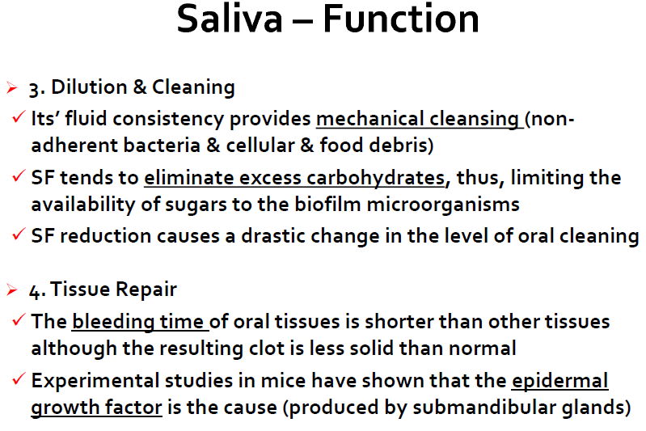

- The flow of saliva keeps dissolving the ingested material until it cleans the mouth from it .
- Salivary flow will decrease the carbohydrates contents on the surface of the teeth which results in less dental carries.
- Salivary content has a role in decreasing the bleeding time that’s why when you have a cut in your finger the first thing you do is sucking it , resulting in a clot that’s less solid than normal .. Growth factor is the cause of this role.

Slide 6 :
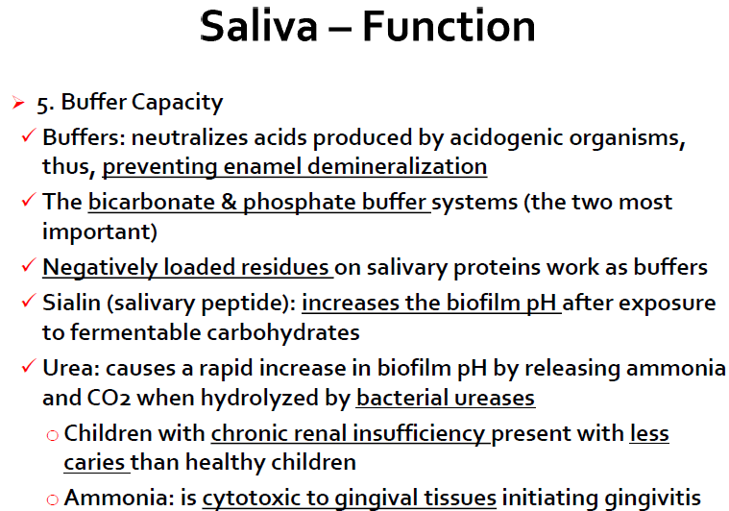
- Saliva works as a buffer because it reduces the acidity that’s produced by bacteria , that’s why it decrease Enamel demineralization ..
- Bicarbonate and phosphate are the two most important buffers in the human body , as well as the the negatively charged proteins .
- The negatively charged proteins linked to H+ decreasing the acidity .
- Sialin ( -ve charged protein ) increases PH decreases acidity .
- Urea also decreases the acidity because it’s a base component .
- Children with chronic renal insufficiency have high urea ratio so more urea will reach the oral cavity resulting in decreasing the acidity thus less dental caries .
- High ratio of urea results in high ratio of ammonia causing gingivitis.

Slide 7 :
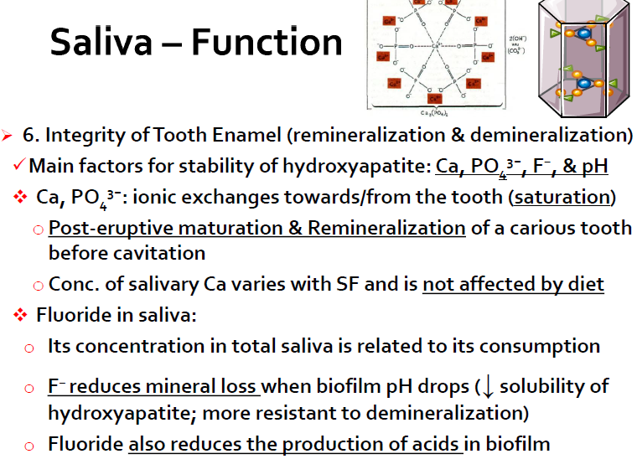

- Increasing Ca ratio will result in less cavitations in teeth ..
- What controls the ratio of Ca is the concentration , if the Ca decreases in the oral cavity it will move out from the teeth to the mouth as to compensate and this activity is ruled by low PH .
- Its important for us to keep in our minds that Ca ratio in the oral cavity is not affected by diet , because what come from the diet aided originally by hormones .
- F replaces the P place in the hydroxyapatite crystals .. results in reducing mineral loss because its less soluble and it also aids in decreasing the acidity.

Slide 8 :
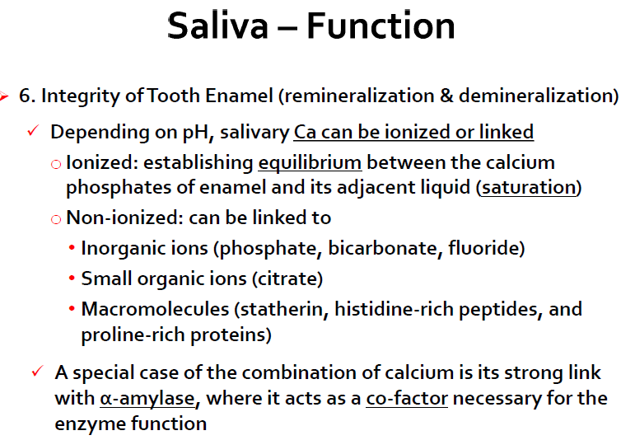

- Ca may be linked to protein or free in the solution ; it depends on the PH.
- Low PH high acidity free Ca
- High PH low acidity linked Ca
- Ca attaches to α-amylase to make it function , if its not attached it wont function so It works as a cofactor.

Slide 9 :

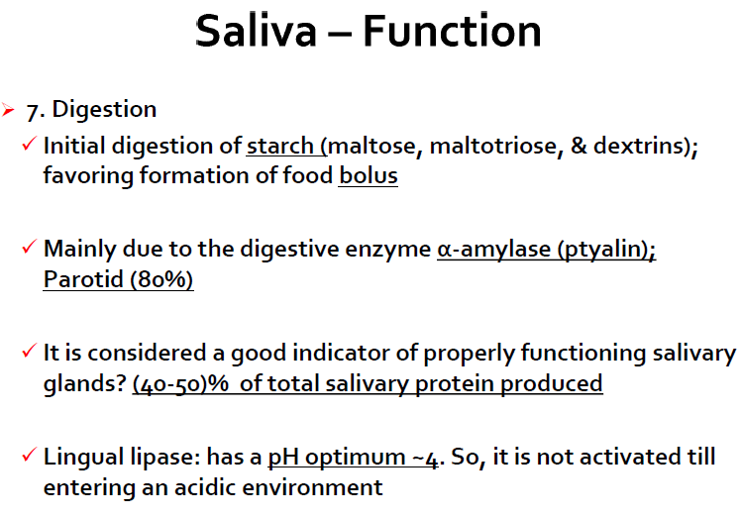

- Salivary lingual lipase doesn’t function in the oral cavity because it needs more acidic environment .

Slide 10 :

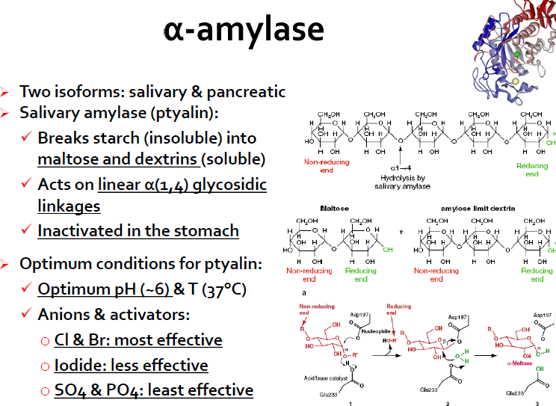

- If we want α-amylase to work better we should increase the Cl and Br ratio because they are the most effective activators for it .

Slide 11 :

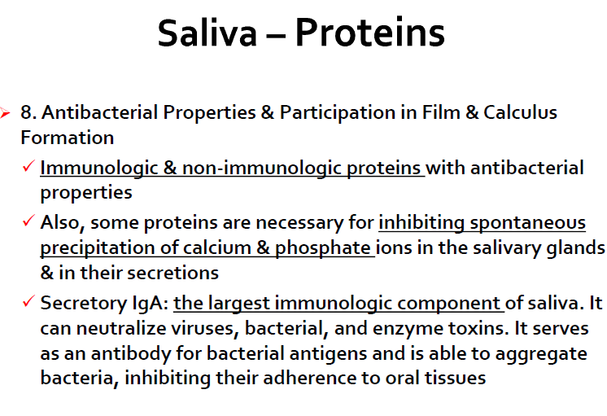

- IgA is in the form of dimer in the secretions .
- As I mentioned earlier we can find IgM and IgG.

- Slide 12 :
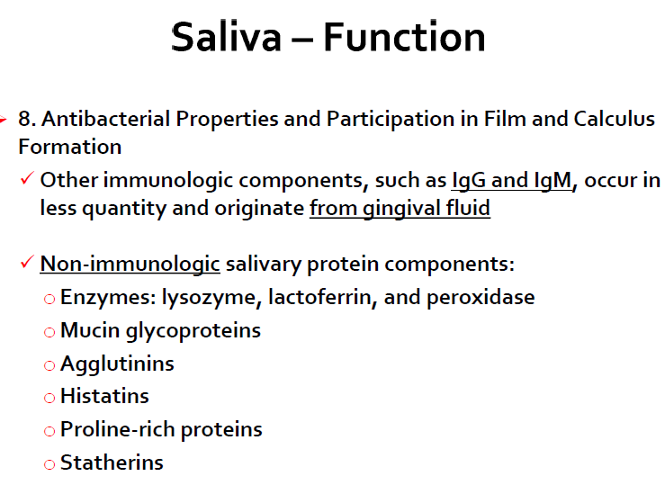

Slide 13 :
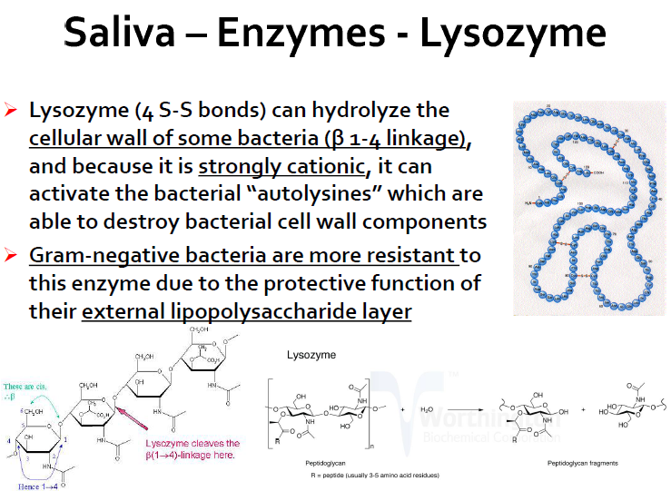

- Since lysozyme is strongly cationic it will link to the –ve carbohydrates in the bacterial wall and breaks it.
- Gram negative bacteria is protected by the external lipolysaccharide layer but still lysozyme can break it also.

Slide 14 :

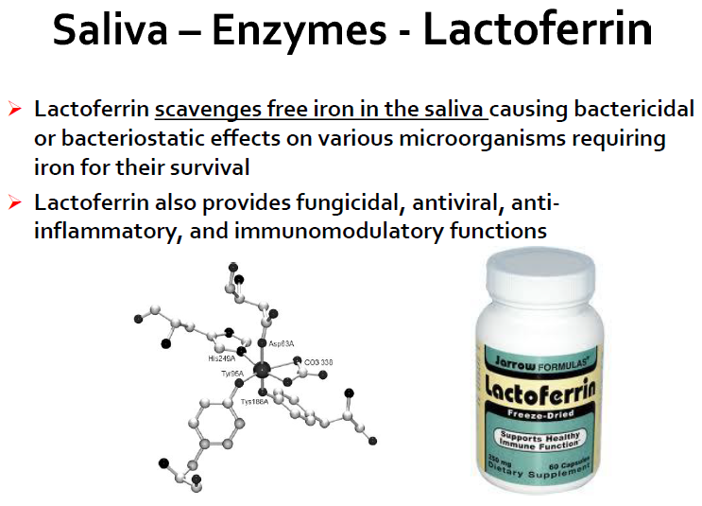

- Iron is an essential element for all organisms and lactoferrin works as a scavenger to it .

Slide 15 :

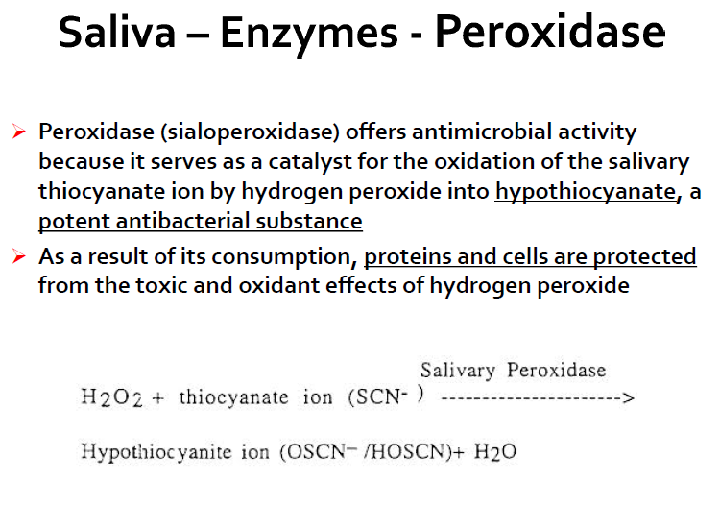

- Peroxidase transform H2O2 into H2o and during the reaction thiocyanate becomes hypothiocyanite which is an antibacterial agent and aids in the immunologic process .

Slide 16 :

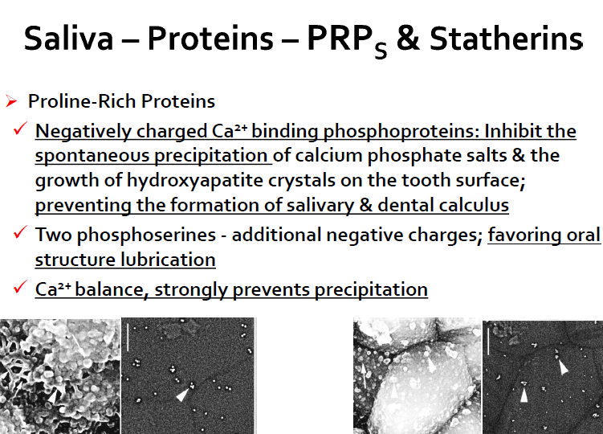

- PRPs and Statherins are negatively charged proteins .
- They bind to Ca so they have a role in Ca balance .
- They also have a role in buffering capacity .
- They have two serines that are bounded to phosphate forming what we call phosphoserine .

Slide 17 :

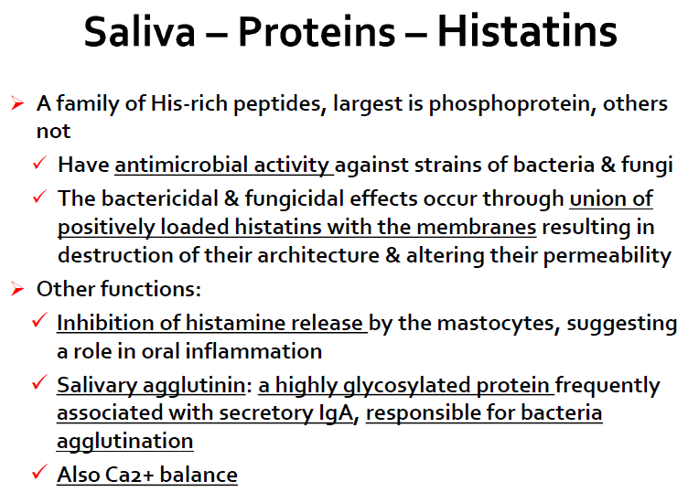

- Histatins are Histidine rich “ +vely charged “
- Since they are positively charged they will bind to the –vely charged carbohydrates in the bacterial wall and break it which give them an antimicrobial activity.
- Agglutination is an example of histatins.
- Ca balance is maintained by PRPs , Statherins and histatins .

- Good luck all ^^
Done by : Ala’a B. Bashir ..

