Bleeding disorders are a group of conditions in which there is a problem with the body's blood clotting process. These disorders can lead to heavy and prolonged bleeding after an injury.
Those patients have bleeding tendency more than others and this depend on homeostasis *.( Hemostasis or homeostasis (from the Ancient Greek: "styptic (drug)") is a process which causes bleeding to stop, meaning to keep blood within a damaged blood vessel (the opposite of hemostasis is hemorrhage))
So some people has severe bleeding because minor trauma and other have bleeding tendency that not clear .
- Normal hemostasis is vital for prevention of blood loss, but controls are necessary to limit coagulation to the site of injury. The hemostatic system is a vital protective mechanism that is responsible for preventing blood loss by sealing sites of injury in the vascular system. However, hemostasis must be controlled so that blood does not coagulate within the vasculature and restrict normal blood flow.
- The endothelial cells of intact vessels prevent thrombus formation by secreting tissue plasminogen activator (t-PA)* and by inactivating thrombin and adenosine diphosphate (ADP).
*Tissue plasminogen activator (TPA) was recently cloned and is now produced in mass quantities by the biotech firm, Amgen. It is used clinically to dissolve clots in coronary arteries following a heart attack. It is also used to dissolve clots in the brain following stroke
After injury of epithelium, we have tow mechanism that occur at the wound site:
1-Primary homeostasis
2-Secondary homeostasis

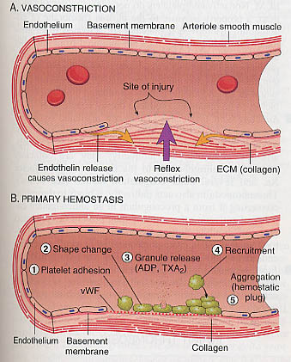According this picture:
First we start with activation of sympathetic system and this activation lead to vasoconstriction then releasing the factors and then platelets aggregation
So the Adhesion occurs when circulating von Willebrand factor (vWf)* attaches to the sub-endothelium. Next, glycoproteins on the platelet surface adhere to the "sticky" von Willebrand factor (vWf). Platelets collect across the injured surface. These platelets are then "activated" by contact with collagen. Collagen-activated platelets form pseudo-pods which stretch out to cover the injured surface and bridge exposed fibers. The collagen-activated platelet membranes expose receptors which bind circulating fibrinogen to their surfaces. Fibrinogen has many platelet binding sites. An aggregation of platelets and fibrinogen build up to form a soft plug. Platelet aggregation occurs about 20 seconds after injury.
* Von Willebrand factor (vWF) is a blood glycoprotein involved in hemostasis. It is deficient or defective in von Willebrand disease and is involved in a large number of other diseases, including thrombotic thrombocytopenic purpura, Heyde's syndrome, and possibly hemolytic-uremic syndrome.^{[1]} Increased plasma levels in a large number of cardiovascular, neoplastic, and connective tissue diseases are presumed to arise from adverse changes to the endothelium, and may contribute to an increased risk of thrombosis.^{[citation needed]}

Secondary Hemostasis
- Secondary hemostasis is responsible for stabilizing the soft clot and maintaining vasoconstriction. Vasoconstriction is maintained by platelet secretion of serotonin, prostaglandin and thromboxane. The soft plug is solidified through a complex interaction between platelet membrane, enzymes, and coagulation factors. It leads to the formation of the permanent plug
- Secondary hemostasis involves the activation of the coagulation cascade. The cascade model consists of sequence of steps where enzymes cleave proenzyme to generate the next enzyme in the cascase. It consists of the extrinsic and intrinsic pathways which merge together into the common pathway leading to activation of thrombin. Thrombin cleaves fibrinogen into fibrin which becomes cross linked to form the permanent plug
According to this picture:
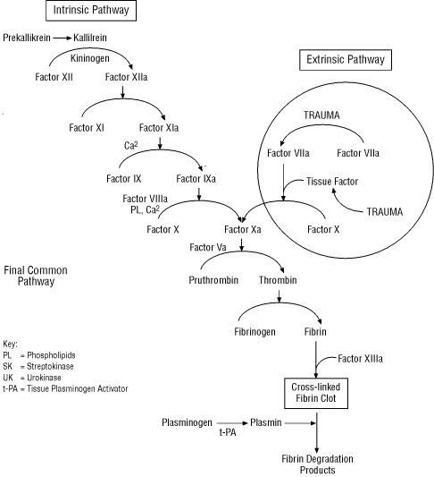
Coagulation pathways have been divided into three distinct pathways: extrinsic, intrinsic and common
Extrinsic pathway: This is composed of:
Tissue factor (cofactor)
The TF-FVIIa complex
So its start always by factor 7

Intrinsic pathway: This is composed of:

FXII, FXI, and FIX

FVIII
So this pathway start with 4 factors (11, 12, 9, 8)

Common pathway: This is composed of:
- Enzymatic coagulation factors: FX, prothrombin (FII) and FXIII (crosslinker)
- The cofactor: FV
- Factor 10
- These pathways interact on the surface of cells to generate thrombin, which cleaves and crosslinks fibrin.
Cell based model of coagulation
New studies suggest that coagulation occurs in vivo in distinct overlapping phases. It requires the participation of 2 different cell types: Platelets and Tissue Factor (TF) bearing cells.
All evidence to date indicates that the sole relevant initiator of coagulation in vivo is TF. Cells expressing TF are generally localized outside the vasculature, which prevents initiation of coagulation under normal flow circumstances with an intact endothelium
*When plasma comes into contact with TF bearing cells, activated factor VII (VIIa) makes a complex with exposed TF( means these cells that outside the vascular compartment inactive until it exposed to tissue factor such as exposed to rapture .
* The TF-VIIa complex activates more FVII as well as Factors IX and X. Which in turn cleaves prothrombin to thrombin?
.
So, why do we have to know those facts?
To make sure that this patient doesn't have any bleeding tendency and this done by make proper history taking and proper diagnosis + evaluation tests+
So bleeding tendency result from: 1- liver disease
2-platlet deficiency or any drug that has anti-platelet effect
3-any patient who has history in platelets function

Note: all coagulation factors are present in liver except factor A which is not present in liver
Factor A*: Vascular endothelial growth factor A (VEGF-A) is a protein that in humans is encoded by the VEGFA gene
Plays a significant role in neurons and is considered to be the main, dominant inducer to the growth of blood vessels so its synthesis in endothelial cells
Note: the history is very important in any disease for example about the (age): if we have old patient so this indicates this patient has a lot of events in his life so that will increase to have bleeding tendency but if we have teenage pt so the number of events that faced a little so the Probability to have bleeding tendency will be less!!
Note: primary homeostasis occur immediately after trauma + The main factor of primary hemostasis: blood vessel, platelet +it happen at mucocutanus surface, gingival bleeding .and skin
While in secondary: it delays the bleeding and stops it and controls it in 24 hrs and the main factor: coagulation factor+ happen deeper to tissue such as soft tissue bleeding or GI bleeding or bleeding in the bone
**this important in gum bleeding, bleeding after minor trauma, after minor surgery
Patient Evaluation
*History is an essential part and almost any patient with bleeding tendency will give a clue if history was undertaken appropriately.
*Previous history of bleeding episodes (e.g. epistaxis, bruises, dental or gingival, excessive menstrual, post surgical procedures, etc)
*Family history of bleeding tendencies (both are negative that’s mean its not exist but if one of them positive so its exist)
- Consanguinity
How you confirm your diagnosis??
First to confirm your diagnosis you should to use tests to evaluate platelets function and bleeding tendency
tests used to evaluate primary hemostasis :
1- CBC/blood smear/platelet estimate or count
2- bleeding time
3- vWF DNA (from Wikipedia)
4- vWF ELISA( Wikipedia )
**Tests used to evaluate secondary hemostasis:
1- PT: prothrombin time, (PT) which measures the extrinsic pathway
2- PTT: activated partial thromboplastin time, PTT is a performance indicator of the efficacy of both the "intrinsic" and the common coagulation pathways

**Platelet role:
Platelets play a major role in primary hemostasis. Platelet malfunction may occur because of two major reasons:
Low platelet count (quantitative defect): Thrombocytopenia
Dysfunctioning (though normal count; Qualitative defect) platelets: Thrombasthenia
Platelet disorder:
- Platelet disorders results in defects involving primary hemostasis. Characteristic physical examination findings include petechiae and purpura, gingival bleeding, and epistaxis.
The patient will have a prolonged bleeding time, and platelet count may be decreased (normal range between 140,000 to 450,000/microL). Other tests which can used to assess platelet function is platelet aggregation and platelet function analyzer.
Look to this picture: This is purpura (thrombocytopenic) + its one of primary homeostasis effect +present in lymph nodes in upper or lower limb + its one of mucocutaneous bleeding
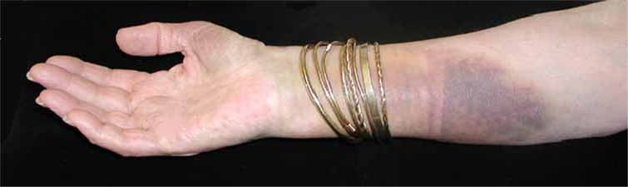
- Thrombocytopenia: Is defined as a platelet count of less than 140,000/microL.
- Patients will complain of signs and symptoms of bleeding, mostly in the mucocutaneous parts.
- Lab tests will show prolonged bleeding time. PT and aPTT tests will be normal
*Causes:
1-most common cause Thrombotic thrombocytopenic purpura (*is a rare disorder of the blood-coagulation system, causing extensive microscopic clots to form in the small blood vessels throughout the body. And the problem beyond the bone marrow so before do the procedure we test the blood smear and if the pt has symptomatic disorder so its sever thromboceptenia and sometimes it could be asymptomatic so the best way for diagnosis is exclusive all other causes )(severe)thromboceptenia in the same time it cause thrombosis
2- Pseudo-thrombocytopenia
3- Immune thrombocytopenic purpura
4- Gestational thrombocytopenia
5- Hypertensive disorders of pregnancy (preeclampsia)(not sever )(mild)
6- Drug-induced thrombocytopenia (anti-platelet drugs, Heparin, antibiotics, antidiuretic) (mild thrombocytopenic)
Any medicines destroy platelets or interfere with the body's ability to make enough of them Chemotherapy drugs and a seizure medication called valproic acid may lead to this problem
- Quinidine
- Amiodarone
- Captopril
- Glibenclamide
- Carbamazepine
- Cimetidine
- Tamoxifen
- Ranitidine
- Valproic Acid
- Vancomycin
- Piperacillin
- Heparin
Chemotherapeutic Agents
7- Vitamin B12 deficiency
8- Leukemia (bone marrow failure) and anything that affect on bone marrow such as alcohol
9- Viral Infections (e.g. HIV infection)
Conclusion: thrombocytopenia:
1-low platelet count <140,000
2- Normal ptt
3-normal pt
4- important in dental procedures and post-surgical procedure

Thrombasthenia:
The underlying etiology is an abnormally functioning platelets in spite of normal count(normal count +abnormal function)
*Causes:
von Willebrand disease (the most common inherited bleeding disorder)* is the most common hereditary coagulation abnormality described in humans, although it can also be acquired as a result of other medical conditions, the dominant type
Uremia
Aspirin and NSAIDs
Glanzmann’s thrombasthenia* (bleeding disorder due to blood abnormality)
Conclusion: Thrombasthenia:
1-prolong bleeding time
2-ptt is normal
3-pt is normal
4-clincally: mucocutanouos bleeding, gingival bleeding
5-abnormal function of platelets

Platelets disorders:
In the absence of platelet qualitative disorder, most surgical procedures can be done safely if platelet count is above 50,000. In case of high risk of bleeding surgeries (e.g. neurosurgical surgeries), a platelet count of at least 100,000 is required
Screening tests:
- The prothrombin time (PT) and its derived measures of international normalized ratio (INR) are measures of the extrinsic pathway of coagulation and common pathway.
  - Measures function of VII, X, Prothrombin, fibrinogen
- Check in Warfarin treatment(produce anticoagulant and anti platelets effect )and, Liver Failure, Vit K deficiency, DIC
So why in the patients who take Warfarin have high (INR)?? because when take Warfarin first that’s lead to consume factor 7 that responsible for externstic pathway so its affect on externstic pathway but if you increases the dose more than normal that will lead to consume all coagulation factors
So patient who take Warfarin?
Normal dose: 1-high pt 2- high INR 3- ptt no affect 4- consume factor 7
High doses: 1- high pt 2- high INR 3-high ptt 4- consume all factors

It is important to monitor the INR (at least once a month and sometimes as often as twice weekly) to make sure that the level of Warfarin remains in the effective range. If the INR is too low, blood clots will not be prevented, but if the INR is too high, there is an increased risk of bleeding. This is why those who take Warfarin must have their blood tested so frequently.*

Screening tests:
*The partial thromboplastin time (PTT) or activated partial thromboplastin time (aPTT or APTT) is a performance indicator measuring the efficacy of both the "intrinsic" and the common coagulation pathways.

*Detects decrease in
XII, XI, IX, VIII, and Anti-phospholipids.
*Check in:
Heparin therapy, hemophilia A and B, antiphospholipid syndrome
- . Disseminated intravascular coagulation (DIC): is a complex systemic thrombohemorrhagic disorder involving the generation of intravascular fibrin and the consumption of procoagulants and platelets. The resultant clinical condition is characterized by intravascular coagulation and hemorrhage.
- Is always secondary to an underlying etiology and can be acute or chronic. DIC is caused by widespread, uncontrolled and ongoing activation of coagulation, leading to micro-vascular fibrin deposition, compromising blood supply to various organs.
- The ongoing coagulation process will consume clotting factors and platelets leading to prolonged PT, PTT and thrombocytopenia
- Note :*refer to: from Wikipedia sources
Literary spot
Positive thinking is a mental and emotional attitude that focuses on the bright side of life and expects positive results.
A positive person anticipates happiness, health and success, and believes he or she can overcome any obstacle and difficulty.
Positive thinking is not accepted by everyone. Some, consider it as nonsense, and scoff at people who follow it, but there are a growing number of people, who accept positive thinking as a fact, and believe in its effectiveness.
It seems that this subject is gaining popularity, as evidenced by the many books, lectures and courses about it.
To use it in your life, you need more than just to be aware of its existence. You need to adopt the attitude of positive thinking in everything you do.
DONE BY : MAIS KHRISAT

