Sheet no :3
Refer to slide no : 3
Written by : Mahmoud Qaisi
corrected by Sahem Jamaen
*********************************************************
- After talking about G-banding and FISH techniques, we will start talking about molecular techniques.
In molecular techniques, we are dealing with the DNA more than anything else.
One of the molecular techniques is comparative genomic hybridization “CGH”. Sometimes there are no chromosomal abnormalities, yet there are clinical problems. Here we use two cells for the chromosomal analysis, one cell with normal chromosomes “from a normal person”, and the second cell will be taken from the person suspected to have the disease “a tumor for example”. Chromosomes will be taken from these cells “the chromosomes should be the same, for example if we took chromosome number 2 from one cell we should take chromosome number 2 from the other” then they are labeled with different colors “the chromosome from the normal person will be labeled green and the chromosome from the patient will be labeled red, for example”, then both chromosomes will be put in the same tube, then the tube will be heated, with heating the DNA of the chromosomes which is double stranded, will be separated, then the tubes are cooled, so hybridization “reunion of the DNA strands” will happen, since the chromosomes are the same, hybridization will be arbitrary “the red can bind with the green and vice versa”, then the chromosomes will be examined under the microscope “which will give us the resultant colors” and it will analyze the colors like a spectrophotometer. A hybrid chromosome will result “part green, part red”, to detect the abnormality, we put the result in the spectrum, if the red color is more in the tube then there is loss, but if the green color is more in the spectrum then there is gain, if both colors are present in equal amounts “the result is a mixture of both green and red colors” then the chromosomes are normal in the patient’s sample, but in this method we can’t detect the location of the gain or loss on the chromosome, so when the CGH is finished, the chromosomes are taken and sequenced to determine where the abnormality is present exactly, so CGH is done only to detect if there is an abnormality “deletion or duplication” in the chromosome, not to locate this abnormality, and the whole genome can be examined by this technique not only one or two chromosomes.
Some scientists apply CGH to the “exons of the DNA” only, but other scientists apply to the whole DNA “exons +introns”.
In sister chromatid exchange “unstable chromosomal structure”, the chromtids break and reunion arbitrary, this happens in some diseases like “one kind of anemia”, to examine the “sister chromatid exchange”, the chromatids are separated, then they are labeled “one chromtid is labeled green and the othe is labeled red, for example”, then we let them reunion with each other, the result will be a chromosome with its chromatids having segments from the green labeled chromatid and segments from the red labeled chromatid (like a zebra) “this happens because the chromosomal structure is unstable”.
So these are the three methods used to examine the chromosomes “G-banding, FISH, molecular techniques “CGH””.
Chromosomal abnormalities
chromosomal abnormalities can be classified into:
1-Numerical: depends on the number of chromosomes “normal or abnormal”, and this can be classified further into:
-Aneuploidy: here the abnormality is only in one chromosome “for example, chromosome number 22 instead of being 2 chromosomes “one maternal and one paternal” there will be three chromosome in it”.
The abnormality can be, monosomy “there is one chromosome instead of two”, trisomy “there are three chromosomes instead of two”, tetrasomy “there are four chromosomes instead of two”
-Polyploidy: here the abnormality is in all the chromosomes, here there may be 69 or even 92 chromosomes instead of 46 chromosomes inside the cell. “these patients usually die immediately after birth or they are born dead”.
2-Structural: here the number of chromosomes is normal, but the problem is in the structure of the chromosome, there may be: translocation, inversion, insertion, deletion, ring formation, duplication and isochromosomes.
Chromosomes can be Haploids “23 chromosomes” as in meioses 2, or Diploids as in any normal cell, where there will be 46 chromosomes, or Euploid, an exact or multiple of “n” or of the monoploid number.
One of the causes of chromosomal numerical abnormalities, is non-disjunction (it is the failure of homologous chromosomes or sister chromatids to separate properly during cell division.) happening in the sperm or the ovum, the sperm and the ovum after maturation they should only contain 23 chromosomes.
for example , Sometimes segregation doesn’t happen in the sperm, so after meioses the sperm still contains 46 chromosomes and when it fertilizes a normal ovum the resultant zygote will have 69 chromosomes, this also can happen when two normal sperms fertilize a normal ovum.
The non-disjunction can also happen in the ovum.
If the non-disjunction happens in both sperm and ovum the resultant cell will contain 92 chromosomes.
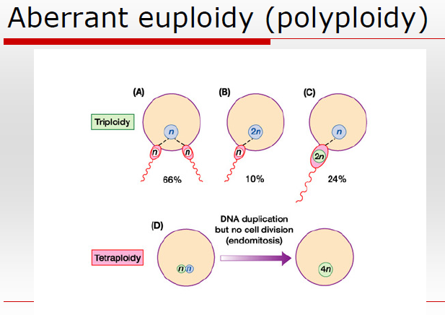 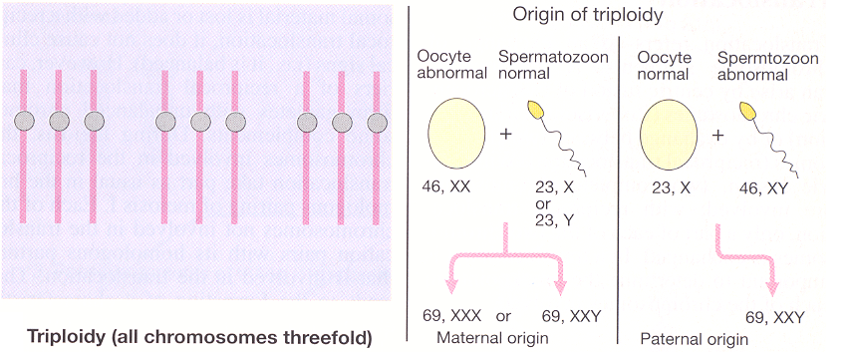
Aneuploidy, in general if there is one extra chromosome or one less chromosome in the somatic chromosomes then the human is not compatible with life, there are some exceptions like in Down and Patau syndromes, but life expectancy will be short .
Down syndrome patients usually survive up to 40-45 years, while in Patau syndrome it’s up to 7 years only, and there is Edward syndrome where the patients survive only for few years.
On the other hand numerical abnormalities can be present in the sex chromosomes, patients with these abnormalities can survive, but they will have problems.
These numerical abnormalities as mentioned happens due to non-disjunction either in:
-Meiosis 1: Two members of homologous chromosomes fails to separate and both members of a pair move into one cell. “monosomy and trisomy will result”
-Meiosis 2: When sister chromatids fail to separate. “monosomy, trisomy, and disomy “normal” will result”
Mosaicism: here in the same person, monosomy/trisomy.. can be seen in the patient in addition to normal cells. Mosaicism happens in early cell division, and 1% of cases of Down syndrome are mosaic cases.
Ovum age is equal to the mother’s age, while sperm is produced later during the life of the father, so because the ovum is aging “unlike the sperm which is produced instantly” the main problems that happens in the chromosomes are most likely from the maternal chromosomes.
The following chart shows “Distribution of non-disjunction”, so as you can see maternal chromosomes are more vulnerable to non-disjunction
Abnormalities can also result from rearrangement “cross-over”, usually in normal conditions cross-over happens between maternal and paternal chromosomes so the resultant child will have different chromosomes than his father and mother, but this cross-over can result in some cases with abnormalities.
Somatic chromosomal abnormalities.
As mentioned earlier there are three conditions where the patient can survive,
1-Down syndrome patient, it’s very easy to diagnose, and the patient will have certain characteristics, his face is typical, he has low sets of ears, the eyes are small, the bridge of the nose is flat, his hand contain only one line instead of two, they will have brushfield spots instead of eye lashes, the skin around the eye is folded, there is a space between the first and the second toe, they are mentally retarded, they have congenital heart problems, intestinal stenosis, and a short neck.
They have Alzheimer like dementia, because the gene that is responsible for Alzheimer disease is found on chromosome number 21, in the area where Down syndrome happens.
1/800 live birth is born with Down syndrome, but this incidence increases with age, but this doesn’t mean that the first baby for a young woman won’t get Down syndrome, unfortunately he can, and if the woman has a child with Down syndrome that doesn’t mean that her other children will have Down syndrome as well.
Chromosomal abnormalities that are present in patients with Down syndrome are different, 95% of the patient will have one extra chromosome “trisomy at chromosome 21” “they have 47 chromosomes instead of 46”, other cause is unbalanced translocation between chromosomes “13,14,15 which are acrocentric” and chromosome number 21 “which is also acrocentric” in 4% of the cases , in these patients if the chromosomes are counted 46 chromosomes will result but they actually have 47 chromosomes “the chromosomes have united with each other and formed long chromosomes”, and as mentioned earlier mosaicism can be seen in 1% of the cases.
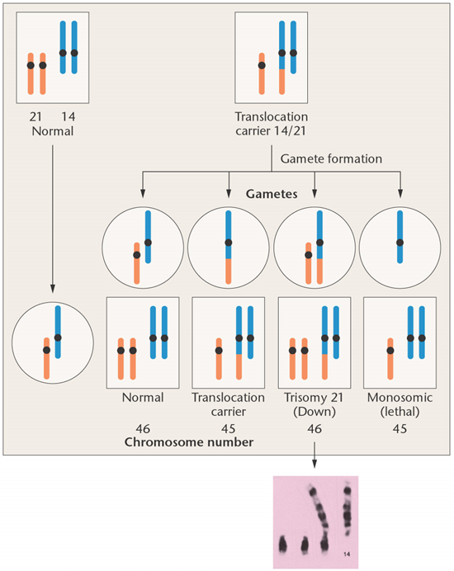
In the previous picture, at the left, there are normal chromosomes “number 14 and number 21”, they have segregated normally and the resultant was a normal gamete with 1 strand of chromosome #21 and 1 strand from chromosome #14, on the right, the cell isn’t normal (it’s a carrier), it has translocation that happened between chromosome #14 and chromosome #21 “a strand of chromosome 21 has become a part of chromosome 14 and the chromosome became long (red star), so in this cell if we counted the number of chromosomes the result will be 45, but in fact they are 46, because as mentioned one strand of chromosome #21 has become part of chromosome #14”, when this abnormal cell forms gametes the resultants will be:
1- normal gamete “green star”, 2- gamete with translocation (considered carrier) “yellow star”,3- gamete with three chromosome “orange star” 4- gamete with single chromosome “blue star”.
After fertilization with the normal gamete “on the left” the bottom four cells will result “the green arrow” and they are as described in the picture.
In this case “translocation” Down syndrome is considered inherited disease, but in the previous cases it’s not considered inherited disease in them.
In chromosome 13 if trisomy appeared, then there is Patau syndrome, the characteristics of this syndrome are, polydactyly “extra fingers in hands and feet”, cleft lip and palate, severe mental retardation, very small eyes, their fingers can’t be open completely and their grip is typical, they have seizures.
In this syndrome here are the causes
Translocation and mosaicism contribution in Patau syndrome is more than their contribution in Down syndrome.
In chromosome 18 if trisomy appeared, then the patient has Edward syndrome, the characteristics of the syndrome are, they have typical hand, very low set of ears, club like feet, mental retardation, very small mouth, heart problems, very short neck. 50% of the patients survive about 1 month, and the rest 50% die in 1 year.
There may be other trisomies in other chromosomes, for example trisomy 16, but they are very rare and they can’t survive.
The numerical abnormality may also be present in Sex chromosomes. X and Y chromosomes are the sex chromosomes, Y is the smallest chromosome in the body, and it contains the least number of genes.
Barr bodies, in females there are two X chromosomes, but usually one of them is inactive, the inactive X can be seen in some cells and is called a “Barr body”, it can be seen in the cytoplasm of the cell very close to the membrane of the cell.
Mary Lyon has discovered that the other X chromosome in females is inactive, by measuring the concentration of proteins that are coded by genes present on the X chromosome “factor 9 or factor 8 of the coagulative factors, G6PD” in both males and females, theoretically these proteins should be present in higher concentrations in females comparing to males, but actually their concentration was the same in both males and females.
So there is what’s called pseudo-genes meaning that the genes on the second X chromosome in females are not completely active, only the genes that are homologous to Y chromosome genes are active.
Depending on the previous information, in normal females there should be one Barr body, in males there shouldn’t be Barr bodies, but if a Barr body has been found in a male, this means that the male has another X chromosome “XXY”, and if two Barr bodies have been found in males then he has three X’s “XXXY”, and if there is 2 Barr bodies in females then she has 3 X’s “XXX”.
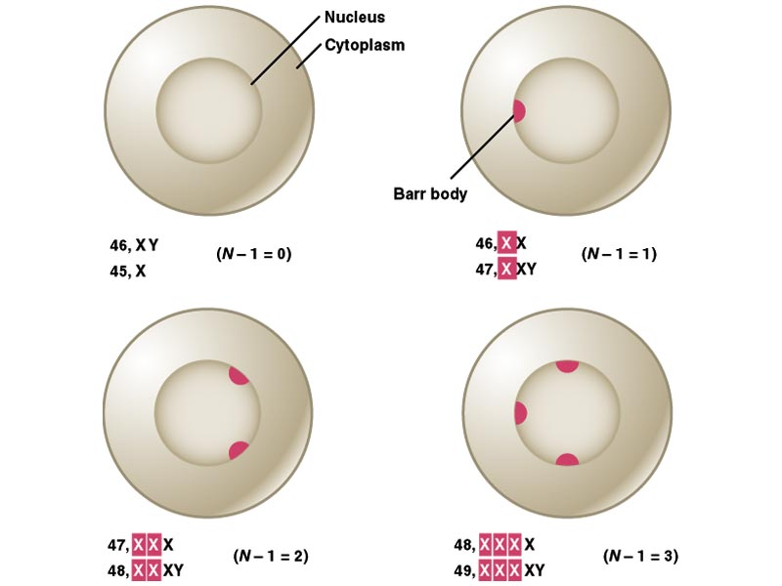
Barr bodies were used to know the sex of the infant “because in some cases infant’s gender can’t be detected”, and these Barr bodies were searched for in a buccal smear from the infant, the control cell for this test is taken from the mother, or from a pregnant woman.
In sex chromosomes are like somatic chromosomes, the abnormalities can result from non-disjunction at the first meiosis or, or at the second meiosis
the difference is that all the resultant are compatible with life except for those which doesn’t contain the X chromosome at all.
** Note: in Turner syndrome, the child is a girl but with no Barr body.
Turner syndrome, is a disease with typical characteristics, the patients survive normally, they have a short and very wide neck, there is a distance between the nipples, they have aortic problems, they have pigments “brown spots” spread all over the body, they have no ovaries “they are sterile”, and they have no menstruation.
The incidence is 1/1000, and as mentioned they are sterile, they may have 45 chromosomes, isochromosome, they may have also deletion in the p-arm of the X chromosome, deletion in the q-arm of X-chromosomes, ring formation, or mosaicism. All these can be found in Turner syndrome patient.
Klinefelter syndrome, here the patient is a male with two X’s, the patient has very long extremities, high levels of “LH, FSH”, gynecomastia “the breasts are well developed”, he has also high levels of prolactin, so breasts can produce milk in this patient, feminized habitus, he is also mentally retard.
60% of the patients are XXY, there may be mosaicism.
The incidence here is also 1/1000.

