Sheet no. : 9

Refer to slide no. :#1 dr. Mohammad Rababa'a

Written by: Rawan Mazen and Mayazeen Al-Awamleh
Corrected by : Farah Khouly

Matrices in restorative dentistry
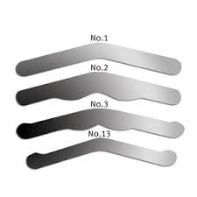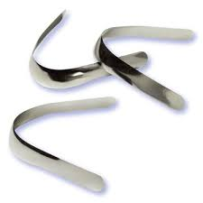
-Direct restorative material =its called also= plastic restorative material, because they are able to be molded by carving and condensation before they become firm
-In class | there are enough walls just to confine our material ...but in class || cavity preparation there is a missing wall so condensation is difficult and the placed material will flow to the gingiva and other tissues.
-Our main aim of doing cavity preparation is to restore the missing tooth structure ,at the same time we should prevent any further damage .
- 60 % of our job in dentistry is replacement “not placement”
Restorative cycle "occur in 60% of cases"
for example amalgam filling have an average cycle 10 years then it should be replaced each 10 years .with each replacement; we take off further sound tooth structure because there might be secondary carries .

Matrices are temporary wall for the missing one in- class || for example- when using plastic restorative material.
- Different type of bands used with eathier amalgam 'posterior teeth ' or composite 'with anterior teeth and posterior '
The purpose is to convert class || to class | to make it easier for condensation when using amalgam. For composite, bands must be thinner ,sometimes can exceed 50 microns but we need it as thin as possible to achieve the positive contact. Matrix bands are small ,shiny ,metal and their thickness shouldn't exceed 0.045=45 micron
* So Matrix bands are used for :
1- class || ..proximal surfaces MO, DO
2-class | with buccal and lingual extension.
3- cervical lesion which confined with cervical matrix band because " at the cervical wall , the lesion come from almost two plains "
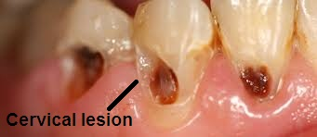

Ideal features of the matrix band

1- Re-establish the contour : in occlusal cavities I can carve it , but for proximal surfaces the matrix should be as smooth as enamel , if it is rough then we will have a plaque retentive area . So roughness shouldn't be more than the bacterial size " 10micron "for example .
-If the roughness is more, we can smoothen it by using : - glassed porcelain.- polished composite. .- polished amalgam ' by using the matrix band.'
matrix band made a polished surface .
2- Form positive contact so the food would not stuck between teeth .
3- Seal the gingival margin and make it able to be cleaned by flossing .
4-Allow adequate bulk of material to avoid fracture.
5- As thin as possible to form +ve contact .
6- It should be withdrawn easily , in order to not attract the restorative material.
7- It could be used with all direct restorative material.
8- It should be smooth to avoid plaque retentive area formation .

The universal matrix band/ retainer :
We call it Tofflemire matrix retainer , it has two slots for placement .
These matrices are smooth , shiny , brittle and their thickness arent more 45 micron ( its better to be thin to create a positive contact with the adjacent tooth ).
*Note: There is something called matrix band or helium we call it tofflemire matrices of helium ,have two slots .
** The opened notch of the tofflemire matrix band should be toward the gingival surface.
**All the tofflemire matrix bands should be placed buccally not lingually for easier manipulation.
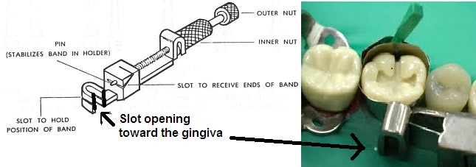

The inlet " narrow circumference" of the matrix band also should be toward the gingival surface, because the tooth from cervically to occlusally will become wider mesodistally
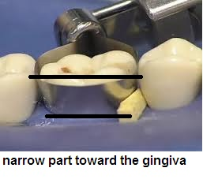
Matrix bands alone are not enough to provide a positive contact and to form the ideal contour , so we have to use wedges which may be plastic or wood .
Clinically you are free to choose any type . If we use the wooden type there will be a problem >>it is soft and can't withstand much condensation ,so the plastic wedges are better . And some dentists use these with composite . But its better in the posterior teeth even with composite to use always metal matrix band rather than plastic , and we call it minor strips .
when we put the band around the tooth it should be higher than the marginal ridges not more than 1 mm and not less than that, because when I do my cavity specially with amalgam I overfill it then to be able to carve it. At the same time shouldn't be high because that will interfere the biting ability
Matrix band with retainer should be removed easily when the amalgam become initially set (it needs 8 mins ) , then I stabilize the band itself and just loosen the retainer , slice the band mesially then distally " we can't pull it forcefully"
, finally we remove the wedges . If we removed the wedges before the band, the thickness of the band will affect the positive contact . As we know the wedge do a slight separation between the teeth , so when we remove them after the band , we will get a good positive contact due to the elastic recoil of the teeth.

** Note : after that you should be able to floss normally .

*Tofflemire matrix band is the most common type used with amalgam , there is another type : ivory matrix retainer .We can put them in autoclave to sterilize them and use them again.

According to tofflemire matrix band , all circumference of the tooth was surrounded by the band so we called it circumferential type of matrix band .

On the other hand ivory matrix band surround just one side of the tooth .
We use it in partially erupted tooth , or when the third molar is partially covered with gingiva and from the other side is carious , or sometimes when the first molar is partially erupted in children.
Some dentists consider ivory matrix band as circumferential type because it surround more than half of the tooth , but others do not so there are many opinions ,however doctor will not ask us about it in exam.

Also we have retainless carbon matrix band which called Automatrix system , they are circumferential

Retainer less matrix band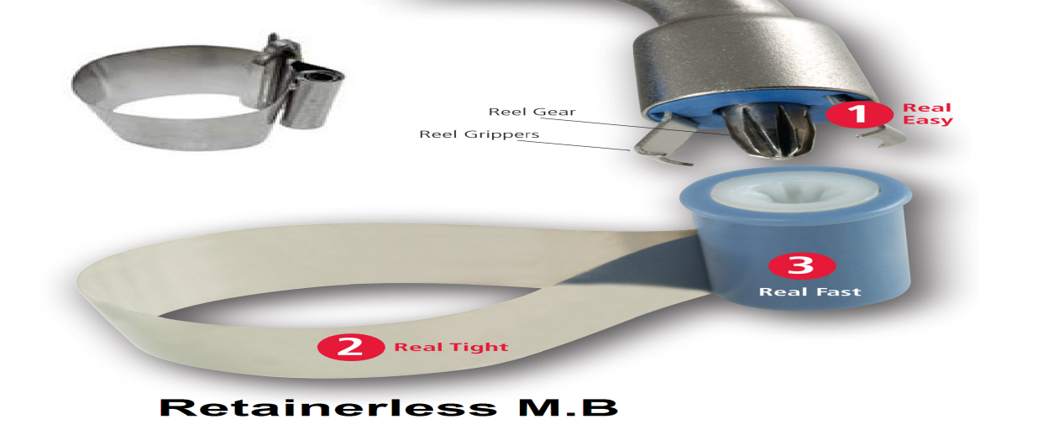
I tight them with activator nope ,when I finish I just cut them and slice them normally .
Amalgam you can condense it using condenser , whereas Composite contain matrix , filler ,and( silein coupling agent ,which have two faces hydrophobic and hydrophilic )
Composite can be condensed due to its resin component , but the monomer you can't condense it and you can't get the positive contact by using the circumferential matrix band.
So with composite on the posterior teeth we use: the sectional matrix band which consist of :
-preformed band "we also call it anatomical-shaped band
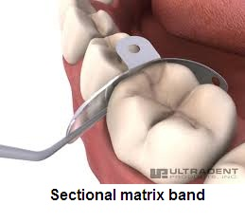
-pre wedging
-separating ring , along with the wedge it make more separation between the teeth "the patient may feel pain" because I adapt the composite rather than condense it.
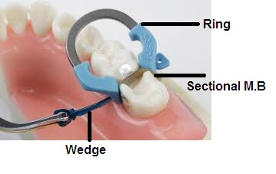
- There are different systems of the rings , like paldonet system which have two types of rings, and we can work on two teeth or one tooth with M & D .
The band itself should be thin to make proper adaptation .
Basically in the clinics they use the basic type with a ring and pre- shaped/anatomical band with a very thin thickness which we call it " dead soft metal " , has a standard size of .0021 inch.
*we have also supernate system which is either metal or plastic transparent .
*We use the metal type with posterior composite filling because plastic cant do good separation , then we do light cure and then after removing the band we do light cure to the outer surface .
**Note : the maximum polymerization is 70-80 % , so no harm of additional light curing .
**Note : you should use a good type of light curing because halogen type for ex will do heat generation and may harm the pulp , but LED type is better because is generates less heat .
However the tightness of the contact point of the composite is not enough so we always need to check it up "as soon as the pt enter the restorative cycle" we need to check the positive contact annually by the floss .
*In small sized cavity (less than 1/3 of the occlusal surface) we can use toflemire matrix band .

Sorry for any mistake ;)
If you have any questions .. don’t hesitate to contact

