MAXILLARY SINUS
FROM THE TEXT BOOK CHAPTER 20 PAGE 382
LECTURE OUTLINE:
-embryology and anatomy
- clinical examination of maxillary sinus .
- radiographic examination of maxillary sinus .
- non_odontogenic infection of maxillary sinus.
- odontogenic infection of maxillary sinus .
- treatment of maxillary sinusitis .
- antral pseudocysts.
- complication of oral surgery involving the maxillary sinus .

* Embryology :
- DR said we must refer to our text book .
- the maxillary sinus : air containing spaces that occupy maxillary bone bilaterally .
- in general , why the sinus found : ( all these are theories )
1- increase the resonance of the voice .
2- decrease the weight of skull.
3- filter air entering the body before it reaches the lung .
-in the 3rd month of the fetal life , maxillary sinus start formation , also term first\ primary pneumatization .
- 2nd pneumatization begins in the on 5th month of fetal life .

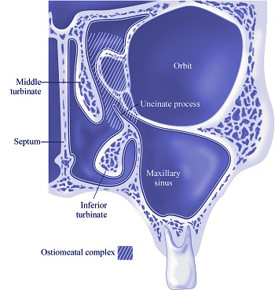
*Anatomy :
-the maxillary sinus also known as "antrum" which mean cave and " antrum of Highmore".
- start as small size then increased .
- the avg volume of maxillary sinus in adult approximately 15-20 ml .
-once permanent teeth are erupted sinus expansion and reach it's normal size .
- pneumatization happen esp. if we extract upper post. teeth or do surgery on upper post. jaw .
- the sinuses are pyramidal in shape within maxilla , we must know the anatomy cause once the infection happen it will spread :
above it : orbit , between the roof of the sinus and the floor of orbit the posterior orbital nerve and posterior orbital vessel pass .
below it : alveolar process
posterior : post. wall of the maxilla , bifurcation of maxillary artery .
anterior : facial surface of maxilla .

-maxillary sinus lined by respiratory epith. ( part of respiratory system ) > open and drainage in the nasal cavity .
cilia and mucosa necessary for the drainage , cause sinus opening lies on the middle not on the floor of the sinus , so the cilia move it toward the ostium.

- A nasal meatus is a nasal passage of the nasal cavity, of which there are three; the superior meatus, middle meatus and inferior meatus , the maxillary sinus open at level of middle meatus

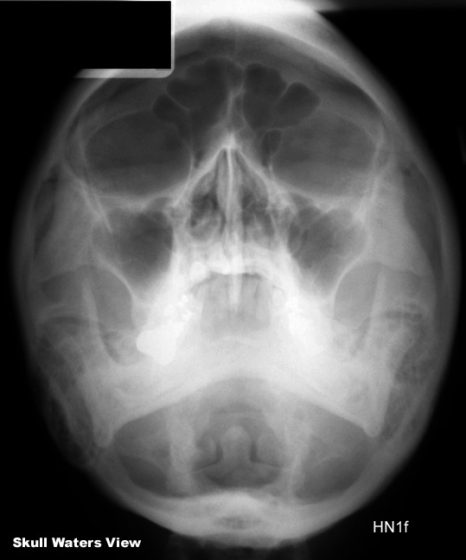
- radiographic examination :
- the best radiograph to show the sinus is" water's view " occipitomental view , pt with upward head

- CT scan : coronal view , showing normal maxillary sinus anatomy with thin bony walls without any thickening of the mucosal lining , masses or fluid .
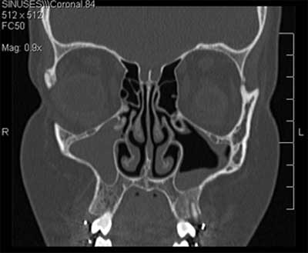
orbital muscle ( superior rectus , inferior rectus , medial rectus and lateral rectus ) and the optic nerve in the central .

-if the sinus appear gray in color or the border no clear \ not uniform usually we talk about sinusitis ( the normal color is black without any whitish ) .
-we can also use OPG.

* non_odontogenic infection
1) infection , from ear or other site .
2) allergy
3)neoplasm ( benign or malignant ) ex: pseudocysts .
- any inflammatory disease on the sinus cause hyperplasia and hypertrophy of the mucosa lead to obstruction of ostium ( no drainage ) , patient feel pain on these area increase when downward her head due to fluid accumulation .

- signs and symptom of sinusitis same whether it's caused by infection or allergy .
*odontogenic infection :
- from teeth
-due to close relation between the teeth and maxillary sinus .
- account for approximately 10%-12% of all maxillary sinusitis .
- mostly mixed bacteria ( same as oral cavity ).

* treatment of maxillary sinusitis :
1) antibiotic if we have infection or pus discharge .

2) drainage : we administrate decongestant to decrease the congestion on the mucosa and make the open wider and facilitate normal drainage , so we decrease the symptoms in the patient .

3) surgery : especially in chronic sinusitis case , traditionaly they do open surgery ; accesses to the sinus from the lateral wall known as " caldwell_luc procedure " >> open flap > remove periosteum > lateral wall of the sinus > make window > go into the sinus > remove abnormal tissue > restore normal drainage through the ostium or anew opening for more dependent drainage into the nose ( termed antrostomy ) .
nowaday we have FESS ( functional endoscopic sinus surgery ) we go through nose > ostium > suction the secretion and gradually widening the opening .
sometimes these technique called " useless"

- sinus work mean there's no congestion , no infection if congestion happen patient will complain from difficulty in breathing .

- sometimes when we take OPG for our patient we notice round , high density (more than air density ) called " antral polyp " or " pseudocysts " .
like an expansion on the mucosa of the sinus , asymptomatic , no need for treatment .

- we can avoid complication by proper evaluation and examination .

- for example if we have divergent roots we hemi section it to facilities the extraction .

When you take out a posterior tooth with susceptibility of oroantral communication. At this stage don't ask the pt to blow his nose in order to preserve the continuity of the sinus membrane because you are not sure of communication occurance even if you get a small piece of bone because the membrane might still intact.
After extraction you should check the socket, if there is air bubbles or more amount of blood is getting out, you can ask the pt to rinse his mouth gently then if there is air bubbles or water get out of his nose or you can grossly see an opened sinus with discontinuity of the membrane then there is an oroantral communication.
- If the opening is very small you can suture it as the aim is to preserve the blood clot to be formed then organized and become a new bone then the soft tissue close and epithelium is formed to solve the problem. It's very important in this stage to give the pt what's called "sinus precautions" which are:

- Avoid mouth rinsing in the first 24hrs then after this period he can use a soft mouth rinsing.
- Don't blow your nose.
- Don't open your mouth widely.
- Avoid smoking.
- Don't drink with a straw.
- antibiotics and antihistamines
- Don't sneeze through your nose. Sneeze with your mouth open.
- Eat a soft or liquid diet.
- Continue to brush your teeth but avoid the surgical area. Rinse three times a day with warm water.

- If the communication is medium in size:
At the time of the surgery we can do a flap then suture it but there are important things here;
  - The flap should be on intact viable bone or viable cartilage or soft tissue in order not to be opened later on.
  - There should be no tension in order not to be opened.

- If there were no response to what was mentioned and the communication became a fistula which mean development of epithelial tissue in its track then you have to treat this fistula:
1- Excision of the fistula (epithelium) and take it out and clean until you reach an area with fresh clot.
2- Closure with a soft tissue flap.
- Types of flaps:

- Local flaps which are:

- Buccal advanced flap.
- Buccal pad of fat flap.
- Double-layered closure using buccal fat pad and buccal advancement flap.
- Palatal pedicle flap.
- Palatal rotational advancement flap.

- Distant flaps which are:

- Tongue flap.
- Temporalis muscle flap.

- Buccal advanced flap; It involves scoring of the buccal periosteum to enhance flap mobility and then stretching the buccal tissues medially (palatally or lingually) to obtain tension-free closure of a wound.
- You create a buccal advanced flap,raise the flap then bring it palatally to close the communication and suture it into place. This type of flap is done in a particular way to preserve the blood supply which is very important criterion so not to become a necrotic tissue that's why it's important to know the anatomy.
- The disadvantages of this type of flaps:
- Loss of the depth of the buccal sulcus; it results in shallow buccal sulcus that causes discomfort to the pt and it can adversely affect patients' options for future prosthetic rehabilitation.
- The width of the keratinized tissue on the buccal aspect of the alveolus will be diminished and nonkeratenized mucosa will become at the level of the alveolar crest.

- Note:
The difference between flap and graft:
Graft does not have an intact blood supply and therefore relies on growth of new blood vessels; it's not as the vascularity in the flap (the vascularity is better in the flap).
- Palatal pedicle flap:
Pedicle is: A section of tissue, with its blood supply intact, which is maneuvered to another part of the body.
The palatal flap with its total thickness laterally rotated must have a large base to include the greater palatine artery at the site of its exit from the foramen. The anterior extension of the flap must exceed the diameter of the bony defect and have a length sufficient to allow its lateral rotation and the replacement and the suture without exerting tension on the vestibular mucosa.
However this type of flap is only indicated for closing fistulas in the premolar area since an excessive rotation required when operating in the molar region could cause ischemia of the flap due to the palatal artery occlusion and necrosis.
- Advantages of the palatal flap include:
- Good vascularization.
- Adequate thickness and optimal tissue quality.
However as a consequence of this technique, exposure of the bony palatal surface, pain and later surface irregularities of the surgical area due to secondary epithelialization two or three months later, are often observed.
The most important disadvantage is the necrosis of the palatal flap that can occur following excessive rotation of the flap.
* We raise the pedicle and expose the palatal bone which is one of the disadvantages of this type of flaps and this exposed bone can be then dressed and you can give the pt a night guard.
- Modified palatal pedicle flap:
We don't take the full thickness we just take the surface layer and keep the other part covering the palate.
- Palatal rotational advancement flap;
The palatal rotation-advancement flap is recommended for the late repair of oroantral fistula owing to its good vascularization, excellent thickness and tissue bulk, and easy accessibility; it also allows for the maintenance of the vestibular-sulcus depth. It is particularly indicated in cases of unsuccessful buccal flap closure.
- Distant flaps:
In more advanced cases with very huge defects in the maxilla we can use large flaps from temporalis muscle or tongue.
- Temporalis muscle flap: we cut the coronoid (the insertion of the temporalis muscle) and remove it with the temporalis and fix it with the maxilla so we close the defect of the maxilla with the temporalis muscle.

- Tongue flap: we take part of the tongue and close the defect in the maxilla. The flap is left in place (attached to the tongue and the palate) for around 21 days and then the attachment to the tongue is taken down and the flap is inset into the palate, presumably now having a good blood supply from the surrounding palatal tissue.

