Benign OdontogenicLesions
Of The Jaw 2
dr. Baqain said that the HOSTOOGY of the lesions is not included and he will focus in exam on the surgical Tx. and recurrence rates .

In any lesion you have to describe the following:
- Size of the lesion (small/ large).
- Site of the lesion (max./man., ant./post.)
- Proximity to vital structure and its effect on them (nerves).
- Effect on teeth (resorption, displacement).
- Shape of lesion (uni/multi locular, well defined or not, corticated or not, expansile or not, if expansile does it invade the soft tissue or not).
- You have to take an incisional biopsy for the lesion And do further radiography (CT or soft tissue projections) to reach to more detailed information about the lesion, and if you find tissues inside the lesionthen it’s a tumor not a cyst.
- Treatment Modalities:

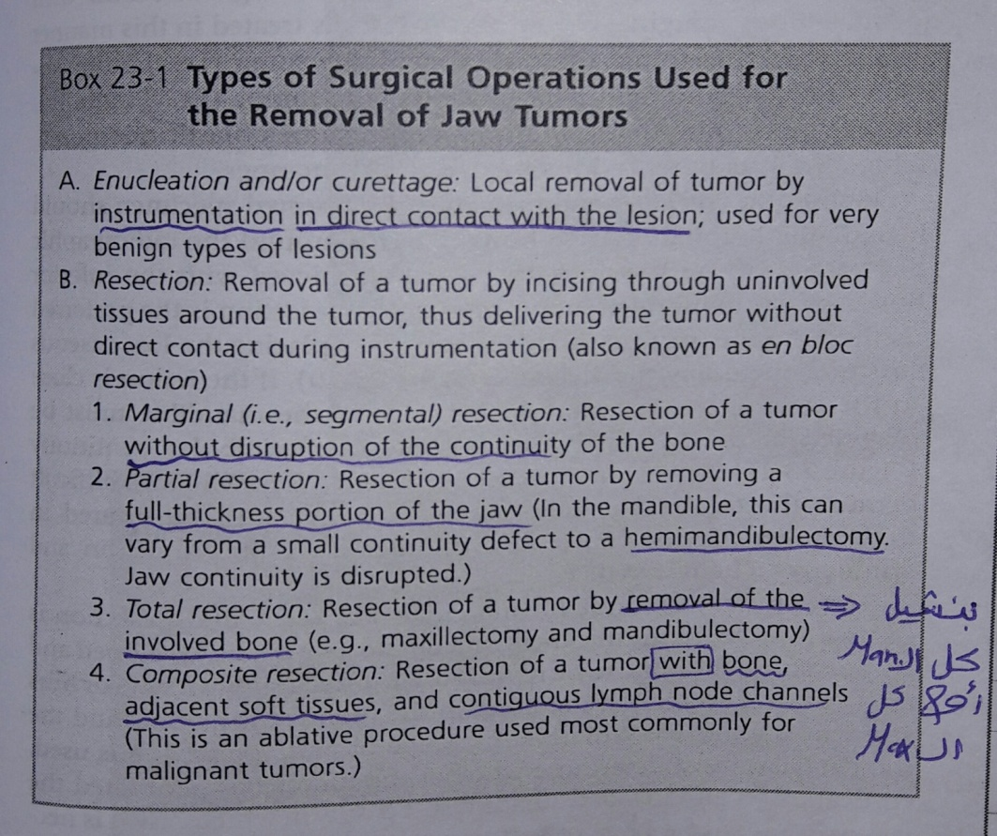

- Note: In the maxilla mainly we do partial or total maxillectomy,but notice that if we did not enter the maxillary sinus it’s a Marginal resection, but if we do,it’s aPartial resection, and if we remove the whole maxilla it’s a Total resection.

The above was an introduction, now we will start from slide 25.

- Slide 25: You have to memories them 😂.
*Notes:
-Teeth are derived from ectoderm.
-The WHO classification depends on the active component (histologically).
-Ectomesenchyme is not a mesoderm.

- Slide26
*Notes:
-The most common benign odontogenic lesion is Odontomes which is considered as hamartomas not tumors.
-Ameloblastoma is benign but in sometimes it's locally aggressiveso while doing surgery we have to remove a safety margins.
-Not in all radiolucent lesions you take a biopsy, specially if it was small and looks benign, But you have 2 choices: remove the lesion then send it to the histopathologist and if it was an ameloblastoma,open again and remove more "safety margins", OR you can take an incisional biopsy before you open and then you can determine your tx plan …… in 2 choices we open twice.

- Slide27: same as slides.

- Slide28: the type of epithelial cells in the lesion will not affect our surgical procedure (it will be the same in all types ; and note that we'll know the type of cells that we have after finishing the whole surgery), BUT the difference is that I have to inform the ptnthat he'll need a thorough follow up and strict observation if the type is DESMOPLASTIC, and to a lesser extent if it was follicular or plexiform.

- Slide 29: same as slides.

- Slide 30+31:
*Notes: the difference between the uni and multi cystic ameloblastoma is that the unicystic happens with ptn in a younger ages and it is associated with an impacted tooth; because of that some said that it may be developed from a Dentigerous cyst (any dentigerous cyst we find and LEAVE it without treatment will either expand more and weaken the bone OR developed into a unicystic ameloblastoma).
-Luminal type; means that tumor cells are only inside the capsule,Intra Luminal type; meansthat tumor cells are getting larger inside the cystwhich is fine cause if you shell out the cyst the tumor will gone,Mural type; means thattumor cells perforate the capsule and go inside marrow spaces (this type is the bad one cause we will discover that this is a mural type of a UNICYSTIC AMELOBLASTOMA after surgery after sending the enucleated cystinto the lab, so you'll open again and remove moreand inform the ptn that he'll need thorough follow up).

Slide 32 :
Peripheral ameloblastoma
- The tumor does not really makes indent (not really invaded) .
- Usually diagnosed after removal .
Slide 33 :
squamous odontogenic tumour
- its treated like aggressive tumor ( ameloblastoma) , safety margin and then you resect .
Slide 34 :
pindborg tumour
- it does not happen at the angle of the mandible .
- In multilocular mixed lesions you always role out ameloblastoma from your DDx .
- You have to differentiate it from calcifying cystic odontognic tumor (in the mixed type of Pindborg tumor they look similar )
slide35 :
histology
- if the pathologists was not aware they maybe give you a false diagnosis as intra alveolous squamous cell carcinoma and this makes big difference in Tx plan so you should be careful
- One of the signs of malignancy : the presence of abnormal mitotic activity , atypia and variation in the nuclei site , in the Pindporg tumor there's no abnormal mitosis but there's a variation in the nuclear size and staining so you need a good pathologist to tell you that it's not SCC.
Slide36 :
- It varies so the treatment differs if it was small ( enucleation with good solid curettage ) but if its larger you might need marginal/segmental resection depending on the size

slide37:
Adenomatoid odontogenic tumor
- Although it’s a tumor it behaves like a dentigerous syst, its so benign .
- A picture of canine that has a follicular cyst around it , you take it out and notice that there's something solid in it ( adenomatoid tumor ) you don’t have to do anything in addition due to the presence of this tumor .
slide 39 :
Ameloblastic fibroma
- DDx includes ameloblastoma, fibroma, etc .
- the one in mixed group that does not show mineralization.
slide41:
Ameloblastic fibrodentinoma & Ameloblastic fibro- odontome .
- the difference between them is that the odontome is more aggressive .
- Both diagnosed after excise them .
- Generally, When the lesion large it's more easily to diagnose than the smaller one.
- Tx : depending on the size if it was small you might treat it more conservatively.

slide 44 :

calcifying odontogenic cyst
- the difference between it and the pindborg tumor is that the pindborg has more recurrence rate.
slide 46:
odontogenic fibroma
- no calcification.
- ameloblastic fibroma is more aggressive .
slide 47 :
odontogenic mixoma
- more aggressive .
- affects older ages .
- fibroblasts show atypia ͢͢ sign of aggressiveness.
slide 48:
- spillage happens when performing incisional biobsy and this will lead to recurrence of it in the site of biobsy , so that we do resection .

Done by :
sana’a ben tareef
Elaf alomoush
شكر خاص ل الجميلة ختام الداودية ( أبو طفيلة ) لتصحيحها هذا الشيت

