Oral Cancer
- 90% of oral cancer are SCC, and other small variant like Voracious carcinoma , Basaloid carcinoma may be encountered , but we mainly talked about SCC ؛ and because these tumors behave similarly they can be treated in a similar manner.
- Unfortunately , In the past 50 years , treatment modality and diagnosis become more advanced , but the survival rate or the prognosis doesn't change ,and 50% of patients diagnosed with oral cancer will die of their disease. However what changes is the quality of the patient's life.
- in this lecture we aim to understand the basic technique and , their indications & complications .
Treatment modalities :-
The cornerstone of treatment is the surgery . But there are other choices for treatment like chemotherapy and Radiotherapy , gene therapy ..ect.
- One of the most challenging part in cancer treatment is the "Field cancerization" which mean:
- 11% of patients have a chance to have multiple foci of cancer elsewhere in the GI tract because they are one system , & the mouth is just part of it.
- Remote area of dysplastic changes in other part than the primary site.
- Even if histopathology show no dysplastic changes at the margin , however the genetic test may show a gene alteration "like altered P53 gene" that demonstrate premalignant changes .
- As an example HPV screening that provide an information to whom are susceptible to develop oral cancer , and so they undergo an early prophylactic treatment like HPV vaccine " like in Canada"
The basic surgical procedures Goals are to :-
- To eradicate the pathological lesion , and then 2) to do functional rehabilitation after surgery .
- The oral region is very special ; because of the variant function like eating ,speaking,… , so we consider the eradication as 50% of problem and the reconstruction after surgery is the other 50% of the issue.
- For oral cancer you have to get the definitive diagnosis , and to do staging for the tumor before you impart your treatment plan ; because these two things may affect the formulated treatment and the prognosis.

TNM definition : T is the tumor size
N ; lymph node metastasis
- N0 no metastasis
- N1 in single ipsilateral node =<3cm
- N2A single ipsilateral >3cm ,=<6cm
- N2B multiple ipsilateral not >6cm
- N2C contralateral or bilateral not >6cm
- N3 >6cm
M : distant metastasis M0 none , M1 present
Staging:
- Stage 1 T1N0M0
- Stage 2 T2N0M0
- Stage 3 T3N0M0 OR N1+T1,T2OR T3
- Stage 4 T4N0M1 , any N2,N3,M1
- When we want to treat cancer what we aim for ideally is the disease free state , but sometimes if we aim for this we may affect the quality of life so, we need to balance this in the right way .
- Five yr survival of tongue cancer " which is the most common site for oral tumors ,it also an aggressive one " it depend on the staging of the tumor.( stage 1 it is 90%, stage 2 =64% , stage 3=34% , stage 4 =6% only )
Why do we fail to cure cancer :-
- Most common factor is the failure of local control , because sometimes we can't really excise all the pathognomic part.
- Distance metastasis
- Second primaries .
Types /principles of cancer surgery :
- Definitive surgery which is curative resection to eradicate the tumor with a free margins
- Sometimes the tumor is at a late stage or in the absence of cure ,so we palliate to improve the quality of life without eradicate the tumor but just to minimize pain! and maintain functional vital structures .
- Sometimes we aim to do multiple treatment for a big sized tumor to get into a very close of definite kind of treatment ,so we de-bulk the tumor then we do provide other kind of treatment like chemotherapy , radiotherapy .. this type not applied so much in the oral cancer.
- Reconstruction after the surgery to restore function, aesthetic and improve the quality of life .

The treatment of oral cancer has to be decided by a professional teamwork ,it need a multidisciplinary management, surgeons ,radiotherapist ,chemotherapist , oncologist, Prosthodontics , speech & language therapist they may all participate To end up with acceptable quality of life and fulfill the patient willingness'
Malignancies of the oral cavity are treated with surgery, radiation, chemotherapy, or a combination of these modalities. The treatment for any given case depends on several factors, including:
- the histo-pathologic diagnosis,
- the location of the tumor,
- the presence and degree of metastasis,
- the radiosensitivity or chemosensitivity of the tumor,
- the age and general physical condition of the patient,
- the experience of the treating clinicians, and
- the wishes of the patient.
To determine the appropriate type of therapy we have some factors to be considered :
- local factors like the
1- aggressiveness of the lesion , prognosis is related more to the histological diagnosis ,which indicate the biologic behavior of the lesion than to any other single factor.
2- Anatomic location of the lesion : * maxillary tumors can grow to larger size asymptomatically ,with lately occurring presentation and thus poorer prognosis , however the mandible have more boundaries.
*Proximity to adjacent vital structures ,* the size of the tumor which affect the surgical procedure to be done ,* intra VS extra osseous location : cortical perforation and soft tissue invasion indicates more aggressive tumor and more difficult removal .
3-Duration of the lesion : slowly growing lesions are usually more benign , but if the lesion grow fast over time then it tend to be aggressive.
4-Considering how can you affect the quality of life for the patient after the surgery; reconstruction efforts should be planed before initial surgery is performed because it may affect the surgical technique.
- general factors like the age and life expectancy , general health of the patient , and the availability of facilities.
Special considerations/principles of surgical management :
For malignant tumors because of the stellate cells (daughter cells ) that found in the normal tissue around the tumor , we need to do 1-1.5 cm of clear margin beyond the tumor edges.
Once we excise the tumor , we need to take specimen, either from the margin of the already resected tumor or from the remaining tissue boundaries and it should be adequate, and we send it to the histopathology as frozen section from the base of the tumor freezed in liquid carbon dioxide or nitrogen ,but not in formalin , so the frozen section will tell you if there is malignancy at the boundaries or not within 20 min .
If they told you it is positive then it is a problem ; it is a poor prognostic sign and it mandate for a second treatment either to go back to the theater or to go for radiotherapy , chemotherapy.
Oral cancer by site :
Lip: Lower lip is more because of the sun exposure .
Lip cancer usually has a good prognosis because it is easily accessible , and the lip is forgiven ; you can remove 1/3 of the lip out and still have a nice shape and function.90% 5 yr survival .
Basically we do a wedge shape excision of 0.5-1 cm and we suture the two parts together ,if it is small T1 or T2 . if it is large we can go for W shape excision. Neck dissection not usually required .

We take small margin and we can also get frozen section .sometimes we have actinic changes in the vermillion area , so we take the whole vermillion area in technique called “Lip shave” or vermilionectomy.
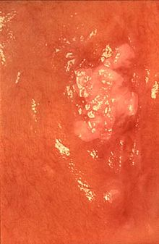
Whitish, exofitic , ulcerative lesion at the posterior BM.. DDx papilloma , traumatic ulcer , ulcerative LP, or malignancy.

To reach a definitive diagnosis we take MHx , Hx of the lesion , .. and we take incisional biopsy and it should be presentative specimen , it should be deep, including normal and diseased part, we can take it from more than one site.
* Usually whenever we suspect malignancy we go for incisional biopsy.
Retro molar area is another region.
Tongue is the most common site for oral SSC and the anterior 2/3 of it is very vascular and because of local regional spread into the neck ; the treatment usually aggressive and need to consider the neck treatment even if it is small.
Tongue tumor may affect the glossopharyngeal nerve and alter the sensation, and the patient may present with otalgia, dysarthria "slurred speech "
It metastasizes early.
Floor of the mouth: the 2nd most common site for oral cancer
It may cause not only ipsilateral spread to the neck but also contra lateral.
Contra lateral spread move the tumor to stage III and IV . so even small tumor we need to consider neck treatment. And also you need to consider rescecting the bone" mandibulotomy maybe required .
Alveolus and ginigiva : Gingival if we talked about the attached gingival and it relatively have better prognosis than the alveolar " unattached mucosa."
-Some time the tumor arise from intra-alveolar part and called intra alveolar carcinoma which is very rare , it and it differentiated from cyst and benign tumor by the aggressive signs like, numb lip at an early stages
anterior 2/3 of the Palate : Common in India because of reverse smoking .
the posterior 1/3 considered as a part from the pharynx
Management of bone:
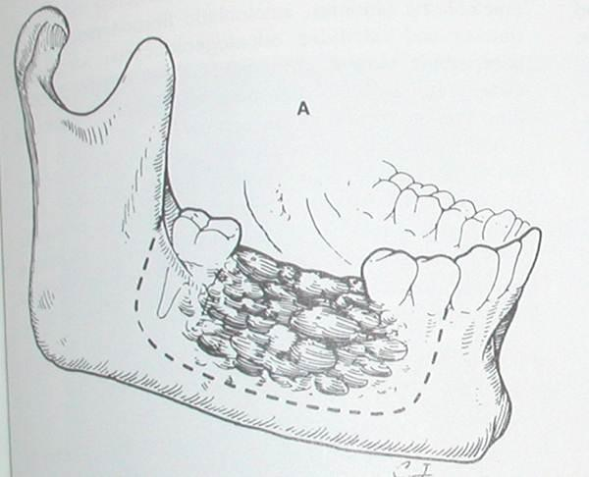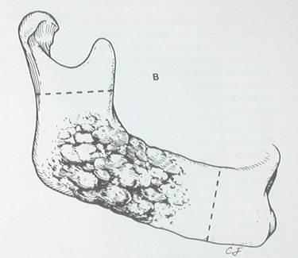
Marginal or segmental , you spare the lower border.
Partial when you do not spare the lower border thus we remove a full-thickness portion of the jaw.
Composite resection; when you take out bone and soft tissue including the lymph node channels.
Soft tissue involvement indicate the need to resects the margin because of perforated cortical plates .
the resected specimen should include the lesion and 1-cm bony margins around the radiographic boundaries of the lesion. If this can be achieved with the inferior border of the mandible left intact, marginal resection is the preferred method. Reconstruction then is limited to replacing the lost osseous structure, including the alveolus .If the lesion is close to the inferior border, the full thickness of the mandible must be included in the specimen, which disrupts mandibular continuity "partial resection"
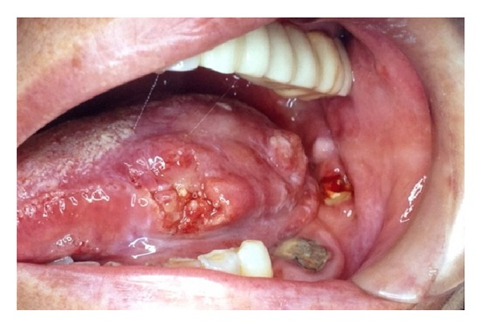
Photo: exofitic, ulcerative mass coming out of the lateral border of the tongue
Maxillary resection :
Mucosal resection :not usually applied to treat cancer; once you have malignancy you have to consider one of these, segmental resection : remove part of the maxilla , you can perform it by intra oral approach.
Maxillectomy "half of the antrum without involving the orbital floor" and radical maxilloctomy, basically you have to go for extra oral approach, and it involve the antrum" sinus" , orbital floor and orbital content .
How do I achieve access to resect the tumor ??/surgical approach :-
Surgical approach : Maxilla
- Transoral: small , superficial tumors
- Splitting upper lip :access to orbital floor and
- Temporal approach :tumor extended behind the posterior tissue
To resects the maxilla we go for weber-ferguson incision/approach you basically do an incision, you split the lip and you open the cheek like a book.
And if you need to do maxillotomy or radical maxilotomy you can go further back . then you resect the bone and the intra oral soft tissue, after resection the rule of the obturaters comes here.
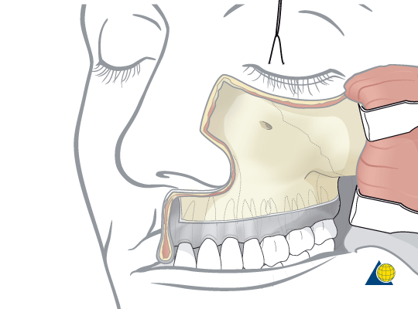

Surgical approach: Mandible
- Submandibular approach: for the body, ramus , base of the tongue & retromolar area.
- Visor incision: entire body and ramus
- Splitting the lower lip and mandibulotomy : sublingual space , posterior lingual , posterior 1/3rd of tongue .
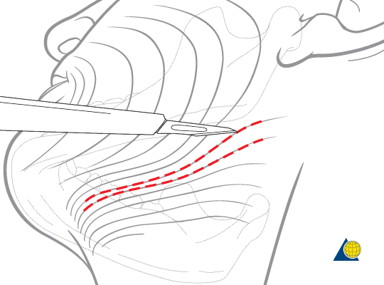 | 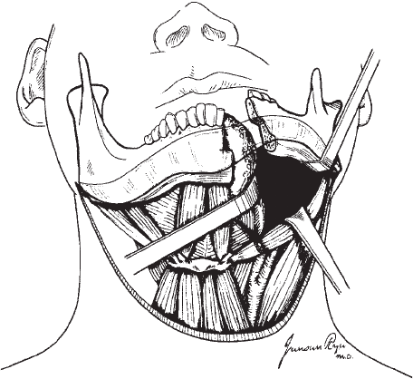 | 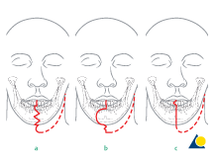

Sometime we do extended submandibular incision approaching it extra-orally , which allowing you to open and see the entire mandible , you can go for mandibulotomy using the saw! Like if the tumor in the posterior aspect of the tongue or in the retro molar region
Visor : extra oral approach if the tumor in the middle or crossing the midline it is like a bilateral submandibular approach.
Surgical approach : In the mid face area :
Coronal flap which basically "degloving" the forehead down to the orbit in cases of trauma or craniotomy. And it approached extra orally.
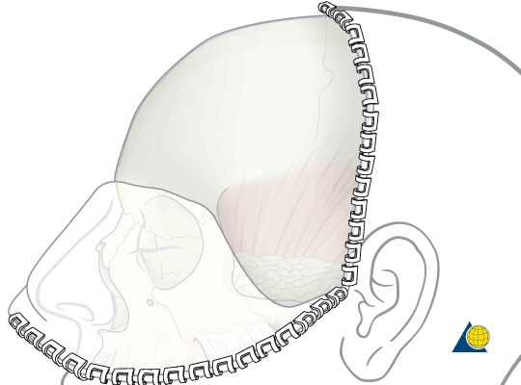
**So for small tumors we go for intra oral approach , for such big tumors we go for extra oral approach .
weber-furgeson in the maxilla, extended sub mandibular approach +/-lip split +/- mandibulotomy in the mandible.
Neck dissection :-
When we treat oral cancer we should consider the neck treatment because the neck contain the cervical chain of lymph nodes where tumors may drain.
If the cancer cells infiltrate into blood vessels ; metastasis to the lung or bone or elsewhere may occur.
If the malignant cells go through the nerves then epithelial neural spread take place.
Treatment of the neck maybe part of the definitive treatment OR as prophylactic treatment , node metastasis decrease chances of cure by 50%.
Cervical lymph nodes found at 5 levels
Level I : submandibular triangle
Level II – IV ; along the sternomastoid which are the cervical chain ; and along the jugular vein.
Level V : posterior triangle , oral cancer rarely spread to this level.
So the risk factors for cervical node metastasis
1- the size ; bigger tumors increase the chance.
2- location in descending order ( the tongue and the floor of the mouth are the most common ,lower alveolus , BM , upper alveolus , hard palate ,the lip is the least)
3- depth of invasion of the primary tumor but it is not really reliable.
Ideally you want to do both surgeries at one time when you resects the tumor you also do the neck dissection at the same time.
If you have good incisional biopsy ;the pathologist can tell if it deep tumor and if there is a muscle invasion , so the chance of spread to the neck lymphatic's is very high.
When would I really do the neck dissection/indications :-
- Positive node in the content of oral cancer, hard ,fixated , usually painless.
- CT SCAN , conventional CT for oral cancer with contrast for soft tissue, which can find 0.5 cm node which can't be detected clinically
- Prophylactic if the risk factors are high.
Types of neck dissection :
- Comprehensive neck dissection 'ND': when you do the level from( I – V ) . and it is either radical ND or modified ND depending on 3 structures..sternomastoid ,IJV , spinal accessory nerve .
-Radical I remove them but, the morbidity would be very high so it is not usually done except in severe cases.
-modified ND usually used; depend on what you spare from these structures :
Type I you spare the spinal accessory
Type II you spare spinal accessory and the IJV
Type III you spare all these structures.
- Selective ND :you select specific levels and usually used in prophylactic ND:
- supraomohyoid ND level I – III
-lateral neck II – IV
Posteriolateral II - V
We do prophylactic ND when there is negative neck clinically and radio graphically.
How do we approach the neck:
Y-shape and Apron , usually combined with the access of the mandibular approaches
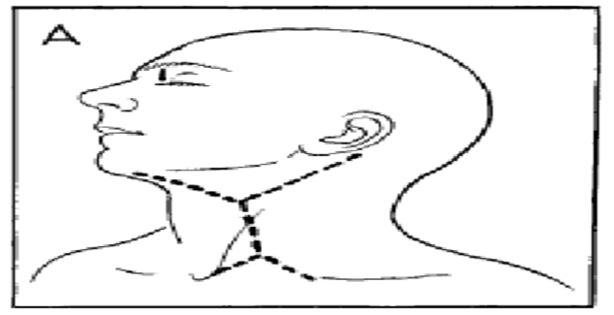 | ??!!

Complication of cancer surgery :
Most common one is the failure to fully excise the tumor
pain , swelling ,bleeding ,salivary fistula, ocular dysfunction, DVT "because of immobility after surgery" , infection , oral dysfunction, recurrence , death .

Oro-nasal tube , NJ "Naso-jejunal" tube , Oro-gastric tube , peg tube " from the stomach to the outer skin to deliver food through a pumb.
So they require good support, nutrition and antibiotic cover.
Dr said Read the book to see the figures
ALL information was written in the slide and Dr. did not mention them in the lecture , are added to the sheet ..

قيمة الإنسان هو ما يضيفه إلى الحياة بين ميلاده وموته ؛
Done by :Mayazeen AlAwamleh

