OS sheet #2

Done by Suad Shamieh

Please refer to the slides

Types and History of implants were mentioned in the previous lecture.

-A successful implant depends on several basics , so planning is very important.

-Implantology is a multidisciplinary approach. Other specialties started doing implants(cons, prostho, perio)

**Elements :**

1-Patient (it is the major criteria of success)

2-Surgical team

3-Restorative team

4-Dental laboratory(the technicians must be scientifically advanced)

**Members of the treating team:**

1-Restorative dentist

2-Prosthodontist

3-Surgeon

4-Periodontist

5-Dental technician

6-Radiologist (**CBCT**>>>panorama),why CBCT? to calculate the amount of bone, if not enough bone , we do bone grafting)

7-Orthodontist(space management)

Patients who lost their teeth due to **bad Oral hygiene** would also have a periodontal disease with implants .

**Treatment options :**

1-No treatment

2-Removable Prosthesis

3-Fixed Partial denture/fixed bridge

4-Dental implant- It is the best because it keeps/stops bone resorption.. so inhibits wrinkles.

Options for a:

**1-Single missing tooth**

a-RPD

b-Fixed bridge

c-implant supported crown



**2-Several missing teeth**

a-RPD

b-Fixed bridge

c-Implant supported fixed bridge

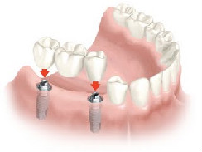

**3-All missing teeth**

a-Removable denture

b-Implant supported overdenture – to be seated on ball attachment

c-fixed bridge on implant

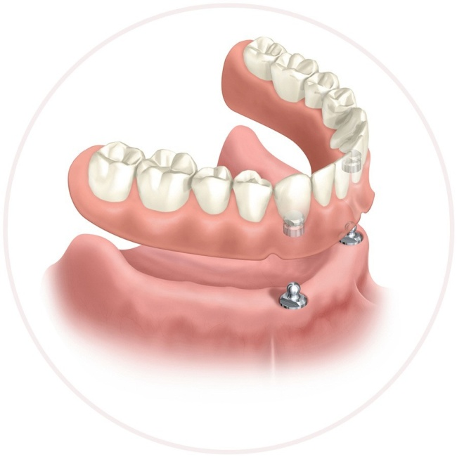

**Note** : Never use cantilevers on implants due to axial and occlusal loads. In case of a 3 or 4 unit bridges , distal abutment must be an implant.

**Patient selection criteria :**

1-Medical history <absolute or relative contraindication>

*uncontrolled diabetes is a contraindication / controlled diabetes affect the success rate but not as the uncontrolled.

*Clotting disorder as Hemophilia

*Anticoagulants( it was absolute , now it is relative) , if the patient is on warfarin , can change to heparin but there is still a risk.

* corticosteroid ( there is no evidence that it’s a contraindication)

*smoking (it was absolute , now it is relative ) better success rate if stopped smoking during the period of implant placement)

*Pacemaker( relative contraindication)

*pregnancy (relative in the 2nd trimester)

*Bisphophonates

Bronj: Bisphosphonates related osteonecrosis of the jaw

Mronj:Medication realted osteonecrosis of the jaw (replaces the condition formerly known as Bronj)

Oral Bisphophonates differ from the IV bisphophonates

Oral (relative contraindication) while the IV (absolute contraindication)

**Histroy of Bisphosphonates** is important , if a multiple myeloma patient used to take bisphophonates , undertook extraction , complications result as open sockets and jaw necrosis because bisphoponates remain stored in the bone tissue.

Drug holiday is to stop the medication by consultation.

*Drug abuse /Pschycological disorders (schizophrenia, paranoia)

------All of those affect the osteointegration

2-Dental History ?

* Aggressive Periodontitis

*Multiple missing teeth

*Very bad Oral hygiene

3-Prosthetic alternatives and options

4-Financial conditions (cannot afford)

5-Esthetic considerations : the most important region to place an implant is the anterior area.

6-Patients motivation for complex and sophisticated dental treatment , the operator must explain to the patient the steps of the procedure.

**Intraoral Examination:**

1. Access : area of surgery must be feasible (limited mouth opening patients and patients with bruxism ,it’s very difficult to place implants for them.
2. Prosthetic space : a lot of GPs don’t consider this thing ( overeruption of opposing )
3. Prognosis of the adjacent teeth : never place an implant when the adjacent is mobile , needs endo treatment or infected
4. Sizes and number of spaces
5. Bone volume , contour and orientation : we have to assess the bone by examination , probing and radiology.
6. Crown height
7. Status of the existing prosthesis
8. Biomechanical consideration ( bruxisim) : because these patient will increase the functional load on the implant > bone resorption > loss of implant
9. Oral hygiene and periodontal status

* loss of bone due to trauma > bone graft> implant

*Overeruption>check the vertical dimension

**In planning the dentist should evaluate:**

-the soft tissue and hard tissue

-sometimes if we are doing a single impant , we might not do an impression but if more than one implant we should do an impression >diagnostic cast > wax up

-In any implant , the occlusal /BL/MD dimensions should be calculated

-Evaluate the soft tissue contours, site, shape, quantity ,texture and color especially in the anterior area.

-Prosthetic value of the implant should be known (not in place of the wisdom , not outside the line of the arch)

-Periodontal tissues should be in the optimal health( thick flattened osseous plates offers higher resistance to recession than a thin tissue biotype).

**You have to consider :**

1.The size , shape and color of interdental papillae

2.The accurate form of the free marginal gingival

3.The relative root shape and size

4.The width of attached gingiva and the prominence of roots on the facial aspects :

If not enough cortical bone in place of the lateral incisors prominent roots , we should be ready for bone grafting and the patient should know everything before undergoing the procedure .. the contraindications of bone graft include the possibility of infection and resorption.

Must leave 2 mm from the buccal plate , if less it will make pressure on the bone >> causing resorption and the implant will start to appear (especially for anterior zone this would be very bad).

**To evaluate the osseous contours:**

**-**Palpation of the undercuts or bony defects

-Mapping , give LA then use special probes, to check the width of the alveolus

-Radiographic examination using markers as GP cones to check the length

-Metallic spheres for standardization

(place a metal sphere near the plane of occlusion when

taking the radiograph. By comparing the radiographic size with the

actual size of the sphere, the magnification can be determined )

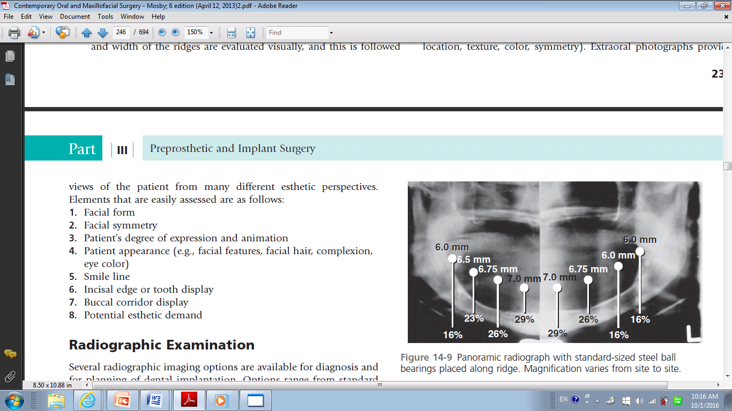

Implant :

**Length** = 6-16 ( 6 is the shortest and 16 is the longest),, **12** is the ideal

**Diameter**=as it is increased , better axial load distribution but cannot put large diameter in the anterior area… anterior zone= 2-3.5max

Posterior zone=more than 3 (wider diameter)

**Shape**=hollow cylinder , solid cylinder,hole screw

**Type**=RTI/Nobel

**Surface characteristics**= depends if its machined and coated with hydroxyapatite , grit plasting , plasma spray , acid etching , bioactive implants.

#the general rule : increasing the roughness >>> will increase the surface contact with the bone

-The CBCT = the inclination, parallelism, distance between the implants,minimal 2mm superior to the ID nerve / 5mm anterior to the mental foramen .

-**Surgical stint /surgical guide** ( an impression and vacuum sheets are made**)**placed on the occlusal surface of the teeth,itgives us an accurate implant placement , predictable outcomes for occlusion , decreases the cost of expensive custom abutment because the angulation is calculated and prevents the fenestration because the orientation is right.

At the end we want to have a successful **osseointegration : which depends on ?**

1. Biocompatibility
2. Design
3. Bone factors
4. Loading conditions
5. Prosthetic considerations

-Primary stability is very important

-**general rule** : implants are more successful in the mandible than the maxilla because of the cortical bone.

**Types of Bone according to the anatomy :**

**lekholm and Zarb bone classification**

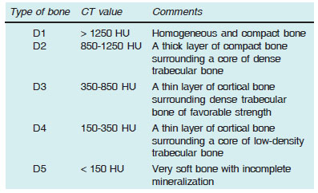

**Type 1> anterior mandible**

**Type2>posterior mandible**

**Type 3>anterior maxilla**

**Type 4>posterior maxilla ( the worst because it** is cancellous bone that’s why implants may get into the sinus.

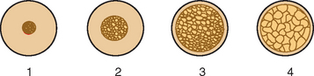

During drilling the temperture musn’t increase above **47** degree >> because it will cause necrosis, Good irrigation is recommended.

-Take in to consideration , smoking, infection, previous exposure to radiation, loading and esthetic

-2 maximum adjacent pontics if few number of implants are used.