21  Dent-2011.weebly.com | Lecture No.
23/3/2016 | Date:
Dr.Shyyab | Doctor:
Aroob Al-Hyari | Done by:
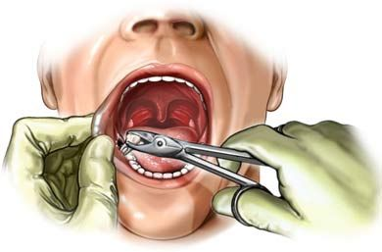
Oral Surgery II
University of Jordan
Faculty of Dentistry
5th year(2015-2016)
Price &Date of printing:

.........................................................................................................................................................................................................................................................
Hand Out
Slide
Sheet
Designed by: HindAlabbadi

Salivary gland diseases – Non neoplastic lesions of salivary glands -
Anatomy:
3 major salivary glands ; parotid , submandibular, sublingual. And 400 minor salivary glands distributed all over the oral cavity; inner side of the lips, cheeks, soft palate and floor of the mouth.
*Sublingual Gland:
Smallest major salivary gland.
Located above the mylohyoid muscle and below the mucosa so the easiest access will be an intraoral approach, lateral to the tongue/ genioglossus muscle and medial to the medial surface of the mandible.
It has an intimate relation with the submandibular gland duct and the terminal branches of the lingual nerve, if I made a dissection I have to retract and recognize these important anatomic structures.
There is no capsule surrounding this gland.
Main secretions : thick, viscous mucin-rich saliva.

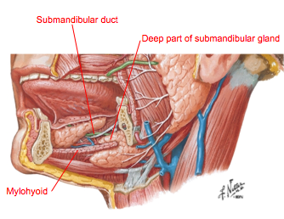
*Submandibular Gland:
Intermediate in size.
Located in the submandibular triangle( which is located between the anterior belly of diagstric m. and posterior belly of diagstric m. and the superior border of this triangle is the inferior border of the mandible).
C-shaped around the mylohyoid muscle, superficial part which can be palpated extra orally, and the deep part above the mylohyoid muscle; these two loops can be palpated extra orally or intraoral.
Duct running forward and medially in a tortuous fashion,for this reason stones are usually found in this gland because stasis of salivary flow to open in the anterior floor of the mouth. Its length about 5cm and a diameter of 5mm.
There is a capsule surrounding the gland, extracapsular submandibular lymph nodes.

- Anatomical vital structures traveling around the gland:
1) sublingual n. 2)12th cranial n. 3) submandibular duct 4)lingual n. 5) marginal mandibular n. located on the lateral aspect of the gland so to avoid this branch you go two fingers below lower border to make incisions for excisions of submandiblar gland
Secretomotor fibers from chorda tympani (branch of facial nerve, parasympathetic fibers).
1st regional lymph nodes to drain an upper lip cancer is submandibular L.N but sometimes parotid L.N in lower lip : if in mid 1/3 goes to submental , and Lateral 2/3 goes to submandibular L.N

*Parotid gland :
Largest one.
Located lateral to the masseter muscle/ lateral aspect ramus , below the ear loop (one of the important features to assist the enlargement of the parotid gland is elevation of ear loop).
An important vital anatomical structure passing within the substance of the parotid gland and divides it into two halves is the Facial nerve, deep loop which is about 1/5 of the total volume and the superficial loop.
There is a capsule surrounding the gland, within the substance of the gland we can find parotid lymph nodes(within the capsule), these lymph nodes are the first to receive from the scalp and part of the ear, so if you find a persistent enlargement of the parotid lymph nodes you have to ask about a pervious history of cancer in the scalp or part of the ear ( metastatic cancer, secondary tumor might be, which is the most common cause of malignancies in the parotid lymph nodes ).
Secretomotor fibers from 9th cranial nerve which gives tympanic fibers, tympanic plexus, Preganglionic parasympathetic fibers from the glossopharyngeal nerve and then through its tympanic and then the lesser petrosal branch pass into the otic ganglion. postganglionic fibers which reach the gland by the auriculotemporal nerve, a branch of the mandibular nerve.
Frey's syndrome (also known as auriculotemporal syndrome,) is a rare neurological disorder resulting from damage to or near the parotid glands responsible for making saliva, and from damage to the auriculotemporal nerve often from surgery, where this nerve makes connections with sweat glands so when there is stimulation of the parasympathetic system and sweat glands and so sweating occurs, needs about one year to develop.
Stenson's duct goes from the most anterior part of the gland then curves medially to perforate the buccinator muscle and open in oral cavity against the upper 2nd molar. Compared to submandibular gland; Same length less diameter but straight passage so less stones than submandibular gland. To locate it draw a line from the upper lip and tragus(tympanic notch), it will be in the middle third, this is important in cases of trauma, if its near the middle third you suspect laceration of the duct.
_________________________________________________________________________________
We have to know the diagnosis of these lesions:
Tumors / neoplasm , neoplastic (benginn/malignant)/non neoplastic

- Non neoplastic :

1. Infection/inflammatory: acute (acute bacterial sialadenitis, acute viral mumps) or chronic (sarcoidosis, TB)
2. Obstructive diseases of salivary glands : stones
3. Systemic / autoimmune diseases: sjogren’s syndrome
4. Reactionary; as a result of drug ex. Chronic use of CHX mouth wash might lead to enlargement of the parotid gland.

So the 1st step in assessment of any pt with salivary gland disorder, is history taking which is the most important step as 90% of the diseases can be diagnosed by history alone.
For example if the pt is complaining from enlargement of the parotid with pain upon or after eating,, clearly this is an obstructive disease.
Another case if the pt is complaining from dry mouth and dry eyes ,,, this is sjogren’s syndrome, but you have to confirm that by the diagnostic criteria. So history taking gives a professional Differential diagnosis before examining the pt.
Another case if the pt is complaining from bilateral enlargement of the parotid gland this viral infection.
Tumors are usually unilateral but may happen bilateral.

Clinical examination of parotid tumor:
1- Inspection
2-palpation
Asses the lesion if its bilateral then its non neoplastic lesion / unilateral then its neoplastic lesion.
Discrete*localized* :neoplastic / diffuse: non-neoplastic.
Superficial features: destruction, ulceration, facial palsy ? will indicate if its slowly growing or rapidly growing

Palpation of parotid gland depends on anatomy and location of structure:
1-bimanual: 2 fingers of 2 hands
2-bidigtal: 2 fingers of one hand especially for parotid ducts stones
3-unidigtal use one finger

In the floor of the mouth How will you know if you palpate the LN or glands !!?
1- in the floor of the month we just have 2 glands sublingual and submandibular & Submandibular L.N
2-if you palpate it just extraorally so this could be lymph node (below mylohyoid only)
3_if it move by use 2 fingers so it's submandibular gland (It has 2 parts one above mylohyoid and other part below it )
4-if you palpate it from internal so we deal with sublingual gland (the only one that's above mylohyoid)

The consequence of DX :
History then examination then confirms your DX by using investigations.

The investigations : always start with minimum invasive to max invasive :
1-Ct scan: according rule of 90%: 90% of stones in the Stenson's duct are radiolucent, 90% of the stones in submandibular are radiopaque, 90% of stones are located in submandibular gland duct.

2-Ultrasound: the least invasive procedure, and not all part of the gland can be detected like the deep loops.

3- Silaograph : features on sailograph could differentiate between 3 categories
1-Obstruction: there’s dilation in the proximal part, reverse flow of saliva & enlargement of the duct itself.
2-Tumor (ball in a hand appearance) where the ball is tumor and hand is the duct.
3-Chronic inflammatory disease that has loss of normal appearance (tree in winter)

## all these procedures has low sensitivity and low specificity

4-biopsy (FNAC);
higher specificity up to 99%,most type of investigation that gives confirmations, But have some false +ves ,and there is a high debate on it, seeding may happen, but it differentiate between surgical and non surgical disease (abnormal lymphocytes ; chemotherapy) and it differentiate between benign or malignant tumors, primary or metastatic.
Changes in the minor salivary glands where found to be representative of what’s occurring in the major salivary gland.

5- MRI
6- Functional advanced images; scintigraphy
7- Minor salivary gland biopsy or major salivary gland biopsy
8-Serology or blood test , immunoglobulin M (ex: in mumps)

Viva Q: If a pt complained from bilateral enlargement of the parotid gland how to approach this case:
History taking, chief complain, medical & social history, history of chief complain,
Examination, type of examination (bidigital bimanual…)
Differential dx, non neoplastic, bacterial sialadenitis(usually unilateral but could occur bilateral), mumps.

Non neoplastic:
- Bacterial sialadenitis
3 features found in the bacterial sialadenitis that cannot be found in the viral sialadenitis:
1. Erythema.
2. Pus discharge from the stenson’s duct.
3. Most commonly occur unilateral, and usually the pt is medically compromised and has to have xerostomia, you have to look for the etiology of xerostomia.

**viral sialadenitis: النكاف/أبودغيم
Bilateral enlargement of the parotid, usually in children, there’s no erythema no pus, very dangerous complications.

**Obstructive diseases:
Stone obstructing the duct with reverse flow of saliva this will lead to atrophy and necrosis of the acini structures, pt complain from pain while eating –meal time syndrome-
Chronically this will lead to dilation of the proximal part of the duct; on sialogram this will give a Sausage link appearance; series of dilation and constrictions.
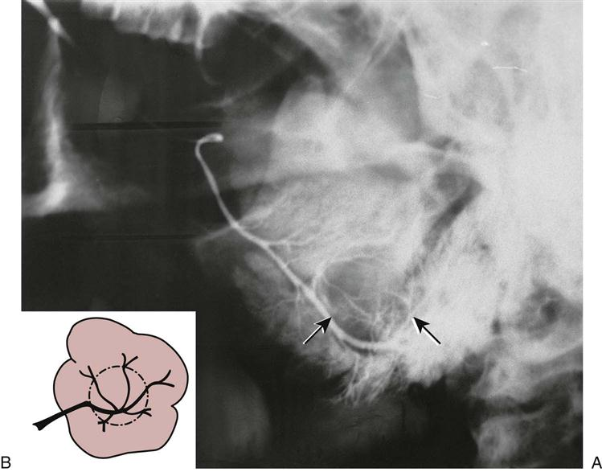
Loss of the normal appearance; “tree in winter appearance” in chronic infection and obstructive disease; fibrosis and atrophy of acini and only the 2ndry ducts are opened.

While in autoimmune disease like sjogren’s syndrome or sarcoidosis which are granulomatous destructive diseases, destruct the acini, in sialogram will give a punctate appearance “snow storm appearance”.

Ball in a hand (img.1): this means this is a tumor

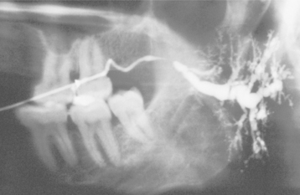
Tree in winter(img.2): chronic sialadenitis/ inflammation

Punctuate/ snow storm appearance(img 3): systemic/sjogren/sarcodosis

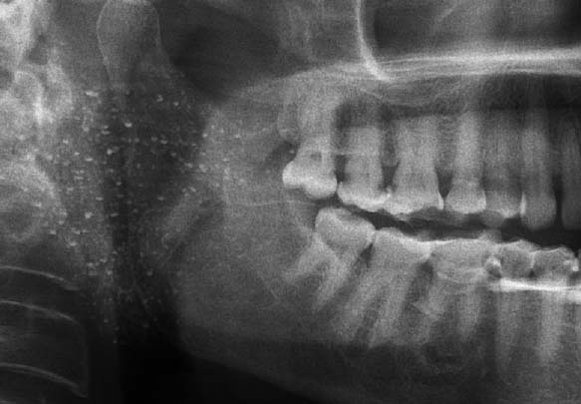
Final treatment should be selected according to the size and location of the stone, if in the gland you have to remove the gland, if in the duct open the duct, remove the stone and suture it with the surrounding mucosa to avoid fibrosis of the duct.

**Sjogren Syndrome:

If you have 4/6 of the following this is enough to be diagnosed as sjogren syndrome:
1. Dry eyes signs
2. Dry eyes symptoms
3. Dry mouth signs
4. Dry mouth symptoms
5. Auto antibodies(immunological tests/blood tests)
6. Histopathology from minor S.G >> most important

Another classification considered the criteria to be objective and subjective, symptoms are more important than signs;
objective ; xerostomia (oral symptoms) and xerophthalmia autoantibodies, histopathology. If you have ¾ including histopathology it will diagnosed as sjogren syndrome & with no history of hepatitis C or radiotherapy.
Sjögren’s can exist as a primary process (also known as sicca disease) when there is no connective tissue disease that can be identified, Secondary Sjögren’s can develop in patients with autoimmune diseases.

Treatment: by corticosteroids, immune modifiers is a new choice.

** Mucocele/Ranula :
Trauma in the minor salivary glands, which might lead to rapture/obstruction of the duct, and this rapture leads to mucous extravasations cyst, if it causes obstruction this leads to mucous retention cyst.
if this process occurs anywhere in the minor salivary gland this is called Mucocele.
But if this mucocele occurs in the sublingual gland this is called ranula.
So ranula is a mucocele occurring in the sublingual gland.
Most common swelling in the lower lip is mucocele.

Viva Q:
If the features of mucocele (soft bluish swelling) are presented on the upper lip, what is your most likely diagnosis?
Canalicular adenoma!!

Best of luck
Many thanks to my mom and dad, Google, Wiki & Mais khrisat for their support

