Surgical aspects in treatment of cleft lip and palate
Note:
This an extremely important topic FOR VIVA , you should study the embryology and anatomy as well.
The dates “weeks” are very important.
__________________________________________________________________________________

- Slide 2:
Birth defects in general are: “the exact terminologies of these are not required”.
1-Malformations: alterations in normal development.
2-Deformations: abnormal mechanical force on an otherwise normal fetus.
3-Disruptions: disruption of an otherwise normal developmental process.

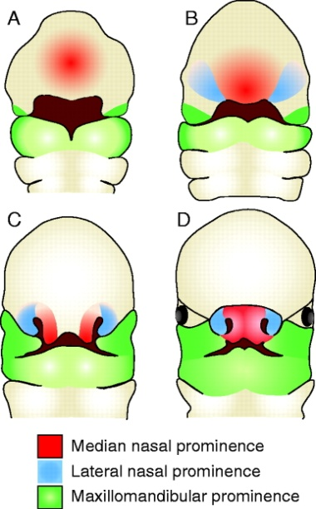
Slide 3:
Incidence differs from area to area but in general:
-cleft lip: 1in 300 births --- 1 in 700 births in some areas
-cleft lip is more common in males ( which is a good thing for females “in which cleft palate is more common”... protects them from the social outcomes they may have to endure due to this defect).
-Unilateral clefts are more common than bilateral (which is also advantageous)
-left side > right side
- Clefts are less in Africans (lucky them!)
- if a baby got a cleft lip or palate the possibility of his sibling to get a cleft lip or palate increases by 30%.
slide 4:
-Multi factorial in etiology “ with genetic background”.
- could be isolated or a part of a syndrome (syndrome: is a collection of features).
Note: it's important to always look for other features if you find one of the features of a syndrome. (to exclude it)
-more than 100 syndromes can have clefts as a feature.
-Viral causes include: HIV, CMV
- Steroids can also cause clefts.
-Smoking in pregnant ladies,, also alcohol is implicated
-x-ray in pregnant ladies is implicated too.(in first trimester)
- Having an affected parent can increase the ratio (risk)
-also having an affected sibling increases the frequency by (10-30%) but increases the over whole percentage to 1 in 10 or (2-5%)
- so having clefts in the family requires GENETIC consultation.
Slide 5:
questions asked by the dr. :
what makes the philtrum?
In humans, the philtrum is formed when the nasomedial and maxillary processes meet during embryonic development (figure a)
when do the palatal shelves fuse?
almost at 9 weeks.
what is the 1ry and 2ry palate?
1ry: Around the fifth week, the intermaxillary segment araises as a result of fusion of the two medial nasal processes and the frontonasal process within the embryo. The intermaxillary segment give rise to the primary palate. The primary palate will form the premaxillary portion of the maxilla (anterior one-third of the final palate). This small portion is anterior to the incisive foramen and will contain the maxillary incisors.
2ry: In human embryology, it refers to that portion of the hard palate that is formed by the growth of the two palatine shelves medially and their mutual fusion in the midline. It forms the majority of the adult palate and meets the primary palate at the incisive foramen.
Secondary palate development begins in the sixth week of pregnancy and can lead to cleft palate when development goes awry.
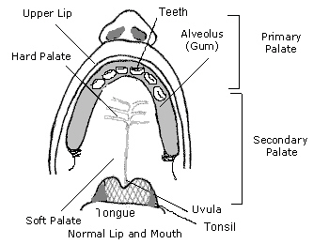
when do the lateral and medial nasal processes fuse?
(4-7 weeks) other studies say (5-10 weeks)
slide 8:
What is new ?
Ultrasound = sonography.
In utero (prenatal) diagnosis has gotten a lot easier now and highly feasible due to :
-3D ULTRASOUND
-4D ULTRASOUND
Which leads to early diagnosis and in-utero surgeries. (interventional procedures)
this happens in western societies mainly and are successful.
بخفف عن نفسية الام
____
slide 12-15:
Post natal management:
- TEAM WORK is important
- There are special teams in western countries specialized in repairing clefts.
it consists of:
-psychologist “first”
-plastic-surgeon
-Maxillofacial-surgeon
-GP
-speech-therapist
-orthodontist
-pediatrician.
-ENT
Breast feeding is not allowed.
Special feeding bottles are present for such cases, to decrease nasal discharge of milk “this is more pronounced in cleft palate.
_______________________________________________________________________
The surgical aspect of the treatment
the earlier the treatment the better , but because these patients are infants we have to consider when they are fit to the surgery .
Rule of tens “it’s important to reduce the stress on the kidneys”:
10 weeks, 10 kg, hemoglobin level is 10mg/dl “most important parameter” (Hgb less than 10 is contraindicated for general anesthesia). In most of the cases the age is 12 weeks when the rule of tens is applicable.
- The surgical repair for cleft lip is done at 3 months of age “not before that, because the liver function is not well developed so the baby can’t handle surgeries”.
- The repair of cleft palate must be done t certain age so that the speech is not affected .in most of the cases the repair is at 6-12 months of age.
The speech therapist has an important role in the treatment specially the treatment of hyper nasality (the sound comes out from the nose instead of the mouth), they know exactly the age of development and the exit of each letter.
It is important to close the palate early but we will have scar and fibrosis and the development of the maxilla “hypo-plastic” will be behind the development of the mandible so those patients will have pseudo class III skeletal relationship. “These patients need maxillary osteotomy at the age of 16 or 17”.
In the treatment we need the orthodontist because the arch is collapsed and we need expansion at certain stage of development mostly early in life, the full orthodontic treatment will be later.
Those patients must be evaluated later in life for the need of orthognathic surgery like distraction osteogenesis, advancement of the maxilla and retraction of the mandible.
Oral hygiene is very important starting from the mother to the dentist and the orthodontists.
- The operation can be done early in life, especially in severe cases (complete or bilateral clefts) when the oral cavity is completely opened with nasal cavity, so we have the problem of asphyxia and difficulties in feeding.
The impression is taken using the finger or the spoon as a tray .
- The plastic surgeon has an important role in the repair .
- The otolaryngologist and the audiologist , when we have problem in the muscle of the palate that means we have a problem regarding the attachment with Eustachian tube, so these patients have frequent ear infections, otitis media …
ENT surgeon must be included during the repair of cleft palate and sometimes they insert a Grolet tube “a small tube that is inserted in the eardrums early in life” to equalize the pressure of the ear and lower the possibility of ear infections.
- Speech therapist must be included in the care early because there are certain letters will be affected and those kids need a special care.
- In cleft lip the muscles attachment is abnormal, so in surgery we try to reattach them in the normal position, keeping in mind the final result of the vermilion borders.
- The ala of the nose and the tip of the nose are usually hypoplastic at one side, so they should be repaired while repairing the cleft lip, but they need revesion another time after the orthognathic surgery at age 16-17 years.
- Pierre robin syndrome is very important, and these patients may suffer from asphyxia as a result of them swallowing their tongue.
Dentist’s and Orthodontist roles starting from Oral hygiene maintenance to proper orthodontic treatment.

The maxillofacial surgeon’s role involves the Bimaxillary surgery, but before that he has a very important role which is Bone grafting.

- What’s the best age to do a bone graft in CL/P cases and why?
Answer: 8-9-10 years, Prior to eruption of upper canines, because clefts usually pass through the lateral incisor and canine area, so mostly the canine or lateral incisor are absent, and if the lateral is present it might be malformed, if the canine is present, it’s high in the arch, so in cleft area which is devoid of bone, the maxillofacial surgeon obtains the bone graft (the type of bone needed is cancellous bone using trephine) from the iliac crest, this procedure is done routinely and is very successful.

After closure of the palate, we eliminate the hyper nasality the patient would be suffering from.

Some patients present with hyper nasality without having CL/P, but after examination they are found to have Submucosal/submucous clefts (the muscles are defected), so these patients need proper alignment of muscles, because the palatine muscles insertion and origin in submucous clefts are disrupted.

- These patients might need rhinoplasty after bimaxillary surgery.*
- Nasal tip revision since the nasal tip is located downwards it’s elevated.
- Cleft palate patients may suffer from problems in the pharyngeal constrictor muscles, which may require pharyngeal surgeries to correct them.

Cleft lip and palate patients usually have an initial surgery followed by revision surgeries, (lip for esthetic reasons) and (palate because closure of the palate is a difficult task that can be complicated by fistulas and dehiscence when the patient returns for followups)

Good luck in your exams =)

