Sheet no. 5
Oral surgery
Dr. Mohammed Al-shayyab
Written by: Nahla Eleiwi

Pre-prosthetic Surgery

It is a surgery that is done before the placement of the final prosthesis or to prepare the mouth (hard and soft tissues) to receive the final prosthesis.

It’s really important to know the indications for each pre-prosthetic surgery, because if the surgeon doesn’t have good clinical assessment, this may lead to a wrong procedure.

Alveolar bone resorption is a continuous physiological process, and it depends on many factors as the medical history of the patient. The location also affects the resorption, as the extraction socket in the Mandible accelerates the resorption of bone more than in Maxilla, and it varies between individuals.

The most important part rather than doing the surgery itself, is the clinical assessment of the case we have (reaching a right diagnosis, taking a good history from the patient), in order to choose the right procedure with the right indications, and steps. And the most important part of the history taking is the chief complain, and the patient expectations, which aims to provide a professional differential diagnosis even before examining the patient.

The medical history of the patient is really important for any surgical procedure, because it determines the patient fitness for surgery and anesthesia, as example: some patients with diabetes are contraindicated to have a surgery, some uncontrolled hypertension patients, or patients with problems with their jaws. Sometimes we expect having more resorption in a diabetic patient who needs an alveoplasty, so the surgeon needs to be as minimal as possible.

So the type of the prosthesis has to be determined before proceeding with the surgery, because the Tx-plan will be different in each case, as if the patient is deciding to have implants in the future, the amount of bone removal must be carefully checked, in order to achieve more stability later on.

- The best denture support has the following characteristics :
1) No evidence of intra- or extra-oral pathologic conditions.
2) Proper inter-arch jaw relationship in the ant-post, vertical and transverse dimensions.
3) Alveolar processes that are as larger as possible and of the proper configuration (the ideal shape of the alveolar process is a broad U-shaped ridge, with the vertical components as parallel as possible).
4) No bony or soft tissues protuberances or undercuts.
5) Adequate palatal vault form.
6) Proper posterior tuberosity notching.
7) Adequate attached keratinized mucosa in the primary denture bearing areas.
8) Adequate vestibular depth for prosthesis extension.
9) Added strength where mandibular fracture may occur.
10) Protection of the neurovascular bundle.
11) Adequate bony support and attached soft tissue covering to facilitate implant placement when necessary.

If one or more of these characteristics isn’t found, the surgeon has to do a pre-prosthetic surgery to prepare the mouth (hard and soft tissues) for the final prosthesis.

So the extra-oral examination (the third part of assessment), and the intra-oral examination, will help us to reach the right design of the final prosthesis.

- Excess growth of the tuberosity :

In this case, there is inadequate inter-arch space, that is not enough to receive a final prosthesis.

This may be due to soft tissue over-growth or increase in bone size, so X-rays need to be taken to diagnose and by clinical examination using a probe.
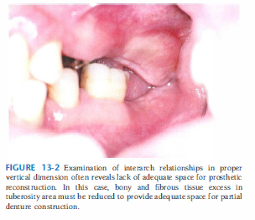
- So if the patient decides to receive an implant here, at first the excess soft tissues must be excised, and the level of bone must be evaluated, and in order to receive a bone graft, there is a need to do direct sinus lifting. Moreover the over-erupted lower molar need to be endo-treated and followed with a crown of an acceptable height.
(Direct sinus lifting, because there isn’t enough bone so we do it directly)

- If the patient decides to get a removable prosthesis, there will be no need to do sinus lifting, only soft tissue excision and lowering the occlusal plane of the over-erupted lower first molar.
Pneumatization of the maxillary sinus

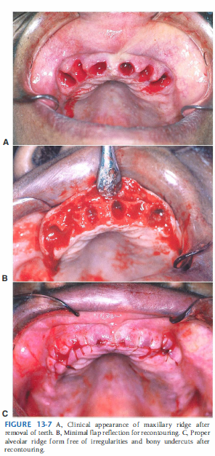
- Simple Alveoplasty
Alveoplasty: to provide an adequate shape of the alveolar ridge, which means getting rid of the undercuts, and any interferences that
Genioplasty: to provide an adequate shape of the chin.
Rhinoplasty: to provide an adequate shape of the nose.

Alveoplasty: the most common pre-prosthetic procedure. The aim is to recontour the bone and remove any irregularities that may cause frequent lacerations and excessive bone resorption when the final prosthesis is placed and compressed against the soft tissues. This also might cause instability and poor adaptation of the final prosthesis.

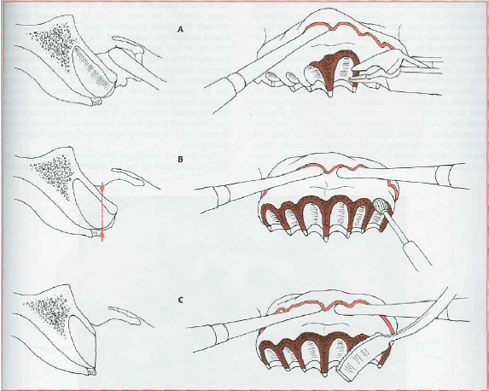
Simple alveoplasty is done by removing the labiocortical surface of the ridge at the time of extraction, or after the healing socket. Using a bur or a Bone-Rongeur depending on the amount of bone that needs to be removed.

This can be achieved by doing a distal incision and extend it 1 cm distal and mesial around the working area, making a full mucoperiosteal window flap to expose the bone. The window flap will make the resorption of the ridge lower.

After removing bone with the bur, we use the bone file to smoothen the bone, and then palpating the area with our fingers to make sure there aren’t any irregularities.
This procedure is done under local anesthesia and the flap is closed using continuous locking sutures (making sure that knots won’t irritate the patient).

- Knife edge ridge :

Inadequate shape of the ridge, this sharp part of the ridge will compress the denture against the soft tissues, causing pain to the patient, frequent ulcerations and accelerates the resorption of the bone.

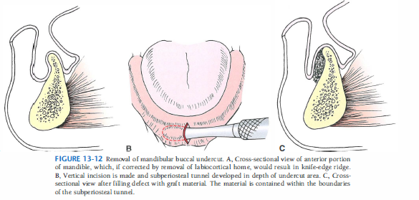
If there is adequate height of bone with sufficient interarch space, alveoplasty is done to recontour the ridge, but if there isn’t enough height of bone and increased interarch space, we have to encounter bone graft and augmentation of the ridge rather than alveoplasty.

Here is a safe technique in this lower ridge, where the surgeon makes a vertical incision, and then the graft material is filled within the subperiosteal tunnel that is developed in depth of the undercut area.

- Intraseptal alveoplasty :
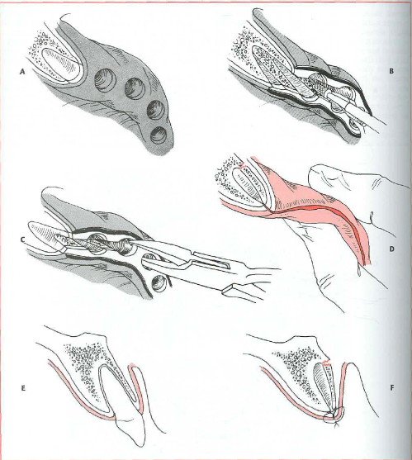
It’s another type of alveoplasty. Where interseptal bone is removed by bone-rongeur or a bur, and then buccal bone is fractured (compressed) against the palatal bone to get rid of the undercut.
This technique is called Split Ridge Technique.
The disadvantage of this technique is that the width of the ridge is decreased.
But in this technique there is no risk of bone resorption, no elevation of a flap, no disturbance to the muscle attachment.

Ideal amount of bone buccal and lingual to the implant is 2 mm on each side.
And the minimum width of the implant is 3 mm, so the minimum width needed for an implant is 7 mm.

There was a study comparing between: Simple alveoplasty, interseptal alveoplasty, and Non-surgical extraction in terms of bone resorption. The results were found to be in this descending order (from the highest resorption rate to the lowest):
1-Simple alveoplasty.
2-Interseptal alveoplasty.
3-Non-surgical extraction. (Least resorption)

- Bony Exostosis in the tuberosity area:
If the interarch space is decreased, exostosis have to be removed, while if it is increased bone graft is the best solution.

In this case, there is bony exostosis in the posterior buccal area, we can remove it by the simple alveoplasty, and it’s performed by a crestal incision and a releasing incision.
Bone is removed by a bur or rongeur. And then the wound is closed with sutures.
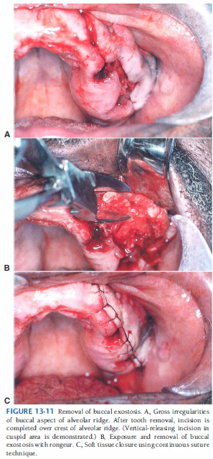
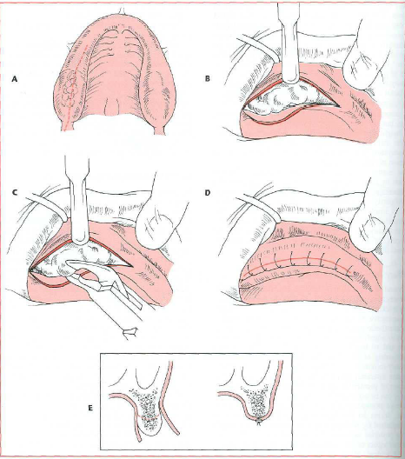

- Prominent mylohyoid ridge :

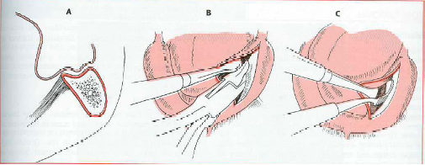
When there is excessive resorption of the mandible, the mylohyoid ridge will be prominent, which will be irritating to the patient whenever the denture is worn, because the lingual flanges of the denture will be directed toward the mylohyoid muscle and this will cause dislodgment of the denture in any function the patient does. (poor stability and retention of the denture).

In picture A: prominent mylohyoid ridge (internal oblique line), prominent external oblique ridge, and depression in the middle of the crest of the ridge which is suitable to receive bone graft if there is increase in the interarch space.
But if there is adequate interarch space, the surgeon needs to do mylohyoid ridge reduction, by making crestal incision and going more buccally to avoid any injury to the lingual nerve. More care need to be taken not to injure the muscles to avoid any profuse bleeding and hematoma production. And then bone is removed and irrigated by saline and then sutures are placed.

If any muscle got dissected it will reattach to bone, and due to this The “Lowering the floor of the mouth “ technique is always UNPREDICTABLE.

- Torus Palatinus :
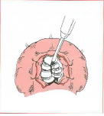
This tori vary in size and shape between individuals, it can be present in dentate or edentulous patients. In dentate patients, it is rarely indicated for removal unless it interferes with speech. While in edentulous patients, if it’s in the post dam area, it will interfere with the peripheral seal of the final prosthesis so it is usually indicated for surgical removal.

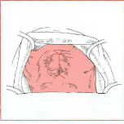
Mucosa in the palate is very thin, and due to this, LA has to be given in sub-periosteum to facilitate flap elevation.

Care need to be taken not to perforate the palatal floor and cause Oronasal communication and fistula.

Start with a midline incision with releasing incisions anteriorly nd posteriorly, retract the soft tissues with retraction sutures and divide the torus into small pieces to ease its removal without fracturing the bone and making communication with the nasal cavity.

Pieces of bone are removed with a fine osteotome or a bur, and then the incision is closed by simple interrupted sutures.

- Torus mandibularis:
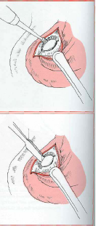
Torus mandibularis varies in size and shape, it may be indicated for removal or not, whether it interferes with speech or a prosthesis.
This area is risky due to the nerves, vessels and ducts that pass there.

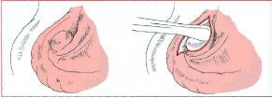
Start with crestal incision more buccal then direct exposure of the bone. If it’s large, don’t use a rongeur to remove it because you may fracture the mandible. So make a trough by a fissure bur between the tori and the lingual plate to separate it, then use osteotome to left it up, finally smoothen the area with a bur or a file and close the incision with continuous suture with lock.
If you do bilateral don’t do continuous incision bilaterally, you have to leave a midline attachment to prevent hematoma which is very dangerous.

The patient must be instructed to ask for help and emergency if any breathing problems occur, or swelling in the sublingual area.

Soft Tissue Irregularities :
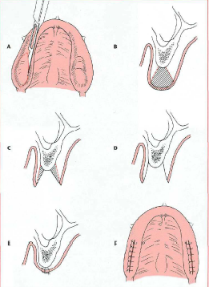
- Excess unsupported soft tissues (Flappy ridge) :
The depth of the soft tissues is measured using a probe, if excess soft tissues need to be removed, an elliptical incision is made (Base narrower than the surface), soft tissue is removed and then healing will occur by primary intention.

- Inflammatory Fibrous Hyperplasia :
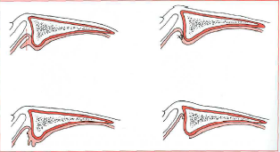
Ill-fitting dentures may cause hyperplasia of the soft tissue due to chronic irritation (Denture fibrosis or Epulis Fissurata). If it’s small we can excise it, and gain primary closure without affecting the depth of the vestibule, while if it’s large, its removal will cause reduction in the depth of the vestibule, so we excise the excess tissue and suture the edges of the incision to the supra-periosteum, to get secondary intention healing and preserve the depth of the sulcus.

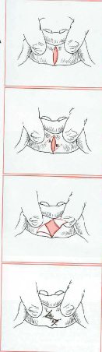
- Frenal attachment: Labial frenum can be excised by simple surgical excision, or by Simple surgical Frenectomy, by making a diamond-shaped incision around the frenum and remove it, then it’s sutured and healed by primary intention.
But in case of having a large frenum with wide base, regular excision and primary closure will reduce the depth of the sulcus, so we remove the frenum and close the incision with suture to the supra-periosteum and make it heal by secondary intention, to maintain the depth of the sulcus.
This can be done under LA and GA.

- Lingual frenum:
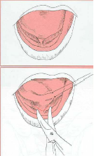
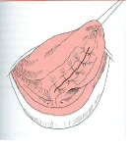
It attaches the ventral surface of the tongue to the lingual surface of the mouth. It’s indicated for excision when it interferes with speech in young children or breaks the seal of the complete denture.

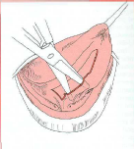
Under LA (ID blocks on both sides), use the hemostat to compress the frenum for about 2 minutes to achieve vasoconstriction, this will compress the blood supply to that area and you will notice the blanching. Retract the tongue either by sutures or by hand and make a transverse incision till you reach the tip of hemostat, undermined the edges of the incision.

Be aware of the sublingual vessels and the mandibular gland ducts, if any dissection to the vessels happens, ligation to the vessels must be done to stop the bleeding.

Best Of Luck !

