Sheet number:7
Date: 24/10/2016
Doctor: Ashraf Abu-Karki
Written by Noor Al-Shakhatrah

Cystic lesions in the jaw

In the previous lecture we talked about surgical management of the cysts of jaw:
1- enucleation
2- marsupialization .
3- enucleation and curettage .
4- marsupialization followed by enucleation .
Sometimes surgeons make excision especially for odontogenic keratocyst
Diagnostic steps of cystic lesion are not important known , , we only aim to have a list of differential diagnosis depending on history , signs and symptoms and radiographic features.
so you have to know the general features of cystic lesions and the feature of the most common cystic lesions ONLY
The most common cystic lesions in the oral cavity)
Radicular cyst
70% of all cystic lesions and it is the most common one .
2- Dentigerous cyst
the 2d most common cyst in the oral cavity .
3- Keratocyst
the 3d most common cyst in the oral cavity.
4- nasopalatine
the 4th most common cyst in the oral cavity.

we will talk about main classification of cystic lesion:
1-odontogenic cyst
odontogenic inflammatory cyst :
Radicular cyst : (most common)
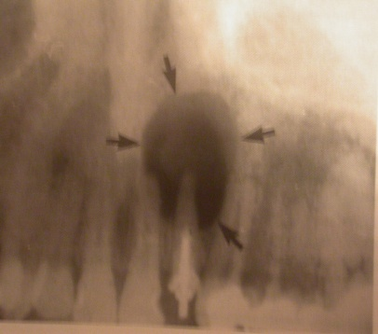
origin :
inflammatory in origin , the source of inflammation is apex of non vital tooth . so to diagnose a cystic lesion as a Radicular cyst it's a must to have a non-vital tooth , it Develops from the epithelial remnants of Hertwigs sheath- the cell rests of Malassez when it is inflamed .
frequency :
the most common cyst in the jaw ( because inflammation is common in the teeth)
age :
usually it is common in adults 20-50 years
site :
apex of a non-vital tooth, if the tooth is an endo-treated tooth then definitely it is non-vital , but if it is not treated endodontically we have to do vitality test and if the tooth is vital then Radicular cyst is excluded .
size :
1.5 – 3 cm in diameter ( the size increase with time if it is left un -treated )
radiographic features :
round , well defined corticated – with clear border – unilocular uniformed radiolucency ( only one radiolucent lesion) .
effect on the surrounding:

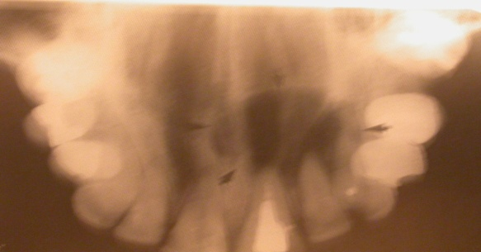
Radicular cyst is a benign lesion as most of the cystic lesion ( only some cystic lesion behave as aggressive ) since it's benign it may :
1-displace the teeth ( push the roots of the teeth without resorbing them ) , it is not easy for any lesion to cause resorption of the cementum unless the lesion is very aggressive .
2-it might cause bone expansion as it grows inside the bone without perforation of lingual or buccal cortex because it is not aggressive enough to do so , this expansion increase with time if the lesion left untreated (buccolingual expansion)
3-it can also cause displacement of the sinus wall .
management of Radicular cyst
we have to manage
- the cyst itself .
- the causing factor ( non-vital tooth ) .
management of the non-vital tooth
- if the tooth is restorable then we go for root canal treatment
- if the tooth is restorable but the root is involved in the lesion then we go for root canal treatment and apicoectomy.
- if the tooth is non- restorable or the surrounding bone is severely resorbed or the tooth is very mobile then we go for extraction .
management of the cyst
by enucleation we remove the lesion without touching the bony borders , once it's enucleated and the cause is treated successfully the recurrence rate is very very low .
** although most of Radicular cyst are of moderate size ( unlike the Dentigerous cyst ) , someone argue that if the cyst left untreated for long time it will be very large in size, so we might think of marsupialization as treatment - remove part of the lesion and allow it to shrink , after shrinkage we enculeate the lesion .
2- residual cyst:

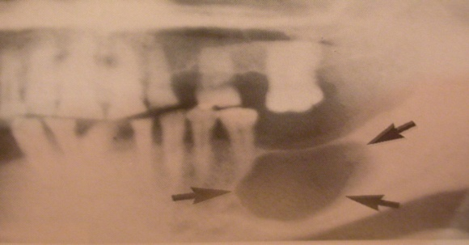
all what we said about Radicular cyst is applicable to the residual one with the only difference that the inflamed tooth has been extracted without treatment of associated cystic lesion .
management : same as Radicular cyst (enculeation).

3- Lateral Radicular cyst:

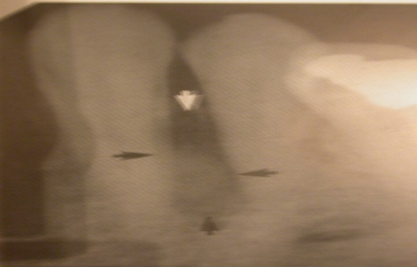
same as Radicular cyst but it only differ in the site , it is between 2 adjacent teeth one of them has to be non-vital -it is not around the apex ( like Radicular cyst ) .
if both teeth are vital then the lesion is lateral periodontal cyst rather than a lateral Radicular cyst .
management : treat the non vital tooth and enculeate the cyst .

odontogenic developmental cysts
1- Dentigerous cyst (follicular cyst)
frequency :
the second most common cystic lesion after Radicular cyst it accounts 20% of all cystic lesion .
location :
associated with the crown of impacted tooth , since the most impacted teeth are lower 3d molar followed by upper canine then lower fives , the most common site of dentigerous cyst are posterior mandible around the lower 8 and canine area in the maxilla
age :
it is usually most common in 20-40 years of age because at this age the teeth already impacted and start to develop a pathological lesion .
size :
variable in size it starts small but if it left untreated it can reach a very large size and it is common to find a large Dentigerous cyst since it is a symptomatic and associated with impacted tooth , unlike the Radicular cyst which is associated with inflamed tooth so it is usually presented with some signs and symptoms .however , the Radicular cyst can also be asymptomatic if it is associated with a non vital tooth without acute infection , but it is more common to have a asymptomatic Dentigerous cyst .
so it is diagnosed accidently when we take an OPG to treat another tooth , or if the pt feels the expansion as swelling, or if the pt complain of pain once the cyst is infected .
radiographic features :
uni- locular , well defined corticated , uniformly radiolucent unless it is infected ,
effect on surrounding structures
- it can cause bucco-lingual expansion ( swelling )
- it can displace the impacted tooth and the surrounding teeth but very rarely to cause resorption
according to cyst- crown relation the Dentigerous cyst might be
- central (lesion around the crown )
- lateral ( lesion lateral to the crown )
- circumferential ( the tooth inside the lesion )
Treatment of Dentigerous cyst ;
We have to take into consideration 2 things ; impacted tooth and cystic lesion . we have different treatment modality according to the case
1- enucleation of cystic lesion and tooth as one piece.
if the impacted tooth is not strategic tooth as lower 3rd molar then we can remove the cyst with the impacted tooth as a one piece , so the treatment is enucleation of both cyst with the tooth
. 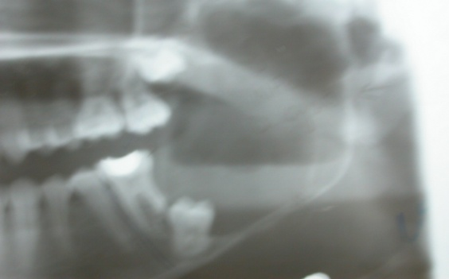
2 marsupialization
- if the Dentigerous cyst is very big and the lower border of the mandible is very minimal so if we enucleate the cyst as one piece we will weaken the mandible and increase susceptibility to fracture .
- if the cyst is very large and the access to it is very difficult and hard to removed as one piece .
So here we have to think of other treatment modalities , as marsupialization ,in which we remove the cover of the lesion and suture it’s lining with the surrounding normal mucosa so we evacuate it’s content and it’s fluid and this will decrease the pressure inside the cyst which will gradually decrease in size so we will be able to enucleate it easily without any risk of mandibular fracture .
***So what we always aim for is enucleation of the whole lesion, but if this impossible due to the size of the lesion , having risk of damage vital structures as inferior alveolar nerve or having a risk of mandibular fracture then we go for marsupialization to decrease the size of the lesion then do enucleation .
in case of having impacted canine , with enough space for it in the arch , by doing enucleation you will lose the canine with the enucleated cyst . so in this case you can do marsupialization , open a part of the lesion , allow the lesion to shrink gradually and the bone will form, this allow the tooth to erupt either by it’s own or by the help of orthodontic treatment , but suppose that the patient is not welling to have orthodontic treatment and he is happy with his occlusion or even there is no enough space for canine to erupt then we will go for enucleation of the cyst with the impacted canine.
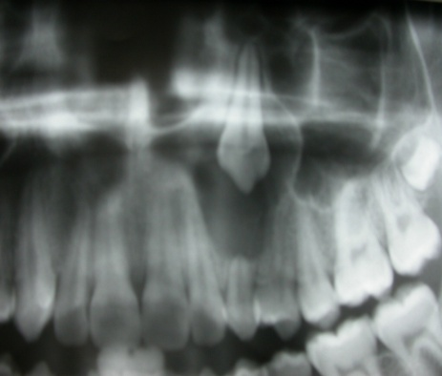
So not all cases of impacted canine is treated by marsupialization .

So always remember that our treatment modality must be determined according to the case .and enucleation alone is not always enough , suppose during enucleation of Radicular cyst or Dentigerous cyst a fragmentation occur then you have to do curettage for the whole walls to be sure that there is no remnants left .
Q: Can we do marsupialization without enucleation ?
Yes we can , if we do marsupialization and wait for long time shrinkage will occur followed by bone formation and eventually the lesion will heal by it's own and this is what we do in case of impacted canine .

2- eruption cyst :follicular cyst during eruption .

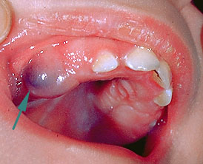

Type : Dentigerous cyst in the soft tissue .
Age : It is very common especially in children in mixed dentition stage during tooth eruption , Due to trauma to the soft tissue which will induce inflammation and fluid accumulation and bluish hematoma may occur .
Management : If it is painful we may give topical anesthesia , If it inhibit tooth eruption , then we give local anesthesia to make a small incision on the soft tissue and wait for eruption after a period of time .

3- Odontogenic Keratocyst ;

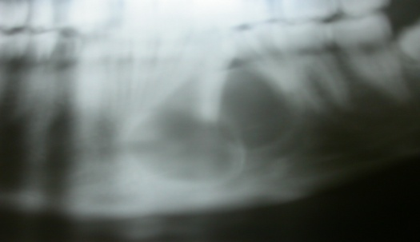

This cyst has a great debate either to call it a cyst or a tumor, this debate arise from it's behavior which is a cyst with high recurrence rate(invasion of the adjacent tissues including bone ) , because the cells are on the wall so it is not enough to do enucleation. Nowadays it is considered as a cystic lesion .
** The associated teeth are vital
Site:
Posterior body of the mandible is the most common site ,, Anterior maxilla in canine region
Radiographic features
It is usually multi-locular , but in some cases may be present as uni-locular, Radiodensity: Uniformly radiolucent
Effects on surrounding :
* rarely to cause resorption of the adjacent teeth , it may cause displacement
* although It doesn’t cause expansion in buccolingual direction it grows in ant.post. direction inside the cancellous bone .
management , there are different types of management :
enucleation alone , but this associated with high recurrence rate
enucleation and curettage with application of Carnoy's Solution (chemically treatment)
Carnoy's Solution which is a mixture of chemicals one of these chemical is formaldehyde , there is a great debate about it's use due to it's irritation and traumatic effect on the soft tissue , and it's carcinogenic effect due to formaldehyde and we can't use it if cyst close to vital structure (nerve)
however , new generation of Carnoy's Solution without formaldehyde is available .

excision remove the lesion with the surrounding bone which result in cure of the lesion without recurrence

Q - why we don’t do excision for all types of Keratocyst ?
as we said before ; we chose the treatment modality according to the case . e.g if we have large Keratocyst you may need to remove the whole mandible in order to excise the Keratocyst . so if it is possible to excise the Keratocyst with a safety margin ( 3-4 mm of the surrounding bone ) then go for excision which is the best treatment modality , If it is not possible ,when the lesion is very large and very close to vital structures you may think of marsupialization and after it shrinks you may do excision .so the first we make incision biopsy then if we sure it is keratocyst go to excision biopsy and we choice correction treatment for keratocyst
You cant say it is wrong to do enucleation with very good curettage but you need to follow it up as recurrence rate is very high .

Multiple keratocysts associated with Gorlin Syndrome (nevoid basal cell carcinoma syndrome) which has the following features :
Multiple Odontogenic Keratocysts , in upper and lower jaws .
Multiple Basal Cell Carcinomas , in the skin
Skeletal Anomalies, e.g. bifid ribs (rib with 2 heads ) and calcification of the flax cerebri (separation between 2 lobes of the brain )
Management is very difficult you have to treat the multiple keratocysts as you are treating each one individually .

The following developmental cysts account less than 5% of oral cystic lesions :
4-Developmental Lateral Periodontal Cyst
Age: Variable
Frequency: Uncommon
Similar to lateral Radicular cyst , but here teeth are vital .
Treatment : enculeation
5- Glandular Odontogenic Cyst :
Site: common in anterior area of the mandible (other cysts common in the post area of the mandible )
It crosses the midline
multilocular
It may cause Paresthesia as it is close to the mental nerve and it is very aggreassive
After enucleation it may re-occur
It is very rare( it has specialized features)

Non-Odontogenic Cysts
Developmental Cysts
Nasopalatine duct cyst (most common)
Nasolabial cyst
Median Palatine Cyst
Globulo-Maxillary Cyst
Median Mandibular cyst
1- Nasopalatine duct cyst (most common)

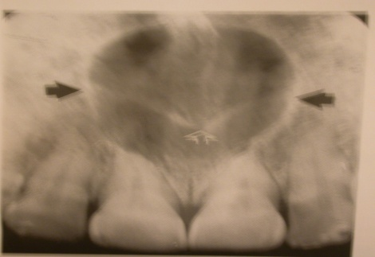
expansion or cystic lesion in the content of the duct from nasopalatine canal ( incisive canal )
Occur at age between 40-60 .
It is only 1% of all cystic lesions
How to Differentiate between Nasopalatine Duct Cyst and a large normal Naopalatine foramen?
You have to know the feature of the cyst :
Size: Variable, but usually from 6mm to several cms in diameter.
Shape: Round uni locular , Well corticated and like heart shape

It’s affect on the Adjacent teeth is distal displacement, rarely resorbed ,

 | Cyst | Normal NP duct
Boundary | Well corticated
Size | More than 6 mm | Less than 6 mm
Shape | Heart shape *
Radiolucency | Uniform | Not uniform ; as it has vessels
Outline | Clear outline

Management of the cyst ; enucleation, open it then clean it up and remove the cyst as one piece .

2-Globulo-Maxillary Cyst :
description of the lesion in the maxilla between upper canine and lateral , but upon biopsy it can be any other type of cystic lesion . so it is only clinical term describe the site of the cyst (not true developmental cyst)

Nasolabial cyst : (it is not a bony cyst )rare cyst occur in the soft tissue at the lateral border of the nose appear as swelling with no radiographic features .

Bone Cysts
1-Solitary bone cyst:
Unknown aetiology, may be associated with trauma.
Site: Premolar and Molar region of the Mandible
Shape: Monolocular
Treatment : aspiration
2-Aneurysmal bone cyst :
Localized non-neoplastic proliferative lesion of vascular tissue, containing Giant Cells.
Age: Usually < 20yrs old
Site: Body/ posterior mandible
Maxilla occasionally
Size: Variable, up to several cms
Shape: - Mono or Multilocular
a soap-bubble appearance. (honey-cell appearance)
treatment: aspiration

3-Stafne Cyst ( Lingual Salivary Gland Inclusion Defect)
Well defined depression in the lingual surface of the posterior body of the mandible (especially below inferior alveolar canal)
Usually asymptomatic
OPG radiograph
Treatment: no need, just follow up

Soft tissue cyst
Dermoid : cystic teratoma derived from embryonic germinal epithelium
Location: if lesion below floor of the mouth ,this is ranyla or dermoid
Branchial : remnant of branchial artery ,it can be found along the anterior border of the Sternocleidomastoid muscle.

Thyroglossal duct cyst: remnant of thyroid gland
Location: It usually presents as a midline neck lump (in the region of the hyoid bone) that is usually painless ,
The mass on the neck moves during swallowing or on protrusion of the tongue because of its attachment to the tongue via the tract of thyroid descent.
Treatment for a thyroglossal cyst is called the Sistrunk procedure: surgical resection of the duct to the base of the trunk and removal of the central portion of the hyoid bone, The Sistrunk procedure involves excision not only of the cyst but also of the path's tract and branches. A removal of the central portion of the hyoid bone is indicated to ensure complete removal of the tract
Thyroid scans and thyroid function studies are ordered preoperatively; this is important to demonstrate that normally functioning thyroid tissue is in its usual area.

Salivary cyst: a mucous cyst, also known as a mucocele, is a fluid-filled swelling that occurs on the lip or the mouth,the cyst develops when the mouth’s salivary glands become plugged with mucus. Most cysts are on the lower lip, but they can occur anywhere inside your mouth. They’re usually temporary and painless. However, cysts can become permanent if they’re not treated. Most common cause: traumatic

at the end of the lecture, Dr. summarized the lecture in the form of a scenario:
"if any doctor showed radiographic and he asked u what is type of the cyst?
First of all u should asked him this is odontogenic cyst or non , if it is odontogenic
Then ask him inflammatory or non , if it is inflammatory , you should find Classic radiographic appearance for cyst , for example ifit is uni-locular radiolucent lesion around the apex of non vital tooth that cause expansion so this is Radicular cyst ..... and so on"
so You have to follow this consequence in determine any cyst

Good Luck

