The Dilemma of clinical diagnosis of dental caries
The lecture is a very important one not for the sake of the exam only, also for our future career.
Although Europe and developed countries are shifting toward preventive (non-operative) treatments, dental caries still the most dominant reason for dental pain and tooth loss not periodontal diseases or surgical problems.
- Why do we diagnose?
Because the treatment depends on the diagnosis.
Diagnosis: it is a mental resting place on the way to intervention. (Depending on data collected from the patient‘s history or the clinical signs and symptoms, I decide what shall I do?, how shall I treat this patient.
Caries: is a minute of PH fluctuation as a result of metabolic activity in the biofilm.
Caries are not a unidirectional process.
PH ---> mineral deposition(minerals gain)

PH ---> mineral loss

Between mineral gain and mineral loss there is a dynamic process.
We don’t actually see the white chalky appearance unless mineral loss exceeds mineral gain and reach the clinical detection.
Caries that we see are the symptoms of the process which reflect the activity in dental plaque and can be modified by altering the biofilm.
When the biofilm makes a shield on the tooth surface it decreases the PH, and allows the bacteria to start working and produce the carious lesion.
If we alter the biofilm (modify it ) by improving the patient’s oral hygiene instructions (encourages the patient to brush his teeth , add fluoride ,,,, etc ) I can stop the process and the symptoms and specially carious lesion
Then dental caries are episodes of demineralization and re-mineralization rather than unidirectional demineralization.
- Why is the world is shifting toward preventive (non operative) treatment?
Because initially caries are reversible.
Only when we reach the clinical detection ( I can see by the naked eye white chalky appearance) I can say there are caries .
Not seeing the white chalky appearance doesn’t necessarily mean that there is no demineralization and re-mineralization.
Modern clinical caries management concept: (these concepts we may not be able to apply it at the university, but we can apply it in our private clinics, and its already applied all over the world except in the third world countries).
- Caries detection: whether have caries or not, whether I have lesion or not.
- Assess the process: the lesion measurement whether it is :
- In the first part of the enamel (E1)
- Deep in the enamel (E2) ( reached the amilo-dentinal junction , but there is no lateral spread )
- Lateral spread that reached the first third of the dentine (D1)
- In the second third of the dentine (D2)
- In the third third of the dentine and reached the pulp (D3)

- Lesion monitoring: give the patient oral hygiene instructions and take x-ray every 6 months, and every recall assess it, whether it is increasing or it became arrested. If it is increasing that means that my measurements were wrong, so I have to intervene. If it stops that means we are in the right track.

- Caries activity measures: it allows us to know whether the lesion is active or arrested.

We have :
a. totally arrested.
b. totally active .
c. partially active partially arrested .

Unfortunately till now we don’t have caries measures, we have crude criteria (blunt criteria not sharp (not accurate)). It helps us detect the lesion roughly whether it is active or arrested.

- Diagnosis: to intervene or not.
- Prognosis: predict the result of the treatment, whether the tooth of poor prognosis, good prognosis or fair.
- My clinical decision : A. to intervene or not
B. operative treatment (OT) or non operative treatment
8. The outcome on long term after 6 months, one year … etc
- we have

- Sub clinical initial lesion: I can’t see any lesion so I can’t do anything for the patient.
- Lesion detectable only with traditional diagnostic aids : we see by special methods
- Intact lesion : white chalky surface ( intact enamel but it’s a detection that there is a beginning of demineralization .
- Caries cavity
- A deep cavity that reached the dentine
- A cavity that reached the pulp

** in lesion detectable only with traditional diagnostic aids , intact lesion and caries cavity the treatment is preventive non operative , but here in Jordan we can’t really depend on the oral hygiene instructions , but in general worldwide they say if the lesion haven’t reach the dentine there is no need for active care .

** We treat deep cavities by preventive care and operative intervention.
This classification is only for class 5 and occlusally caries.

In proximal caries if we see the caries lesion in the x-ray only if it is
- In the enamel it can be re mineralized by oral hygiene instruction.
- The blackness reached the amilo dentinal junction with lateral spread we have to intervene because already the bacteria have been trapped there and entered the dental tubules.

Sometimes you may have patients with the whole occlusal fissure are discolored
How to know if there discolored lesion are arrested or active
We depend on 2 factors:
- Age of the patients if the patients is 60 years old then most likely its arrested caries (discoloration , pigmentation) if it’s a teenager we suspect it to be active caries
- Oral hygiene : if the patient with poor oral hygiene then most probably it is carries

After assess these two factors you take your decision.

If you have the 8 molars (upper and lower) with discolored fissures, if you suspect that these lesion are carious you go to the worst and the most discolored one and treat it if it is like you expected then you go to the less worse then to the less worse .. etc till you reached the one with arrested caries
If from the first one you found it arrested then you don’t proceed.

- How to evaluate the tooth surface?
- Sound ---> we don’t intervene
- Filled or lesion : the lesion either active or inactive

Any very dark smooth shiny surface without any cavity its arrested lesion
Rough matte surface with cavities its active lesion
if the filling is defected we either remove it or remove parts of it .
From minimal invasive dentistry point of view I can repair the filling by removing the defected parts and keep the intact ones.

Diagnostic tool
- Diagnostic tool requirements :
- Valid: the degree to which the measurements measure what it is purposed to measure. when I want to buy a diagnostic tool to measure caries , I don’t buy apex locater that measures length of the pulp
- Reliable: gives the same result every time ( it’s beneficial for the standardization in the world .
- Accurate.
- Sensitive : true positive ( if I have 10 carious lesion then it should detect 10 carious lesion)
- Specific: true negative (if I don’t have any carious lesion then it shouldn’t detect any carious lesion)
Specificity low: when there is no carious lesion and the tool gives me carious lesion.
Sensitivity low: when there is a carious lesion and the tool doesn’t detect any.
- Potential negative aspect must be evaluated
The first thing that’s come up to minds is radiographs and its negative impacts.
- Cost effectiveness.

There is no diagnostic tool that has the perfect requirements.
No single diagnostic modality can be used on all surfaces under all circumstances for caries detection.

Therefore clinician must decide which tooth surface with benefits.

- Detecting methods :
- Visual /tactile: we dry the tooth surface and examine it with probe and mirror under light and this is the traditional way .
Visual by the naked eye
Tactile by the probe
If you examine the tooth surface without drying it and good light you will miss lots of composites, buccal and occlusal caries.
Opacity with or without air drying is an indication of caries initiation.
Chalky matte and rough enamel surface indicate active lesion
Shinny and smooth surface doesn’t indicate any problem
Problems of this technique:
- Subjective: it depends on the person use it (unreliable).
- Visual sensitivity is very low (0.2-0.5) ,tactile sensitivity is better with (0.5-0.6) , but it has high specificity.

It is the best detecting method for occlusal carries. There is no unnecessary over treatment in low caries risk population.

Some new methods may give wrong results, so you open the tooth while it doesn’t have any carious lesion
Nowadays we still use probing, but some theories advise not to use the probing forcefully specially on the occlusal surfaces, because we may produce cavities.

- Radiographs: it helps us assess the proximal caries we either have
- No radiolucency
- Radiolucency in the outer half of the enamel
- Radiolucency in the inner half of the enamel but not exceeding the amilo dentine
- In the dentine without breaking the amilo dental junction (no lateral spread).
- Lateral spread but in the outer half the dentine
- In the inner side but not necessarily to see that it reached the pulp, because histologically the caries are closer to the pulp than it appears in the radiographs.

R0 no radiolucency , R1 in the enamel , R2 in the enamel but not exceeding the amilo dentinal junction (without lateral spread)
R3 reached the amilo dentinal junction with or without breaking it
R4 in the inner half of the dentine

We only intervene when the radiolucency reach the inner half of the dentine and the pulp.

Restore surgically only when a lesion is seen clearly penetrate the amilo dentinal junction, but as long as it is in the amilo dentinal junction without lateral spread we don’t intervene.

Clinical examination is the best diagnostic method for occlusal caries with (75-82%) efficiency, while in detecting caries on proximal surfaces it has (22-32%) efficiency.
- Since the occlusal surfaces are highly mineralized, detection the carious lesion by radiograph is very hard even if it reached the dentine.

Bite wings: you may use 2 bite wings posteriorly, or 4 bite wings; one for the molars and one for the premolar on each side.

Radiographs have high sensitivity and specificity.

Problems of this method
It can’t be used for pregnant ladies
It can’t be used for monitoring
It can’t be used as a preventive measure, because it needs a very high demineralization level to appear in the radiograph. Every six months you have to do another radiograph, and even if there were demineralization it is too late to use preventive methods
(The lesion doesn’t appear radio graphically except after it extended to the dentine).
We have conventional, digital, intra oral, extra oral, 3D, bite wings, pre-apical, panorama … etc radiographs.

- Radio graphs quality :
If the cone beam direction is wrong the teeth will appear overlapping, and we can’t elicit any proximal caries.
The radiograph must have enough contrast and you must be able to see the colors as it is.
** It has
  - Low sensitivity
  - Limited precision: the tooth may have hypocalcification lesion or any non carious lesion but we think it a carious lesion.

- Quality control
- High density
- Good contrast
- Viewing environment
- Processing artifacts

- Cervical burnout: is an area of apparently increased radiolucency in the mesial and distal cervical (neck) regions of the tooth. Such regions are often mistaken for interproximal caries when in fact they only appear radiolucent because they have neither the radiopaque enamel of the region immediately above nor the bone tissue below. (it is due to angulations differences)

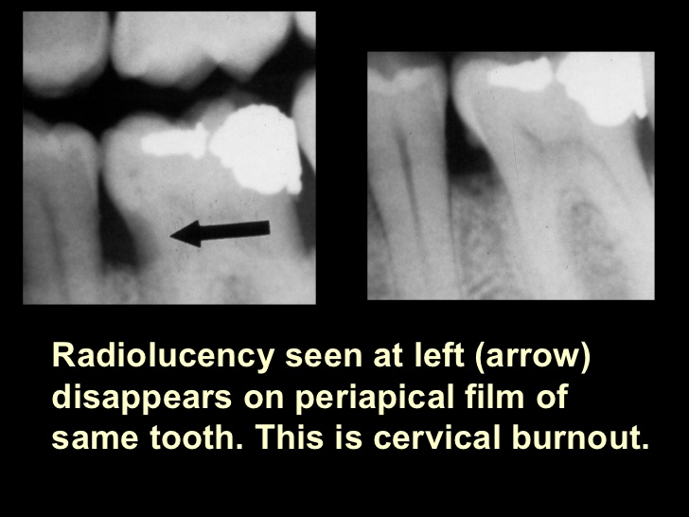

- Black match: the enamel is highly mineralized while the dentine is less mineralized so when they unite they give contrast.

** amilo dentinal junction is hypomineralized in comparisons with the enamel and dentine .

- DIAGNOdent : it is a German invention from Kavo corporation

It is used on
  - Occlusal surfaces
  - Smooth proximal surfaces
  - For enamel and dentine

Prosperities of diagnodent :
- Not invasive
- High reliability
- Valid
- Accurate
- High reducibility
- High co-relation with histological lesions
- Reliable with both occlusal and proximal surfaces
- Reliable with both dentine and enamel .

- Quantitative light fluorescence (QLF): it depends on the tooth auto fluorescence
The lesion appears black
Used for smooth surfaces mainly class 5
Enamel caries only
High sensitivity and specificity
High reliability

- Diagnodent and QLF depend on minerals not on bacteria, histology or collagen.
if they detect a lesion it might be fluorosis or hypocalcification flakes

- Digital fiber optic transmission image :
For dental caries only
Not for occlusal surfaces because of their complex anatomy
It has low sensitivity in proximal surfaces but better than the naked eye

Radiograph > digital fiber optic > clinical diagnosis

No co-relation with histological lesion depth

Dental electrical conductance measure: it depends on the electrical conductivity of the tooth, which depends on minerals

Mineral content -----> electrical conductivity

So if we have a high electrical conductivity then there is a lesion
It has:
- High sensitivity and specificity
- Accurate
- Can be used for enamel or dentine
- Fissure caries in recently erupted molars
- Good for monitoring , non operative treatment

-Currently, early detecting tools such as QLF , electrical conductance measure , and Diagnodent should be used to aid in early caries detection

Independent of the method choosen:
Clinician must be trained to minimize the possibility of false positives and false negatives.

Not all methods can detect early lesion accurately such as radiograph .

Done by: Dana Al-Sharif
Corrected by: Bayan Abu-Halimeh

