Extra lecture – part 2
The Controller System
*What is the function of Respiratory system?
To maintain normal ABG’s
Why do we need the controller system? And Why do we need to control the Respiratory system in general ?What is the goal of controlling the Respiratory System?
To maintain normal ABG’s (PO₂ = 100 , PCO2=40 , PH=7.4 )
-controller system needs inputs to make a proper change
*From where the controller system receives information in order to function ?
If I have to maintain normal ABGs , I must have information regarding to these ABGs ( ABGs ; arterial blood gases” O₂ and CO2” these are the ones which are going to drive the Respiratory system so normal ABGs must feedback the controller system, therefore this tells the controller system whether O2 decreased or CO2 increased and vice versa .
*What are the tools that the Respiratory controller system uses in order to maintain ABGs ?
The Increase or the decrease of ventilation
Controlling ventilation; means to control the Respiratory muscle.
*What is the goal of increasing ventilation( hyper- ventilation ) ?
To make the alveolar air’s composition closer to the composition of outside air which means to increase O₂ and decrease CO₂ , thus decreasing CO₂ in the blood .
*CO₂ is related to H₂ , CO₂ + H_{2O}H₂CO₃
H2CO3 dissociates to H+ and HCO₃, here CO₂ is the same as H^{+ .}
more CO₂ more H ⁺ and vice versa
*Summary to what we said previously :
Increase in ventilation then CO₂ decreases ( you’re washing out CO₂ ) as a result CO2 in the blood goes down which in turn results in the decrease of H+ and this results in alkalosis .
RECALL: ** Alkalosis : PH > 7.5
**shift the equilibrium in the Ca⁺⁺ in the blood , making the free Ca⁺⁺ less .“ you can refer to page 165 of dr.salim’s booklet “ and this is known as hypocalcaemia .
*Hyper ventilation leads to hypocapnia ( decrease of CO2 in the blood ) which reduces H+ resulting in alkalosis , alkalosis shifts the equilibrium making the free Ca++ less ; this is called hypocalcaemia .hypocalcaemia triggers the motor neurons in the spinal cord and this will lead to contraction in muscles of the hand ‘’Carpopedal spasm ‘’if this increases more ( hypocalcaemia will be more ) .
it might cause spasm in the face then in Respiratory muscles ending in death .
** over-crying might lead to hysterical hyper ventilation, in this case you should put a bag on the patients mouth to get back the normal ABGs “ increase CO₂ in the blood “
*hypercapnia : increase CO2 in the blood
What is the goal of hypo-ventilation ?
To increase CO₂ and decrease O₂ which is closer to blood air composition .
CONTROLLER SYSTEM :
in the medulla oblongata : (most of vital signs are from the medulla )
Contains the Respiratory center .
*center means a collection of neurons that have a certain function .
We have 2 collections of neurons:
- One that is located dorsally : dorsal Respiratory neurons
- One that is located ventrally : ventral Respiratory neurons
Dorsal Respiratory neurons: they are inspiratory neurons (iNeurons ), once they are stimulated, they will activate the diaphragm and external intercostal muscles, they beat for 2 seconds and stop beating for 3 seconds so the cycle takes 5 seconds so the Respiratory rate = 60 sec / 5 =12 cycle / min .
From the diaphragm: diaphragm receives orders from phrenic neurons, they are located in the spinal cord between c3 and c5 . These neurons stimulate the diaphragm , however they lack the intrinsic ability to generate their own action potential .

Therefore They aren’t pacemaker cells, they must be stimulated from higher neurons from higher centers.
Remember we have dorsal neurons which stimulate phrenic neurons and these in turn stimulate the diaphragm.
** dorsal Respiratory Neurons : the ones that drives ventilation at Rest . stimulation needed to inspiration since expiration is passive and doesn’t need contraction .
**The ventral are the I and E neurons ( inspiratory and expiratory ) they become active during exercise.
In the inspiratory muscles we have accessory Inspiratory muscles, e.g “neckmuscle,sternocleidomastoid muscle ”
Expiratory muscle sometimes are used during exercise , e.g“ abdominal muscle , terminal SCM muscle “ .
*In pons ,there’s a center called accessory Respiratory center.In the upper one third and in the lower one third ; in the upper one third they are called pneumotaxic center ; it’s function is to switch off the dorsal Respiratory Group.
the lower one third is called apneustic center ;it’s function is to switch on of the dorsal Respiratory center.
-if there’s a cut just below the pneumotaxic center , the dorsal Respiratory center will stay switched on ,without the effect of the pneumotaxic center ,breathing pattern has prolonged inspiratory phases with each breath, followed by a prolonged expiratory phase that is often mistaken for an apneic period and this is called apneusis.
apneusis : is a continuous sustain inspiration with occasional expiration
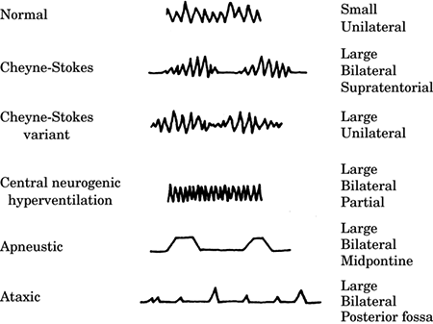
In medulla oblongata, there are cells called chemo sensitive cells in the chemosensetive area, sensitive to chemicals and sensitive to H⁺. hydrogen is in the cerebrospinal fluid .
If hydrogen is injected in the artery , H⁺ can’t enter CSF ,because it is charged .CO2 and O² are only allowed to enter .
If anyone tries to lock his breath, O² decreases and CO² increases . the maximal level for CO2 in the artery is 50 , CO² circulates in the blood until it reaches the CSF then it’s converted to H⁺ ( CO² + H₂O H₂CO₃ H⁺ +HCO₃ ).
H⁺ goes to the chemosensitive area and stimulates it , this results in the stimulation of dorsal Respiratory Group . now what will happen ??
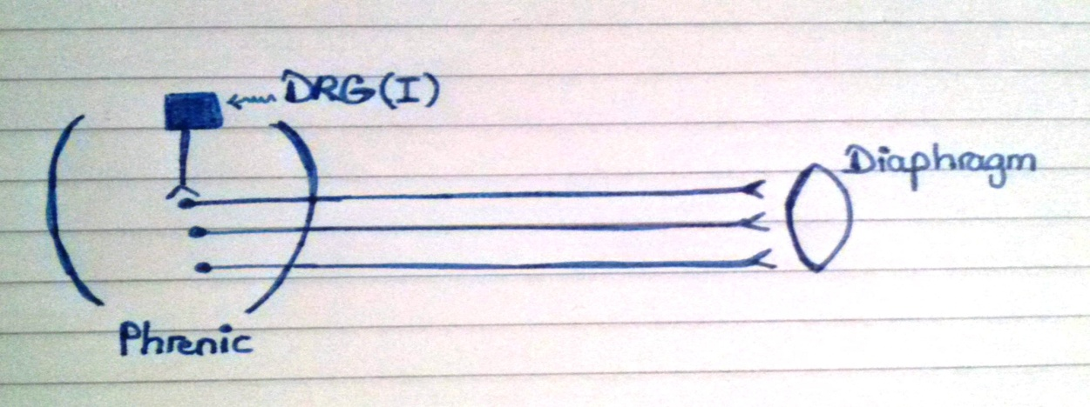
Cortex gives an order directly to phrenic neurons to inhibit the contraction of the Respiratory muscle which is a skeletal muscle.
-holding breath doesn’t result in death but here’s what happens :
CO2 increases in the blood which becomes H+ ,it goes to the chemosensitive area and stimulates dorsal Respiratory Neurons , forcing Phrenic neurons to depolarize instead of the inhibition that comes from the cortex .
ABGs:
We have peripheral chemo receptors : 1- carotid bodies 2- aortic bodies
They are going to tell the dorsal Respiratory group if O2 , CO2 or H⁺ have been changed, then the dorsal Respiratory Group either drives ventilation or decreases it.
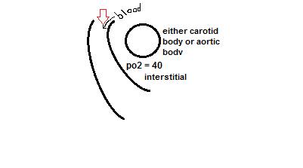
If you want the carotid bodies or aortic bodies to tell the Respiratory center in medulla whether there is a decease or an increase in O₂ and CO₂ . Then the interstitial should be the same as the arterial, but how?
Remember that pO2 in the interstitial = 40 and in everywhere in the body except in these places.
- By largely increasing the blood flow ;its like the cell is not consuming anything including oxygen .
Carotid body weighs 29mg, it has a special artery, it receives 20 ml blood. this blood is not to supply it but to make it exposed to arterial PO₂
*NOTE :muscle receives just 0.03 ml/g
*Carotid body blood flow it the maximum , the next is the kidney
Central chemo receptors are sensitive to H⁺
Peripheral chemo receptors are sensitive to O₂
When carotid bodies and aortic bodies start to send signals?
When pO2 <60
It will not effect if the pO2>100 , because we reached the saturation limit.
* chemosenstive area can sense when the pCO2>40 therefore it increases the ventilation .
As well as it can sense when pCO2<40 thus decreasing the ventilation.
So CO2 has 2 tails (its decrease and its increase both have effects )but O2 has only one .
- During exercise do we have increase in the Respiratory Minute ventilation ?
yes
- What drives ventilation during exercise ?
-Exercise increases ventilation
-PCO₂ in alveoli is proportional to CO2 production and alveolar ventilation
The more the ventilation the less CO2, the more the production
-Exercise increases both of them in the same rate >> so the arterial CO2 is the same
So during exercise, what happens to ABGs ?
Remain constant .
So what drives ventilation ?( oxygen ,CO2 and H remain the same ) .
Receptors in joints ( proprioceptors ) drive ventilation , the stimuli from the cortex go and stimulate the skeletal muscle and then to the Respiratory center .
As a result ABG’s remain the same during exercise .

