general surgery

sheet #7

written by : Razan Al-Lahham

***check every single slide , don’t bypass any picture that was inserted either in the slides or in this sheet .

Water is of major importance to all living things; in some organisms, up to 90% of their body weight comes from water. Up to 60%-70% of the human adult body is water.
the brain and heart are composed of 74.8% water. The skin contains 72% water, muscles 75.6% and kidneys are 82.7%, and even the bones are watery: 22%.
Each day humans must consume a certain amount of water to survive. Of course, this varies according to age and gender, tissue and also by where someone lives. Generally, an adult male needs about 3 liters per day while an adult female needs about 2.2 liters per day. Some of this water is gotten in food.
Water serves a number of essential functions to keep us all going:
- A vital nutrient to the life of every cell, acts first as a building material.
- It regulates our internal body temperature by sweating and respiration
- The carbohydrates and proteins that our bodies use as food are metabolized and transported by water in the bloodstream;
- It assists in flushing waste mainly through urination
- acts as a shock absorber for brain, spinal cord, and fetus
- forms saliva
- lubricates joints
different people have different percentages of their bodies made up of water. Babies have the most, being born at about 80%. By one year of age, that amount drops . In adult men, about 70% of their bodies are water. However, fat tissue does not have as much water as lean tissue. In adult women, fat makes up more of the body than men, so they have about 50% of their bodies made of water. Thus:
- Babies and kids have more water (as a percentage) than adults.
- Women have less water than men (as a percentage).
- People with more fatty tissue have less water than people with less fatty tissue (as a percentage).

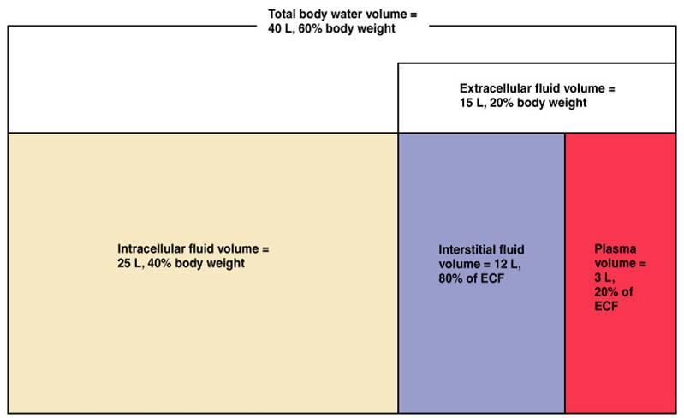

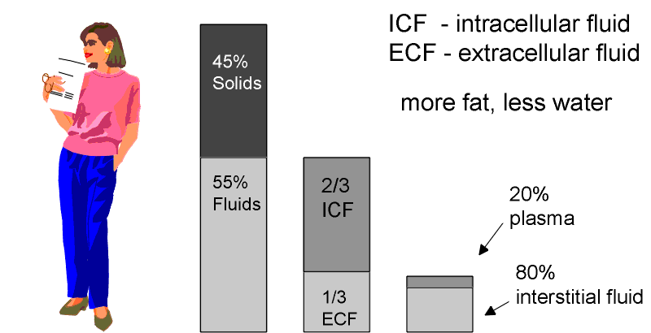

plasma >>> water found within blood vessels *
*interstetial >>> between tissues
water balance :
the intake of water should be almost equal to the output of water which is equal to 2.5 L
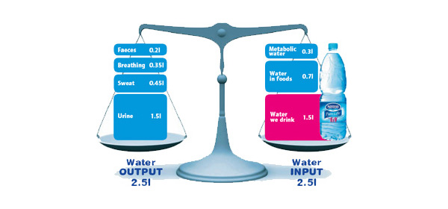

A CAREFUL BALANCING ACT

Mineral salts (electrolytes), such as sodium and potassium, are dissolved in the water in the body. Water balance and electrolyte balance are closely linked. The body works to keep the total amount of water and the levels of electrolytes in the blood constant. For example, when the sodium level becomes too high, thirst develops, leading to an increased intake of fluids. In addition, vasopressin (also called antidiuretic hormone), a hormone secreted by the brain in response to dehydration, causes the kidneys to excrete less water. The combined effect is an increased amount of water in the blood. As a result, sodium is diluted and the balance of sodium and water is restored. When the sodium level becomes too low, the kidneys excrete more water, which decreases the amount of water in the blood, again restoring the balance.
***renin- angiotensin- aldosteron : The system can be activated when there is a loss of blood volume or a drop in blood pressure (such as in hemorrhage or dehydration). This loss of pressure is interpreted by baroreceptors

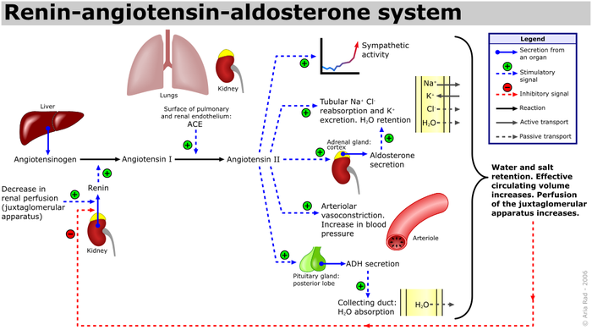

***ANP (atrial natriuretic peptide) :
is a powerful vasodilator, and a protein (polypeptide) hormone secreted by heart muscle cells. It is involved in the homeostatic control of body water, sodium, potassium and fat (adipose tissue). It is released by muscle cells in the upper chambers (atria) of the heart in response to high blood volume. ANP acts to reduce the water, sodium and adipose loads on the circulatory system, thereby reducing blood pressure. ANP has exactly the opposite function of the aldosteron in regard to its effect on sodium in the kidney – that is, aldosterone stimulates sodium retention and ANP generates sodium loss
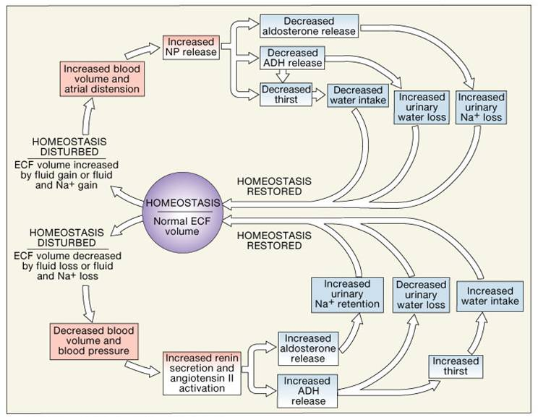
*distention of the heart increases water excretion

***ADH
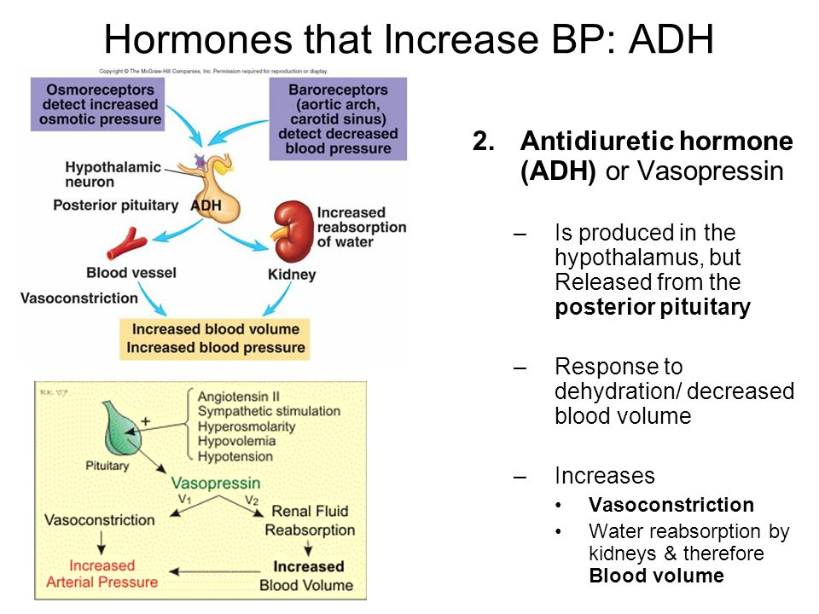

*** bicarbonaten (h2co3) is a major buffer in the human body

In the body, several mechanisms work together to maintain water balance. One of the most important is thirst. When the body needs water, nerve centers deep within the brain are stimulated, resulting in the sensation of thirst. The sensation becomes stronger as the body’s need for water increases, motivating a person to drink the needed fluids. When the body has excess water, thirst is suppressed.
Another mechanism for maintaining water balance involves the pituitary gland (located at the base of the brain) and the kidneys. When the body is low in water, the pituitary gland secretes vasopressin (also called antidiuretic hormone) into the bloodstream. Vasopressin stimulates the kidneys to conserve water and excrete less urine. When the body has excess water, the pituitary gland secretes little vasopressin , enabling the kidneys to excrete excess water in the urine.

***excretion of electrolytes differs from one electrolyte to another
*stomach has a high concentration of sodium and potassium , so in case of vomiting , the patient may suffer from hyponatremia and hypokalemia
*colon has a high concentration of potassium , so patients with chronic diarrhea suffer from hypokalemia

***mechanisms controlling fluid and electrolyte movement :

1. diffusion : Movement of molecules from an area of high concentration to low concentration , Occurs in liquids, solids, and gases , Membrane separating two areas must be permeable to substance for diffusion to occur

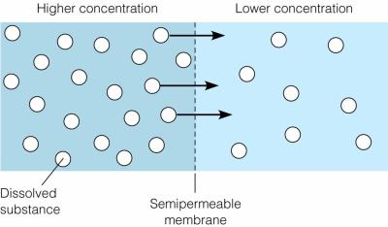
*in diffusion water doesn’t change , the molecules move freely so the that they reach equelibrium (check slide#24)

2. facilitated diffusion : Very similar to diffusion , Specific carrier molecules involved to accelerate diffusion

3. active transport : Process in which molecules move against concentration gradient

Example: sodium-potassium pump

*ATP is energy source
*electrolytes only move by active diffusion
*these pumps help in maintaining the cell in an equilibrium state by pumping the sodium outside the cell and the potassium inside the cell and thus maintaining the osmolality of the cell and the action potential

4.osmosis: Movement of water between two compartments by a membrane permeable to water but not to a solute ,Water moves from area of low solute concentration to area of high solute concentration , Requires no energy , Water flows passively from one area or compartment of the body to another. This passive flow allows the larger volumes of fluid in the cells and the area around the cells to act as reservoirs to protect the more critical but smaller volume of fluid in the blood vessels from dehydration.

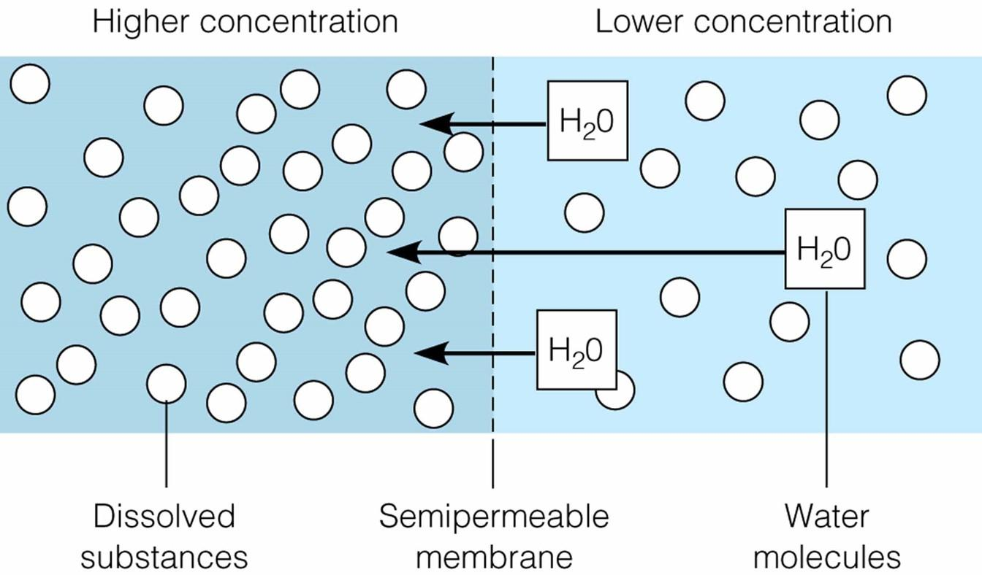

*water moves from the lower concentration to the higher concentration (check slide#25)

5.Hydrostatic Pressure : Force within a fluid compartment , Major force that pushes water out of vascular system at capillary level

6. Oncotic Pressure : Osmotic pressure exerted by colloids in solution

*Proteins are major colloids in vascular system
*water flows to the higher concentration of proteins or solutes

7. selective permeablility : A feature and a function of the plasma membrane that is essential to maintain homeostasis by regulating the passage of some substances while preventing others from entering the cell.
* The plasma membrane is capable of being selectively permeable because of its structure, which is composed of a bilayer of hydrophobic phospholipids, and proteins that act as transporters or channels for certain molecules (e.g. ions).

*hypotonic solution >>> such as in case of hyponatremia >>> water enters the cells by osmosis down their concentration gradient >>> the cell swells
*hypertonic solution >>> such as in case of hypernatremia >>> water leaves the cells by osmosis down the concentration gradient >>> the cell shrinks
***hypernatremia can lead to neuronal cell shrinkage due to the loss of water

***the major determinant of omolality is sodium
osmolality = amount of sodium in the body * 2

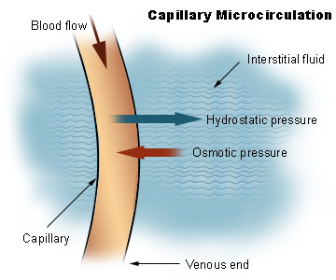
>>> hydrostatic pressure forces fluid out of the capillaries
>>>oncotic pressure pulls fluid into the capillaries
usually the hydrostatic pressure is higher than the oncotic pressure
Oncotic pressure, or colloid osmotic pressure, is a form of osmotic pressure exerted by proteins, notably albumin, in a blood vessel's plasma (blood/liquid) that usually tends to pull water into the circulatory system. It is the opposing force to hydrostatic pressure

*kinds of IV fluid solution :

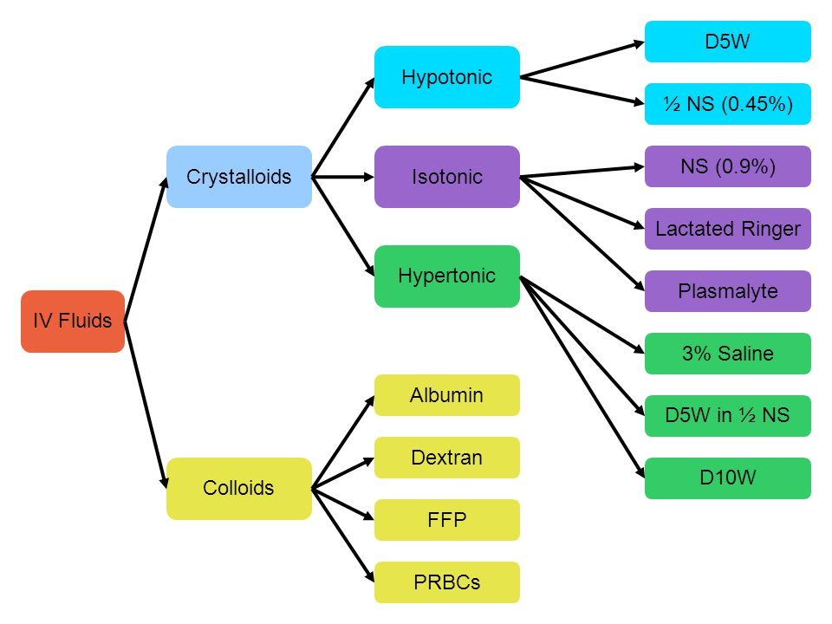

IV fluids are commonly organized into three general categories: isotonic, hypotonic, and hypertonic. Providers typically order a solution based on the particular patient’s serum electrolyte values and fluid-volume balance. All IV fluids must be administered carefully, but hypertonic solutions are particularly risky. These solutions pull fluid into the vascular space by osmosis, resulting in an increased vascular volume that can result in pulmonary edema, particularly in patients who have cardiac or renal disease.
when we give hypertonic solutions we should monitor the patient for hypovolemia due to fluid shifts , they may cause infections , disturb the homeostasis and the osmolarity of the blood and they may cause irritation to the blood vessels , in severe cases hypertonic solutions may absorb all water causing cell death
we must always be carefull when we give iv fluids

Isotonic solutions have an approximate electrolyte content of 275-295 mEq/L. This type of solution is infused to replace fluid losses, usually extracellular losses, and to expand the intravascular volume. Most isotonic solutions do not provide calories or free water. Examples of isotonic solutions are 0.9% sodium chloride, commonly called normal saline (NS), and lactated Ringer’s (LR). , blood is usually isotonic

Hypotonic solutions have an electrolyte content of less than 270 mEq/L and are administered to expand the intracellular space. They are commonly infused to dilute extracellular fluid and rehydrate the cells of patients who have hypertonic fluid imbalances and to treat gastric fluid loss and dehydration from excessive diuresis. This type of solution provides free water, sodium, and chloride but does not provide calories or other electrolytes. An example of a hypotonic solution is 0.45% sodium chloride (0.45% NS), commonly called half normal saline.
Solutions with an electrolyte content of 300 mEq/L or more are considered hypertonic. Hypertonic solutions are infused to treat patients who have severe hyponatremia. Depending on the type of hypertonic fluid infused, it can provide patients with calories, free water, and some electrolytes. Examples of hypertonic solutions are dextrose 10% in water (D10W) and dextrose 5% in 0.9% sodium chloride (D5NS).

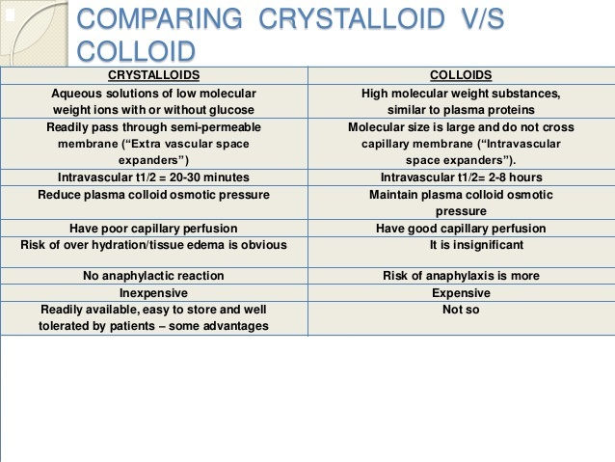
*the disadvantage of crystalloids >>>> they move rapidly from intercellualar space to the interstetial space , they undergo rapid diuresis
colloids : large molecules that increase oncotic pressure , they drag fluids from the interstetium to the intravascular space , they last longer than crystalloids
indications for giving crystalloids :
1. hyponatremia
2. intraoperative/postoverative maintenance fluid
***we mainly give crysatlloids

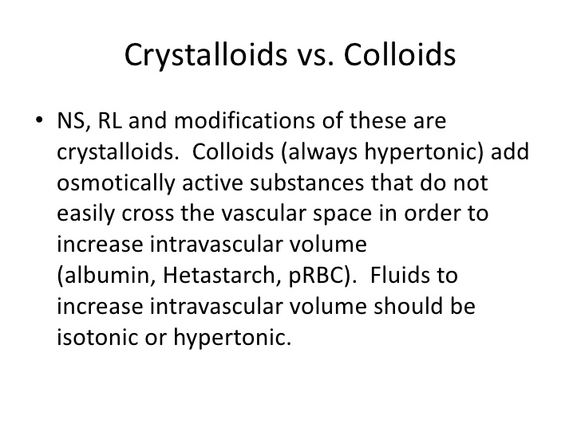
P.S: correct the slide number 67 its not hyponatremia its hypernatremia
D5W >>> we give this fluid to patients before surgery if they needed sugar
normal saline >>> high risk for fluid overload >>> because it contains a high concentration of sodium
lactate ringer >>> more physiologic than normal saline >>> we give it in cases of bleeding , and diarrhea
normal saline doesn’t affect blood products , and it doesn’t change ICF volume because it has sodium
most preferred iv fluid to correct dehydration due to vomiting is isotonic saline , we don't give him ringer lactate , because the acidity is high in the stomach
plasma expanders don’t have any benefit and they are expensive
hypernatremia
in case of hypernatremia >>> fluids move from the cells to intervascular sapces >> that’s why the patient feels thirsty
both the liver and the brain are affected
one of the causes of hypernatremia is diabetes insipidus , diabetes insipidus is either a problem with the production of antidiuretic hormone or kidney's response to antidiuretic hormone leading to excessive excretion of urin
correction of hypernatremia should be done slowly due to the risk of brain edema during treatment (water will move into the brain cells if extracellular tonicity is rapidly decreased )
hyponatremia
>>> leads to swelling of the cell
one of the causes of hyponatremia is ineffecient kidney >> kidney is not excreting water >> hyponatremia
the manifestations in hyponatremia and hypernatremia are almost the same except that in hyponatremia the patient is sweaty and in hypernatremia the patient's skin is dry and sticky , and both affect the brain
hyperkalemia
it’s a life threatening condition
Potassium is the most abundant intracellular cation and about 98% of the body's potassium is found inside cells(that’s why whenever there is cell lyses there is hyperkalemia) , with the remainder in the extracellular fluid including the blood. Membrane potential is maintained principally by the concentration gradient and membrane permeability to potassium with some contribution from the Na+/K+ pump. The potassium gradient is critically important for many physiological processes, including maintenance of cellular membrane potential, homeostasis of cell volume, and transmission of action potentials in nerve cells
***anything that affects the homeostasis e.g; in case of acidosis >>> hydrogen ions get inside the cell and the potassium ions get oitside >>> hyperkalemia
Potassium levels can be falsely elevated by a variety of circumstances surrounding specimen collection and specimen processing. For example, if someone is clenching and relaxing his or her fist, the potassium level in the blood may increase. If blood samples are delayed in getting to the lab or if the blood tubes are subjected to vigorous shaking or rough handling in transit, potassium may leak from red blood cells and falsely elevate the potassium in the serum. A healthcare practitioner may question elevated potassium results when the numbers do not fit the clinical condition. If there are any questions as to how the blood was collected, the healthcare practitioner may request that the test be repeated to verify results.
if potassium levels were above 6 >> ventricular fibrillation >> cardiac arrest >> death and this happens sooo fast unlike sodium disturbances (sodium disturbances >> loss of consciousness followed by coma and then death) so we have to treat him immediately
Hyperkalemia is a common cause of life-threatening heart rhythm changes, or cardiac arrhythmias. It can lead to an emergency condition called ventricular fibrillation. In this condition, the lower parts of your heart flutter rapidly instead of pumping blood.
Untreated, an extremely high amount of potassium in your blood can make your heart stop beating, causing death.
***Atrial flutter is an abnormality in the beating of the heart. Such abnormalities, whether in the rhythm or speed of the heartbeat, are known as arrhythmias.

SLIDE 52 : hyperkalemia >>> a tall tented T wave
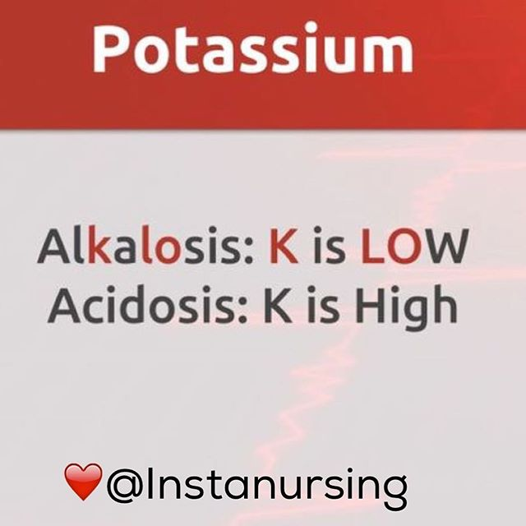

hypokalemia
potassium and magnesium are always associated with each other , that’s why magnesium deficiency is one of the causes of hypokalemia
if any patient after a surgery suffers from paralytic ileus we have to chick the electrolytes levels because hypokalemia has been listed as a cause for paralytic ileus, and correcting electrolyte anomalies is one of the first steps in treatment of a patient with nonfunctioning bowels
calcium
there is a very low concentration of calcium in blood *
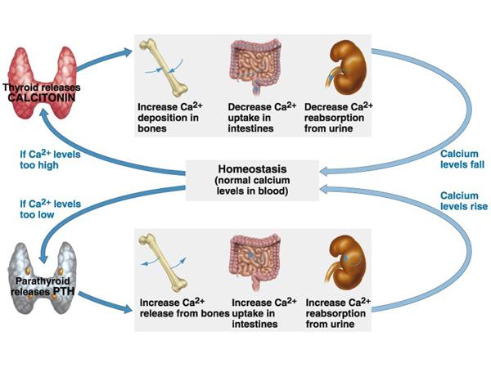
calcium is very important for the GIT
hypercalcemia >>> leads to kidney stones , pain in the GIT and pain in the bones
Hypocalcemia can occur with massive blood transfusions due to the complex of citrate (which is a preservative) with serum calcium.
